
Mathematics and Statistics Department

Knowledge Book

GCSE Statistics
Term 10.5
Time Series
Scan here for revision materials
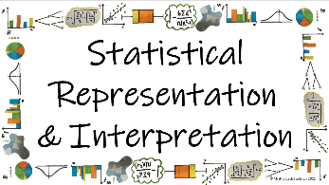
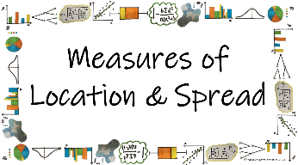
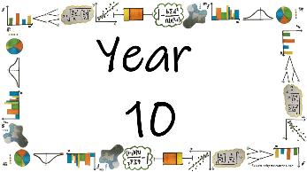
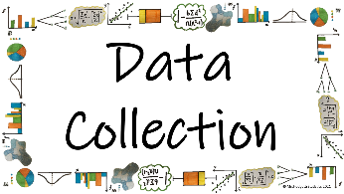

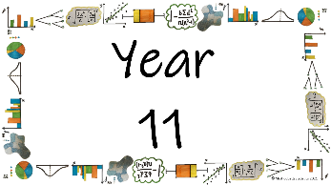
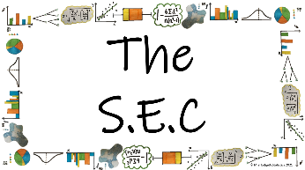
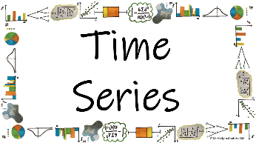
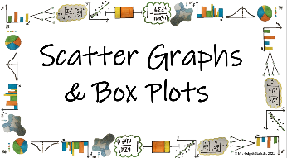

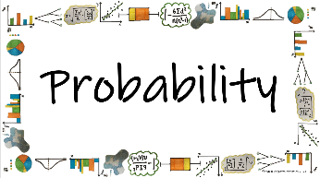
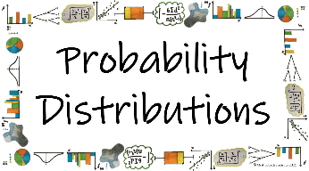
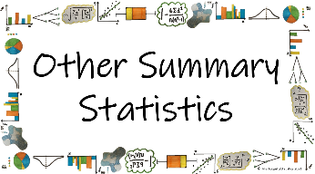


Name: ______________________
Teacher: ______________________
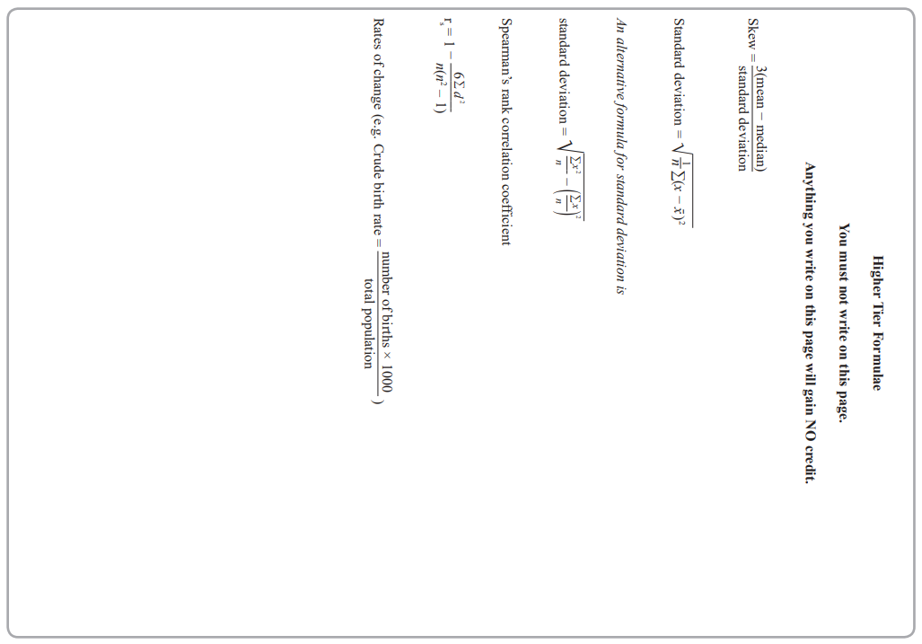
Contents Page
 | How can time series help us to analyse data accurately?
 |  | Page

When do we use a time series and how do we plot it? | 6

How can we draw and describe the trend of the data on a Time Series? | 11

How and why do we calculate moving averages for a time series graph? | 16

How can we find the equation of the trend line? | 24

What is Seasonal Effect and why do we need it? | 28

  Cross-Curricular  Link | All small questions marked with a * are topics that you will be coving in GCSE Maths as well as GCSE Statistics
Vocabulary Pyramid

Peak
Trend
Trough
Time Series
Variable
Gradient
y-intercept
Season
Mean
Moving Average
Seasonality
Effect

Tier 3 Words
Words specific to the subject ‘Statistics’
These may have different meanings in other subjects

Tier 2 Words
Show Data Identify Describe Discuss
Variables Determine Parameter Statistic Construct
Evaluate Respectively Given Explain Conduct Depict
Suggest Assess Validity Research Investigate Decide
Calculate Practical Suitable Collect Complete Frequency

Words that are often seen written in text and exam questions but are not often spoken

Tier 1 Words
Words that are used often in speech and have the same meaning in most contexts
Which Who What Where When Why How
Age Time Weight Mass Length Breadth Width Height
Chart Graph Diagram Advantages Disadvantages



In this Knowledge Book you will see some of the following symbols with interesting facts and information about the words and terminology which will not be assessed but will deepen your understanding of the words.
 | This gives us the origin of a word and the historical development of its meaning.
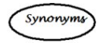 | This gives us a word or phrase that means exactly or nearly the same as another word or phrase in the same language.
  Historical  Origins | Historical Origins. This gives us the historical origin of the word.
  Did you know? | Do you Know? This gives us a fascinating fact about the word or skill,
Cross-Curricular  Link | Cross Curricular Link. This gives us links to where we might use this word or skill in other subjects
  Real World  Application | Real World Application. This gives us an idea of when or how we might use this in the real world.
  Revision Ideas | Revision ideas. This gives us some revision techniques to use for each topic.  Remember to use the revision websites:  - MrsHodgettsStatistics.com  - StatsAcademy.co.uk  - MathsGenie.co.uk  And the Revision techniques websites:  - GetRevising.co.uk
______ / ______ / ______
Plotting Time Series Graphs
 | How can time series help us to analyse data accurately?
 | When do we use a time series and how do we plot it?
Key Vocabulary
Vocab | Mathematical Definition
Time Series | a series of values of a quantity obtained at successive times, often with equal intervals between them.
Variable | a quantity that can be changed and is not fixed
Peak | reach a highest point, either of a specified value or at a specified time
Trough | reach a lowest point, either of a specified value or at a specified time

Historical  Origins | The theoretical developments in time series analysis started early with stochastic processes. The first actual application of autoregressive models to data can be brought back to the work of G. U Yule and J. Walker in the 1920s and 1930s.

The Knowledge Phase
A Time Series is a statistical diagram used to represent data over a period of time
It is used to display a single piece of information (univariate) and looks at how it changes over time

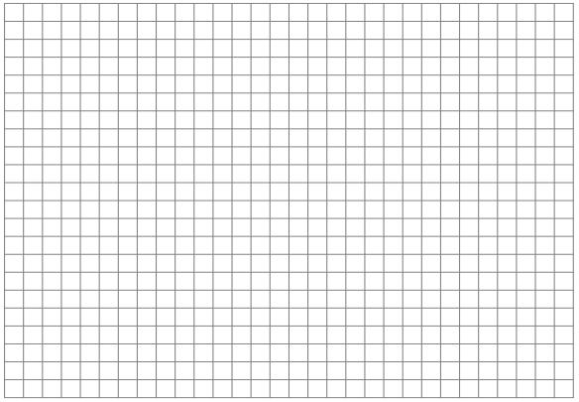
Time series data is displayed as a series of plotted points on a graph with the variable on the vertical (y) axis and time always on the horizontal (x) axis.
Variable
Cross-Curricular  Link | Time series graphs are used in many other subjects such as:  - Science  - Economics  - Geography  - Engineering

Time
(secs/mins/hrs/days/weeks/months/quarters/years)

I DO
How can the following be plotted on a statistical diagram?
Quarterly gas bill for the school over the last 3 years

WE DO
How can the following be plotted on a statistical diagram?
The number of detentions and the number of late marks each student achieves in a year in year 11

YOU DO
How can the following be plotted on a statistical diagram?
The number of goals scored by Kewford United U7s in the 2023/2024 season

Skills Check

1. Quarterly rainfall figures for 2018 □Time Series □Other ........................................................

2. Yr7 and Yr 9 GL test results □Time Series □Other ........................................................

3. Nº of nurses resigned per month □Time Series □Other ........................................................

4. Ice cream sales and temp^{s} in 2018 □Time Series □Other ........................................................

5. A factory's monthly profits □Time Series □Other ........................................................

6. Quarterly sales of new cars □Time Series □Other ........................................................

7. Male and female IQ scores □Time Series □Other ........................................................

8. Hours of sunshine □Time Series □Other ........................................................

9. Numbers of pets owned by 10S □Time Series □Other ........................................................

10. Drink sales and temperature □Time Series □Other ........................................................

The Knowledge Phase
Points are plotted and then joined like a dot-to-dot
Variable
Real World  Application | Seismic time series data is seismogram waveforms recorded at seismic stations. We mostly use digital data, which is a time series of velocity of the ground shaking. Besides the waveform itself, metadata describes critical information of the waveform data.

x
x
x
x
x
x
x
x
x
x
x
x
Time
(secs/mins/hrs/days/weeks/months/quarters/years)

When commenting on the graph we need to look for patterns. Is the peak (highest point on the graph) or trough (lowest point on the graph) always in the same season every year?
Variable
x
x
x
x
x
x
x
x
x
x
x
x
For example, in this graph, the ‘peak’ is always in the 3rd quarter
Variable
x
x
x
x
x
x
x
x
x
x
x
x
For example, in this graph, the ‘trough’ is always in the 1st quarter

Q1 Q2 Q3 Q4 Q1 Q2 Q3 Q4 Q1 Q2 Q3 Q4
Q1 Q2 Q3 Q4 Q1 Q2 Q3 Q4 Q1 Q2 Q3 Q4
WE DO
The quarterly heating bills over three years for a household are given in the table below
Plot this data on a time series graph

What does this graph show?

 | Jan-Mar | Apr-Jun | Jul-Sept | Oct-Dec
Quarter | 1st | 2nd | 3rd | 4th
2016 | £80 | £54 | £47 | £75
2017 | £88 | £68 | £53 | £82
2018 | £97 | ~ | £60 | £89

Practice Questions

1) The table shows information about the average temperature (ºC) recorded in Chester in quarter year periods over the years 2020, 2021 and 2022. Draw a time series graph for the data
Year | 2020 |  |  |  | 2021 |  |  |  | 2022
Quarter | Q1 | Q2 | Q3 | Q4 | Q1 | Q2 | Q3 | Q4 | Q1 | Q2 | Q3 | Q4
Temp | 7 | 12 | 19 | 8 | 9 | 15 | 20 | 10 | 8 | 15 | 21 | 11

- Plot this information on a time series below

- Which quarter shows the highest average temperature each year?

2) The table and time series graph show information about the sales, in £thousands, of Petz@Padstow over a 3 year period.
Year | 2017 |  |  |  | 2018 |  |  |  | 2019
Quarter | Q1 | Q2 | Q3 | Q4 | Q1 | Q2 | Q3 | Q4 | Q1 | Q2 | Q3 | Q4
Sales | 5.2 | 3.1 | 3.8 | 5.8 | 5.5 | 3.5 | 4.1 | 6.4 | 5.7 | 3.6 | 4.0 | 6.5

- Plot this information on a time series below

b) In which quarter were the most sales recorded each year?
3) The table shows information about the average sales per day made by Annie’s Flowers over a three-year period.
Year | 2018 |  | 2019 |  |  |  | 2020 |  |  |  | 2021
Quarter | Q3 | Q4 | Q1 | Q2 | Q3 | Q4 | Q1 | Q2 | Q3 | Q4 | Q1 | Q2
Average Sales | 280 | 410 | 140 | 320 | 250 | 380 | 110 | 300 | 290 | 320 | 80 | 260

- Plot this information on a time series below

- Which quarter shows the highest average sales? Why do you think this might be?

4) The number of parcels delivered by Nigel each day he works for a 3-week period is calculated and shown in the table below
Week | 1 |  |  |  |  | 2 |  |  |  |  | 3
Day | Fri | Sat | Mon | Weds | Thurs | Fri | Sat | Mon | Weds | Thurs | Fri | Sat | Mon | Weds | Thurs
Parcels | 21 | 25 | 30 | 7 | 10 | 26 | 28 | 30 | 8 | 12 | 20 | 27 | 32 | 8 | 10

- Plot this information on a time series below

- On which day each week does Nigel deliver the lowest number of parcels? Why do you think this might be?

______ / ______ / ______
Trend Line
How can time series help us to analyse data accurately?
How can we draw and describe the trend of the data on a Time Series?
Key Vocabulary
Vocab | Mathematical Definition
Time Series | a series of values of a quantity obtained at successive times, often with equal intervals between them.
Trend | the long-term change in the level of a time series

Old English trendan ‘revolve, rotate’, of Germanic origin; compare with trundle. The verb sense ‘turn in a specified direction’ dates from the late 16th century, and gave rise to the figurative use ‘develop in a general direction’ in the mid 19th century, a development paralleled in the noun.

The Knowledge Phase
The general trend can be shown on the graph by drawing a trend line. Look at the general trend of the data and draw a line through the middle of the data
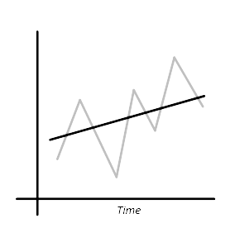
- This is an example of a ‘rising trend’
- It can also be called an ‘upwards trend’
- It can also be called an ‘increasing trend’
- We must NEVER use the term ‘positive’
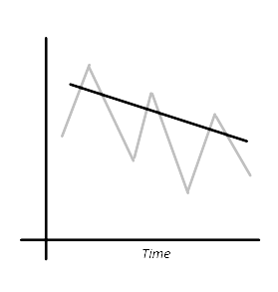
- This is an example of a ‘falling trend’
- It can also be called an ‘downwards trend’
- It can also be called an ‘decreasing trend’
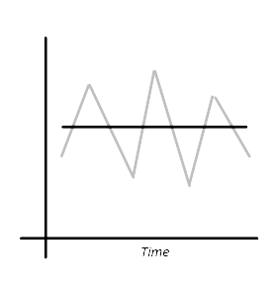
- We must NEVER use the term ‘negative’

- This is an example of a ‘level trend’
- We must NEVER use the term ‘no trend’

Skills Check

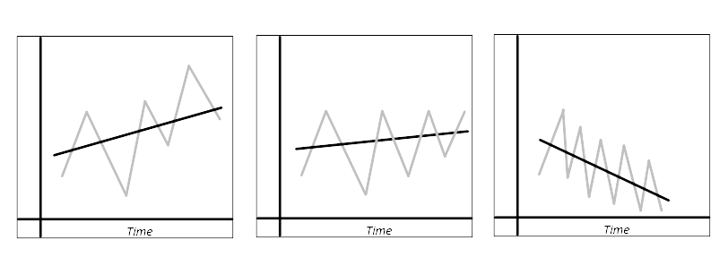
For each of the following time series graphs, choose the trend of the data shown

a) Trend: Rising □ b) Trend: Rising □ c) Trend: Rising □
Falling □ Falling □ Falling □
Level □ Level □ Level □
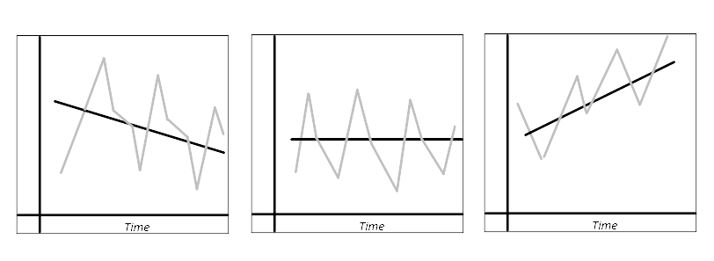
- Describe the trend show by each of the following time series

a) Trend: ………..…………. b) Trend: …………..………. c) Trend: ……………………

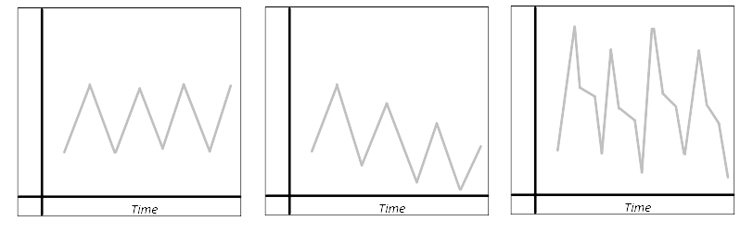

d) Trend: ………..…………. e) Trend: …………..………. f) Trend: ……………………
Real World  Application | Time series analysis helps organizations understand the underlying causes of trends or systemic patterns over time. Using data visualizations, business users can see seasonal trends and dig deeper into why these trends occur. With modern analytics platforms, these visualizations can go far beyond line graphs.

WE DO
The quarterly heating bills over three years for a household are given in the table below
 | Jan-Mar | Apr-Jun | Jul-Sept | Oct-Dec
Quarter | 1st | 2nd | 3rd | 4th
2016 | £80 | £54 | £47 | £75
2017 | £88 | £68 | £53 | £82
2018 | £97 | ~ | £60 | £89

Plot this information on a Time Series and draw the trend line by eye

What trend is shown by this Time Series?

Practice Questions

1) The table shows information about the average temperature (ºC) recorded in Chester in quarter year periods over the years 2020, 2021 and 2022. Draw a time series graph for the data
Year | 2020 |  |  |  | 2021 |  |  |  | 2022
Quarter | Q1 | Q2 | Q3 | Q4 | Q1 | Q2 | Q3 | Q4 | Q1 | Q2 | Q3 | Q4
Temp | 7 | 12 | 19 | 8 | 9 | 15 | 20 | 10 | 8 | 15 | 21 | 11

- Plot this information on a time series below and draw the trend line by eye

- What trend is shown by the graph?

2) The table and time series graph show information about the sales, in £thousands, of Petz@Padstow over a 3 year period.
Year | 2017 |  |  |  | 2018 |  |  |  | 2019
Quarter | Q1 | Q2 | Q3 | Q4 | Q1 | Q2 | Q3 | Q4 | Q1 | Q2 | Q3 | Q4
Sales | 5.2 | 3.1 | 3.8 | 5.8 | 5.5 | 3.5 | 4.1 | 6.4 | 5.7 | 3.6 | 4.0 | 6.5

- Plot this information on a time series below and draw the trend line by eye

b) What trend is shown by the graph?
3) The table shows information about the average sales per day made by Annie’s Flowers over a three-year period.
Year | 2018 |  | 2019 |  |  |  | 2020 |  |  |  | 2021
Quarter | Q3 | Q4 | Q1 | Q2 | Q3 | Q4 | Q1 | Q2 | Q3 | Q4 | Q1 | Q2
Average Sales | 280 | 410 | 140 | 320 | 250 | 380 | 110 | 300 | 290 | 320 | 80 | 260

- Plot this information on a time series below and draw the trend line by eye

b) What trend is shown by the graph?

4) The number of parcels delivered by Nigel each day he works for a 3-week period is calculated and shown in the table below
Week | 1 |  |  |  |  | 2 |  |  |  |  | 3
Day | Fri | Sat | Mon | Weds | Thurs | Fri | Sat | Mon | Weds | Thurs | Fri | Sat | Mon | Weds | Thurs
Parcels | 21 | 25 | 30 | 7 | 10 | 26 | 28 | 30 | 8 | 12 | 20 | 27 | 32 | 8 | 10

- Plot this information on a time series below and draw the trend line by eye

b) What trend is shown by the graph?

______ / ______ / ______
Moving Averages
How can time series help us to analyse data accurately?
How and why do we calculate moving averages for a time series graph?
Key Vocabulary
Vocab | Mathematical Definition
Time Series | a series of values of a quantity obtained at successive times, often with equal intervals between them.
Time Frame | a specified period of time in which something occurs or is planned to take place.
Variability | lack of consistency or fixed pattern; liability to vary or change
Seasons | each of the four divisions of the year (spring, summer, autumn, and winter) marked by particular weather patterns and daylight hours, resulting from the earth's changing position with regard to the sun.
Mean | the number you get by dividing the sum of a set of values by the number of values in the set.
Moving Average | - a succession of averages derived from successive segments (typically of constant size and overlapping) of a series of values.

Historical  Origins | In 1909 G. U. Yule (Journal of the Royal Statistical Society, 72, 721-730) described the “instantaneous averages” R. H. Hooker calculated in 1901 as “moving-averages.” Yule did not adopt the term in his textbook, but it entered circulation through W. I. King's Elements of Statistical Method (1912).
The Knowledge Phase
How can we split a time frame?
When looking at presenting data in a time series graph we need to think about what 'seasons' to use for the data itself.
We need to think of sensible ways to split the data to be able to plot it more accurately and look for patterns

I DO
Give 3 examples of how we can split a year

WE DO
Give another 2 examples of how we can split a year

YOU DO
Give a further example of how we can split a year

Skills Check
Give three examples of how you can split each of these time frames
a) A month
1. ___________________________________________________________________________
2. ___________________________________________________________________________
3. ___________________________________________________________________________
b) A week
1. ___________________________________________________________________________
2. ___________________________________________________________________________
3. ___________________________________________________________________________
c) A day
1. ___________________________________________________________________________
2. ___________________________________________________________________________
3. ___________________________________________________________________________
d) An hour
1. ___________________________________________________________________________
2. ___________________________________________________________________________
3. ___________________________________________________________________________
Real World  Application | Often household bills are sent for different ‘seasons’ of the year. For example, a mobile phone bill may come out once a month (12 ‘seasons’) but the gas or electricity bill may come out once every three moths (4 ‘seasons’)

The Knowledge Phase
For a time series graph we need to be aware of how many seasons are in each time frame. Each time frame can be split differently depending on how frequently the data is collected and recorded. These ‘seasons’ are then used to calculate more accurate moving averages and in turn make more accurate predictions from the data.

I DO
Hospital admissions are collected every month for a period of 3 years. What would be a suitable way to split the data? | each time frame (year) is split into ____ seasons

WE DO
For the time series graph below, what would be a suitable way to split the data? | each time frame (year) is split into ____ seasons

YOU DO
Elouise keeps a record of how many children she collects from school each day of the week as part of her childminding services. What would be a suitable way to split the data? | each time frame (week) is split into ____ seasons

Skills Check
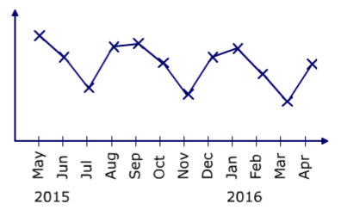
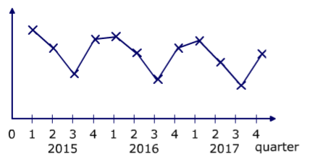
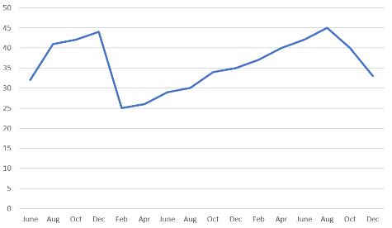
- For each of the time series shown below, state a suitable way to split the data
a) b) c)

- The number of customers who enter the exhibition is recorded every hour. What would be a suitable way to split this data when calculating a moving average? ANS: Each time frame (day) is split into ____ seasons

- Mr Jaine received his electricity bill quarterly. What would be a suitable way to split this data when calculating a moving average for the bills each year? ANS: Each time frame (year) is split into ____ seasons

- Percy record how many hours he spends in the garden every Saturday and Sunday for 3 months. How should he split this data for a moving average? ANS: Each time frame (week) is split into ____ seasons

- Martha has recorded their weekly expenditure on groceries each week for the last 5 years. What would be the best way to split this data for a moving average? ANS: Each time frame (year) is split into ____ seasons

The Knowledge Phase
Moving averages are an efficient and practical way of finding the trend and mean you make more ACCURATE predictions
Moving averages tend to reduce the amount of VARIABILITY present in a time series
An ‘n-point’ moving average relies on how many SEASONS are repeated
To calculate a moving average, we must work out the MEAN of each n points in the data, overlapping values so the averages ‘move’
We then plot the moving averages on the Time Series and draw our trend line as a line of best fit through these points.

I DO
The data recorded below are the quarterly gas bills for Ms Kamura.
Calculate an appropriate n-point moving average for these data
 | 2018 |  |  |  |  |  |  |  | 2019
 | Q1 |  | Q2 |  | Q3 |  | Q4 |  | Q1 |  | Q2 |  | Q3 |  | Q4
X | 165 |  | 200 |  | 147 |  | 126 |  | 184 |  | 251 |  | 156 |  | 163
MA

WE DO
A family business makes 'Jelly Teddies' and the following table show the amount sold (in kg)
Calculate an appropriate n-point moving average for these data
Year | 2010 |  |  |  |  |  |  | 2011 |  |  |  |  |  |  |  | 2012 |  |  |  |  |  |  |  | 2013
Quarter | 1 | 2 |  | 3 |  | 4 |  | 1 |  | 2 |  | 3 |  | 4 |  | 1 |  | 2 |  | 3 |  | 4 |  | 1
Sweets | 8.8 | 11.3 |  | 23.4 |  | 30.8 |  | 11.8 |  | 13.3 |  | 23.9 |  | ~ |  | 16.8 |  | 14.3 |  | 25.9 |  | 0.5 |  | 18.8
M.A

YOU DO
For the data shown below indicating the minimum temperature reached on each day over a period of three weekends, calculate an appropriate n-point moving average
 | Weekend  1 |  |  | Weekend  2 |  |  | Weekend  3
 | Fri | Sat | Sun | Fri | Sat | Sun | Fri | Sat
X | 1.6 | 2.4 | 0.7 | 1.9 | 2.7 | 0.4 | 2.0 | 2.9
MA

Real World  Application | The moving average can be used to identify buying and selling opportunities with its own merit. When the stock price trades above its average price, it means the traders are willing to buy the stock at a price higher than its average price.

Practice Questions
 | 1 | The table shows the numbers, in thousands, of visitors to a local theme park each year (ths)
 |  | Calculate a 4-point moving average
 | Year |  |  | 2007 |  |  |  |  |  |  |  | 2008 |  |  |  |  |  |  |  | 2009 |  |  |  |  |  |  |  | 2010
 | Quarter |  |  | 1 |  | 2 |  | 3 |  | 4 |  | 1 |  | 2 |  | 3 |  | 4 |  | 1 |  | 2 |  | 3 |  | 4 |  | 1
 | Visitors |  |  | 25.4 |  | 22.2 |  | 9.4 |  | 13.1 |  | 29.4 |  | 25.2 |  | 11.4 |  | 14.1 |  | 34.4 |  | 28.2 |  | 12.4 |  | 16.1 |  | 36.4
 | M.A
 | 2 | Crazy Cutz record the number of customers making bookings on Tuesdays, Fridays and Saturdays.
 |  | The table below shows this data for the last 3 weeks. Calculate a 3-point moving average
 | Week |  |  | 1 |  |  |  |  |  | 2 |  |  |  |  |  | 3
 | Day |  |  | Tues |  | Fri |  | Sat |  | Tues |  | Fri |  | Sat |  | Tues |  | Fri |  | Sat
 | Bookings |  |  | 4 |  | 8 |  | 12 |  | 4 |  | 7 |  | 10 |  | 3 |  | 7 |  | 9
 | M.A
 | 3 | The table below show the total expenditure (in £millions) of household in the UK on technology
 |  | Calculate a 4-point moving average
 | Year |  |  | 2004 |  |  |  |  |  |  |  | 2005 |  |  |  |  |  |  |  | 2006 |  |  |  |  |  |  |  | 2007
 | Quarter |  |  | 1 |  | 2 |  | 3 |  | 4 |  | 1 |  | 2 |  | 3 |  | 4 |  | 1 |  | 2 |  | 3 |  | 4 |  | 1
 | Spent |  |  | 1049 |  | 940 |  | 1238 |  | 2147 |  | 974 |  | 915 |  | 1182 |  | 2117 |  | 910 |  | 870 |  | 1162 |  | 2076 |  | 878
 | M.A
 | 4 | Kingsbury Travel organise package holidays for families that are sold across the world
 |  | The sales of such holidays (in thousands) for the last three years are shown below
 |  | Calculate an appropriate moving average for this data
 | Year |  |  | 2012 |  |  |  |  |  |  |  | 2013 |  |  |  |  |  |  |  | 2014
 | Season |  |  | W |  | SP |  | SU |  | A |  | W |  | SP |  | SU |  | A |  | W |  | SP |  | SU |  | A
 | Sales |  |  | 4 |  | 9 |  | 10 |  | 6 |  | 3 |  | 7 |  | 7 |  | 4 |  | 2 |  | 6 |  | 5 |  | 3
 | 5 | A shop hires two new members of staff who work an alternate days each weekend
 |  | The table below shows the days worked, by whom and the takings (in £hundreds) for 3 weeks
 |  | Calculate an appropriate moving average for this data
 | Week |  |  | 1 |  |  |  | 2 |  |  |  | 3
 | Staff |  |  | Jack |  | Jill |  | Jack |  | Jill |  | Jack |  | Jill
 | Takings |  |  | 17.3 |  | 3.6 |  | 18.5 |  | 5.9 |  | 19.8 |  | 8
 | 6 | An A level student has the opportunity to take an exam in January or June of their school year
 |  | The number of students entered at each exam period is shown in the table below
 |  | Calculate an appropriate moving average for this data
 | Year |  |  | 2010 |  |  |  | 2011 |  |  |  | 2012 |  |  |  | 2013 |  |  |  | 2014
 | Period |  |  | Jan |  | June |  | Jan |  | June |  | Jan |  | June |  | Jan |  | June |  | Jan
 | Students |  |  | 191 |  | 338 |  | 179 |  | 327 |  | 165 |  | 320 |  | 142 |  |  |  | 138
WE DO
The table below shows the number of times the main characters name was used in an episode each week over 3 series’. Calculate an appropriate moving average for the data and use it to plot a trend line
Series | 1 |  |  |  |  | 2 |  |  |  |  | 3
Episode | 1 | 2 | 3 | 4 | 5 | 1 | 2 | 3 | 4 | 8 | 1 | 2 | 3 | 4 | 5
Name | 5 | 9 | 8 | 2 | 6 | 5 | 12 | 10 | 3 | 4 | 6 | 12 | 12 | 5 | 8

YOU DO
The table below shows the number of sales (£) made in the Gornal store every weekend for 5 weeks. Calculate an appropriate moving average for this data and use them to draw a trend line
Week | 1 |  | 2 |  | 3 |  | 4 |  | 5
Day | Sat | Sun | Sat | Sun | Sat | Sun | Sat | Sun | Sat | Sun
Sales | 540 | 260 | 520 | 250 | 500 | 230 | 500 | 200 | 450 | 180

The Knowledge Phase
What if we know the moving averages?
It could be that we are told the moving averages (or shown them on a graph) and use them to calculate missing data points.
By using some simple algebraic manipulation of the formula for the mean was can work backwards to calculate the original values

I DO
A food van hires two new members of staff who work an alternate days each weekend
The table below shows the days worked, by whom and the takings (in £hundreds) for 3 weeks
Use the calculated moving averages to find the missing taking for Ellen
Week |  |  | 1 |  |  |  | 2 |  |  |  | 3
Staff |  |  | Ellen |  | Rhys |  | Ellen |  | Rhys |  | Ellen |  | Rhys
Takings |  |  | 22.4 |  | 8.1 |  | 23.6 |  | 10.4 |  | 24.9 |  | 12.5
 |  |  |  | 15.25 |  | 15.85 |  | 17 |  | 17.65 |  | 18.7

WE DO
Below is a table showing the number of booking (thousands) taken by a national travel agent each week, along with the moving averages.
There are two values missing from the viewing figures, use the calculated moving averages to find the missing viewing figures
Week | 1 |  |  | 2 |  |  | 3
Day | Mon | Wed | Fri | Mon | Wed | Fri | Mon | Wed | Fri
Bookings | 22.6 | 24.8 | 32.1 | 22.4 | 24.9 | 36.3 | 22.8 | 24.7 | 34.2
M.A |  | 26.5 | 26.43 | 26.47 | 27.87 | 28 | 27.93 | 27.23

YOU DO
Ruff Paws record the number of customers using their services over a period of three weeks
The table below shows this data for the last 3 weeks with the three-point moving average calculated below
Use this moving average to fins the missing data for the three Fridays
Week | 1 |  |  | 2 |  |  | 3
Day | Tues | Fri | Sat | Tues | Fri | Sat | Tues | Fri | Sat
Customers | 3 | 7 | 11 | 3 | 10 | 11 | 6 | 13 | 14
M.A |  | 7 | 7 | 8 | 8 | 9 | 10 | 11

Practice Questions

1 | The table shows the numbers, in thousands, of visitors to a local museum each year (ths)
 | Use the calculated 4-point moving average to find the missing data for the third quarter of each year
Year |  |  | 2018 |  |  |  |  |  |  |  |  |  |  |  |  |  | 2019 |  |  |  |  |  |  |  |  |  |  |  |  |  |  |  | 2020 |  |  |  |  |  |  |  |  |  |  |  |  |  |  |  | 2021
Quarter |  |  | 1 |  | 2 |  |  |  | 3 |  |  |  | 4 |  |  |  | 1 |  |  |  | 2 |  |  |  | 3 |  |  |  | 4 |  |  |  | 1 |  |  |  | 2 |  |  |  | 3 |  |  |  | 4 |  |  |  | 1
Visitors |  |  | 23.4 |  | 19.2 |  |  |  | 10.4 |  |  |  | 11.1 |  |  |  | 27.4 |  |  |  | 22.2 |  |  |  | 12.4 |  |  |  | 12.1 |  |  |  | 32.4 |  |  |  | 25.2 |  |  |  | 13.4 |  |  |  | 14.1 |  |  |  | 34.4
M.A |  |  |  |  |  |  | 16.03 |  |  |  | 17.03 |  |  |  | 17.78 |  |  |  | 18.28 |  |  |  | 18.53 |  |  |  | 19.78 |  |  |  | 20.53 |  |  |  | 20.78 |  |  |  | 21.28 |  |  |  | 21.78
2 | A local company makes piggy face sweets and the following table show the amount sold (in kg)
 | A 4-point moving average has been calculated.
 | Use this data to calculate the weight of sweets sold in the first quarter of each year
Year |  |  | 2020 |  |  |  |  |  |  |  |  |  |  |  |  |  | 2021 |  |  |  |  |  |  |  |  |  |  |  |  |  |  |  | 2022 |  |  |  |  |  |  |  |  |  |  |  |  |  |  |  | 2023
Quarter |  |  | 1 |  | 2 |  |  |  | 3 |  |  |  | 4 |  |  |  | 1 |  |  |  | 2 |  |  |  | 3 |  |  |  | 4 |  |  |  | 1 |  |  |  | 2 |  |  |  | 3 |  |  |  | 4 |  |  |  | 1
Sweets |  |  | 12.8 |  | 17.3 |  |  |  | 18.4 |  |  |  | 31.8 |  |  |  | 15.8 |  |  |  | 19.3 |  |  |  | 18.9 |  |  |  | 32.8 |  |  |  | 20.8 |  |  |  | 20.3 |  |  |  | 20.9 |  |  |  | 33.3 |  |  |  | 22.8
M.A |  |  |  |  |  |  | 20.08 |  |  |  | 20.83 |  |  |  | 21.33 |  |  |  | 21.45 |  |  |  | 21.7 |  |  |  | 22.95 |  |  |  | 23.2 |  |  |  | 23.7 |  |  |  | 23.83 |  |  |  | 24.33
3 | The table below show the total expenditure (in £millions) of Grenscape Corp. for a series of 3 years
 | An appropriate moving average has been calculated, use this to find the missing expenditures
Year |  |  | 2017 |  |  |  |  |  |  |  |  |  |  |  |  |  | 2018 |  |  |  |  |  |  |  |  |  |  |  |  |  |  |  | 2019 |  |  |  |  |  |  |  |  |  |  |  |  |  |  |  | 2020
Quarter |  |  | 1 |  | 2 |  |  |  | 3 |  |  |  | 4 |  |  |  | 1 |  |  |  | 2 |  |  |  | 3 |  |  |  | 4 |  |  |  | 1 |  |  |  | 2 |  |  |  | 3 |  |  |  | 4 |  |  |  | 1
Spent |  |  | 1228 |  | 613 |  |  |  | 1555 |  |  |  | 2748 |  |  |  | 1153 |  |  |  | 588 |  |  |  | 1499 |  |  |  | 2718 |  |  |  | 1089 |  |  |  | 543 |  |  |  | 1479 |  |  |  | 2677 |  |  |  | 1057
M.A |  |  |  |  |  |  | 1536 |  |  |  | 1517 |  |  |  | 1511 |  |  |  | 1497 |  |  |  | 1490 |  |  |  | 1474 |  |  |  | 1462 |  |  |  | 1457 |  |  |  | 1447 |  |  |  | 1439
4 | Kingsbury Travel organise package holidays for families that are sold across the world
 | The sales of such holidays (in thousands) for the last three years are shown below but some of the data is
 | missing. Use the calculated moving averages to find these missing sales figures
Year |  |  | 2020 |  |  |  |  |  |  |  |  |  |  |  |  |  | 2021 |  |  |  |  |  |  |  |  |  |  |  |  |  |  |  | 2022
Season |  |  | W |  | SP |  |  |  | SU |  |  |  | A |  |  |  | W |  |  |  | SP |  |  |  | SU |  |  |  | A |  |  |  | W |  |  |  | SP |  |  |  | SU |  |  |  | A
Sales |  |  | 12 |  | 4 |  |  |  | 10 |  |  |  | 8 |  |  |  | 16 |  |  |  | 6 |  |  |  | 12 |  |  |  | 10 |  |  |  | 16 |  |  |  | 8 |  |  |  | 14 |  |  |  | 10
 |  |  |  |  |  |  |  | 8.5 |  |  |  | 9.5 |  |  |  | 10 |  |  |  | 10.5 |  |  |  | 11 |  |  |  | 11 |  |  |  | 11.5 |  |  |  | 12 |  |  |  | 12
5 | AWAY! are an escape room company and the Wolverhampton branch must submit their quickest time
 | every 6 months. Below are the fastest times recorded for the first half of each year.
 | Use the calculate moving averages to find the fasted time for the second half of the year
Year |  |  | 2017 |  |  |  |  |  | 2018 |  |  |  |  |  |  |  | 2019 |  |  |  |  |  |  |  | 2020 |  |  |  |  |  |  |  | 2021
Period |  |  | J-J |  | J-D |  |  |  | J-J |  |  |  | J-D |  |  |  | J-J |  |  |  | J-D |  |  |  | J-J |  |  |  | J-D |  |  |  | J-J
Time (mins) |  |  | 42.7 |  |  |  |  |  | 48.3 |  |  |  |  |  |  |  | 45.6 |  |  |  |  |  |  |  | 40.2 |  |  |  |  |  |  |  | 41.2
 |  |  |  | 41.65 |  |  |  | 44.45 |  |  |  | 45.7 |  |  |  | 44.35 |  |  |  | 41.9 |  |  |  | 39.2 |  |  |  | 41.45 |  |  |  | 41.95

______ / ______ / ______
Equation of the Trend Line
How can time series help us to analyse data accurately?
How can we find the equation of the trend line?
Key Vocabulary
Vocab | Mathematical Definition
Time Series | a series of values of a quantity obtained at successive times, often with equal intervals between them.
Trend | the long-term change in the level of a time series
Moving Average | a succession of averages derived from successive segments (typically of constant size and overlapping) of a series of values.
Gradient | The steepness of the line
y-intercept | The point at which the line passes through the y axis

The Knowledge Phase
The equation of the trend line

y = mx + c or y = a + bx

I DO
State the gradient and y-intercept of the following equation of the trend line

y = 4 + 2x

WE DO
State the gradient and y-intercept of the following equation of the trend line

2y = 5 – 0.6x

YOU DO
State the gradient and y-intercept of the following equation of the trend line

y = 3x - 7
Skills Check
For each of the following equations of the trend line, state the gradient and intercept
- y = 7 + 3x Gradient: ________ y-intercept: ________
- y = 5 + 0.4x Gradient: ________ y-intercept: ________
- y = 0.1 + 9x Gradient: ________ y-intercept: ________
- y = 6 - 4x Gradient: ________ y-intercept: ________
- y = 4 - 0.5x Gradient: ________ y-intercept: ________
- y = 0.2 - 8x Gradient: ________ y-intercept: ________
- y = 5x - 5 Gradient: ________ y-intercept: ________
- y = 0.6x + 3 Gradient: ________ y-intercept: ________
- y = 7x - 0.3 Gradient: ________ y-intercept: ________
- y = 6x Gradient: ________ y-intercept: ________
- y = -0.7x Gradient: ________ y-intercept: ________
- y = 4 Gradient: ________ y-intercept: ________
- y = x Gradient: ________ y-intercept: ________
- 2y = 4 + 3x Gradient: ________ y-intercept: ________
- 2y + 2 = 5x Gradient: ________ y-intercept: ________

The Knowledge Phase: Gradient – how do we calculate it?
To find the gradient you need to:
- pick 2 coordinates on your line
- divide the difference in the y coordinates, by the difference in the x coordinates

N.B. It is important to pay close attention to the scale on both the x and the y axis and whether the trend line is going up (positive gradient) or going down (negative gradient)

I DO
Find the gradient of the trend line for a time series graph which passes though the coordinates
(2015 Q1 , 45 000) and (2016 Q3, 54 000)

WE DO
Find the gradient of the trend line for a time series graph which passes though the coordinates
(Friday , 1164) and (Tuesday , 1147)

YOU DO
Find the gradient of the trend line for a time series graph which passes though the coordinates
(4pm , 220) and (10pm, 130)
Skills Check
Find the gradient of each of the trend lines for a time series graph which passes though the following pairs of coordinates:
- (Monday , 1.6) and (Friday , 2.2)
- (2020 Q2 , 443200) and (2021 Q2 , 465800)
- (Spring 2019 , 52.7) and (Autumn 2020 , 41.9)
- (5pm , 475) and (9pm , 560)
- (February , 52) and (October , 47)
- (2015 , 6.4) and (2022 , 9.3)
- (Sunday , 8.9) and (Wednesday , 8.5)
- (8am , 109450) and (8pm , 110600)
- (Week 6 , 22.8) and (Week 14 , 20.4)
- (2018 Q4 , 125) and (2020 Q1 , 237)
The Knowledge Phase: Gradient – What does it mean?
The gradient tells us how much y increases each time x increases by 1
Think about what this means in context of the question by considering what the scale of the x axis is.

I DO
The gradient of the trend line showing the quarterly heating bill for the Ferris household is calculated to be +62.9. Explain what this mean in the context of the data

WE DO
A time series graph shows the total amount of money (£billion) in Individual Savings Accounts each year in the UK for the years 2008-2020.
The equation of the trend line is given as
y = 204 + 25x. Interpret the value of the gradient in context of the question

YOU DO
The gradient of the trend line for a time series graph showing the monthly number of births, in thousands, for the UK has an equation
y = 0.2x + 21.7. Interpret the value of the gradient in context of the question
Skills Check
- The total number of hours of sunshine in Combourne was recorded each quarter over 3 years. The data is plotted on a time series and a trend line is draw. The equation of the trend line is given as
y = 450 - 10x. Interpret the value of the gradient in context of the question

- A time series graph is drawn to show the total amount of money spent by overseas tourists in the UK for each quarter for the years 2011 to 2013. A trend line is draw and the equation of the trend line is given as y = 450 - 10x. The equation of the trend line is given as y = 5000 + 220x. Interpret the value of the gradient in context of the question

- A time series graph shows information about the mean number of hours per week that people listened to the radio from 2007 to 2009. A trend line is draw and the equation of the trend line is given as y = 23.2 - 0.1x. Interpret the value of the gradient in context of the question

- A time series graph shows the numbers of motor cycles, in thousands, registered each quarter from the first quarter of 2005 to the first quarter of 2008. A trend line is plotted and the equation of the trend line is given as y = 33.1 + 0.3x. Interpret the value of the gradient in context of the question

- Information about the numbers, in millions, of visitors to Great Britain during the years 2007 to 2009 was recorded and plotted on a time series graph. Moving averages were calculated and used to plot an accurate trend line. The equation of the trend line is given as y = 8.62 - 1.8x. Interpret the value of the gradient in context of the question
______ / ______ / ______
Seasonal Variation
How can time series help us to analyse data accurately?
What is Seasonal Effect and why do we need it?
Key Vocabulary
Vocab | Mathematical Definition
Time Series | a series of values of a quantity obtained at successive times, often with equal intervals between them.
Peak | reach a highest point, either of a specified value or at a specified time
Trough | reach a lowest point, either of a specified value or at a specified time
Trend | the long-term change in the level of a time series
Seasonality | variation within the seasons
Effect | a change which is a result or consequence of an action or other cause

The Knowledge Phase
There are several different types of variation which we can observe in a time series graphs, the most common being:

Seasonal Variation: when data follows the same pattern each season over a series of time frames.
Seasonal variation can help us to make more accurate predictions for future values

Cyclic or Short-Term Variation: when a pattern repeats for a short period but not continuously across the whole graph. It can also be where a pattern appears to be visible but on closer inspection it is not reflected by the seasons.

Random Variation: This unpredictable component of the series is called random variation. It is impossible to forecast random variation. If it can be forecast then it is not random. All real time series graphs will contain some random variation which is impossible to forecast although time series usually have a long term
trend (upward or downward).

The most common (and most useful) is Seasonal Variation. This can be seen when a particular season repeats its pattern each time frame

WE DO
The time series graph below shows the Sales of Pizzas at Tasty Plaice over the last 3 years.
Comment on the variation seen in this time series graph

YOU DO
The number of accidents reported at two different factories each month are recorded and the data is presented in the time series graph below. Compare the variation shown in these graphs

Skills Check

- This graph shows the number of technical faults reported to the IT technicians by the call centre each quarter.

What do you notice about the variation in the number of faults shown in this time series?

- This time series represents the number of patients seen by the local walk in centre each day in the morning session (8am-12pm) and the afternoon session (12pm-4pm)

What comments can be made about the variation in the number of patients seen each day?

- The sales (£000’s) made by a local baby boutique each half year have been recorded and presented in the time series graph below.

What do you notice about the variation of the number of sales shown in this graph?

- The time series below represents the number of customers two rival online shoe stores receive each quarter over the last 2 ½ years.

Comment on the variation in the number of customers shown on both Store A and Store B

The Knowledge Phase: Calculating Seasonal Effect

Seasonal Effect is the difference between the actual value and the value read from the trend line at a given point (season)

Seasonal Effect can be seen on the graph as the distance between the y value on the time series and the y value on the trend line at the same value for x
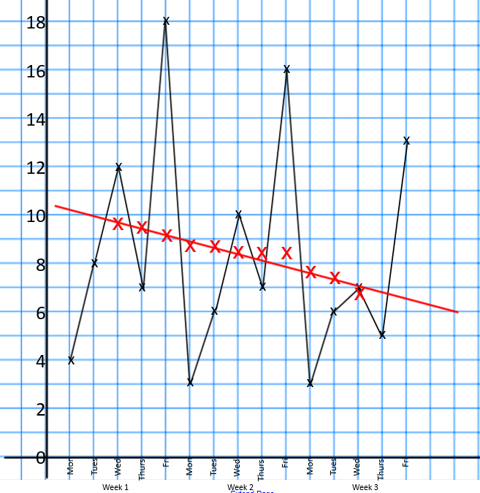

Seasonal Effect = Observed Value - Trend Line Value

A trend line value should be read from the graph as substituting into the equation of the trend line is not always possible as the value on the x axis may not be quantitative. The equation of the trend line can be used if we know the scale on the x axis and where the trend line begins.

WE DO
For each of the following quarters, use the trend line to calculate the Seasonal Effects (S.E)
Year | 2019 |  |  | 2020 |  |  |  | 2021
Quarter | Q2 | Q3 | Q4 | Q1 | Q2 | Q3 | Q4 | Q1 | Q2
y | 8 | 12 | 20 | 16 | 10 | 15 | 21 | 18 | 11

Trend Value
S.E.

The Knowledge Phase: Mean Seasonal Variation

The average of each seasonal effects can be calculated for one season over several years to find the

Mean Seasonal Variation (M.S.V)

By simply calculating the mean of the seasonal effect values for one particular season

- A positive M.S.V mean that on average the values in that season are above the trend line
- A negative M.S.V means that on average the values in that season are below the trend line

Real World  Application | Seasonal effects are different from cyclical effects, as seasonal cycles are observed within one calendar year, while cyclical effects, such as boosted sales due to low unemployment rates, can span time periods shorter or longer than one calendar year.
I DO
The Mean Seasonal Variation for May is calculated to be 0.47 on a Time Series graph showing the average number of customers each months from 2015-2022. What does this number mean?

WE DO
Using the information provided, calculate the mean seasonal effect for the morning session of the show
Day | Fri |  |  | Sat |  |  | Sun
Time | 10am | 2pm | 7pm | 10am | 2pm | 7pm | 10am | 2pm | 7pm
Seats | 154 | 129 | 207 | 163 | 107 | 224 | 158 | 130 | 220
S.E | -6 | -13 | 47 | 5 | -25 | 51 | -1 | -9 | 46

YOU DO
The seasonal effect for each quarter has been calculate on the previous page for 2019-2021. Calculate the mean seasonal variation for quarter 2.
Skills Check
- For each of the following values for MSV, explain what they represent
  - 2.9
  - 1.3
  - 0
  - -0.2
  - -1.8
- Using the information provided, calculate the mean seasonal effect for Tuesday
Week | Week 1 |  |  |  |  | Week 2 |  |  |  |  | Week 3
Day | M | T | W | Th | F | M | T | W | Th | F | M | T | W | Th | F
Sales | 250 | 140 | 160 | 175 | 320 | 245 | 135 | 150 | 160 | 300 | 220 | 120 | 145 | 150 | 290
S.E | 26 | -34 | -26 | -8 | 51 | 34 | -31 | -27 | -4 | 48 | 29 | -28 | -19 | -4 | 50

- The seasonal effect for each hour was calculated for the time series for the average daily temperature in a school classroom. Use this information to calculate the mean seasonal variation for 3pm
Day | Monday |  |  |  |  |  |  | Tuesday |  |  |  |  |  |  | Wednesday
Time | 9 | 10 | 11 | 12 | 1 | 2 | 3 | 9 | 10 | 11 | 12 | 1 | 2 | 3 | 9 | 10 | 11 | 12 | 1 | 2 | 3
Temp | 15 | 17 | 17 | 18 | 20 | 22 | 24 | 14 | 15 | 15 | 16 | 19 | 20 | 22 | 15 | 16 | 17 | 18 | 18 | 20 | 21
S.E | -5 | -2 | -1 | 1 | 3 | 4 | 7 | -5 | -4 | -2 | 1 | 3 | 5 | 6 | -4 | -4 | -2 | -1 | 0 | 2 | 4

- The quarterly spending for the Maths department is recorded for the last 3 years and a seasonal effect has been calculated in the table below
Year | 2019 |  |  |  | 2020 |  |  |  | 2021
Quarter | Q1 | Q2 | Q3 | Q4 | Q1 | Q2 | Q3 | Q4 | Q1 | Q2 | Q3 | Q4
Spending | 264 | 1175 | 140 | 634 | 306 | 845 | 16 | 480 | 252 | 1341 | 267 | 905
SE | -41 | +326 | -120 | +25 | -22 | +5 | -187 | +16 | -34 | +541 | -56 | +239

- The number of detentions set by Mrs Blake each day are recorded in the table below
Week | Week 1 |  |  |  |  | Week 2 |  |  |  |  | Week 3
Day | M | T | W | Th | F | M | T | W | Th | F | M | T | W | Th | F
Detentions | 4 | 8 | 12 | 7 | 18 | 3 | 6 | 10 | 7 | 16 | 3 | 6 | 7 | 5 | 13

(a) Plot this data on a time series graph

(b) Calculate appropriate moving averages for the data

(c) Calculate the average seasonal variation for Wednesday
The Knowledge Phase: Making Predictions
We use the Mean Seasonal Variation to help make more accurate predictions from our Time Series Graph. When making a prediction we read off the value from the trend line then ADD our M.S.V to compensate for the average difference between the trend line and observed values

It is always the case with Time Series predictions that the following assumptions are made:
- The seasonal variation will continue in the same pattern
- The trend will continue at the same rate
- There will be no big changes that cause the data to behave differently

This means that our predictions may not always be accurate
I DO
The mean seasonal variation for quarter 2 is calculated to be +22.6
Using the trend line, Q2 for 2024 reads as 174.2
Use the MSV to predict the value for Q2 2024

WE DO
The mean seasonal variation for the first reading of the day (9am) was calculated to be -3.5
The reading from the trend line for tomorrow is 8.2
Use the MSV to predict the value for 9am tomorrow

YOU DO
A trend line reads 119 when extended to Wednesday next week
Previous data has lead to an MSV of +6.8
Use this to estimate the number of detentions expected next Wednesday

Real World  Application | Numerical weather forecasts use atmospheric models to predict future weather conditions based on current weather conditions [3, 4, 5]. Unlike numerical weather prediction, time series forecasting uses a model to predict future values based on past values.
Skills Check
For each of the following values from the trend line, use the given M.S.E to make a prediction for the next quarter.
Trend Line Value | M.S.V | Predicted Value
325.4 | 61.9
1.562 | -0.221
24.61 | -6.417
184.7 | 23.2
WE DO
 |  | The table shows the numbers, in thousands, of people who passed through London ZSL
 |  | Over a period of 3 years. Plot the data on the graph below, calculate the moving averages
 |  | and determine the seasonal effect of the 2nd quarter of each year and hence use this
 |  | to predict the number of visitors for the 2nd quarter of 2010
 | Year |  |  | 2017 |  |  |  |  |  |  |  | 2018 |  |  |  |  |  |  |  | 2019 |  |  |  |  |  |  |  | 2020
 | Quarter |  |  | 1 |  | 2 |  | 3 |  | 4 |  | 1 |  | 2 |  | 3 |  | 4 |  | 1 |  | 2 |  | 3 |  | 4 |  | 1
 | Visitors |  |  | 22.4 |  | 15.2 |  | 15.4 |  | 6.1 |  | 26.4 |  | 18.2 |  | 17.4 |  | 7.1 |  | 31.4 |  | 21.2 |  | 18.4 |  | 9.1 |  | 33.4
 | M.A
 | S.E
 |  |  | Visitors (Thousands)

Practice Questions

 | 1 | A family business makes Ginger cake and the weight (in kg) of ginger they use each year
 |  | is recorded below. Calculate the moving averages
 |  | and determine the seasonal effect of the 2nd quarter of each year and hence use this
 |  | to predict the weight of ginger needed for the 2nd quarter of 2013
 | Year |  |  | 2020 |  |  |  |  |  |  |  | 2021 |  |  |  |  |  |  |  | 2022 |  |  |  |  |  |  |  | 2023
 | Quarter |  |  | 1 |  | 2 |  | 3 |  | 4 |  | 1 |  | 2 |  | 3 |  | 4 |  | 1 |  | 2 |  | 3 |  | 4 |  | 1
 | Sweets |  |  | 11.8 |  | 10.3 |  | 15.4 |  | 26.8 |  | 14.8 |  | 12.3 |  | 15.9 |  | 27.8 |  | 19.8 |  | 13.3 |  | 17.9 |  | 28.3 |  | 21.8
 | M.A
 | S.E
 |  |  | Ginger Used (kg)

 | 2 | The table below shows how much money people in the UK spend on
 |  | prescriptions ach year. Calculate the moving averages
 |  | and determine the seasonal effect of the 2nd quarter of each year and hence use this
 |  | to predict the money the UK will spend on prescriptions in the 2nd quarter of 2007
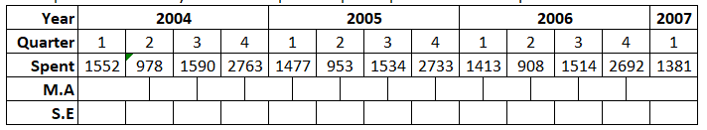
Spending)

3 | The table below shows how many scientific calculators are sold in Cradley Heath Tesco
 | each year. Calculate the moving averages
 | and determine the seasonal effect of the 2nd quarter of each year and hence use this
 | to predict the number of calculators sold in the 2nd quarter of 2015
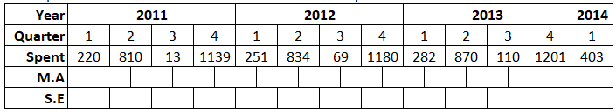
Spending)
Key words to learn

Formulas to learn

Copyright List
https://www.tableau.com/learn/articles/time-series-analysis#:~:text=Time%20series%20analysis%20helps%20organizations,go%20far%20beyond%20line%20graphs.
https://sites.google.com/msu.edu/wei-seismic-training/seismic-time-series-data
https://iopscience.iop.org/article/10.1088/1757-899X/394/5/052024/pdf#:~:text=Numerical%20weather%20forecasts%20use%20atmospheric,values%20based%20on%20past%20values.
https://en.wikipedia.org/wiki/Time_series#:~:text=Time%20series%20are%20used%20in,science%20and%20engineering%20which%20involves
https://www.su.se/english/research/research-subjects/statistics/statistical-models-in-the-social-sciences/a-brief-history-of-time-series-analysis-1.612367#:~:text=The%20theoretical%20developments%20in%20time,in%20the%201920s%20and%201930s.
https://towardsdatascience.com/understanding-time-series-trend-addfd9d7764e?gi=1ef0e498beac#:~:text=Trend%20as%20a%20building%20block%20of%20time%20series&text=The%20trend%20represents%20the%20long,then%20the%20trend%20is%20monotonic.
https://www.mcoscillator.com/learning_center/kb/market_history_and_background/who_first_came_up_with_moving_averages/#:~:text=MOVING%20AVERAGE.&text=In%201909%20G.%20U.,of%20Statistical%20Method%20(1912).
https://www.5paisa.com/finschool/course/technical-analysis-advance/moving-averages/#:~:text=5.5%20Real%20Life%20Application%20of,higher%20than%20its%20average%20price.
https://www.statsacademy.co.uk/_files/ugd/d7dae4_5cecae6b7290401f938be8e2eceb377c.pdf

