
Mathematics and Statistics Department

Knowledge Book

GCSE Statistics
Term 10.5
Time Series
Scan here for revision materials
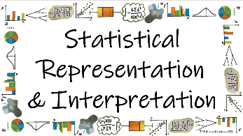
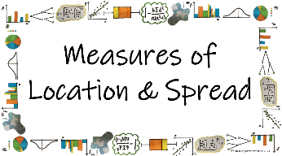
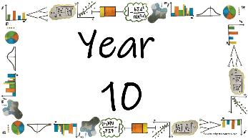
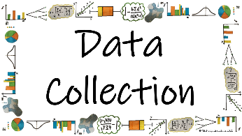

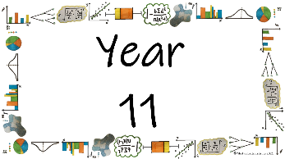
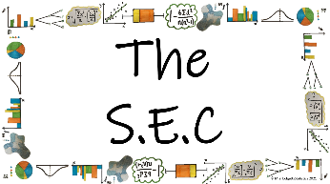
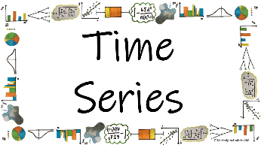
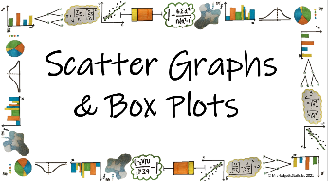

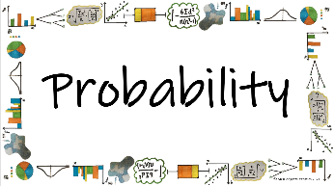
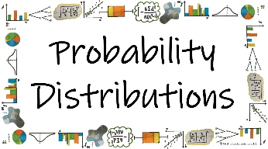
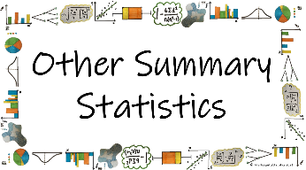


Name: ______________________
Teacher: ______________________
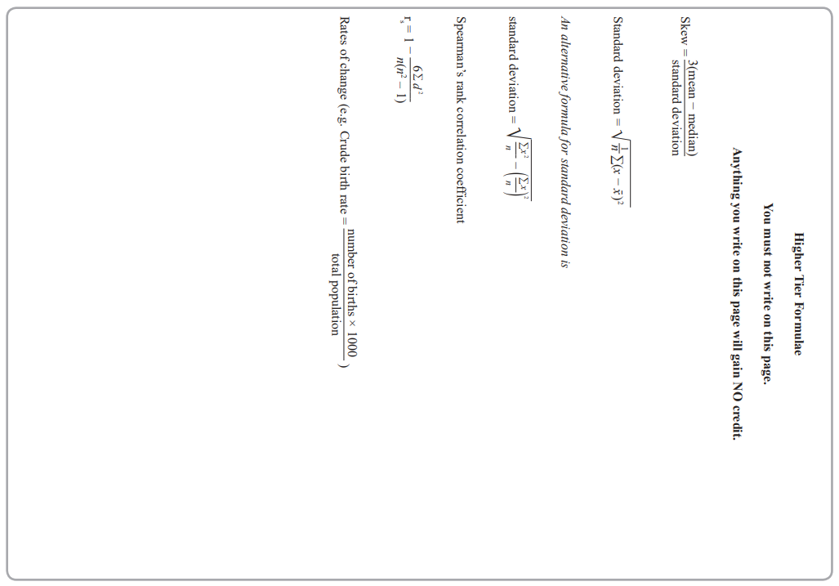
Contents Page
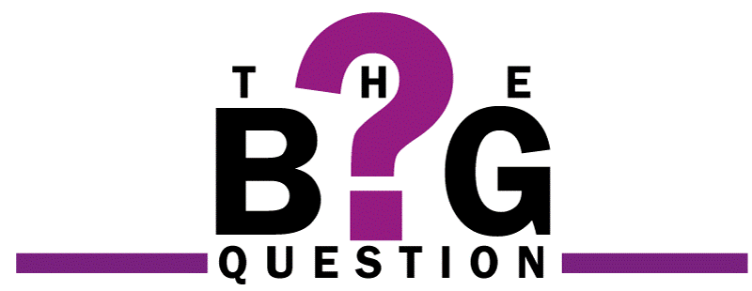 | How can time series help us to analyse data accurately?
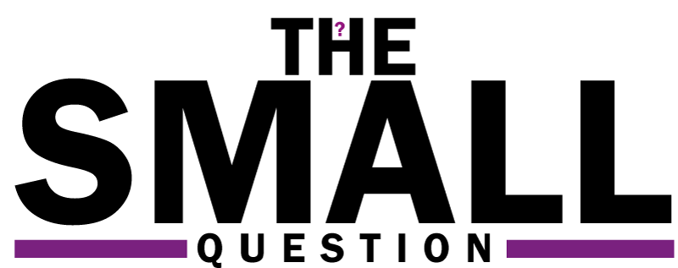 |  | Page

When do we use a time series and how do we plot it?

How can we draw and describe the trend of the data on a Time Series?

How and why do we calculate moving averages for a time series graph?

How can we find the equation of the trend line?

What is Seasonal Effect and why do we need it?

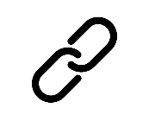  Cross-Curricular  Link | All small questions marked with a * are topics that you will be coving in GCSE Maths as well as GCSE Statistics
Vocabulary Pyramid

Peak
Trend
Trough
Time Series
Variable
Gradient
y-intercept
Season
Mean
Moving Average
Seasonality
Effect

Tier 3 Words
Words specific to the subject ‘Statistics’
These may have different meanings in other subjects

Tier 2 Words
Show Data Identify Describe Discuss
Variables Determine Parameter Statistic Construct
Evaluate Respectively Given Explain Conduct Depict
Suggest Assess Validity Research Investigate Decide
Calculate Practical Suitable Collect Complete Frequency

Words that are often seen written in text and exam questions but are not often spoken

Tier 1 Words
Words that are used often in speech and have the same meaning in most contexts
Which Who What Where When Why How
Age Time Weight Mass Length Breadth Width Height
Chart Graph Diagram Advantages Disadvantages

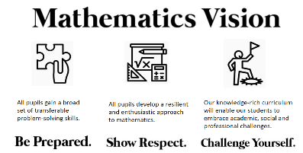

In this Knowledge Book you will see some of the following symbols with interesting facts and information about the words and terminology which will not be assessed but will deepen your understanding of the words.
 | This gives us the origin of a word and the historical development of its meaning.
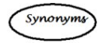 | This gives us a word or phrase that means exactly or nearly the same as another word or phrase in the same language.
  Historical  Origins | Historical Origins. This gives us the historical origin of the word.
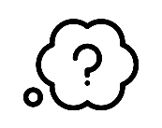  Did you know? | Do you Know? This gives us a fascinating fact about the word or skill,
Cross-Curricular  Link | Cross Curricular Link. This gives us links to where we might use this word or skill in other subjects
  Real World  Application | Real World Application. This gives us an idea of when or how we might use this in the real world.
  Revision Ideas | Revision ideas. This gives us some revision techniques to use for each topic.  Remember to use the revision websites:  - MrsHodgettsStatistics.com  - StatsAcademy.co.uk  - MathsGenie.co.uk  And the Revision techniques websites:  - GetRevising.co.uk
______ / ______ / ______
Plotting Time Series Graphs
 | How can time series help us to analyse data accurately?
 | When do we use a time series and how do we plot it?
Key Vocabulary
Vocab | Mathematical Definition
Time Series | a series of values of a quantity obtained at successive times, often with equal intervals between them.
Variable | a quantity that can be changed and is not fixed
Peak | reach a highest point, either of a specified value or at a specified time
Trough | reach a lowest point, either of a specified value or at a specified time

Historical  Origins | The theoretical developments in time series analysis started early with stochastic processes. The first actual application of autoregressive models to data can be brought back to the work of G. U Yule and J. Walker in the 1920s and 1930s.

The Knowledge Phase
A Time Series is a statistical diagram used to represent data over a period of time
It is used to display a single piece of information (univariate) and looks at how it changes over time

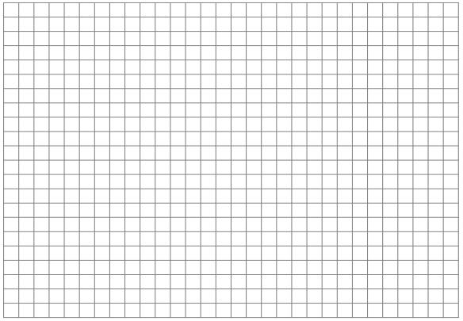
Time series data is displayed as a series of plotted points on a graph with the variable on the vertical (y) axis and time always on the horizontal (x) axis.
Variable
Cross-Curricular  Link | Time series graphs are used in many other subjects such as:  - Science  - Economics  - Geography  - Engineering

Time
(secs/mins/hrs/days/weeks/months/quarters/years)

The Knowledge Phase
Points are plotted and then joined like a dot-to-dot
Variable
Real World  Application | Seismic time series data is seismogram waveforms recorded at seismic stations. We mostly use digital data, which is a time series of velocity of the ground shaking. Besides the waveform itself, metadata describes critical information of the waveform data.

x
x
x
x
x
x
x
x
x
x
x
x
Time
(secs/mins/hrs/days/weeks/months/quarters/years)

When commenting on the graph we need to look for patterns. Is the peak (highest point on the graph) or trough (lowest point on the graph) always in the same season every year?
Variable
x
x
x
x
x
x
x
x
x
x
x
x
For example, in this graph, the ‘peak’ is always in the 3rd quarter
Variable
x
x
x
x
x
x
x
x
x
x
x
x
For example, in this graph, the ‘trough’ is always in the 1st quarter

Q1 Q2 Q3 Q4 Q1 Q2 Q3 Q4 Q1 Q2 Q3 Q4
Q1 Q2 Q3 Q4 Q1 Q2 Q3 Q4 Q1 Q2 Q3 Q4

______ / ______ / ______
Trend Line
How can time series help us to analyse data accurately?
How can we draw and describe the trend of the data on a Time Series?
Key Vocabulary
Vocab | Mathematical Definition
Time Series | a series of values of a quantity obtained at successive times, often with equal intervals between them.
Trend | the long-term change in the level of a time series

Old English trendan ‘revolve, rotate’, of Germanic origin; compare with trundle. The verb sense ‘turn in a specified direction’ dates from the late 16th century, and gave rise to the figurative use ‘develop in a general direction’ in the mid 19th century, a development paralleled in the noun.

The Knowledge Phase
The general trend can be shown on the graph by drawing a trend line. Look at the general trend of the data and draw a line through the middle of the data
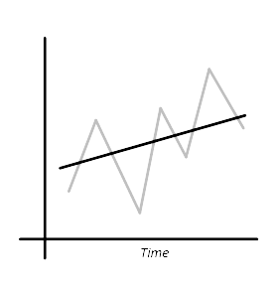

Real World Application
Time series analysis helps organizations understand the underlying causes of trends or systemic patterns over time.
Using data visualizations, business users can see seasonal trends and dig deeper into why these trends occur. With modern analytics platforms, these visualizations can go far beyond line graphs.

- This is an example of a ‘rising trend’
- It can also be called an ‘upwards trend’
- It can also be called an ‘increasing trend’
- We must NEVER use the term ‘positive’
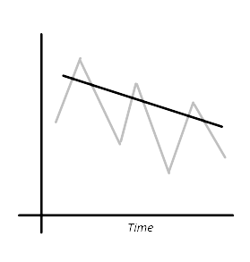
- This is an example of a ‘falling trend’
- It can also be called an ‘downwards trend’
- It can also be called an ‘decreasing trend’
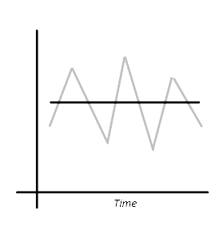
- We must NEVER use the term ‘negative’

- This is an example of a ‘level trend’
- We must NEVER use the term ‘no trend’

______ / ______ / ______
Moving Averages
How can time series help us to analyse data accurately?
How and why do we calculate moving averages for a time series graph?
Key Vocabulary
Vocab | Mathematical Definition
Time Series | a series of values of a quantity obtained at successive times, often with equal intervals between them.
Time Frame | a specified period of time in which something occurs or is planned to take place.
Variability | lack of consistency or fixed pattern; liability to vary or change
Seasons | each of the four divisions of the year (spring, summer, autumn, and winter) marked by particular weather patterns and daylight hours, resulting from the earth's changing position with regard to the sun.
Mean | the number you get by dividing the sum of a set of values by the number of values in the set.
Moving Average | - a succession of averages derived from successive segments (typically of constant size and overlapping) of a series of values.

Historical  Origins | In 1909 G. U. Yule (Journal of the Royal Statistical Society, 72, 721-730) described the “instantaneous averages” R. H. Hooker calculated in 1901 as “moving-averages.” Yule did not adopt the term in his textbook, but it entered circulation through W. I. King's Elements of Statistical Method (1912).
The Knowledge Phase
How can we split a time frame?
When looking at presenting data in a time series graph we need to think about what 'seasons' to use for the data itself.
We need to think of sensible ways to split the data to be able to plot it more accurately and look for patterns

Real World  Application | Often household bills are sent for different ‘seasons’ of the year. For example, a mobile phone bill may come out once a month (12 ‘seasons’) but the gas or electricity bill may come out once every three moths (4 ‘seasons’)

The Knowledge Phase
For a time series graph we need to be aware of how many seasons are in each time frame. Each time frame can be split differently depending on how frequently the data is collected and recorded. These ‘seasons’ are then used to calculate more accurate moving averages and in turn make more accurate predictions from the data.

The Knowledge Phase
Moving averages are an efficient and practical way of finding the trend and mean you make more ACCURATE predictions
Moving averages tend to reduce the amount of VARIABILITY present in a time series
An ‘n-point’ moving average relies on how many SEASONS are repeated
To calculate a moving average, we must work out the MEAN of each n points in the data, overlapping values so the averages ‘move’
We then plot the moving averages on the Time Series and draw our trend line as a line of best fit through these points.

Real World  Application | The moving average can be used to identify buying and selling opportunities with its own merit. When the stock price trades above its average price, it means the traders are willing to buy the stock at a price higher than its average price.

The Knowledge Phase
What if we know the moving averages?
It could be that we are told the moving averages (or shown them on a graph) and use them to calculate missing data points.
By using some simple algebraic manipulation of the formula for the mean was can work backwards to calculate the original values

______ / ______ / ______
Equation of the Trend Line
How can time series help us to analyse data accurately?
How can we find the equation of the trend line?
Key Vocabulary
Vocab | Mathematical Definition
Time Series | a series of values of a quantity obtained at successive times, often with equal intervals between them.
Trend | the long-term change in the level of a time series
Moving Average | a succession of averages derived from successive segments (typically of constant size and overlapping) of a series of values.
Gradient | The steepness of the line
y-intercept | The point at which the line passes through the y axis

The Knowledge Phase
The equation of the trend line

y = mx + c or y = a + bx

The Knowledge Phase: Gradient – how do we calculate it?
To find the gradient you need to:
- pick 2 coordinates on your line
- divide the difference in the y coordinates, by the difference in the x coordinates

N.B. It is important to pay close attention to the scale on both the x and the y axis and whether the trend line is going up (positive gradient) or going down (negative gradient)

The Knowledge Phase: Gradient – What does it mean?
The gradient tells us how much y increases each time x increases by 1
Think about what this means in context of the question by considering what the scale of the x axis is.

______ / ______ / ______
Seasonal Variation
How can time series help us to analyse data accurately?
What is Seasonal Effect and why do we need it?
Key Vocabulary
Vocab | Mathematical Definition
Time Series | a series of values of a quantity obtained at successive times, often with equal intervals between them.
Peak | reach a highest point, either of a specified value or at a specified time
Trough | reach a lowest point, either of a specified value or at a specified time
Trend | the long-term change in the level of a time series
Seasonality | variation within the seasons
Effect | a change which is a result or consequence of an action or other cause

The Knowledge Phase
There are several different types of variation which we can observe in a time series graphs, the most common being:

Seasonal Variation: when data follows the same pattern each season over a series of time frames.
Seasonal variation can help us to make more accurate predictions for future values

Cyclic or Short-Term Variation: when a pattern repeats for a short period but not continuously across the whole graph. It can also be where a pattern appears to be visible but on closer inspection it is not reflected by the seasons.

Random Variation: This unpredictable component of the series is called random variation. It is impossible to forecast random variation. If it can be forecast then it is not random. All real time series graphs will contain some random variation which is impossible to forecast although time series usually have a long term
trend (upward or downward).

The most common (and most useful) is Seasonal Variation. This can be seen when a particular season repeats its pattern each time frame

The Knowledge Phase: Mean Seasonal Variation

The average of each seasonal effects can be calculated for one season over several years to find the

Mean Seasonal Variation (M.S.V)

By simply calculating the mean of the seasonal effect values for one particular season

- A positive M.S.V mean that on average the values in that season are above the trend line
- A negative M.S.V means that on average the values in that season are below the trend line

Real World  Application | Seasonal effects are different from cyclical effects, as seasonal cycles are observed within one calendar year, while cyclical effects, such as boosted sales due to low unemployment rates, can span time periods shorter or longer than one calendar year.
The Knowledge Phase: Making Predictions
We use the Mean Seasonal Variation to help make more accurate predictions from our Time Series Graph. When making a prediction we read off the value from the trend line then ADD our M.S.V to compensate for the average difference between the trend line and observed values

It is always the case with Time Series predictions that the following assumptions are made:
- The seasonal variation will continue in the same pattern
- The trend will continue at the same rate
- There will be no big changes that cause the data to behave differently

This means that our predictions may not always be accurate

Real World  Application | Numerical weather forecasts use atmospheric models to predict future weather conditions based on current weather conditions [3, 4, 5]. Unlike numerical weather prediction, time series forecasting uses a model to predict future values based on past values.

Key words to learn

Formulas to learn

Copyright List
https://www.tableau.com/learn/articles/time-series-analysis#:~:text=Time%20series%20analysis%20helps%20organizations,go%20far%20beyond%20line%20graphs.
https://sites.google.com/msu.edu/wei-seismic-training/seismic-time-series-data
https://iopscience.iop.org/article/10.1088/1757-899X/394/5/052024/pdf#:~:text=Numerical%20weather%20forecasts%20use%20atmospheric,values%20based%20on%20past%20values.
https://en.wikipedia.org/wiki/Time_series#:~:text=Time%20series%20are%20used%20in,science%20and%20engineering%20which%20involves
https://www.su.se/english/research/research-subjects/statistics/statistical-models-in-the-social-sciences/a-brief-history-of-time-series-analysis-1.612367#:~:text=The%20theoretical%20developments%20in%20time,in%20the%201920s%20and%201930s.
https://towardsdatascience.com/understanding-time-series-trend-addfd9d7764e?gi=1ef0e498beac#:~:text=Trend%20as%20a%20building%20block%20of%20time%20series&text=The%20trend%20represents%20the%20long,then%20the%20trend%20is%20monotonic.
https://www.mcoscillator.com/learning_center/kb/market_history_and_background/who_first_came_up_with_moving_averages/#:~:text=MOVING%20AVERAGE.&text=In%201909%20G.%20U.,of%20Statistical%20Method%20(1912).
https://www.5paisa.com/finschool/course/technical-analysis-advance/moving-averages/#:~:text=5.5%20Real%20Life%20Application%20of,higher%20than%20its%20average%20price.
https://www.statsacademy.co.uk/_files/ugd/d7dae4_5cecae6b7290401f938be8e2eceb377c.pdf

