
Mathematics and Statistics Department

Knowledge Book
GCSE Statistics

Term 10.6
The Statistical Enquiry
Cycle
Scan here for revision materials
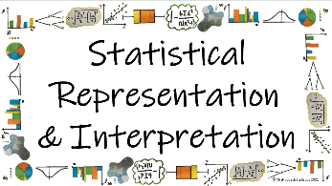
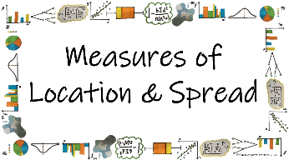
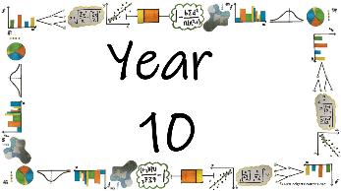
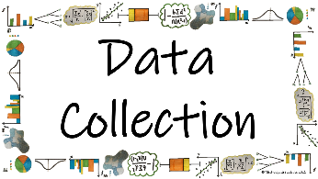

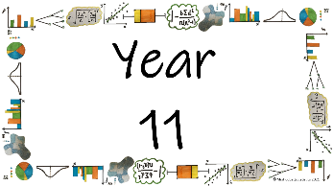
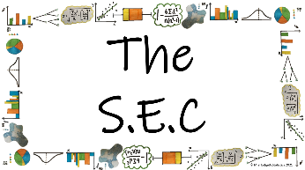
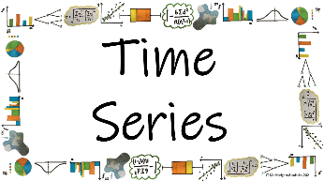
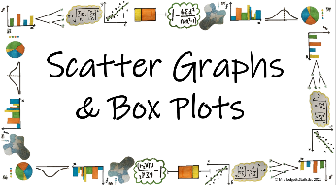

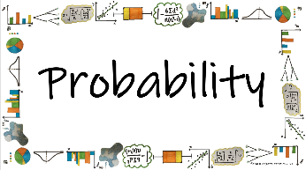
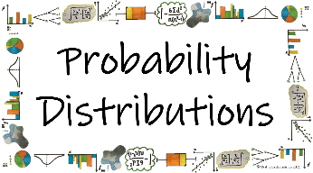
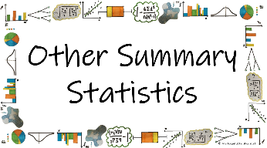


Name: ______________________
Teacher: ______________________
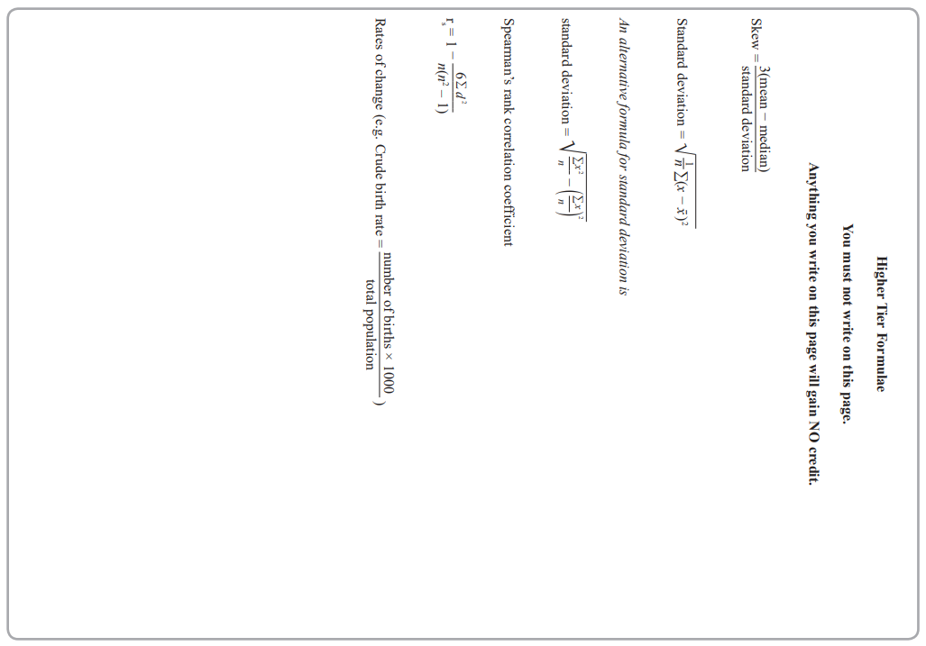
Contents Page
 | How do we use the Statistical Enquiry Cycle to plan and evaluate a statistical investigation?
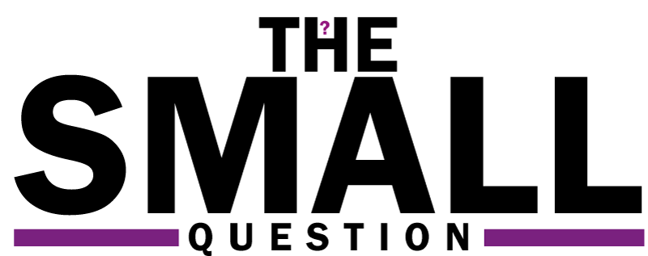 |  | Page

How do we write appropriate questions and hypotheses for our SEC? | 8

How do we collect appropriate data to answer our SEC investigations? | 14

How do we decide which diagrams and calculations to analyse to answer our SEC investigations? | 23

How do we predict what our results will show to prove our hypothesis? | 30

Am I able to plan and carry out a statistical investigation? | 40

  Cross-Curricular  Link | All small questions marked with a * are topics that you will be coving in GCSE Maths as well as GCSE Statistics
Vocabulary Pyramid

The SEC
Hypothesis
Question
Primary Secondary
Qualitative Quantitative
Discrete Continuous
Interviews Questionnaires
Understanding Candour Bias
Resources Inclusivity Sampling
Convenience Random Stratified Prediction
Systematic Quota Cluster Mode Skew
Median Mean Range Standard Deviation
Skew

Tier 3 Words
Words specific to the subject ‘Statistics’
These may have different meanings in other subjects

Tier 2 Words
Show Data Identify Describe Discuss
Variables Determine Parameter Statistic Construct
Evaluate Respectively Given Explain Conduct Depict
Suggest Assess Validity Research Investigate Decide
Calculate Practical Suitable Collect Complete Frequency

Words that are often seen written in text and exam questions but are not often spoken

Tier 1 Words
Words that are used often in speech and have the same meaning in most contexts
Which Who What Where When Why How
Age Time Weight Mass Length Breadth Width Height
Chart Graph Diagram Advantages Disadvantages

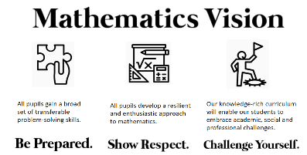

In this Knowledge Book you will see some of the following symbols with interesting facts and information about the words and terminology which will not be assessed but will deepen your understanding of the words.
 | This gives us the origin of a word and the historical development of its meaning.
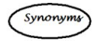 | This gives us a word or phrase that means exactly or nearly the same as another word or phrase in the same language.
  Historical  Origins | Historical Origins. This gives us the historical origin of the word.
  Did you know? | Do you Know? This gives us a fascinating fact about the word or skill,
Cross-Curricular  Link | Cross Curricular Link. This gives us links to where we might use this word or skill in other subjects
  Real World  Application | Real World Application. This gives us an idea of when or how we might use this in the real world.
  Revision Ideas | Revision ideas. This gives us some revision techniques to use for each topic.  Remember to use the revision websites:  - MrsHodgettsStatistics.com  - StatsAcademy.co.uk  - MathsGenie.co.uk  And the Revision techniques websites:  - GetRevising.co.uk
Introduction
Within GCSE (9-1) Statistics the new Assessment Objective 3, which contributes approximately 20% of the total assessment, will be assessed through questions on the component parts of the Statistical Enquiry Cycle. Furthermore “any given question may assess one stage or more than one stage of the SEC”.
This means that in any part of the assessment you can be asked to answers questions in the context of a real-life statistical enquiry. This also means that you can be asked to answer a question about a statistical enquiry explicitly.
The SEC is a cycle that is used to carry out a statistical investigation. The cycle consists of five stages: Problem, Plan, Data, Analysis, Conclusion.
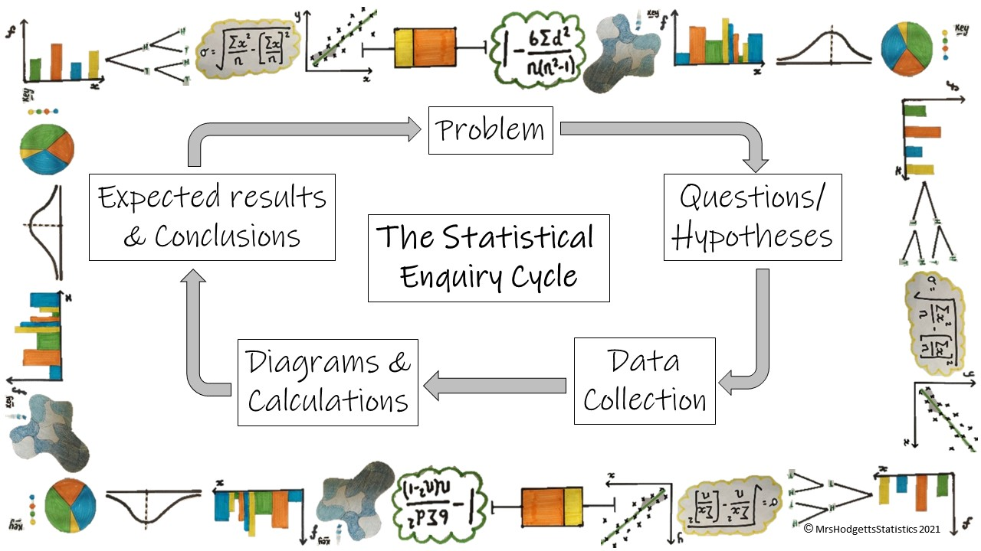
The problem section is about identifying the problem you want to investigate. This may be due to concerns that have been raised, a change that has happened or other problems that you believe to have caused disruption
The plan section is about how the data will be gathered including what questions you want to answer and what hypotheses you are testing
The data section is about how the data is managed and organised. What data collection methods you will be using and why they are the best ones to use
The analysis section is about exploring and analysing the data, using a variety of data displays and numerical summaries, and reasoning with the data. Here you will need to explain which statistical diagrams and calculations you will be using and why you think they are the best choice.
The conclusion section is about answering the question in the problem section and giving reasons based on the analysis section. It may be that you are predicting these results, what they will look like to prove your hypotheses are correct rather than seeing actually results.
So far we have covered everything in year 10 for the statistical enquiry cycle. We will go through each of the stages of the SEC with no new knowledge but looking at how the knowledge we have already accumulated can be used in real-life problems.
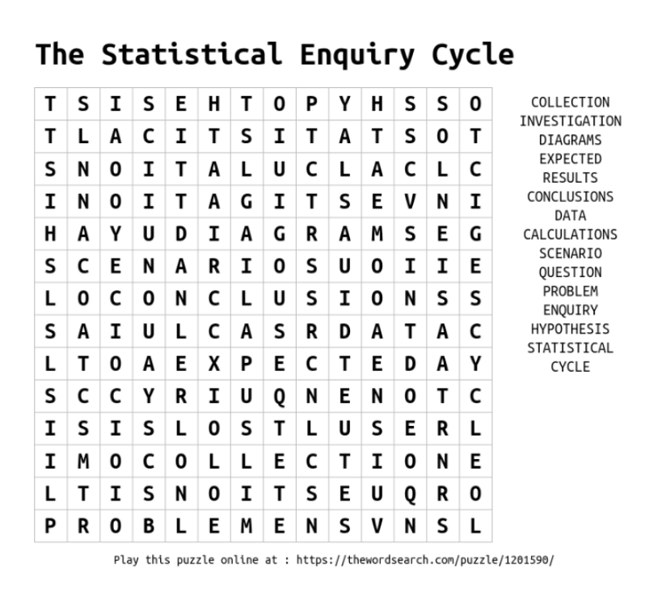
______ / ______ / ______
The Plan
How do we use the Statistical Enquiry Cycle to plan and evaluate a statistical investigation?
How do we write appropriate questions and hypotheses for our SEC?
Key Vocabulary
Vocab | Mathematical Definition
The SEC | The Statistical Enquiry Cycle
Question | a sentence worded or expressed so as to elicit information.
Hypothesis | a sensible assumption written as a statement that can be tested to see if it is correct or not

The Knowledge Phase
- Read the Problem or Scenario
- What could you ask about the scenario?
- What do you expect the answer to be?

Questions which start with 'What is the most ...' or 'What is the average ...' etc are still questions which we can write hypotheses for but they are very low skill and would score you the lowest marks in SEC questions

Questions and hypotheses which look for relationships and comparisons between groups are the backbone to a good investigation and what you should be aiming for when answering a SEC question

For those of you looking to push for grade 7/8/9 answers, your should direct your question and hypotheses to not just look for a relationship but the strength of that relationship

GRADE 9 We can look for distributions too but we haven't done these yet, we will look at them in year 11

Some things we need to remember when writing a hypothesis …
- A hypothesis is not a question
- A hypothesis should be a statement
- A hypothesis should suggest a testable answer to the question
- A hypothesis should relate to as many aspects of the scenario as possible

How to start a hypothesis …
- The most popular / most common / most frequent … is …
- The average … is …
- There is a

  - weak / moderate / strong / very strong
  - positive / negative relationship between and
- … do better on average than …

And remember …
- If you are writing a hypothesis about averages include a time frame. E.G. The average cost PER HOUR / PER DAY / PER WEEK / PER MONTH / PER YEAR
- Your hypothesis must be testable. i.e. do not write a hypothesis about something you cannot measure or get the information for – be specific NOT vague
RECALL Skills Check
For each of the scenarios below, select one option that would be considered an appropriate hypothesis
- Josie, the manager of a plastic factory, wants to look into the production of plastic bin lids made each week
[ ] On average, how many bin lids does the factory produce each week?
[ ] The factory can produce no more than 2500 bin lids per week
[ ] How many differeny types of bin lid does the factory produce?
[ ] The factroy employees have an average age of 32 years

- Mr Camden is looking at the stationary he needs to order ready for the next school year
[ ] Mr Camdens classe suse an average of 60 glue sticks per year
[ ] What is the most number of rulers Mr Camdens’s studetns have used in a single half term?
[ ] Mr Camden will be teaching both History and Geography next year
[ ] How many pens are borrow by each student each week?

- A local MP (from party A) is looking at the ages of the voters in their constituancy
[ ] Male voters are more liekly to vote for party A
[ ] What was the average age of voters in the last election?
[ ] The younger a voter is, the more likely they are to vote in the next election
[ ] What is the average number of times a person votes in their lifetime?

- Dr Halisan is looking at the side effects of a new hay fever drug of men and women
[ ] Who is more liekly to show side effects from the new hay fever drug, men or women?
[ ] They hay fever drug works better in hotter countries
[ ] Do both men and women suffer from side effects from the new hay fever drug?
[ ] Men show fewer side effects to the hay fever drug than women

- A reporter at a local newspaper is investigating the complaints made by residents and money spent by the government on pot holes in the local area
[ ] There is a strong positive correlaiton between the number of complaints made by residents and the money spent by the government on pot holes in the local area
[ ] Is there a string positive correlation between the number of complaints made by residents and the money spent by the government on pot holes in the local area?
[ ] It takes an average of 46.3 days to fix a pot hole in the area
[ ] How many complaints about pot holes have been made in the last 3 months?

I DO
'A researcher is investigating  how much money people in  Hanston spend on parking' | What is the most ....................................................................................................................  HYP:.........................................................................................................................................  What is the average ...............................................................................................................  HYP:.........................................................................................................................................  Is there a relationship between .............................................................................................  HYP:.........................................................................................................................................  How do _____________________________ compare ..........................................................  HYP:.........................................................................................................................................  How strong is the relationship between ................................................................................  HYP:.........................................................................................................................................  How does the distribution ......................................................................................................  HYP:.........................................................................................................................................
WE DO
‘ Trevor, a music shop owner, wants to investigate the eating habits of his customers’ | What is the most ....................................................................................................................  HYP:.........................................................................................................................................  What is the average ...............................................................................................................  HYP:.........................................................................................................................................  Is there a relationship between .............................................................................................  HYP:.........................................................................................................................................  How do _____________________________ compare ..........................................................  HYP:.........................................................................................................................................  How strong is the relationship between ................................................................................  HYP:.........................................................................................................................................  How does the distribution ......................................................................................................  HYP:.........................................................................................................................................
Practice Questions
For each of the following scenarios, write 6 questions of varying difficulty that you could investigate
with a hypothesis to go with at least 2 for each scenario
- Debbie, the local weather reporter, wants to investigate the temperature in Gatenborough over the last few years
What is the most ................................................................................................................................................
HYP:....................................................................................................................................................................
What is the average ..........................................................................................................................................
HYP:...................................................................................................................................................................
Is there a relationship between ........................................................................................................................
HYP:....................................................................................................................................................................
How do _____________________________ compare ......................................................................................
HYP:....................................................................................................................................................................
How strong is the relationship between ............................................................................................................
HYP:....................................................................................................................................................................
How does the distribution .................................................................................................................................
HYP:....................................................................................................................................................................

- Mr Jassal, a PE teacher at Handown Park School, wants to investigate the academic abilities of his school football team
What is the most ................................................................................................................................................
HYP:....................................................................................................................................................................
What is the average ..........................................................................................................................................
HYP:...................................................................................................................................................................
Is there a relationship between ........................................................................................................................
HYP:....................................................................................................................................................................
How do _____________________________ compare ......................................................................................
HYP:....................................................................................................................................................................
How strong is the relationship between ............................................................................................................
HYP:....................................................................................................................................................................
How does the distribution .................................................................................................................................
HYP:....................................................................................................................................................................

- Simina is interested in the shopping habit of the people that work in her office where there are over 100 staff of various skills
What is the most ................................................................................................................................................
HYP:....................................................................................................................................................................
What is the average ..........................................................................................................................................
HYP:...................................................................................................................................................................
Is there a relationship between ........................................................................................................................
HYP:....................................................................................................................................................................
How do _____________________________ compare ......................................................................................
HYP:....................................................................................................................................................................
How strong is the relationship between ............................................................................................................
HYP:....................................................................................................................................................................
How does the distribution .................................................................................................................................
HYP:....................................................................................................................................................................

- Lucas is looking into the revision habits of pupils in year 11 at his school
What is the most ................................................................................................................................................
HYP:....................................................................................................................................................................
What is the average ..........................................................................................................................................
HYP:...................................................................................................................................................................
Is there a relationship between ........................................................................................................................
HYP:....................................................................................................................................................................
How do _____________________________ compare ......................................................................................
HYP:....................................................................................................................................................................
How strong is the relationship between ............................................................................................................
HYP:....................................................................................................................................................................
How does the distribution .................................................................................................................................
HYP:....................................................................................................................................................................

Real World  Application | Jobs in research-based roles involve developing and testing hypotheses, analysing data and making conclusions. Almost every field of work has research roles within it, including technology, business, science and history. These include Research Assistant, Market Researcher, Research Scientist, Archaeologist, Historian, Research Engineer, Data Analyst and Actuary

- For each of the questions below there are 3 correct hypothesis. Select the hypothesis that will gain you the least marks in a SEC question
- [ ] The most money spent by a teacher during the 6 weeks holidays was £3224
[ ] The more time a teacher has off, the more money they spend
[ ] There is a strong positive correlation between the amount of days not in school and the amount of money spent

- [ ] There is a moderate negative correlation between the time students spend on social media and the amount of Vitamin D found in their body
[ ] Students will spend and average of 9.5 hours a day on social media during the school holidays
[ ] Girls will spend more time on social media that boys during the summer holiday

- [ ] On average, monkeys will score a lower IQ than humans
[ ] Monkeys have a higher average IQ in the morning than the afternoon
[ ] A monkey will score no lower than 34 in the IQ test

- [ ] A normal distribution can be used to model the time it takes for a sweet to be produced in the factory
[ ] It takes an average of 2.3 minutes for a sweet to get from one side of the factory conveyor belt to the other
[ ] There is a weak positive correlation between the time taken to make the sweet in the factory and the profit that the sweet will make

- [ ] The lower the score in the game, the more likely you are to win
[ ] The probability of scoring ‘5’ in the board game can be uniformly distributed
[ ] There is a strong positive correlation between the score you get and the probability of winning the game

Cross-Curricular  Link | Scientific experiments require a hypothesis to support the scientific research and breakthroughs in knowledge. In your science lessons you will write a hypothesis before conducting the experiment to test if you are correct.

______ / ______ / ______
The Data
How do we use the Statistical Enquiry Cycle to plan and evaluate a statistical investigation?
How do we collect appropriate data to answer our SEC investigations?
Key Vocabulary
Vocab | Mathematical Definition
Primary | data which you collect yourself or is collected by your team specifically for the investigation in hand
Secondary | data which has already been collected or already exists but can be used for the investigation in hand
Qualitative | data which is non-numerical
Quantitative | data which is numerical. This can be split into two sub-categories
Discrete | numerical data which is countable
Continuous | numerical data which is measurable
Interviews | a way for one person to ask questions and another to answer them.
Questionnaires | a set of questions that have been written and used to obtain data
Understanding | how well questions are understood by the participant
Inclusivity | how easy it is to ensure as many participants take part as possible
Resources | how much time/money it takes for participants to take part
Candour | how comfortable [participants feel answering the questions
Bias | a systematic distortion of a statistical result due to a factor not allowed for in its derivation.
Sampling | using a small proportion of the population
Convenience | a sampling method which collects data in the most convenient way to the investigator
Systematic | a sampling method which uses a system of a regular interval to find the sample.
Random | a sampling method in which everyone or everything has an equal chance of being chosen
Stratified | a sampling method which ensure the sample taken is proportionate to the strata which makes up the population
Quota | a sampling method which includes categories of data to fit a given quota
Cluster | a sampling method which groups data into categories and with either takes a sample of one cluster or a sample from a small group of clusters
Write the letter of the correct statistical definition next to each statistical term

 | Primary data |  | Data that is non-numerical | A
 | Secondary Data |  | Pairs of related variables | B
 | Qualitative Data |  | Everybody or everything that can be tested | C
 | Quantitative data |  | A numerical value which is calculated or known about the population | D
 | Discrete Data |  | Data that has been collected first hand | E
 | Continuous Data |  | A small proportion which can be used to represent the population | F
 | Categorical Data |  | A list of the population from which a sample can be obtained | G
 | Ranked Data |  | Numerical data that is countable | H
 | Bivariate Data |  | Data that has already been collected | I
 | Hypothesis |  | Data that can be put into rank order | J
 | Population |  | Information about the whole population | K
 | Census |  | Data that is numerical | L
 | Sample |  | A testable statement about the investigation | M
 | Sample Units |  | A numerical value which is calculated or known about the sample | N
 | Sample Frame |  | Numerical data that is measurable | O
 | Parameter |  | The people being sampled | P
 | Statistic |  | Data that can be put into groups | Q

The Knowledge Phase
- Read the Problem or Scenario
- Think about your questions
- How are you going to get the data to answer them?

What do we know from GCSE Statistics so far?

Type of Data
Primary: _________________________________
Secondary: _______________________________
Qualitative: _______________________________
Continuous: ______________________________
Discrete: _________________________________

Primary:
+ _____________________________________________________________________________________
- _____________________________________________________________________________________
Secondary:
+ _____________________________________________________________________________________
- _____________________________________________________________________________________

RECALL Skills Check

For each of the following scenarios, decide if this is an example of primary or secondary data
- Looking on the internet for how many people live in one house

[ ] Primary
[ ] Secondary
- Asking your teacher for the year 7 test results

[ ] Primary
[ ] Secondary

- Asking people in your form for their favourite colour

[ ] Primary
[ ] Secondary

For each of the following scenarios, decide if primary or secondary data would be most appropriate
- Collecting data on the number of goals scored over the last 10 years by a particular goal scorer

[ ] Primary
[ ] Secondary

- The number of teachers working in every secondary school in the UK

[ ] Primary
[ ] Secondary

- The amount of time year 11s at your school spend on social media

[ ] Primary
[ ] Secondary

Methods of Data Collection
Interviews: _____________________________________________________________________________
Questionnaires: __________________________________________________________________________
For each of the following points, identify how they relate to both quesiotnnaires and interviews and decide which is an advantage (shade in green) and which is a disadvantage (shade in red)

Questionnaires | Interviews
UNDERSTANDING
INCLUSIVITY
CANDOUR
RESOURCES
INTERVIEWER BIAS

RECALL Skills Check
- UNDERSTANDING: is this an advantages or disadvantage of interviews?
[ ] Advantage [ ] Disadvantage [ ] Other
- INCLUSIVITY: Is this an advantage or disadvantage of questionnaires?
[ ] Advantage [ ] Disadvantage [ ] Other
- CANDOUR: Is this an advantage or disadvantage of interviews?
[ ] Advantage [ ] Disadvantage [ ] Other
- RESOURCES: Is this an advantage or disadvantage of questionnaires?
[ ] Advantage [ ] Disadvantage [ ] Other
- INTERVIEWER BIAS: Is this an advantage or disadvantage of interviews? *
[ ] Advantage [ ] Disadvantage [ ] Other
Sampling Methods :
Random: _______________________________________________________________________________

Stratified: _______________________________________________________________________________
Systematic: _____________________________________________________________________________
Cluster: ________________________________________________________________________________
Convenience: ____________________________________________________________________________
Quota: _________________________________________________________________________________
RECALL Skills Check

For each of the following scenarios, choose which sampling method is being described

- Take a list of all the people in the village and pick 50 people at random
 | Convenience |  | Systematic |  | Random
 | Quota |  | Cluster |  | Stratified

- Split the village into 3 different age categories and choose a proportionate amount for each group
 | Convenience |  | Systematic |  | Random
 | Quota |  | Cluster |  | Stratified

- Use a random name generator to select 50 students from the school register
 | Convenience |  | Systematic |  | Random
 | Quota |  | Cluster |  | Stratified

- Choose 15 students from each of the 5 houses in Windsor
 | Convenience |  | Systematic |  | Random
 | Quota |  | Cluster |  | Stratified

- Randomly choose one year group from school and take a small sample from just that year group
 | Convenience |  | Systematic |  | Random
 | Quota |  | Cluster |  | Stratified

- Ask 10 men, 10 women, 10 girls and 10 boys
 | Convenience |  | Systematic |  | Random
 | Quota |  | Cluster |  | Stratified

- Take a list of all the people in the village and choose every 200th person on the list
 | Convenience |  | Systematic |  | Random
 | Quota |  | Cluster |  | Stratified

Sampling
Random
+ _____________________________________________________________________________________
- _____________________________________________________________________________________
To take a random sample:
- _________________________________________________________________________________
- _________________________________________________________________________________
- _________________________________________________________________________________
- _________________________________________________________________________________

Stratified
+ _____________________________________________________________________________________
- _____________________________________________________________________________________
To take a Stratified Sample:
- _________________________________________________________________________________
- _________________________________________________________________________________
- _________________________________________________________________________________
- _________________________________________________________________________________
- _________________________________________________________________________________
- _________________________________________________________________________________

Systematic
+ _____________________________________________________________________________________
- _____________________________________________________________________________________
To take a Systematic Sample:
- _________________________________________________________________________________
- _________________________________________________________________________________
- _________________________________________________________________________________
- _________________________________________________________________________________

Cluster
+ _____________________________________________________________________________________
- _____________________________________________________________________________________
Convenience
+ _____________________________________________________________________________________
- _____________________________________________________________________________________
Quota
+ _____________________________________________________________________________________
- _____________________________________________________________________________________
RECALL Skills Check

On the grid below are the instructions for taking 3 different samples using Random, Stratified and Systematic Sampling.
Decide which instructions below with which scenario and write them in the correct order
NB watch out for red herrings!
$\frac{15 000}{500}$ = 30  Every 30th pen | Use a RNG to select 30 numbers from 1-120 | Choose the corresponding pen as a starting point | Continue to choose every 30th pen thereafter
Number the pens 1-n as they appear | Use a RNG to select 30 numbers from 1-370 | Number all of the children from 1-120 | Choose the corresponding cows
Farmer Ellis wants to take a sample of 30 of his 250 cows for a health check | Dr Amaya wants to take a sample of 30 of her 120 child and 250 adult patients | Mr Grayson would like a sample of 500 pens from the approximate 15 000 that will be made in his factory | $$\frac{120}{370} X 30=10$$  $$\frac{250}{370} X 30=20$$
Ignore repeats and numbers > 120 | Use a RNG to select a number from 1-30 | Number all of the cows from 1-250 | Use a RNG to select 30 numbers from 1-15000
Use a RNG to select 30 numbers from 1-250 | Repeat for the adult patients | Ignore repeats and numbers > 250 | Choose the corresponding children
Random Sample:
Scenario: _______________________________________________________________________________
- _________________________________________________________________________________
- _________________________________________________________________________________
- _________________________________________________________________________________
- _________________________________________________________________________________
Stratified Sample:
Scenario: _______________________________________________________________________________
- _________________________________________________________________________________
- _________________________________________________________________________________
- _________________________________________________________________________________
- _________________________________________________________________________________
- _________________________________________________________________________________
- _________________________________________________________________________________
Systematic Sample:
Scenario: _______________________________________________________________________________
- _________________________________________________________________________________
- _________________________________________________________________________________
- _________________________________________________________________________________
- _________________________________________________________________________________
I DO
Shoppers pay an average of £2.40 per hours to park at the Kingfisher Centre | Types of Data:
 | Collection Method:
 | Sampling Method:

WE DO
There is a weak positive correlation (approximately 0.195) between the number of cups of coffee sold at a coffee shop and the number of customers who entre with children | Types of Data:
 | Collection Method:
 | Sampling Method:

YOU DO
The price of stationary in Shop ‘a’ are on average higher than those in Shop ‘b’ | Types of Data:
 | Collection Method:
 | Sampling Method:
Practice Questions

The temperature in Fangledale has increased by an average of 0.5ºC per year over the last 5 years | Types of Data:
 | Collection Method:
 | Sampling Method:
Students in 11A2 revise, on average, more hours per week than students in 11B2 | Types of Data:
 | Collection Method:
 | Sampling Method:
There is a positive correlation between the number of hours practice footballers from Halford United put in each week and the number of goals they score on a Sunday | Types of Data:
 | Collection Method:
 | Sampling Method:

Real World  Application | Sampling is very often used in our daily life. For example, while purchasing fruits form a shop, we usually examine a few to assess the quality. A doctor examines a few drops of blood as a sample and draws a conclusion about the blood constitution of the whole body.
______ / ______ / ______
The Analysis
 | How do we use the Statistical Enquiry Cycle to plan and evaluate a statistical investigation?
 | How do we decide which diagrams and calculations to analyse to answer our SEC investigations?
Key Vocabulary
Vocab | Mathematical Definition
Qualitative | data which is non-numerical
Quantitative | data which is numerical. This can be split into two sub-categories
Discrete | numerical data which is countable
Continuous | numerical data which is measurable
Mode | a measure of location (average) which identifies the most frequent data value
Median | a measure of location (average) which identifies the middle data value
Mean | a measure of location (average) which uses the formula $\frac{\sum{x}}{n}$
Range | the difference between the largest and smallest number in a data set
Standard Deviation | a measure of spread which tells us how spread out the data is around the mean. The square root of the variance
Skew | when data has a long tail on one side or the other, so it is not symmetrical
Correlation | the way in which the data is related on a scatter graph

The Knowledge Phase
- Read the Problem or Scenario
- Think about your questions
- What can you draw and calculate that will help to answer them?

Real World  Application | Data visualization is a practical method that individuals use to interpret and present information using graphical representations to colleagues or clients tangibly to make data more accessible and understandable. Many organizations across a variety of industries have positions that use this in-demand skill. Understanding the general duties of data visualization positions may help you make a more informed career choice that fulfils your goals.

Which Diagram to Use…
It is important to use a diagrams that is relevant to the data you have collected. Different diagrams are used for different types of data, some diagrams are more versatile than others and can be used for more than one type of data but there is usually a ‘better’ diagram for your analysis

Univariate Data: One set of data
Qualitative data | Discrete Data | Continuous Data
- Tally chart  - Two-Way tables  - Pictograms  - Bar charts  - Pie Charts  - Stem and leaf diagrams | - Tally chart  - Two-Way tables  - Pictograms  - Bar charts  - Pie Charts  - Stem and leaf diagrams | - Two-Way tables  - Bar charts  - Pie Charts  - Frequency Polygon  - Histogram

Comparisons: Two sets of unpaired data
Qualitative data | Discrete Data | Continuous Data
- Comparative Pie Charts  - Multiple Bar Charts | - Comparative Pie Charts  - Multiple Bar Charts  - Box Plots | - Comparative Pie Charts  - Multiple Bar Charts  - Population pyramid  - Box Plots  - Frequency Polygon  - Histograms

Bivariate Data: Paired data sets
Qualitative data | Discrete Data | Continuous Data
X | - Scatter diagrams.  (with line of best fit) | - Time Series  - Scatter diagrams.  (with line of best fit)

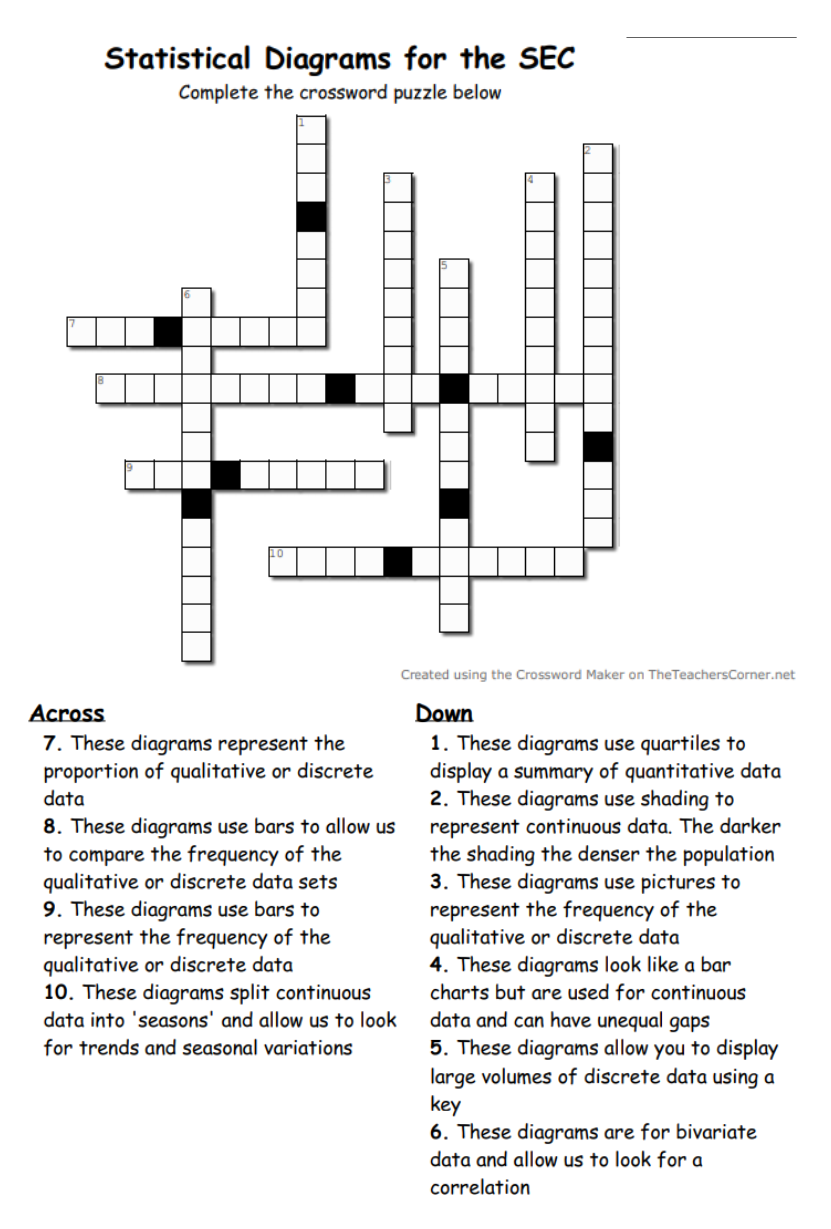
Which Calculations to Use …
In statistics there are several calculations that we can do that help us evaluate the data.
Most of these allow for ease with comparisons too.
N.B. a companion should always state which is the highest/lowest value
- Total
- Mean
- Median
- Mode
- Range
- Quartiles and IQR
- Variance and Standard Deviation
- Skew

Some calculations need to be done in order to complete other statistics such as sampling methods and statistical diagrams
Statistical Method | Corresponding Calculation
Stratified Sampling | Proportion of the population
Systematic Sampling | Regular interval
Pie Charts | Angles for a pie chart
Histograms | Frequency density
Box and Whisker plot | Quartiles  Range  IQR  Skew  Outliers
Scatter graph | Equation of the line of best fit  Residuals  PMCC  SRCC
Time Series | Moving averages  Seasonal Variation

RECALL Skills Check
When drawing and comparing box plots we need the following statistical calculations as well:
L __ __ __ __ __ V __ __ __ __
L __ __ __ __ Q __ __ __ __ __ __ __
M __ __ __ __ __
U __ __ __ __ Q __ __ __ __ __ __ __
H __ __ __ __ __ __ V __ __ __ __
R __ __ __ __
I __ __ __ __ Q __ __ __ __ __ __ __ R __ __ __ __
S __ __ __
O __ __ __ __ __ __ __

When drawing a histogram we need the following statistical calculations as well:
F __ __ __ __ __ __ __ __ D __ __ __ __ __ __

When drawing a scatter graph we can use the following statistical calculations as well:
E __ __ __ __ __ __ __ O __ T __ __ L __ __ __ O __ B __ __ __ F __ __
R __ __ __ __ __ __ __ __
P __ __ __ __ __ __ M __ __ __ __ __ C __ __ __ __ __ __ __ __ __ __ C __ __ __ __ __ __ __ __ __ __
S __ __ __ __ __ __ __ '__ R __ __ __ C __ __ __ __ __ __ __ __ __ __ C __ __ __ __ __ __ __ __ __ __

*EXT*
When drawing a time series we can calculate the following statistical calculations as well:
- M __ __ __ __ __ A __ __ __ __ __ __ __
- S __ __ __ __ __ __ __ V __ __ __ __ __ __ __ __
- S __ __ __ __ __ __ __ E __ __ __ __ __

When drawing and comparing a normal distribution curve we need the following statistical calculations as well:
- M __ __ __
- S __ __ __ __ __ __ __ D __ __ __ __ __ __ __ __

I DO
What is the average ... 'price to park per hour?' | Diagrams:
What is the average ... 'price to park per hour?' | Calculations:

WE DO
How strong is the relationship between ... 'the location and the price of a parking spot?' | Diagrams:
 | Calculations:

YOU DO
How do 'parking prices in the city centre' compare ... 'to those on the outskirts?' | Diagrams:
 | Calculations:

Practice Questions
- For each of the following questions, decide if the statistical diagram chose is a sensible choice or not.
If not, give an example of a more suitable diagram
- What is the most popular colour car on the staff car park?
Use a pie chart to display this data
[ ] Suitable [ ] Not Suitable: _________________________________________________________
- What is the average number of ice creams sold by Mr Whippy per day during Summer?
Use a scatter graph to display this data
[ ] Suitable [ ] Not Suitable: _________________________________________________________
- What is the correlation between the number of hours overtime and the happiness scale of staff?
Use a box plot to display this data
[ ] Suitable [ ] Not Suitable: _________________________________________________________
- Who runs faster on average; girls or boys?
Use a multiple bar chart to display this data
[ ] Suitable [ ] Not Suitable: _________________________________________________________
- When is the most popular time of year for people to visit cannon hill park?
Use a time series to display this data
[ ] Suitable [ ] Not Suitable: _________________________________________________________
- Who is the most contacted member of the Royal Family?
Use a stem and leaf diagram to display this data
[ ] Suitable [ ] Not Suitable: _________________________________________________________

- For each of the following hypotheses, decide if the statistical calculation is a sensible choice or not.
If not, give an example of a more suitable calculation
- There is an average of 27 students in each Maths class
Use the mean and median to investigate this hypothesis
[ ] Suitable [ ] Not Suitable: _________________________________________________________
- There is a strong positive correlation between the position athletes came in the race and their blood sugar levels at the end of the race Use the standard deviation to investigate this hypothesis
[ ] Suitable [ ] Not Suitable: _________________________________________________________
- Year 7 complete more homework on average and are more consistent with how much they hand in than year 11 Use moving averages to investigate this hypothesis
[ ] Suitable [ ] Not Suitable: _________________________________________________________
- The most popular day for school dinners is Friday
Use the mode to investigate this hypothesis
[ ] Suitable [ ] Not Suitable: _________________________________________________________
- Over 3 years, most sales occur in Oct-Dec
Use the mean, median and mode to investigate this hypothesis
[ ] Suitable [ ] Not Suitable: _________________________________________________________
- Hayley has the most consistent sales in the store
Use the range to investigate this hypothesis
[ ] Suitable [ ] Not Suitable: _________________________________________________________

______ / ______ / ______
The Conclusion
How do we use the Statistical Enquiry Cycle to plan and evaluate a statistical investigation?
How do we predict what our results will show to prove our hypothesis?
Key Vocabulary
Vocab | Mathematical Definition
Prediction | a forecast, an expectation of what is to come

The Knowledge Phase
- Read the Problem or Scenario
- Think about your questions
- What would you expect your results to look like if out hypothesis was true?

- The reason we write our hypothesis is because we think that will be the answer to our question
- The reason we chose our diagrams and calculations is because we think these will show our hypothesis is correct
- Therefore, we must know what these results will look like if our hypothesis it true.

Mean/Median/Mode | If we are looking for an average usually the higher the average the better the result except for races where the lower the average the better the result
Range/IQR/S.D | If we are looking for a measure of spread, the higher the measure of spread the more consistent (or less varied) the data
Box Plots | When comparing box plots we are looking for a higher (or lower) median  And we are looking for a wider (or narrower) range/IQR  We can also look for and compare skew
Scatter Graphs | If we are looking for a positive correlation we should see an upward trend  We may also have a coefficient of 0 < x ≤ 1  If we are looking for a negative correlation we should see an downward trend  We may also have a coefficient of -1 ≤ x < 0
Time Series | If we are looking for a seasonal variation we should see peaks and troughs at the same point each year  If we are looking for a trend our time series should show a rising or falling trend

I DO
Which of the following diagrams would we expect to see if our hypothesis was true?
HYPOTHESIS: The most amount of money males and females spend on parking at Hope Hospital is £5 per day
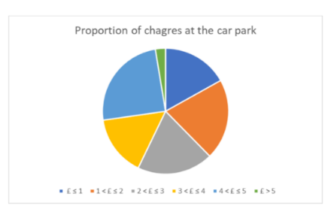
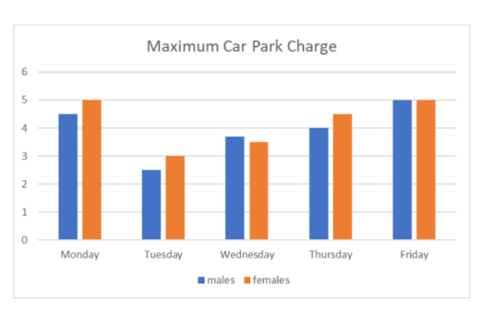
0 5 5 5 7 8 8 9
1 2 2 4 4 6 6 8 8 8 8 8 8
2 0 0 0 0 2 2 6 6 8 8
3 0 0 0 2 4 4 6 6 6 6
4 0 0 0 0 6 6 8
5 0 0 0 0 0 0 0 2 2 4 4 6 6 8 8
6 0 0
KEY 0 I 5 means 50p

WE DO
0 5 5 5 7 8 8 9
1 2 2 4 4 6 6 8 8 8 8 8 8
2 0 0 0 0 2 2 6 6 8 8
3 0 0 0 2 4 4 6 6 6 6
4 0 0 0 0 6 6 8
5 0 0 0 0 0 0 0 2 2 4 4 6 6 8 8
6 0 0
KEY 0 I 5 means 50p

Which of the following would we expect to see if our hypothesis was true?
HYPOTHESIS: The average price people pay to park at Silverton Shopping Centre is £2.60 per day
The total amount spent on the car park by 50 visitors was £147
The mean amount spent by visitors per day was £2.90
The median amount spent by visitors per day was £2.00
The modal amount spent by visitors was £2.00

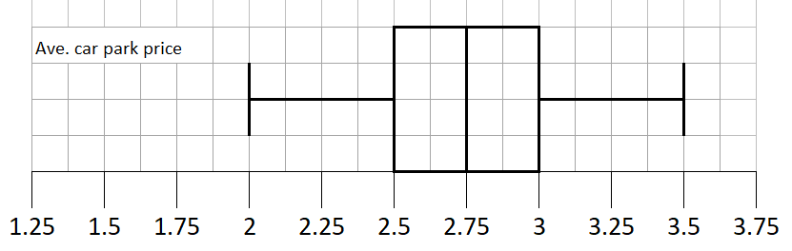

YOU DO
Which of the following diagrams would we expect to see if our hypothesis was true?
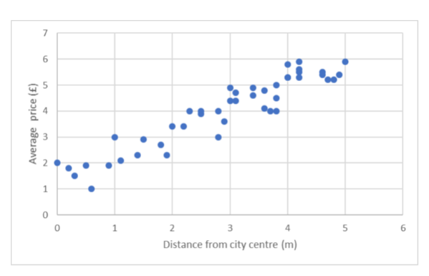
HYPOTHESIS: The closer the parking space is to the city centre, the more expensive the parking per hour is
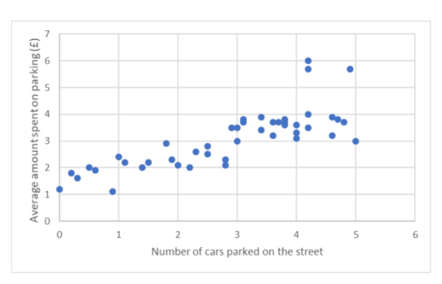
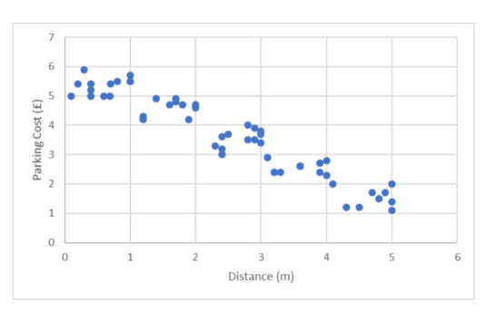

Which of the following diagrams would we expect to see if our hypothesis was true?
On street parking per hour is more expensive in the 'inner circle' than in the 'outer circle'
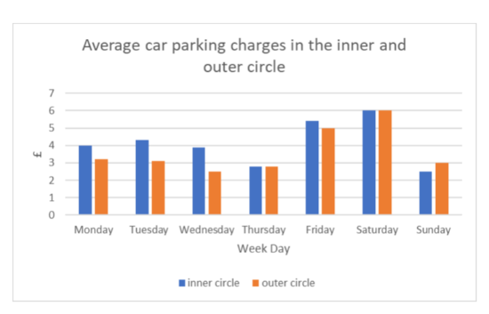
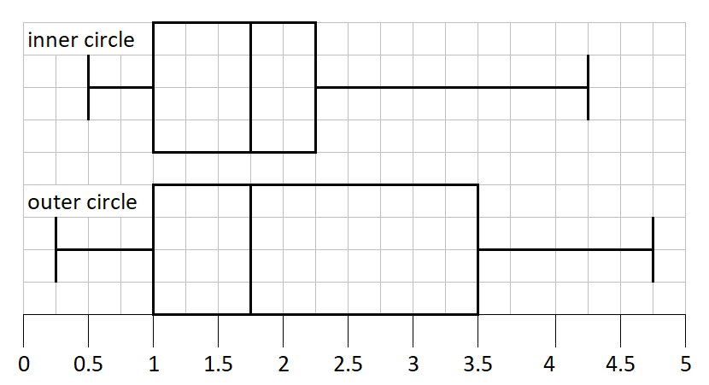
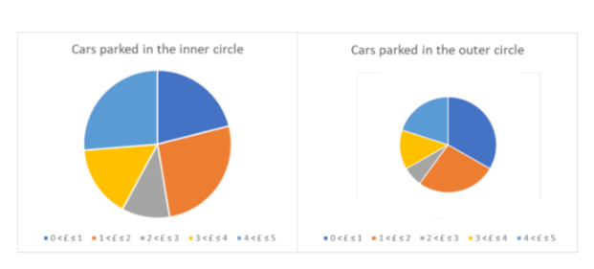

Which of the following would we expect to see if our hypothesis was true?
HYPOTHESIS: There is a strong relationship between the location of the parking space and the price to park per hour
SRCC for distance and price per hour is 0.94
PMCC for distance and price per hour is 0.63
SRCC for distance and price per hour is -0.82
PMCC for distance and price per hour is -0.38

Exam Questions
1 Youssef is investigating the amount of time students spend on social media. Here is what Youssef has written down for his hypothesis and how he plans to collect, process and present his data.
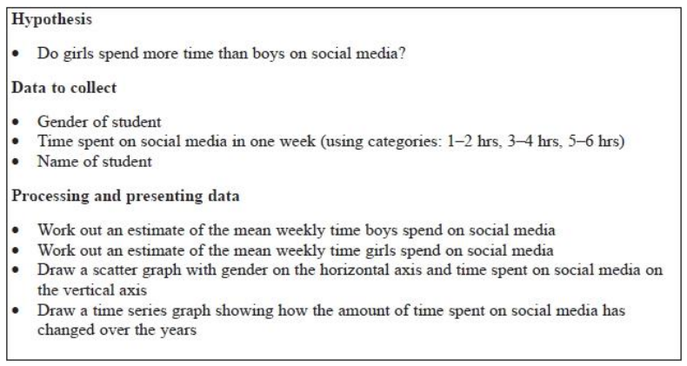
Discuss whether Youssef's hypothesis and his plans for collecting, processing and presenting his data are appropriate.
(5 marks)
_______________________________________________________________________________________________
_______________________________________________________________________________________________
_______________________________________________________________________________________________
_______________________________________________________________________________________________
_______________________________________________________________________________________________
_______________________________________________________________________________________________
_______________________________________________________________________________________________
_______________________________________________________________________________________________
_______________________________________________________________________________________________
_______________________________________________________________________________________________
_______________________________________________________________________________________________
_______________________________________________________________________________________________
_______________________________________________________________________________________________
_______________________________________________________________________________________________
_______________________________________________________________________________________________
2 Gary is going to investigate the amounts of time students spend watching TV.
He is going to write a plan for this investigation.
His hypothesis is
"The amount of time that boys spend watching TV is greater than the amount of time that girls spend watching TV".
Write down three other things he should include in his plan.
Explain why each of these things is appropriate.
You must refer to more than one stage of the statistical enquiry cycle.
(6 marks)
_______________________________________________________________________________________________
_______________________________________________________________________________________________
_______________________________________________________________________________________________
_______________________________________________________________________________________________
_______________________________________________________________________________________________
_______________________________________________________________________________________________
_______________________________________________________________________________________________
_______________________________________________________________________________________________
_______________________________________________________________________________________________
_______________________________________________________________________________________________
_______________________________________________________________________________________________
_______________________________________________________________________________________________
_______________________________________________________________________________________________
_______________________________________________________________________________________________
_______________________________________________________________________________________________
_______________________________________________________________________________________________
_______________________________________________________________________________________________
_______________________________________________________________________________________________
_______________________________________________________________________________________________
_______________________________________________________________________________________________
_______________________________________________________________________________________________
_______________________________________________________________________________________________
_______________________________________________________________________________________________
_______________________________________________________________________________________________
_______________________________________________________________________________________________
3 Tariq wants to investigate the distance people travel to get to their holiday destination and the price of the holiday. He is going to write a plan for this investigation.
Write down one thing that he should include in his plan for each of
• data collection
• presenting and interpreting diagrams
• presenting and interpreting calculations Explain why each of your choices is appropriate
(6 marks)
_______________________________________________________________________________________________
_______________________________________________________________________________________________
_______________________________________________________________________________________________
_______________________________________________________________________________________________
_______________________________________________________________________________________________
_______________________________________________________________________________________________
_______________________________________________________________________________________________
_______________________________________________________________________________________________
_______________________________________________________________________________________________
_______________________________________________________________________________________________
_______________________________________________________________________________________________
_______________________________________________________________________________________________
_______________________________________________________________________________________________
_______________________________________________________________________________________________
_______________________________________________________________________________________________
_______________________________________________________________________________________________
_______________________________________________________________________________________________
_______________________________________________________________________________________________
_______________________________________________________________________________________________
_______________________________________________________________________________________________
_______________________________________________________________________________________________
_______________________________________________________________________________________________
_______________________________________________________________________________________________
_______________________________________________________________________________________________
_______________________________________________________________________________________________
_______________________________________________________________________________________________
4 A vet wants to estimate the average weight of adult female shorthair cats.
She took a sample of 8 adult female shorthair cats that were brought to her clinic.
Here are the cats' weights in kilograms.
4.0 4.5 9.8 5.1 4.1 4.5 4.2 3.9
(a) Identify the outlier.
........................................................... kg
(1 mark)
The vet plans to estimate the average weight of adult female shorthair cats using this data.
(b) Give her advice.
You should consider the data she plans to use and which average she should choose.
Give reasons for your answer.
(5 marks)
_______________________________________________________________________________________________
_______________________________________________________________________________________________
_______________________________________________________________________________________________
_______________________________________________________________________________________________
_______________________________________________________________________________________________
_______________________________________________________________________________________________
_______________________________________________________________________________________________
_______________________________________________________________________________________________
_______________________________________________________________________________________________
_______________________________________________________________________________________________
_______________________________________________________________________________________________
_______________________________________________________________________________________________
_______________________________________________________________________________________________
_______________________________________________________________________________________________
_______________________________________________________________________________________________
_______________________________________________________________________________________________
_______________________________________________________________________________________________
_______________________________________________________________________________________________
_______________________________________________________________________________________________
_______________________________________________________________________________________________
_______________________________________________________________________________________________
5 A database contains information about the 2567 people registered at a medical centre.
Here is the information that the database contains on each person.
Rebecca wants to see if there is a relationship between the age of a person registered at the medical centre and the number of appointments this person has had at the medical centre.
Describe how Rebecca can plan to use technology to help her process and present the data for this investigation.
You should refer to the advantages of using technology to process and present data compared to doing so by hand.
(6 marks)
_______________________________________________________________________________________________
_______________________________________________________________________________________________
_______________________________________________________________________________________________
_______________________________________________________________________________________________
_______________________________________________________________________________________________
_______________________________________________________________________________________________
_______________________________________________________________________________________________
_______________________________________________________________________________________________
_______________________________________________________________________________________________
_______________________________________________________________________________________________
_______________________________________________________________________________________________
_______________________________________________________________________________________________
_______________________________________________________________________________________________
_______________________________________________________________________________________________
_______________________________________________________________________________________________
_______________________________________________________________________________________________
_______________________________________________________________________________________________
_______________________________________________________________________________________________
_______________________________________________________________________________________________
_______________________________________________________________________________________________
_______________________________________________________________________________________________
_______________________________________________________________________________________________
_______________________________________________________________________________________________
_______________________________________________________________________________________________
6 Barbara found the following information about the average gross pay, in euros (€), for males and for females in ten countries in 2010
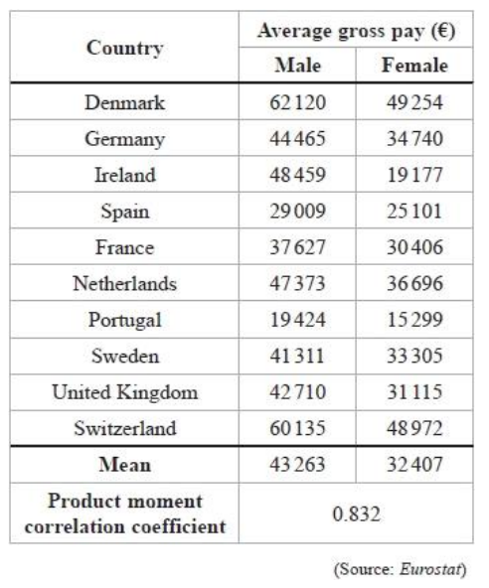
Barbara investigates this information using a suitable graph.
Using the information in the table and her graph, she reaches the following conclusion:
There is strong evidence that, for every €10 000 increase in gross pay for males, gross pay for females increases by €8000
(a) Explain, giving reasons, what Barbara is most likely to have done to reach this conclusion. You should consider
• which type of graph she will have used and why
• how she will have used the graph and the information in the table
(5 marks)
_______________________________________________________________________________________________
_______________________________________________________________________________________________
_______________________________________________________________________________________________
_______________________________________________________________________________________________
_______________________________________________________________________________________________
_______________________________________________________________________________________________
_______________________________________________________________________________________________
_______________________________________________________________________________________________
_______________________________________________________________________________________________
_______________________________________________________________________________________________
(b) Explain why Barbara's conclusion, based on using the data in the table, may be unreliable.
(1 mark)
_______________________________________________________________________________________________
_______________________________________________________________________________________________
7 Anne is investigating the effect of caffeine on reaction times.
Here is what Anne has written down for her hypothesis and how she plans to collect, process and present her data.
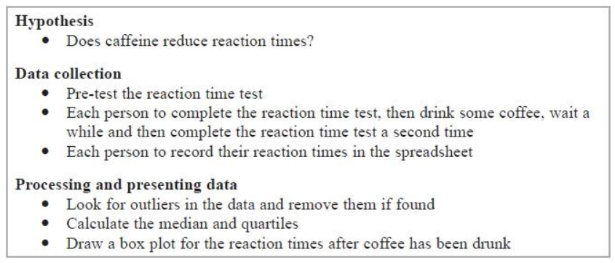
Discuss whether Anne's hypothesis and her plans for collecting, processing and presenting data are appropriate.
(5 marks)
_______________________________________________________________________________________________
_______________________________________________________________________________________________
_______________________________________________________________________________________________
_______________________________________________________________________________________________
_______________________________________________________________________________________________
_______________________________________________________________________________________________
_______________________________________________________________________________________________
_______________________________________________________________________________________________
_______________________________________________________________________________________________
_______________________________________________________________________________________________
_______________________________________________________________________________________________
_______________________________________________________________________________________________
_______________________________________________________________________________________________
_______________________________________________________________________________________________
_______________________________________________________________________________________________
_______________________________________________________________________________________________
_______________________________________________________________________________________________
_______________________________________________________________________________________________
_______________________________________________________________________________________________
_______________________________________________________________________________________________
_______________________________________________________________________________________________
_______________________________________________________________________________________________
Self-Assessment Sheet
 | ☺ | 😐 | ☹
I can write an appropriate question for a given scenario
I can write an appropriate hypothesis for a question
I can identify Qualitative, Discrete and Continuous data
I know the pros and cons of questionnaires and interviews
I can identify the 6 types of sampling
I can write explicit instructions for the 3 main sampling methods
I know the names various statistical diagrams
I can recall the calculations needed for key statistical diagrams
I can choose appropriate diagrams and calculations to prove my hypothesis
I know what my diagrams and calculations should look like if my hypotheses are correct
I can answer a SEC exam style question

______ / ______ / ______
The Investigation
How do we use the Statistical Enquiry Cycle to plan and evaluate a statistical investigation?
Am I able to plan and carry out a statistical investigation?
Key Vocabulary
Vocab | Mathematical Definition
The SEC | The Statistical Enquiry Cycle
Investigation | a formal inquiry or systematic study.

Historical  Origins | History. While hypothesis testing was popularized early in the 20th century, early forms were used in the 1700s. The first use is credited to John Arbuthnot (1710), followed by Pierre-Simon Laplace (1770s), in analyzing the human sex ratio at birth; see § Human sex ratio.

PROBLEM The GCSE option choices of KS4 students at Aldersley High School

QUESIOTNS/HYPOTHESES:
> Choose from the following questions and write an appropriate hypothesis
[ ] What is the most popular option choice of KS4 students at Aldersley High School?
[ ] What is the average number of students in a GCSE option lesson at Aldersley High School?
[ ] How do the option choices of girls and boys compare at Aldersley High School?
[ ] Is there a relationship between the number of students per class for option and compulsory GCSE subjects at Aldersley High School ?
[ ] How strong is the relationship between the number of students per class for option and compulsory GCSE subjects at Aldersley High School ?
[ ] How do the predicted grades of KS4 students for GCSE Maths vary over each year at Aldersley High school?

My Hypothesis: __________________________________________________________________________
_______________________________________________________________________________________

DATA COLLECTION
> Will you be using primary or secondary data for this project?
[ ] Primary [ ] Secondary
By discussing the pros and cons of each of these methods:
> Explain why you have chosen this method
_______________________________________________________________________________________
_______________________________________________________________________________________
> Explain how this method will affect your investigation
_______________________________________________________________________________________
_______________________________________________________________________________________

> What is the population you will be using?
_______________________________________________________________________________________
> Will you take a census or a sample?
[ ] Census [ ] Sample
> Why have you chosen this method (pros/cons)
_______________________________________________________________________________________
_______________________________________________________________________________________
_______________________________________________________________________________________
> How will this affect your investigation?
_______________________________________________________________________________________
_______________________________________________________________________________________
> If taking a sample, how many pupils will you select? Why that number?
________ because ________________________________________________________________________

> If taking a sample which sampling method will you use?
[ ] Random [ ] Stratified [ ] Systematic [ ] Convenience [ ] Quota [ ] Cluster
By discussing the pros and cons of each of these methods:
> Explain why you have chosen this method
_______________________________________________________________________________________
_______________________________________________________________________________________
> Explain how this method will affect your investigation
_______________________________________________________________________________________
_______________________________________________________________________________________
DIAGRAMS/CALCULATIONS:
> Choose from the list any statistical diagrams you will use in your investigation
[ ] Tally Chart [ ] Pictogram [ ] Bar Chart [ ] Composite Bar Chart
[ ] Multiple Bar Chart [ ] Pie Chart [ ] Comparative Pie Chart [ ] Two Way Table
[ ] Frequency Polygon [ ] Stem & Leaf [ ] Histogram [ ] Box Plot
[ ] Scatter Graph [ ] Time Series
_______________________________________________________________________________________
> Explain why you have chosen this diagram
_______________________________________________________________________________________
_______________________________________________________________________________________
> What calculations are needed for this diagram?
_______________________________________________________________________________________

> Choose from the list any statistical calculations you will use in your investigation
[ ] Mean [ ] Median [ ] Mode [ ] Quartiles [ ] Range [ ] IQR [ ] Skew
[ ] Standard Deviation [ ] Equation of the line of best fit [ ] PMCC [ ] SRCC
[ ] Moving Averages [ ] Seasonal Variation [ ] MSE
> Explain why you have chosen these calculations
_______________________________________________________________________________________
_______________________________________________________________________________________

EXPECTED RESULTS AND CONCLUSIONS
> For my hypothesis to be correct I expect my statistical diagram to look like this:

> For my hypothesis to be correct I expect my calculations to be:
_______________________________________________________________________________________
_______________________________________________________________________________________
_______________________________________________________________________________________
_______________________________________________________________________________________
Key words to learn

Formulas to learn

Copyright List
https://nzmaths.co.nz/category/glossary/statistical-enquiry-cycle#:~:text=The%20cycle%20consists%20of%20five,and%20why%20it%20is%20important.
https://www.statsacademy.co.uk/_files/ugd/d7dae4_47045e2dfead49819c633256c5fd304a.pdf
https://blog.masterofproject.com/sample-in-statistics/#:~:text=Sampling%20is%20very%20often%20used,constitution%20of%20the%20whole%20body.
https://uk.indeed.com/career-advice/finding-a-job/careers-in-research#:~:text=Jobs%20in%20research-based%20roles,%2C%20business%2C%20science%20and%20history.
https://www.indeed.com/career-advice/finding-a-job/data-visualization-jobs-with-salary
https://www.theteacherscorner.net
https://thewordsearch.com/maker/

