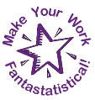
Mathematics and Statistics Department

Knowledge Book
GCSE Statistics

Term 10.6
The Statistical Enquiry
Cycle
Scan here for revision materials
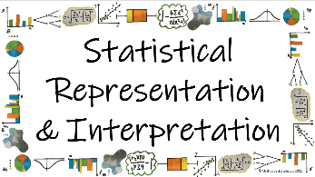
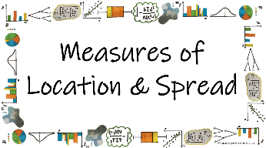
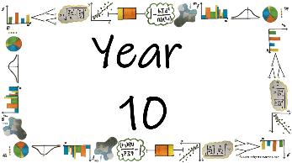
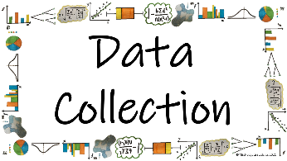

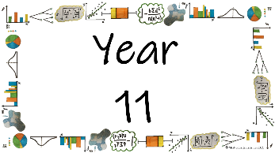
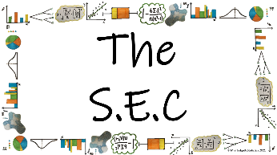
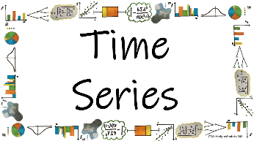
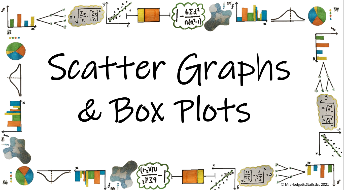

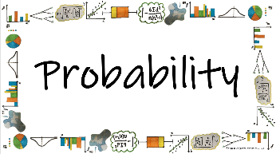
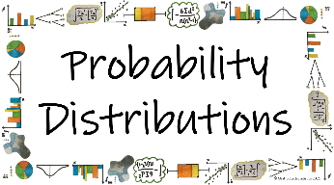
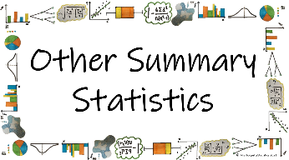
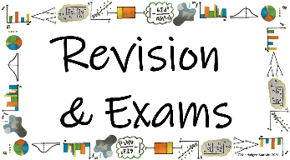

Name: ______________________
Teacher: ______________________
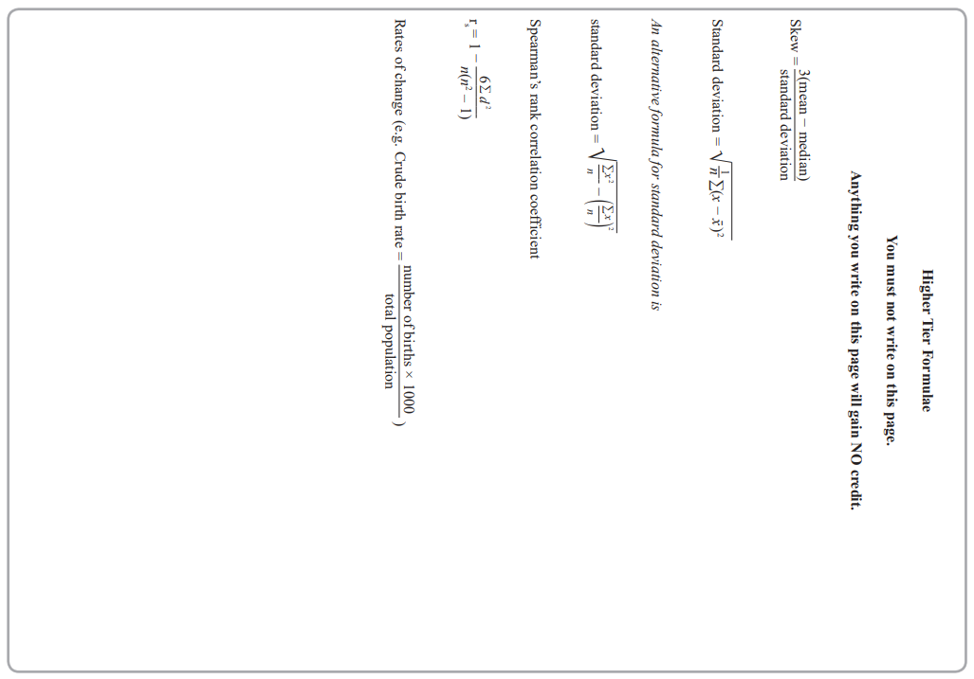
Contents Page
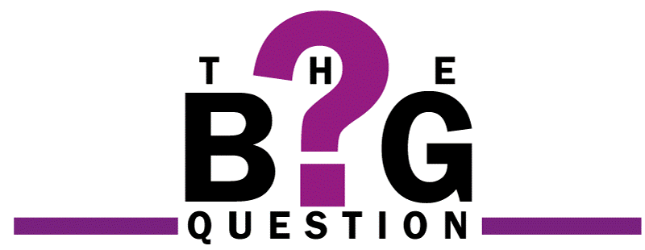 | How do we use the Statistical Enquiry Cycle to plan and evaluate a statistical investigation?
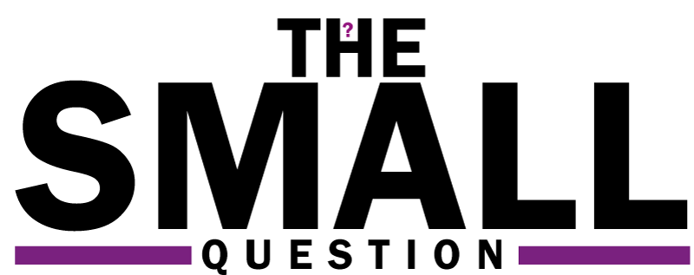 |  | Page

How do we write appropriate questions and hypotheses for our SEC?

How do we collect appropriate data to answer our SEC investigations?

How do we decide which diagrams and calculations to analyse to answer our SEC investigations?

How do we predict what our results will show to prove our hypothesis?

Am I able to plan and carry out a statistical investigation?

  Cross-Curricular  Link | All small questions marked with a * are topics that you will be coving in GCSE Maths as well as GCSE Statistics
Vocabulary Pyramid

The SEC
Hypothesis
Question
Primary Secondary
Qualitative Quantitative
Discrete Continuous
Interviews Questionnaires
Understanding Candour Bias
Resources Inclusivity Sampling
Convenience Random Stratified Prediction
Systematic Quota Cluster Mode Skew
Median Mean Range Standard Deviation
Skew

Tier 3 Words
Words specific to the subject ‘Statistics’
These may have different meanings in other subjects

Tier 2 Words
Show Data Identify Describe Discuss
Variables Determine Parameter Statistic Construct
Evaluate Respectively Given Explain Conduct Depict
Suggest Assess Validity Research Investigate Decide
Calculate Practical Suitable Collect Complete Frequency

Words that are often seen written in text and exam questions but are not often spoken

Tier 1 Words
Words that are used often in speech and have the same meaning in most contexts
Which Who What Where When Why How
Age Time Weight Mass Length Breadth Width Height
Chart Graph Diagram Advantages Disadvantages

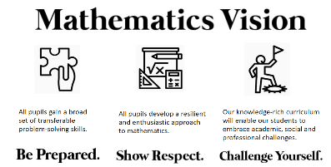

In this Knowledge Book you will see some of the following symbols with interesting facts and information about the words and terminology which will not be assessed but will deepen your understanding of the words.
 | This gives us the origin of a word and the historical development of its meaning.
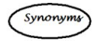 | This gives us a word or phrase that means exactly or nearly the same as another word or phrase in the same language.
  Historical  Origins | Historical Origins. This gives us the historical origin of the word.
  Did you know? | Do you Know? This gives us a fascinating fact about the word or skill,
Cross-Curricular  Link | Cross Curricular Link. This gives us links to where we might use this word or skill in other subjects
  Real World  Application | Real World Application. This gives us an idea of when or how we might use this in the real world.
  Revision Ideas | Revision ideas. This gives us some revision techniques to use for each topic.  Remember to use the revision websites:  - MrsHodgettsStatistics.com  - StatsAcademy.co.uk  - MathsGenie.co.uk  And the Revision techniques websites:  - GetRevising.co.uk
Introduction
Within GCSE (9-1) Statistics the new Assessment Objective 3, which contributes approximately 20% of the total assessment, will be assessed through questions on the component parts of the Statistical Enquiry Cycle. Furthermore “any given question may assess one stage or more than one stage of the SEC”.
This means that in any part of the assessment you can be asked to answers questions in the context of a real-life statistical enquiry. This also means that you can be asked to answer a question about a statistical enquiry explicitly.
The SEC is a cycle that is used to carry out a statistical investigation. The cycle consists of five stages: Problem, Plan, Data, Analysis, Conclusion.
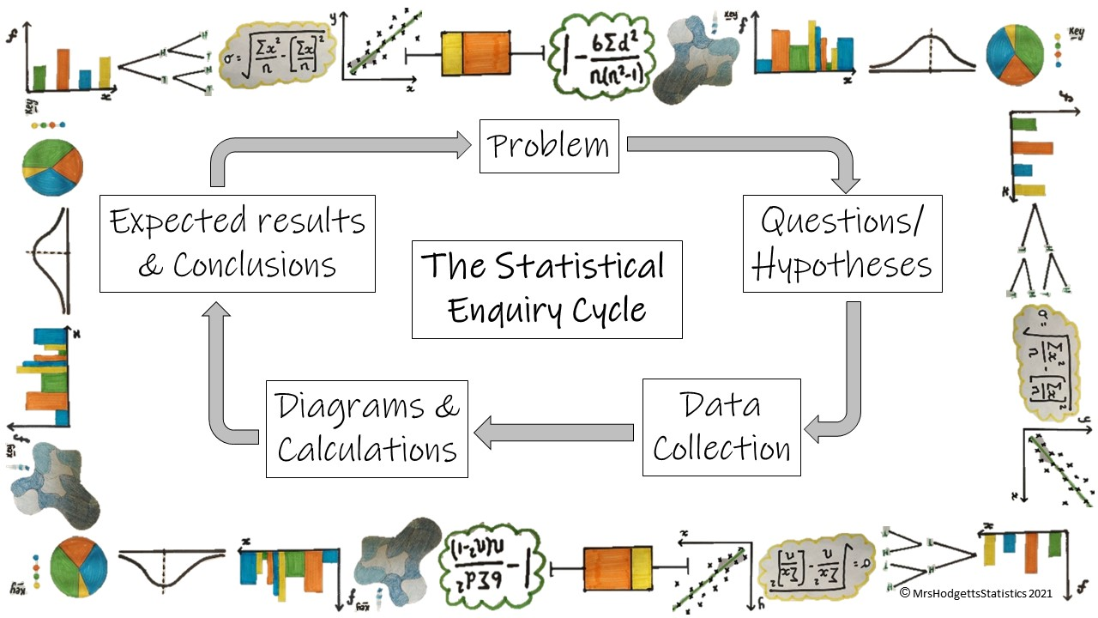
The problem section is about identifying the problem you want to investigate. This may be due to concerns that have been raised, a change that has happened or other problems that you believe to have caused disruption
The plan section is about how the data will be gathered including what questions you want to answer and what hypotheses you are testing
The data section is about how the data is managed and organised. What data collection methods you will be using and why they are the best ones to use
The analysis section is about exploring and analysing the data, using a variety of data displays and numerical summaries, and reasoning with the data. Here you will need to explain which statistical diagrams and calculations you will be using and why you think they are the best choice.
The conclusion section is about answering the question in the problem section and giving reasons based on the analysis section. It may be that you are predicting these results, what they will look like to prove your hypotheses are correct rather than seeing actually results.
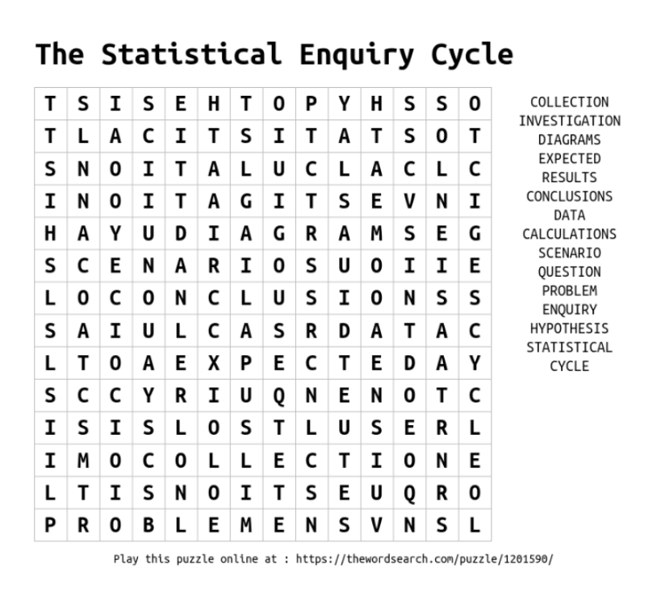
So far we have covered everything in year 10 for the statistical enquiry cycle. We will go through each of the stages of the SEC with no new knowledge but looking at how the knowledge we have already accumulated can be used in real-life problems.
______ / ______ / ______
The Plan
How do we use the Statistical Enquiry Cycle to plan and evaluate a statistical investigation?
How do we write appropriate questions and hypotheses for our SEC?
Key Vocabulary
Vocab | Mathematical Definition
The SEC | The Statistical Enquiry Cycle
Question | a sentence worded or expressed so as to elicit information.
Hypothesis | a sensible assumption written as a statement that can be tested to see if it is correct or not

The Knowledge Phase
- Read the Problem or Scenario
- What could you ask about the scenario?
- What do you expect the answer to be?

Questions which start with 'What is the most ...' or 'What is the average ...' etc are still questions which we can write hypotheses for but they are very low skill and would score you the lowest marks in SEC questions

Questions and hypotheses which look for relationships and comparisons between groups are the backbone to a good investigation and what you should be aiming for when answering a SEC question

For those of you looking to push for grade 7/8/9 answers, your should direct your question and hypotheses to not just look for a relationship but the strength of that relationship

GRADE 9 We can look for distributions too but we haven't done these yet, we will look at them in year 11

Some things we need to remember when writing a hypothesis …
- A hypothesis is not a question
- A hypothesis should be a statement
- A hypothesis should suggest a testable answer to the question
- A hypothesis should relate to as many aspects of the scenario as possible

How to start a hypothesis …
- The most popular / most common / most frequent … is …
- The average … is …
- There is a

  - weak / moderate / strong / very strong
  - positive / negative relationship between and
- … do better on average than …

And remember …
- If you are writing a hypothesis about averages include a time frame. E.G. The average cost PER HOUR / PER DAY / PER WEEK / PER MONTH / PER YEAR
- Your hypothesis must be testable. i.e. do not write a hypothesis about something you cannot measure or get the information for – be specific NOT vague
Real World  Application | Jobs in research-based roles involve developing and testing hypotheses, analysing data and making conclusions. Almost every field of work has research roles within it, including technology, business, science and history. These include Research Assistant, Market Researcher, Research Scientist, Archaeologist, Historian, Research Engineer, Data Analyst and Actuary

Cross-Curricular  Link | Scientific experiments require a hypothesis to support the scientific research and breakthroughs in knowledge. In your science lessons you will write a hypothesis before conducting the experiment to test if you are correct.

______ / ______ / ______
The Data
How do we use the Statistical Enquiry Cycle to plan and evaluate a statistical investigation?
How do we collect appropriate data to answer our SEC investigations?
Key Vocabulary
Vocab | Mathematical Definition
Primary | data which you collect yourself or is collected by your team specifically for the investigation in hand
Secondary | data which has already been collected or already exists but can be used for the investigation in hand
Qualitative | data which is non-numerical
Quantitative | data which is numerical. This can be split into two sub-categories
Discrete | numerical data which is countable
Continuous | numerical data which is measurable
Interviews | a way for one person to ask questions and another to answer them.
Questionnaires | a set of questions that have been written and used to obtain data
Understanding | how well questions are understood by the participant
Inclusivity | how easy it is to ensure as many participants take part as possible
Resources | how much time/money it takes for participants to take part
Candour | how comfortable [participants feel answering the questions
Bias | a systematic distortion of a statistical result due to a factor not allowed for in its derivation.
Sampling | using a small proportion of the population
Convenience | a sampling method which collects data in the most convenient way to the investigator
Systematic | a sampling method which uses a system of a regular interval to find the sample.
Random | a sampling method in which everyone or everything has an equal chance of being chosen
Stratified | a sampling method which ensure the sample taken is proportionate to the strata which makes up the population
Quota | a sampling method which includes categories of data to fit a given quota
Cluster | a sampling method which groups data into categories and with either takes a sample of one cluster or a sample from a small group of clusters
The Knowledge Phase
- Read the Problem or Scenario
- Think about your questions
- How are you going to get the data to answer them?

What do we know from GCSE Statistics so far?

Type of Data
Primary: _________________________________
Secondary: _______________________________
Qualitative: _______________________________
Continuous: ______________________________
Discrete: _________________________________

Primary:
+ _____________________________________________________________________________________
- _____________________________________________________________________________________
Secondary:
+ _____________________________________________________________________________________
- _____________________________________________________________________________________

Methods of Data Collection
Interviews: _____________________________________________________________________________
Questionnaires: __________________________________________________________________________
Sampling Methods :
Random: _______________________________________________________________________________

Stratified: _______________________________________________________________________________
Systematic: _____________________________________________________________________________
Cluster: ________________________________________________________________________________
Convenience: ____________________________________________________________________________
Quota: _________________________________________________________________________________
Real World  Application | Sampling is very often used in our daily life. For example, while purchasing fruits form a shop, we usually examine a few to assess the quality. A doctor examines a few drops of blood as a sample and draws a conclusion about the blood constitution of the whole body.

______ / ______ / ______
The Analysis
How do we use the Statistical Enquiry Cycle to plan and evaluate a statistical investigation?
How do we decide which diagrams and calculations to analyse to answer our SEC investigations?
Key Vocabulary
Vocab | Mathematical Definition
Qualitative | data which is non-numerical
Quantitative | data which is numerical. This can be split into two sub-categories
Discrete | numerical data which is countable
Continuous | numerical data which is measurable
Mode | a measure of location (average) which identifies the most frequent data value
Median | a measure of location (average) which identifies the middle data value
Mean | a measure of location (average) which uses the formula $\frac{\sum{x}}{n}$
Range | the difference between the largest and smallest number in a data set
Standard Deviation | a measure of spread which tells us how spread out the data is around the mean. The square root of the variance
Skew | when data has a long tail on one side or the other, so it is not symmetrical
Correlation | the way in which the data is related on a scatter graph

The Knowledge Phase
- Read the Problem or Scenario
- Think about your questions
- What can you draw and calculate that will help to answer them?

Real World  Application | Data visualization is a practical method that individuals use to interpret and present information using graphical representations to colleagues or clients tangibly to make data more accessible and understandable. Many organizations across a variety of industries have positions that use this in-demand skill. Understanding the general duties of data visualization positions may help you make a more informed career choice that fulfils your goals.

Which Diagram to Use…
It is important to use a diagrams that is relevant to the data you have collected. Different diagrams are used for different types of data, some diagrams are more versatile than others and can be used for more than one type of data but there is usually a ‘better’ diagram for your analysis

Univariate Data: One set of data
Qualitative data | Discrete Data | Continuous Data
- Tally chart  - Two-Way tables  - Pictograms  - Bar charts  - Pie Charts  - Stem and leaf diagrams | - Tally chart  - Two-Way tables  - Pictograms  - Bar charts  - Pie Charts  - Stem and leaf diagrams | - Two-Way tables  - Bar charts  - Pie Charts  - Frequency Polygon  - Histogram

Comparisons: Two sets of unpaired data
Qualitative data | Discrete Data | Continuous Data
- Comparative Pie Charts  - Multiple Bar Charts | - Comparative Pie Charts  - Multiple Bar Charts  - Box Plots | - Comparative Pie Charts  - Multiple Bar Charts  - Population pyramid  - Box Plots  - Frequency Polygon  - Histograms

Bivariate Data: Paired data sets
Qualitative data | Discrete Data | Continuous Data
X | - Scatter diagrams.  (with line of best fit) | - Time Series  - Scatter diagrams.  (with line of best fit)

Which Calculations to Use …
In statistics there are several calculations that we can do that help us evaluate the data.
Most of these allow for ease with comparisons too.
N.B. a companion should always state which is the highest/lowest value
- Total
- Mean
- Median
- Mode
- Range
- Quartiles and IQR
- Variance and Standard Deviation
- Skew

Some calculations need to be done in order to complete other statistics such as sampling methods and statistical diagrams
Statistical Method | Corresponding Calculation
Stratified Sampling | Proportion of the population
Systematic Sampling | Regular interval
Pie Charts | Angles for a pie chart
Histograms | Frequency density
Box and Whisker plot | Quartiles  Range  IQR  Skew  Outliers
Scatter graph | Equation of the line of best fit  Residuals  PMCC  SRCC
Time Series | Moving averages  Seasonal Variation

______ / ______ / ______
The Conclusion
How do we use the Statistical Enquiry Cycle to plan and evaluate a statistical investigation?
How do we predict what our results will show to prove our hypothesis?
Key Vocabulary
Vocab | Mathematical Definition
Prediction | a forecast, an expectation of what is to come

The Knowledge Phase
- Read the Problem or Scenario
- Think about your questions
- What would you expect your results to look like if out hypothesis was true?

- The reason we write our hypothesis is because we think that will be the answer to our question
- The reason we chose our diagrams and calculations is because we think these will show our hypothesis is correct
- Therefore, we must know what these results will look like if our hypothesis it true.

Mean/Median/Mode | If we are looking for an average usually the higher the average the better the result except for races where the lower the average the better the result
Range/IQR/S.D | If we are looking for a measure of spread, the higher the measure of spread the more consistent (or less varied) the data
Box Plots | When comparing box plots we are looking for a higher (or lower) median  And we are looking for a wider (or narrower) range/IQR  We can also look for and compare skew
Scatter Graphs | If we are looking for a positive correlation we should see an upward trend  We may also have a coefficient of 0 < x ≤ 1  If we are looking for a negative correlation we should see an downward trend  We may also have a coefficient of -1 ≤ x < 0
Time Series | If we are looking for a seasonal variation we should see peaks and troughs at the same point each year  If we are looking for a trend our time series should show a rising or falling trend

Key words to learn

Formulas to learn

Copyright List
https://nzmaths.co.nz/category/glossary/statistical-enquiry-cycle#:~:text=The%20cycle%20consists%20of%20five,and%20why%20it%20is%20important.
https://www.statsacademy.co.uk/_files/ugd/d7dae4_47045e2dfead49819c633256c5fd304a.pdf
https://blog.masterofproject.com/sample-in-statistics/#:~:text=Sampling%20is%20very%20often%20used,constitution%20of%20the%20whole%20body.
https://uk.indeed.com/career-advice/finding-a-job/careers-in-research#:~:text=Jobs%20in%20research-based%20roles,%2C%20business%2C%20science%20and%20history.
https://www.indeed.com/career-advice/finding-a-job/data-visualization-jobs-with-salary
https://www.theteacherscorner.net
https://thewordsearch.com/maker/

