
Mathematics and Statistics Department

Knowledge Book

GCSE Statistics
Term 11.3
Other Summary Statistics
Scan here for revision materials
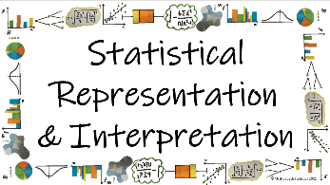
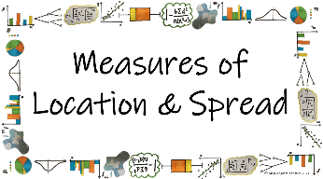
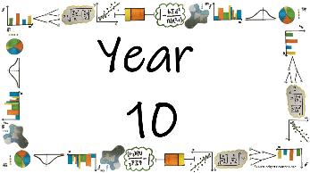
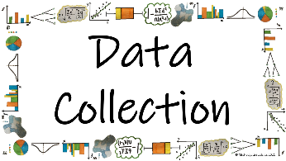

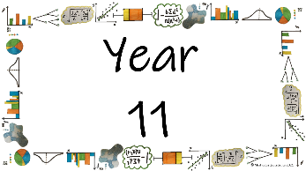
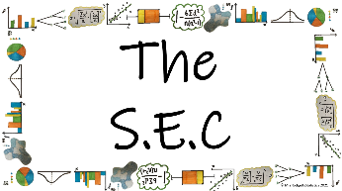
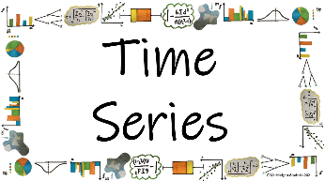
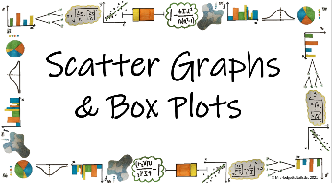

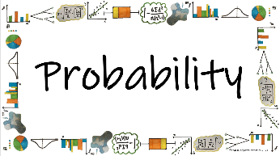
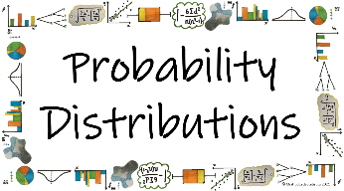
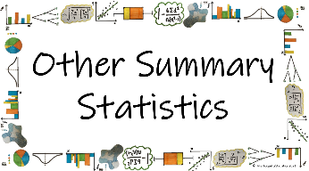


Name: ______________________
Teacher: ______________________
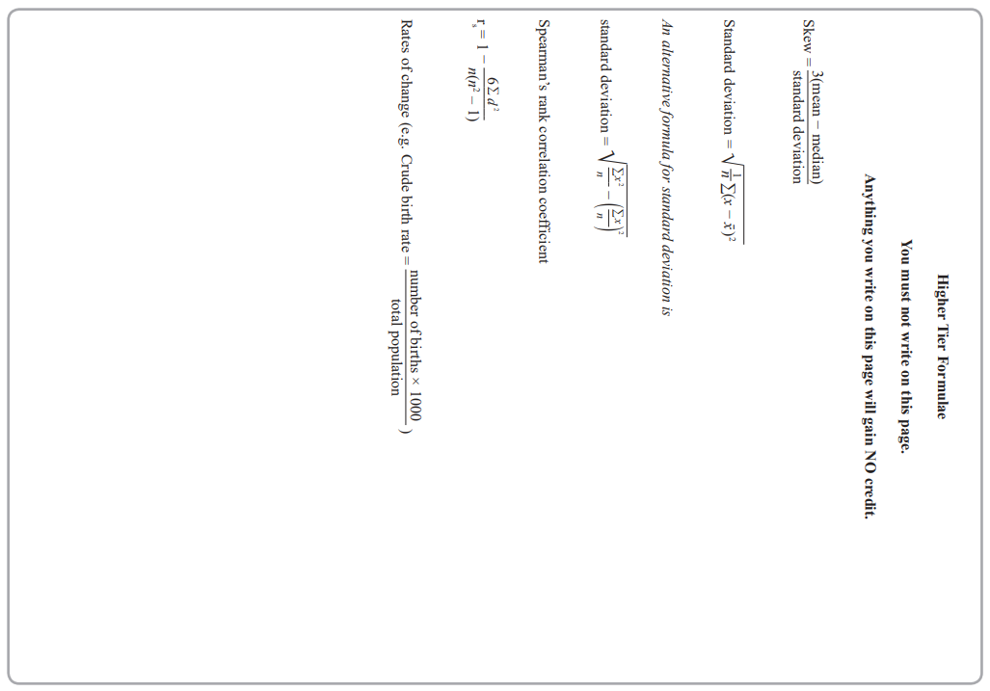
Contents Page
 | What are some ‘other summery statistics’ that can be seen in everyday circumstances and how can we analyse them?

 | Page
How to we calculate standardised scored and what do they mean?
How do we calculate index numbers and what do they mean?
How do we calculate chain base index numbers and what do they mean?
How do we calculate weighted index numbers and what do they mean?
How do we calculate population averages and what do they mean?
What are control charts and how do we use them to assess quality control?

  Cross-Curricular  Link | All small questions marked with a * are topics that you will be coving in GCSE Maths as well as GCSE Statistics
Vocabulary Pyramid

Rate
Mean
Crude
Warning
Action Limit
Standardized Score
Standard Deviation
Base Year Index
Annual Weighted Relative

Tier 3 Words
Words specific to the subject ‘Statistics’
These may have different meanings in other subjects

Tier 2 Words
Show Data Identify Describe Discuss
Variables Determine Parameter Statistic Construct
Evaluate Respectively Given Explain Conduct Depict
Suggest Assess Validity Research Investigate Decide
Calculate Practical Suitable Collect Complete Frequency

Words that are often seen written in text and exam questions but are not often spoken

Tier 1 Words
Words that are used often in speech and have the same meaning in most contexts
Which Who What Where When Why How
Age Time Weight Mass Length Breadth Width Height
Chart Graph Diagram Advantages Disadvantages



In this Knowledge Book you will see some of the following symbols with interesting facts and information about the words and terminology which will not be assessed but will deepen your understanding of the words.
 | This gives us the origin of a word and the historical development of its meaning.
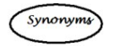 | This gives us a word or phrase that means exactly or nearly the same as another word or phrase in the same language.
  Historical  Origins | Historical Origins. This gives us the historical origin of the word.
  Did you know? | Do you Know? This gives us a fascinating fact about the word or skill,
Cross-Curricular  Link | Cross Curricular Link. This gives us links to where we might use this word or skill in other subjects
  Real World  Application | Real World Application. This gives us an idea of when or how we might use this in the real world.
  Revision Ideas | Revision ideas. This gives us some revision techniques to use for each topic.  Remember to use the revision websites:  - MrsHodgettsStatistics.com  - StatsAcademy.co.uk  - MathsGenie.co.uk  And the Revision techniques websites:  - GetRevising.co.uk
______ / ______ / ______
 | What are some ‘other summery statistics’ that can be seen in everyday circumstances and how can we analyse them?
 | How to we calculate standardised scored and what do they mean?
Key Vocabulary
Vocab | Mathematical Definition
Standardized Score | A score calculated to allow comparisons between scores with different totals, means and standard divisions.
Mean | The total of all the numbers in a data set divided by the number of pieces of data in that set
Standard Deviation | A measure of how spread the data is around the mean
The Knowledge Phase
A standardised score is A score calculated to allow comparisons between scores with different totals, means and standard divisions.

It compares an individual result to the average
- A positive standardised score implies that the score is above the mean (average)
- A negative standardised score implies that the score is below the mean (average)
- The further away from zero the score is, the further away from the average the score is
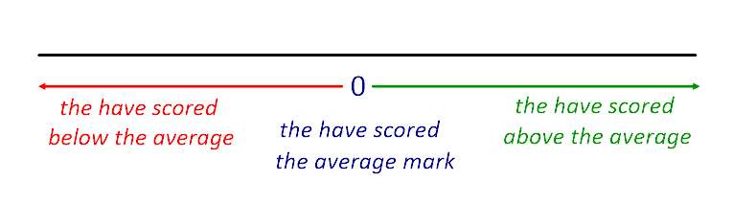
Knowledge Phase
To compare values from different sets of data you usually need to set up standardised scores.
For this you need to know the mean and standard deviation

Standardised Score (z) = $\frac{score - mean}{standard deviation}$

Real World  Application | The standard score (more commonly referred to as a z-score) is a very useful statistic because it (a) allows us to calculate the probability of a score occurring within our normal distribution and (b) enables us to compare two scores that are from different normal distributions.
______ / ______ / ______
 | What are some ‘other summery statistics’ that can be seen in everyday circumstances and how can we analyse them?
 | How do we calculate index numbers and what do they mean?
Key Vocabulary
Vocab | Mathematical Definition
Base Year | the first of a series of years in an economic or financial index
Index | a measure of something.
The Knowledge Phase - RECALL
Percentage multipliers allow us to increase or decrease a number by a given percentage simply by multiplying by the corresponding decimal

It works on the principal that the original amount is 100% = 1

To INCREASE by a percentage we ADD on the percentage
To DECREASE by a percentage we SUBTRACT the percentage

I DO
INCREASE by 2%
DECREASE by 54%

WE DO
INCREASE by 40%
DECREASE by 80%

YOU DO
INCREASE by 72%
DECREASE by 6%

Cross-Curricular  Link | In Maths we learn about percentage increase and decrease using decimal multipliers particularly for us in simple and compound interest problems

The Knowledge Phase
An index number is a number showing the variation in a price or value compared with the price or value at a specified earlier time
The number we compare to is usually known as the ‘base year’ and has an index of 100
The formula for calculating index number is as follows:
$$Index Number= \frac{quatity}{quantity in base year} X 100$$

Price relative is the most commonly used index number
It allows us to compare values from a starting point - we can look at if there has been an increase or decrease compared to the original price
The formula for calculating price relative is as follows:

$$Price Relative= \frac{price}{price in base year} X 100$$

______ / ______ / ______
What are some ‘other summery statistics’ that can be seen in everyday circumstances and how can we analyse them?
How do we calculate chain base index numbers and what do they mean?
Key Vocabulary
Vocab | Mathematical Definition
Annual | occurring once every year

The Knowledge Phase
To find out how the price of an item has changed over a year, you use the previous year as the base year to calculate the index number.

A chain base number gives the relative value of an item using the previous year as the base year (hence creating a ‘chain’) rather than always comparing to one particular year.

A Chain base index tells you the annual percentage change

$$Chain Base Index Number= \frac{quatity}{quantity in previous year} X 100$$

Historical  Origins | No clear consensus has emerged on who created the first price index. The earliest reported research in this area came from Welshman Rice Vaughan, who examined price level change in his 1675 book A Discourse of Coin and Coinage. Vaughan wanted to separate the inflationary impact of the influx of precious metals brought by Spain from the New World from the effect due to currency debasement. Vaughan compared labor statutes from his own time to similar statutes dating back to Edward III.

______ / ______ / ______
What are some ‘other summery statistics’ that can be seen in everyday circumstances and how can we analyse them?
How do we calculate weighted index numbers and what do they mean?
Key Vocabulary
Vocab | Mathematical Definition
Weighted | attribute importance or value to
Relative | considered in relation or in proportion to something else
The Knowledge Phase - RECALL
To calculate a weighted mean you:
- Calculate the mean for each element then,

- Multiply each mean by it's weight and add together

- Divide this total by the total of the weight

$$Weighted Mean= \frac{\sum{(mean x weight)}}{\sum{weights}}$$

The Knowledge Phase
To calculate a weighted index number you:
- Calculate the index number for each element,

- Multiply each index number by it's weight and add together

- Divide this total by the total of the weights

$$Weighted Index Number= \frac{\sum{(index number x weight)}}{\sum{weights}}$$

**SPECIAL CASE** Retail Price Index
The retail price index (RPI) is a weighted mean of the price relatives of goods and services
Weightings are chosen to reflect the spending habits of an 'average' household

$$Weighted Price Relative= \frac{\sum{(price relative x weight)}}{\sum{weights}}$$

Real World  Application | The RPI is still used by the government as a base for various purposes, such as the amounts payable on index-linked securities, including index-linked gilts, and social housing rent increases.

______ / ______ / ______
What are some ‘other summery statistics’ that can be seen in everyday circumstances and how can we analyse them?
How do we calculate population averages and what do they mean?
Key Vocabulary
Vocab | Mathematical Definition
Crude | Lacking in taste, tact or refinement; vulgar; a crude joke in a natural or unrefined state
Rate | assign a standard or value to (something) according to a particular scale
The Knowledge Phase
Population Averages
These are a way of expressing an estimate for important statistics such as births, deaths, marriages etc
They are expressed as a number per thousand of the population
The crude birth rate (CBR) and crude death rate (CBR) are statistical values that can be used to measure the growth or decline of a population.
The crude birth rate is called "crude" because it does not take into account age or sex differences among the population.

Crude birth rates of more than 30 per 1,000 are considered high, and rates of less than 18 per 1,000 are considered low. The global crude birth rate in 2016 was 19 per 1,000.

The crude death rate measures the rate of deaths for every 1,000 people in a given population. Crude death rates of below 10 are considered low, while crude death rates above 20 per 1,000 are considered high.

The formula for population averages is given on the formula page in your exam papers:

$$Crude (birth/death/…) rates= \frac{number of (birth/death/…)}{total populaiton} X 1000$$

The Knowledge Phase
Standardized rates take account of the age distribution of a population
For example, if a town has a high population of elderly residents we would expect there to be a higher crude death rate

To calculate a standardized rate:
- calculate the crude rates for each age group then,
- calculate a weighted mean average using 'standard population'' data as the weights

$$Standardized Rates= \frac{\sum{(crude rate x standard population)}}{\sum{standard populaiton}}$$
The standardized rates then gives us the number of births/deaths/etc per thousand of the population for each age group

standardized
also standardise, "compare to or conform with a standard, regulate by a standard," 1854, a hybrid from standard (adj.) + -ize. Related: Standardized; standardizing. The earlier verb was simply standard (1690s).

______ / ______ / ______
What are some ‘other summery statistics’ that can be seen in everyday circumstances and how can we analyse them?
What are control charts and how do we use them to assess quality control?
Key Vocabulary
Vocab | Mathematical Definition
Warning | a statement or event that warns of something or that serves as a cautionary example
Action | the fact or process of doing something, typically to achieve an aim.
Limit | a point or level beyond which something does not or may not extend or pass
The Knowledge Phase
Statistical process control may be used when a large number of similar items are being produced.
Its purpose is to give a signal when the process mean has moved away from the target value or when item-to-item variability has increased.
The most common method of statistical process control is to take samples at regular intervals and to plot the sample mean on a control chart
A Control Chart is a graph used to study how a process changes over time with data plotted in time order. Means and ranges of samples are plotted on a control chart are plotted and the position on the graph determines the next step in the process

UPPER ACTION LIMIT
UPPER WARNING LIMIT

TARGET VALUE

LOWER WARNING LIMIT

LOWER ACTION LIMIT

Cross-Curricular  Link | In 2024 there were over 20 000 jobs in industry which were related to quality assurance such as Site QC Civil Engineer, Quality Assurance officer and Technical Quality Lead

ACTIONS:
If the sample mean lies between the warning limits |  | no action to be taken

If the sample mean is between a warning and action limit |  | take another sample immediately  If new sample mean outside warning limits  then take action

If the sample mean is outside of the action limits |  | take action immediately

Setting the Limits
The warning and action limits are not drawn at random but calculated using the following formulae:
The warning limits are set at:
μ ± 2σ
95% of the data should lie within the warning limits

The action limits are set at:
μ ± 3σ
99.8% of the data should lie within the warning limits

Key words to learn
Formulas to learn

Copyright List
https://www.statsacademy.co.uk/_files/ugd/d7dae4_009d26f66a8a4f42b98b110571348957.pdf
https://www.statsacademy.co.uk/_files/ugd/d7dae4_a10e291b38c24f7c82bc3251ab468ae4.pdf
https://www.statsacademy.co.uk/_files/ugd/d7dae4_937d2f5eb1734f888d6e555f5a511773.pdf
https://www.statsacademy.co.uk/_files/ugd/d7dae4_a6ece009620548a5aefbfeaf9fbccdfa.pdf
https://www.thoughtco.com/crude-birth-rate-1435459#:~:text=The%20crude%20death%20rate%20measures,per%201%2C000%20are%20considered%20high.
https://en.wikipedia.org/wiki/Price_index
https://www.mathsgenie.co.uk/papers/stats/StandardisedScores.pdf

