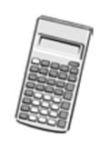
*OPEN BOOK KLT*
YOU CAN USE THE NOTES YOU MADE IN CLASS TO HELP YOU ANSWERT THESE QUESTIONS
WE ARE TESTING WHAT YOU UNDERSTAND NOT WHAT YOU CAN REMEMBER
You must have:
Ruler graduated in centimetres and millimetres, protractor, pen, HB pencil, eraser, scientific calculator.
Total Marks:
Statistics

Probability Distributions
Paper reference
Time: 50 mins Autumn (2) KLT(9)
Surname Other Names
Write your name here

Centre Number Candidate Number
Windsor High School and Sixth Form
Level1/Level2 GCSE (9-1)

Instructions
• Use black ink or ball-point pen.
• Fill in the boxes at the top of this page with your name, centre number and candidate number
• Answer all questions
• Answer the questions in the spaces provided
- there may be more space than you need.
• Scientific calculators may be used.
• You must show all your working out with your answer clearly identified at the end of your solution.

Information
• The total mark for this paper is 32
• The marks for each question are shown in brackets
- use this as a guide as to how much time to spend on each question.

Advice
• Read each question carefully before you start to answer it.
• Try to answer every question.
• Check your answers if you have time at the end.

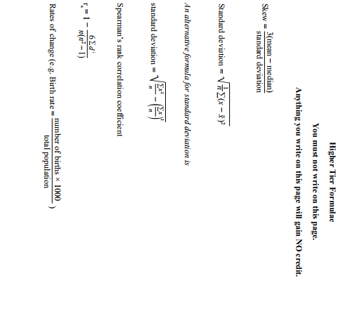
1.
The list below gives three probability distributions which could be used to model real life data.
A Discrete uniform distribution
B Binomial distribution
C Normal distribution
From this list, choose the best distribution which could be used to model each of the variables below. You must give a reason for each answer.
(i) The time taken to travel the same journey to work each day.
Distribution..................................................................................................
Reason ....................................................................................................................................................
..................................................................................................................................................................
..................................................................................................................................................................
..................................................................................................................................................................
............................................................................................................................................................. (2)
(ii) The next digit selected from a random number table.
Distribution..................................................................................................
Reason ....................................................................................................................................................
..................................................................................................................................................................
..................................................................................................................................................................
..................................................................................................................................................................
............................................................................................................................................................. (2)

2.
Sketch A shows the distribution of colours of sweets in a box.
Sketch B shows the distribution of weights of edible crabs caught by a fishing boat
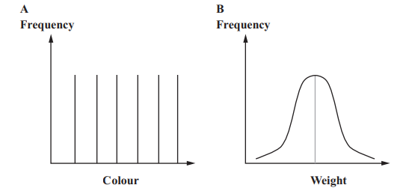

Write down the name of the distribution that will model the data in each case.

Sketch A ............................................................................................................

Sketch B ............................................................................................................ (2)

3.
Some students did two mathematics tests.
The students’ marks for the tests are normally distributed.
The diagram shows the distribution of marks for Test 1 and Test 2.
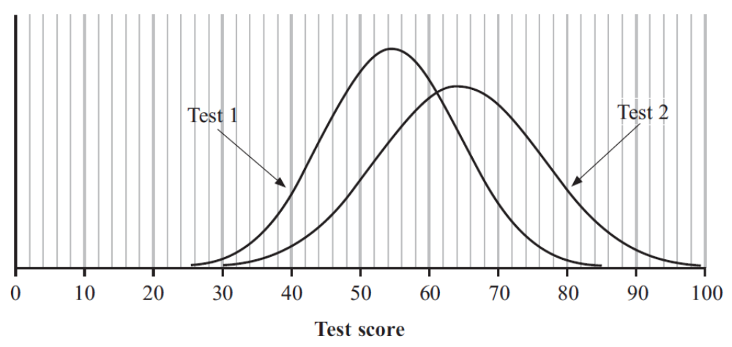
Estimate the mean and standard deviation of the marks for Test 1.

Mean ..........................................

Standard deviation ......................................... (3)
4.
The probability of a person having an allergy to a particular nut is 0.1
A test is available to see if a person has this allergy.
In 80% of the cases where the person has this allergy the test gives a positive result.
If the patient does not have this allergy there is a 0.05 probability of getting a positive result.
- Complete the tree diagram for the two events (2)
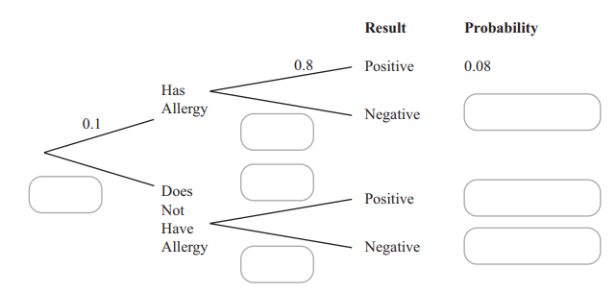

- Given that Mular receives a positive result, work out the probability that Mular has this allergy.
...................................... (2)

- Five people are selected at random.
X is the number of these people who have the allergy.
  - What is the name of the probability distribution that is a suitable model for X? .................................................................................................................................. (1)

  - Write down the properties needed, in this context, for this distribution to be a suitable model for X

........................................................................................................................................

........................................................................................................................................

........................................................................................................................................

................................................................................................................................... (2)
  - Work out the probability that out of these five people there will be exactly 3 people who have the allergy.

.............................................................. (3)
5.
Comfi Cabs always has five taxis working at the same time.

Each working taxi is either available or not available.
At any time, the probability that a taxi is not available is 0.4.

(a) Write down the probability that a particular taxi is available. ....................................... (1)

(b) Find the probability that all five taxis are not available at the same time.

....................................... (2)
(c) Find the probability that exactly two of the five taxis are available at the same time.

......................................... (2)
The Smith family need two taxis at the same time to take them all to the airport.

(d) Find the probability that Comfi Cabs cannot take all the Smith family at the same time.

......................................... (3)
6.
A variable, X, has a normal distribution with mean 60.
95% of the values of X lie between 45 and 75.
(a) Sketch a diagram to show this distribution.

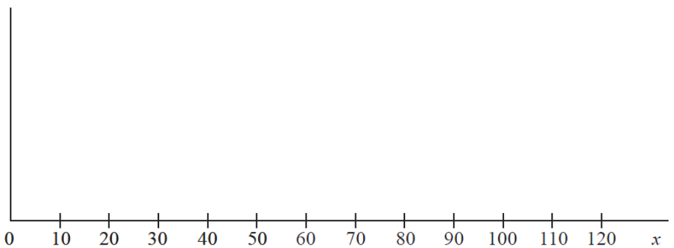

(3)
Ross wants to find out how long it takes boys and girls in different year groups
to complete jigsaw puzzles.
He collects the following information for each child.

Gender
Year group
Number of pieces in the jigsaw puzzle
Time taken to complete the puzzle
Favourite subject

(b) Which of these variables is most likely to be modelled by a normal distribution?
Give a reason for your answer.

......................................................................................................................................................

......................................................................................................................................................

......................................................................................................................................................
(2)

