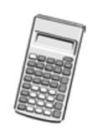
*OPEN BOOK KLT*
YOU CAN USE THE NOTES YOU MADE IN CLASS TO HELP YOU ANSWERT THESE QUESTIONS
WE ARE TESTING WHAT YOU UNDERSTAND NOT WHAT YOU CAN REMEMBER
You must have:
Ruler graduated in centimetres and millimetres, protractor, pen, HB pencil, eraser, scientific calculator.
Total Marks:
Statistics

Probability
Paper reference
Time: 50 mins Autumn (1) KLT(7)
Surname Other Names
Write your name here

Centre Number Candidate Number
Windsor High School and Sixth Form
Level1/Level2 GCSE (9-1)

Instructions
• Use black ink or ball-point pen.
• Fill in the boxes at the top of this page with your name, centre number and candidate number
• Answer all questions
• Answer the questions in the spaces provided
- there may be more space than you need.
• Scientific calculators may be used.
• You must show all your working out with your answer clearly identified at the end of your solution.

Information
• The total mark for this paper is 55
• The marks for each question are shown in brackets
- use this as a guide as to how much time to spend on each question.

Advice
• Read each question carefully before you start to answer it.
• Try to answer every question.
• Check your answers if you have time at the end.

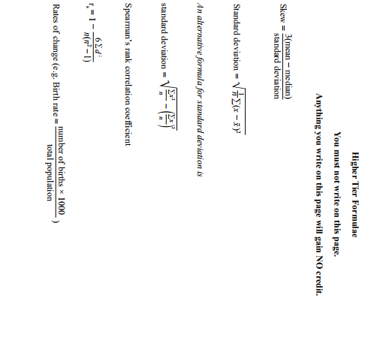
1.
Here is a list of probability words

Impossible Unlikely Evens Likely Certain

Write down the word from the list above that best matches the chance of each event
(4)

A 5 is rolled on a fair, ordinary, six-sided dice .....................................................

A fair coin lands heads up when it is flipped ………………………………………………….

It will rain in London sometime in 2020 ………………………………………………….

A student will get 200 marks on this KLT ………………………………………………….

A person will live to be at least 20 years old ………………………………………………….
2.
200 people have been chosen as winners of a competition
Each winner is given one of four types of prize
The table shows the probability of winning each type of prize

Type of Prize | Probability
Car | 0.03
Holiday | 0.12
£1000 | 0.25
Television | 0.6

Ernie is one of the 200 winners
- Which of the four prizes is he least likely to win?

……………………………………………………………………………………………………………………………… (1)

- Write down the probability that he wins a washing machine

……………………………………………………………………………………………………………………………… (1)

- Work out the probability that he wins a holiday or £1000

……………………………………………………………………………………………………………………………… (2)

There are 200 prizes
- How many of the prizes are cars?

……………………………………………………………………………………………………………………………… (2)

3.
Kendra and Liam are in a high jump competition
They each have one chance to jump a height of 170cm
The probability that Kendra can jump the height is 0.75
The probability that Liam can jump the height is 0.8
- Complete the tree diagram.
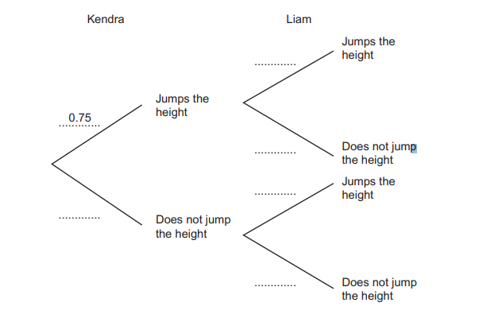
Assume that the jumps of Kendra and Liam are independent (2)

- Work out that probability that both Kendra and Liam jump the height (2)

……………………………………………………………………………………………………………………………………

……………………………………………………………………………………………………………………………………

……………………………………………………………………………………………………………………………………
- Work out the probability that at least one of them jumps the height (3)

……………………………………………………………………………………………………………………………………

……………………………………………………………………………………………………………………………………

……………………………………………………………………………………………………………………………………
4.
100 planes landed at Heathrow airport in a 3 hour period
40 of the planes were from Europe
20 of the planes were late, including 5 planes form Europe

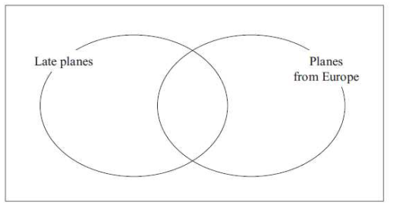
- Complete the Venn diagram using the information above (3)

One of the planes is chosen at random
- Find the probability that
  - The planes was not from Europe

……………………………….. (1)

  - The plane was on time and was from Europe

…………………..…………… (2)

- Given that the plane was late
Find the probability that the plane was from Europe

…………………………….... (2)

5.
A bag contains 7 green balls and 3 red balls
A ball is selected at random and the colour of the ball is recorded
The ball is put back into the bag
A second ball is selected at random and the colour of the ball is recorded

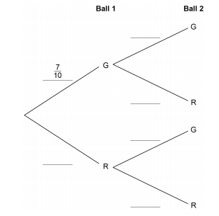
- Complete the tree diagram to represent the information (2)

- Work out the probability of selecting two red balls (2)
……………………………………………………………………………………………………………………………

……………………………………………………………………………………………………………………………

……………………………………………………………………………………………………………………………

- Work out the probability of selecting one ball of each colour (3)

……………………………………………………………………………………………………………………………

……………………………………………………………………………………………………………………………

……………………………………………………………………………………………………………………………
6.
The two-way table shows information about the membership of a tennis club
Type of member | male | female | Total
Adult | 43 | 31
Teenager | 12 | 10 | 22
Junior | 10 |  | 24
Total |  | 55 | 120

- Complete the table (1)

One of the club members I chosen at random

  - Write down the most likely type of member to be chosen

………………………………… (1)

  - Find the probability that the member chosen in a Junior

…………………………………. (1)

A Teenage member is chosen at random to be on the club committee

- Find the probability that this member is a female (2)

……………………………………………………………………………………………………………………………

……………………………………………………………………………………………………………………………

……………………………………………………………………………………………………………………………

7.
A farmer supplies both free-range eggs and barn eggs.
45% of the eggs are free-range. The rest are barn eggs
An egg cannot be sold when it does not meet a particular standard
5% of the free-range eggs cannot be sold
8% of the barn eggs cannot be sold
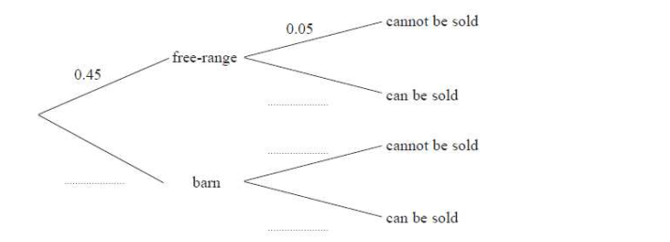
- Complete the probability tree diagram to show this information (2)

One egg is selected at random
- Find the probability that it cannot be sold

………………………………… (3)
One of the eggs that cannot be sold is selected at random
- Find the probability that it is a free-range egg

………………………………… (2)
8.
A department store surveys 120 people who visit their store
- 9 buy clothing, food and home-are
- 5 buy food and home-ware but not clothing
- 13 buy clothing and home-ware but not food
- 89 buy clothing, 55 buy food and 31 buy home-wares
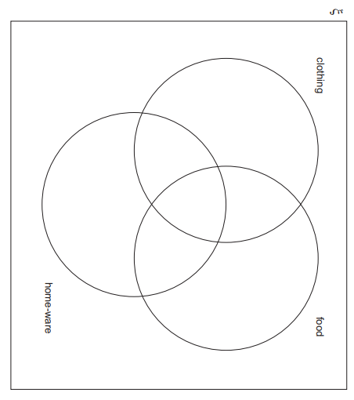
- 40 buy clothing and food

- Use the data to help you complete the Venn diagram (4)

- How many people did not buy clothing or food or home-ware?

………….………………………. (1)

- One of these 120 people is chosen at random
Find the probability that the person bought
  - food and home-ware

………………………………… (2)

  - clothing or home-ware

…………………………………. (2)

  - home-ware given that they bought clothing

…………………………………. (2)

