
*OPEN BOOK KLT*
YOU CAN USE THE NOTES YOU MADE IN CLASS TO HELP YOU ANSWERT THESE QUESTIONS
WE ARE TESTING WHAT YOU UNDERSTAND NOT WHAT YOU CAN REMEMBER
You must have:
Ruler graduated in centimetres and millimetres, protractor, pen, HB pencil, eraser, scientific calculator.
Total Marks:
Statistics

Other Summary Statistics
Paper reference
Time: 50 mins Spring (1) KLT(10)
Surname Other Names
Write your name here

Centre Number Candidate Number
Windsor High School and Sixth Form
Level1/Level2 GCSE (9-1)

Instructions
• Use black ink or ball-point pen.
• Fill in the boxes at the top of this page with your name, centre number and candidate number
• Answer all questions
• Answer the questions in the spaces provided
- there may be more space than you need.
• Scientific calculators may be used.
• You must show all your working out with your answer clearly identified at the end of your solution.

Information
• The total mark for this paper is 35
• The marks for each question are shown in brackets
- use this as a guide as to how much time to spend on each question.

Advice
• Read each question carefully before you start to answer it.
• Try to answer every question.
• Check your answers if you have time at the end.

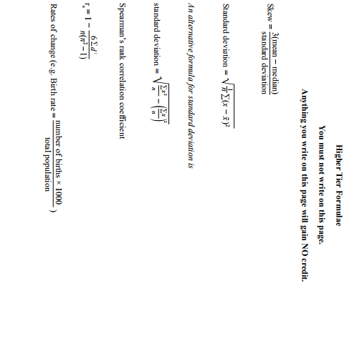
1.
In 2010, a factory had the following monthly running costs.
Category Staff wages Premises Raw material
Monthly running cost (£) 52 000 8000 20 000
(a) Show why appropriate weightings for the running cost categories are:
Category Staff wages Premises Raw material
Weighting 65 10 25

(2 marks)
Using 2010 as the base year, the index numbers for the running cost categories in 2015 were
Category Staff wages Premises Raw material
Index number 107.2 114.6 112.0
(b) Find the monthly cost of staff wages in 2015

£....................................................... (2 marks)
The factory manager says that the total monthly running costs have risen by less than 10% since 2010
(c) By finding the weighted index number for the total running costs of the factory in 2015, show that she is correct.

(3 marks)
2.
Pablo takes a reading test, a writing test and a speaking test.
Each test has the same total score.
The table shows Pablo’s score in each test.
Test Score
Reading 55
Writing 41
Speaking 57

- Calculate Pablo’s mean test score.
....................................................... (1 mark)
Each test score is now given a weighting.
Test Score Weighting
Reading 55 30
Writing 41 45
Speaking 57 25

(b) (i) Describe in words why Pablo’s weighted mean test score will be less than his mean test score. ..................................................................................................................................................................
..................................................................................................................................................................
..................................................................................................................................................................
..................................................................................................................................................................
(ii) Calculate Pablo’s weighted mean test score.
....................................................... (3 marks)
3.
The table shows the chain base index numbers for the price of an annual season rail ticket from Gloucester to Birmingham for each of the years 2011 to 2015

Year 2010 2011 2012 2013 2014 2015
Chain base index number 109 106 104 103 102
Source: Transport Focus

(a) Describe what the chain base index numbers show about the price of an annual season rail ticket for the years 2010 to 2015

..................................................................................................................................................................

..................................................................................................................................................................

..................................................................................................................................................................

..................................................................................................................................................................

..................................................................................................................................................................

..................................................................................................................................................................

.................................................................................................................................................. (2 marks)

The cost of an annual season rail ticket in 2010 was £3032

(b) Work out the cost of the ticket in 2011

....................................................... (2 marks)

(c) Show that the cost of an annual season rail ticket has increased by more than 25% over the period from 2010 to 2015

(2 marks)
4.
The table shows the simple index numbers for mean annual earnings in manufacturing
for the years 2004 to 2006.

The base year is 2000.

Year | 2004 | 2005 | 2006
Index number | 112 | 116 | 123

Data Source: Adapted from www.fsmq.org

(a) Describe the mean annual earnings in 2004 compared with the mean annual earnings
in 2000.
................................................................................................................................................................

.................................................................................................................................................................

.................................................................................................................................................................

.................................................................................................................................................................

.................................................................................................................................................. (2 marks)

The mean annual earnings in manufacturing in the year 2000 was £14 000.

(b) Work out the mean annual earnings in 2006.

£.......................................... (2 marks)

5.
Kirstin took tests in Maths, in Physics and in French. The table shows information about the marks of all students who took the tests.
Maths Physics French
Mean 53 69 48
Standard deviation 8 10 6

Kirstin scored 63 marks in Maths.
- Show that Kirstin’s standardised score in Maths is 1.25

(1 mark)

Kirstin scored 78 marks in Physics.

(b) Work out whether Kirstin did better in Maths or in Physics. You must explain your answer.

..................................................................................................................................................................

..................................................................................................................................................................

..................................................................................................................................................................

..................................................................................................................................................................

………………………………………………………..……................................................................................. (3 marks)

Kirstin’s standardised score in French was –0.5

(c)Work out Kirstin’s mark in French.

............................................................. (2 marks)
6.
A production line is set up to produce chocolate bars with a target weight of 104 g.
For quality control, random samples are taken to check that the production line is
working correctly.

The chocolate bars in each sample should have a mean weight of 104 g and a standard
deviation of 2 g.

The sample mean weights have a normal distribution.

A quality control chart is used to plot the sample mean weights.

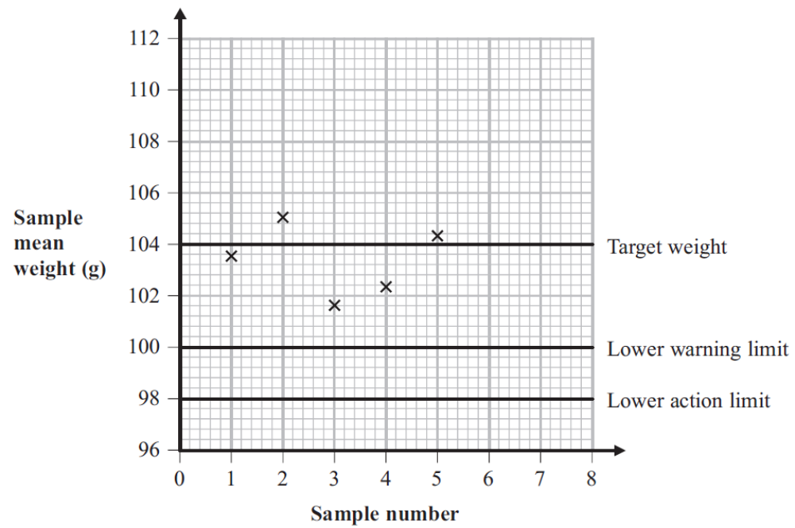

The lower warning limit and the lower action limit have been drawn on the chart.

(a) Complete the control chart by adding the upper warning limit and the upper action
limit.
Label your lines.
(2 marks)
(b) When the chocolate production is working correctly, write down the percentage
of samples expected to have a mean weight outside the warning limits.

.......................... %
(1 marks)
Five sample means have been plotted on the control chart.

The next sample has a mean weight of 97.8 g.

(c) (i) Plot this sample mean on the control chart.

(ii) Describe the action that now needs to be taken.

......................................................................................................................................................

......................................................................................................................................................

......................................................................................................................................................
(2 marks)
(c) Explain how warning limits on a control chart are used.

......................................................................................................................................................

......................................................................................................................................................

......................................................................................................................................................

......................................................................................................................................................

......................................................................................................................................................

......................................................................................................................................................

......................................................................................................................................................

......................................................................................................................................................

......................................................................................................................................................

......................................................................................................................................................

......................................................................................................................................................

......................................................................................................................................................
(3 marks)

