
Questions with a * are topics that we have not yet covered in Statistics but you will have covered in Maths previously
*OPEN BOOK KLT*
YOU CAN USE THE NOTES YOU MADE IN CLASS TO HELP YOU ANSWERT THESE QUESTIONS
WE ARE TESTING WHAT YOU UNDERSTAND NOT WHAT YOU CAN REMEMBER
You must have:
Ruler graduated in centimetres and millimetres, protractor, pen, HB pencil, eraser, scientific calculator.
Total Marks:
Statistics

Processing, Representing and Analysing Data
Paper reference
Time: 50 mins Spring (1) KLT (3)
Surname Other Names
Write your name here

Centre Number Candidate Number
Windsor High School and Sixth Form
Level1/Level2 GCSE (9-1)

Instructions
• Use black ink or ball-point pen.
• Fill in the boxes at the top of this page with your name, centre number and candidate number
• Answer all questions
• Answer the questions in the spaces provided
- there may be more space than you need.
• Scientific calculators may be used.
• You must show all your working out with your answer clearly identified at the end of your solution.

Information
• The total mark for this paper is 46
• The marks for each question are shown in brackets
- use this as a guide as to how much time to spend on each question.

Advice
• Read each question carefully before you start to answer it.
• Try to answer every question.
• Check your answers if you have time at the end.

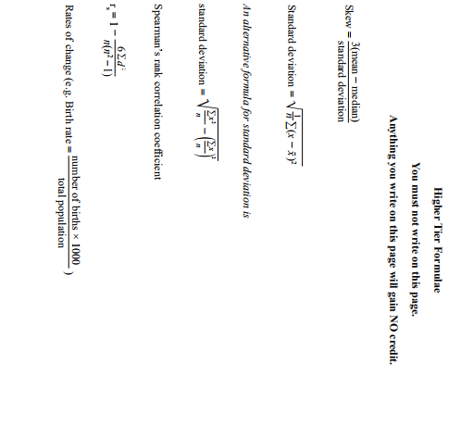
1.
The table gives some information about house prices in a small town.

House Price  (£p thousands) | Number of houses
100 ≤ p < 200 | 1
200 ≤ p < 300 | 9
300 ≤ p < 350 | 10
350 ≤ p < 400 | 8
400 ≤ p < 500 | 2
500 ≤ p < 700 | 3

Some of these data are represented on this histogram
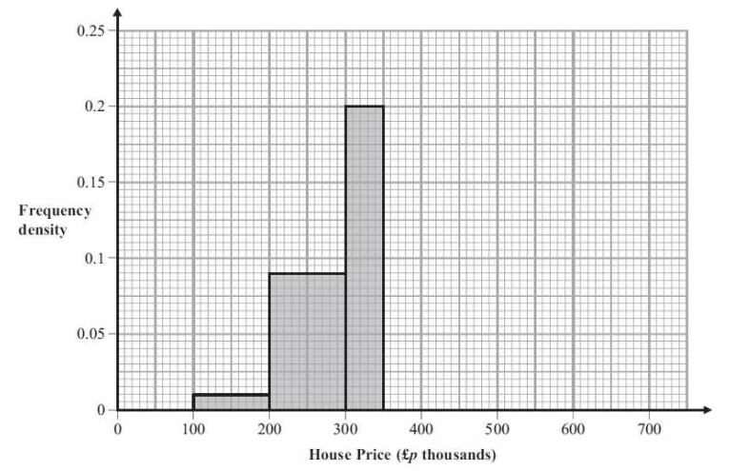

- Use the table to complete the histogram (3 marks)
Jason thinks the median of these prices is £350 000
Jason is wrong
- Explain why (2 marks)

_____________________________________________________________________

_____________________________________________________________________

_____________________________________________________________________

_____________________________________________________________________

_____________________________________________________________________

_____________________________________________________________________

The mean price of these houses is £340 000
- Find an estimate for the number of houses with a price less than the mean price (2 marks)

2.
The multiple bar chart shows some information about the nutritional content of a standard chicken curry and a light chicken curry.
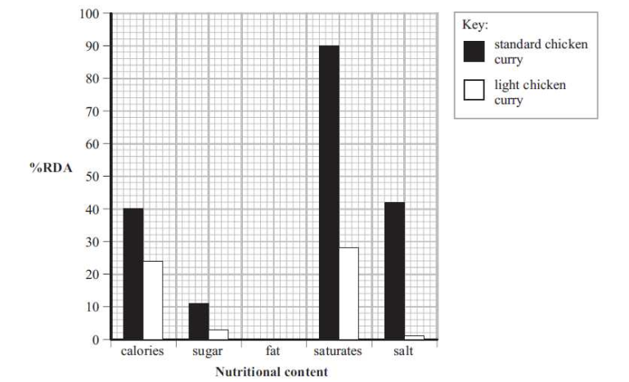
The information given as %RDA (percentage of ‘recommended daily allowance’)

The missing information for fat is
 | %RDA
Standard chicken curry | 54
Light chicken curry | 12

- Complete the multiple bar chart (2 marks)

- Write down the %RDA for salt in the standard chicken curry
____________ (1 mark)
- Write down the nutritional content with the lowest %RDA
for a standard chicken curry ____________ (1 mark)

- Compare the %RDA for saturates in the two chicken curries (2 marks)

_____________________________________________________________________

_____________________________________________________________________
3.
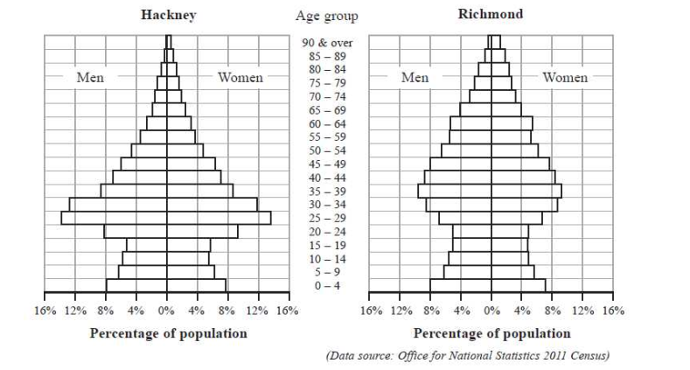
The two population pyramids show the percentages of men and women in each group in Hackney and in Richmond in 2011

- Write down the age group that has the greatest percentages of both men and women for:
  - Hackney ___________
  - Richmond ___________ (2 marks)

In Richmond, 4% of men and 4% of women are in the same age group
- Write down this age group ____________ (1 mark)

- Compare the percentage of people aged 60 and over in Hackney with the percentage of people aged 60 and over in Richmond. (1 mark)

_____________________________________________________________________

_____________________________________________________________________

_____________________________________________________________________
4.
Archaeologists divided a field into 36 squares of equal size.
The number of Roman roof tiles found in each of the squares is shown below
Number of Roman Roof Tiles
KEY:
3 means 3 roof tiles in found in that square
 | A | B | C | D | E | F
1 | 3 | 9 | 4 | 18 | 16 | 24
2 | 5 | 3 | 11 | 14 | 20 | 12
3 | 1 | 0 | 8 | 16 | 18 | 4
4 | 2 | 2 | 5 | 10 | 5 | 3
5 | 1 | 4 | 6 | 4 | 3 | 2
6 | 2 | 3 | 4 | 1 | 2 | 2

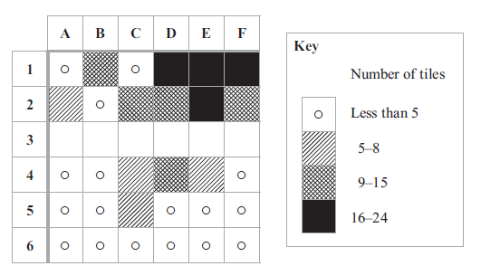
- Use the information above to complete the choropleth map (2 marks)

- Use the choropleth map to describe the area in which they found the greatest number of roof tiles. Give a reason for your answer (2 marks)

_____________________________________________________________________

_____________________________________________________________________

_____________________________________________________________________

_____________________________________________________________________
5.
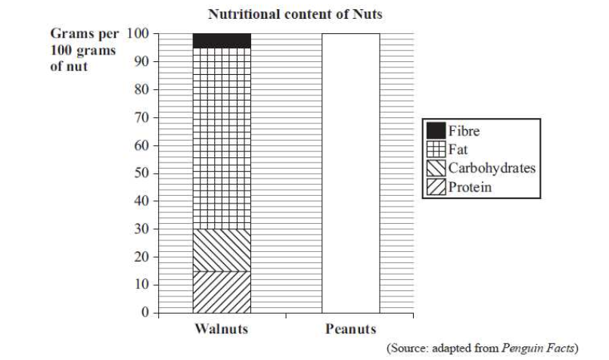
The composite bar chart shows the nutritional content of walnuts

The nutritional content of peanuts is shown in the table
 | Grams per 100 grams of peanut
Protein | 24
Carbohydrates | 20
Fat | 48
Fibre | 8
- Complete the composite bar chart for peanuts (2 marks)

- Write down the number of grams of fat in 100g of walnuts
____________ (1 mark)
Michael says that a peanut has more protein than a walnut
- Explain why Michael may not be right (1 mark)
_____________________________________________________________________

_____________________________________________________________________

_____________________________________________________________________

6.
The comparative pie charts give information about the number of women who got married in 1991 and in 2005 and the age at which they married
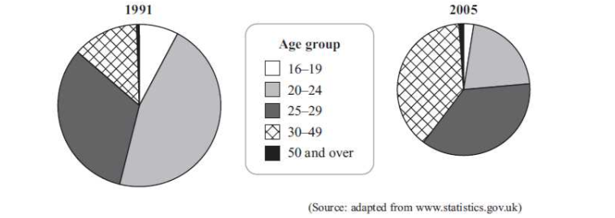

- What has happened to the total number of women who married in 2005 compared the total number in 1991? (2 marks)

_____________________________________________________________________

_____________________________________________________________________

_____________________________________________________________________

- Write down the age group with the greatest decrease from 1991 to 2005
____________ (1 mark)

- For the 30-49 age group, describe how the number of women who married changed in 2005 compared to 1991
Give a reason for your answer (2 marks)
_____________________________________________________________________

_____________________________________________________________________

_____________________________________________________________________

_____________________________________________________________________
7.
There are 16 children at a party
Here are their weights in kg
14.8 18.5 15.1 15.4 15.8 17.3 16.4 16.7 16.7 14.9 17.0 17.1
16.3 16.9 17.5 16.5
- Complete the ordered stem and lead diagram for the weights (2 marks)

14 Key
15 16 l 3 = 16.3
16
17
18

- Find the median weight * ___________ (1 mark)

- Work out the mean weight * ___________ (2 marks)

Another child arrives at the party
This child weighs 16.6kg
- Use words to describe the effect this will have on
  - The median *
_______________________________________________________________

_______________________________________________________________

  - The mean * (2 marks)
_______________________________________________________________

_______________________________________________________________
One child is picked at random from the children now at the party
- Work out the probability that this child weighs less than 16kg *

_____________ (2 marks)

8.
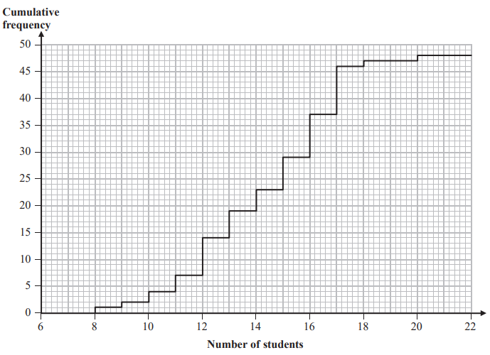
The cumulative frequency step polygon shows information about the numbers of students in the 48 teaching sets in Year 12 at Pearson Academy.

- For the numbers of students in the teaching sets, find
  - the median _______________
  - the interquartile range _______________
  - the mode _______________ (4 marks)

- Write down the number of students in the largest teaching set.
_______________ (1 mark)

- Find the number of teaching sets which have more than 16 students.
_______________ (2 marks)
9.
The table shows some information about the total money spent in British supermarkets in the 12 weeks up to 22 February for 2009 and for 2010
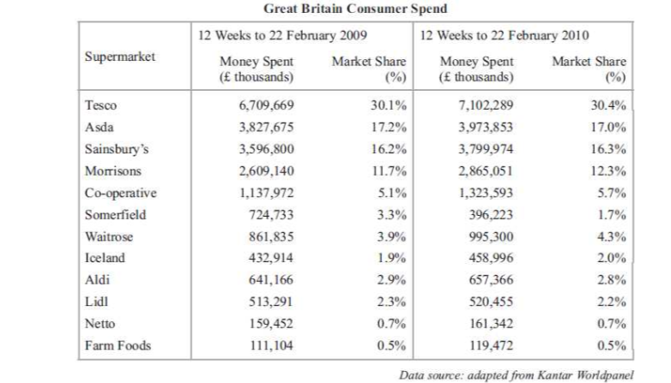
It also shows the market share for each supermarket

More money was spent in one of these supermarkets in 2009 than in 2010 for these 12 weeks.
- Write down the name of this supermarket
………………………………………………. (1 mark)

More money was spent in Netto in 2010 than in 2009 for these 12 weeks
- Work out how much more money
………………………………………………. (1 mark)

- Work out the total Market Share (%) for the first four supermarkets in the table for the 12 weeks in each year

2009 ……………………………………….
2010 ………………………………………. (3 marks)

- Comment on your answers in part (c)
…………………………………………………………………………………………………………………………………………………………………………………………………………………………………………………………………………………………………………………………………………………………………………………………………………………………………………………….……………………………………………………………………………………………………………………………(1 mark)
10.
A national newspaper printed this bar chart
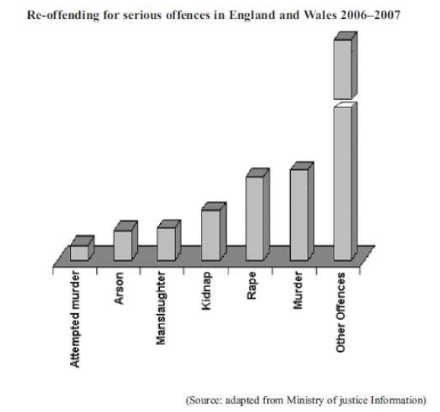

Write down three ways in which this bar chart is misleading

1: ………………………………………………………………………………………………………………………………………………………

………………………………………………………………………………………………………………………………………………………….

2: ………………………………………………………………………………………………………………………………………………………

………………………………………………………………………………………………………………………………………………………….

3: ………………………………………………………………………………………………………………………………………………………

………………………………………………………………………………………………………………………………………………………….
(3 marks)

