
Questions with a * are topics that we have not yet covered in Statistics but you will have covered in Maths previously
*OPEN BOOK KLT*
YOU CAN USE THE NOTES YOU MADE IN CLASS TO HELP YOU ANSWERT THESE QUESTIONS
WE ARE TESTING WHAT YOU UNDERSTAND NOT WHAT YOU CAN REMEMBER
You must have:
Ruler graduated in centimetres and millimetres, protractor, pen, HB pencil, eraser, scientific calculator.
Total Marks:
Statistics

Processing, Representing and Analysing Data
Paper reference
Time: 50 mins Spring (1) KLT (3)
Surname Other Names
Write your name here

Centre Number Candidate Number
Windsor High School and Sixth Form
Level1/Level2 GCSE (9-1)

Instructions
• Use black ink or ball-point pen.
• Fill in the boxes at the top of this page with your name, centre number and candidate number
• Answer all questions
• Answer the questions in the spaces provided
- there may be more space than you need.
• Scientific calculators may be used.
• You must show all your working out with your answer clearly identified at the end of your solution.

Information
• The total mark for this paper is 46
• The marks for each question are shown in brackets
- use this as a guide as to how much time to spend on each question.

Advice
• Read each question carefully before you start to answer it.
• Try to answer every question.
• Check your answers if you have time at the end.

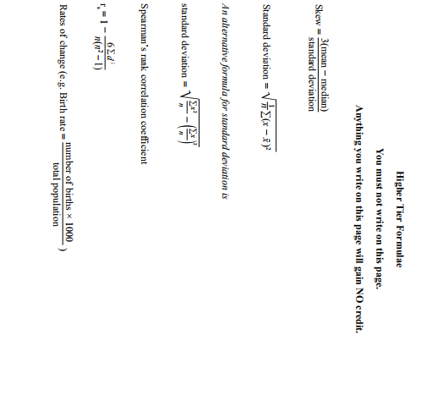

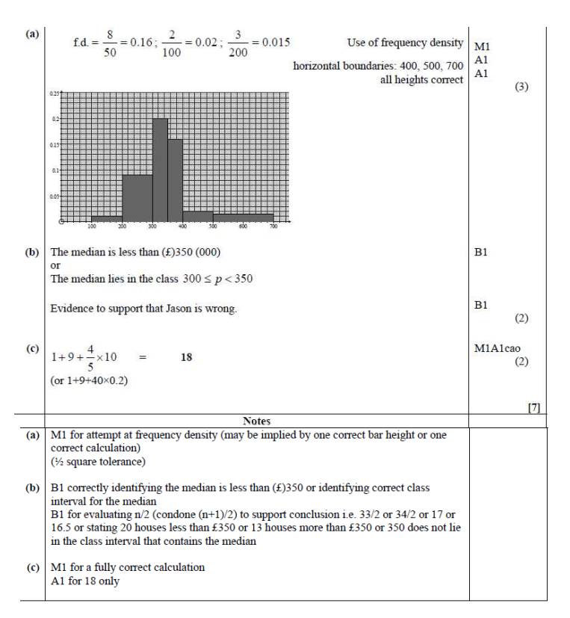
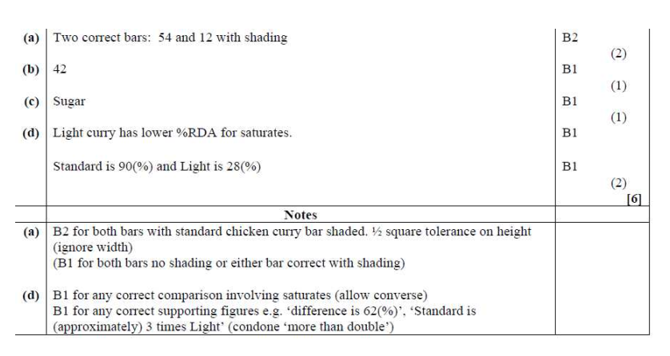
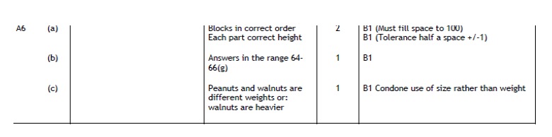
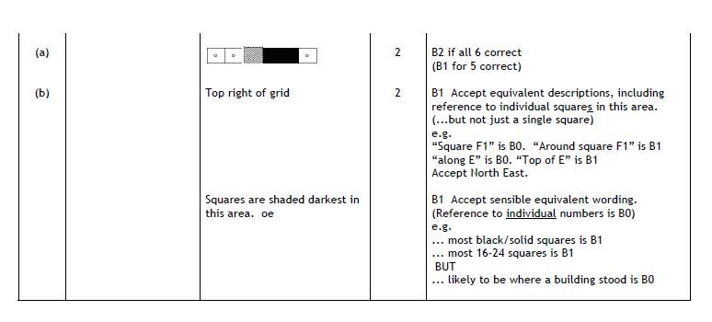
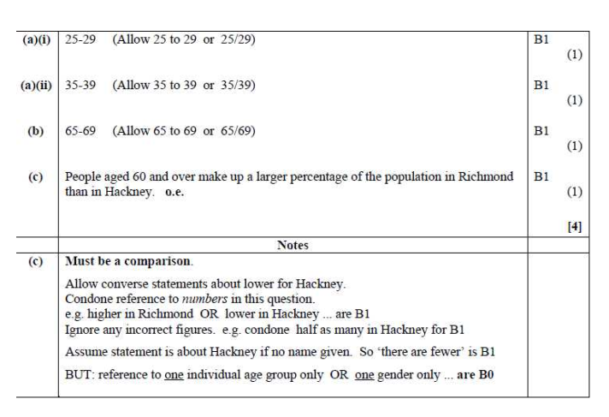
A1
A2
A5
A4
A3
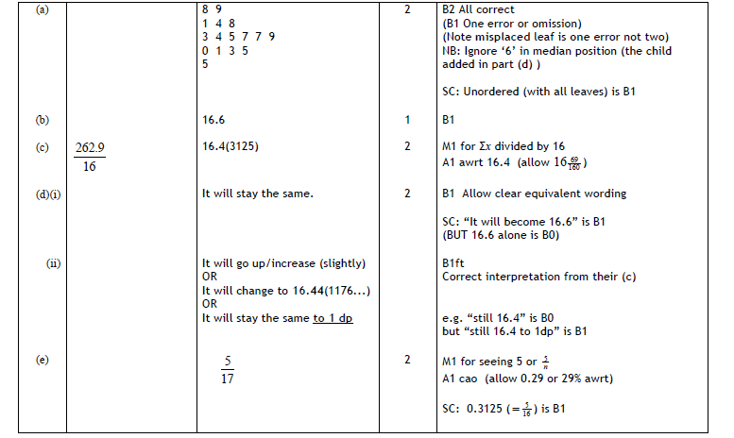
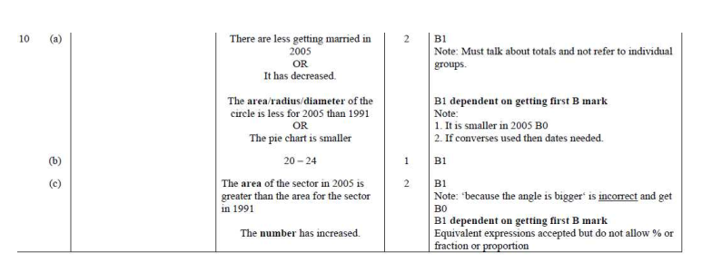
A7
A6
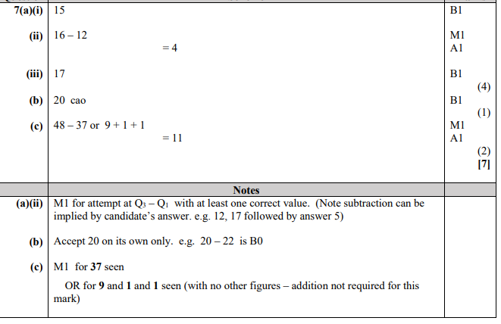
A8
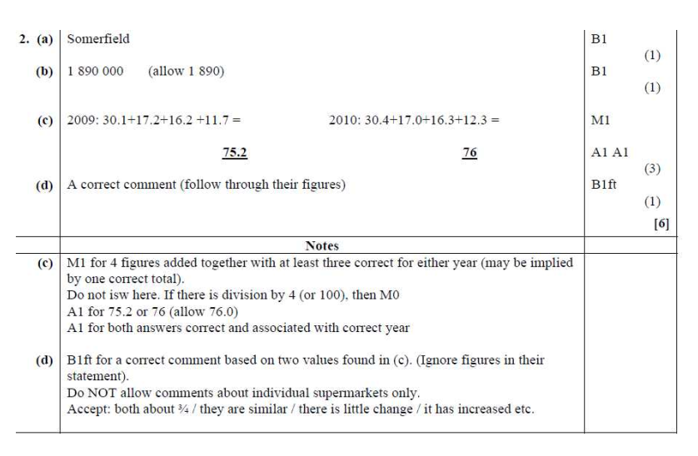
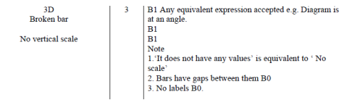
A10
A9

