
Mathematics and Statistics Department

Knowledge Book
GCSE Statistics
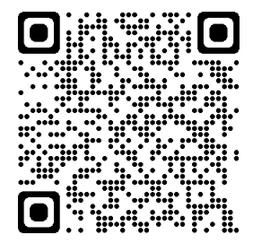
Term 10.3
Statistical Representation and Interpretation
Scan here for revision materials
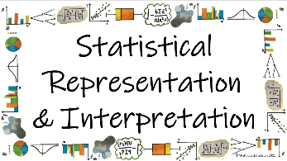
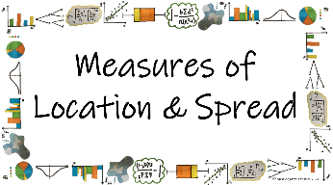
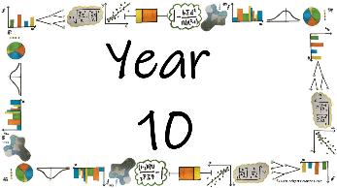
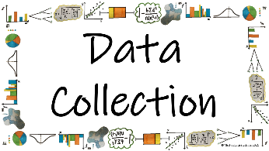

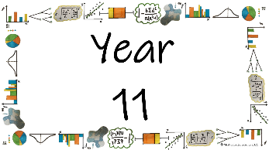
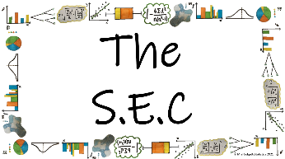
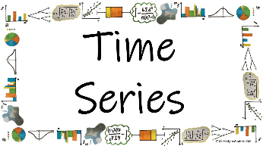
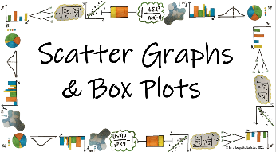

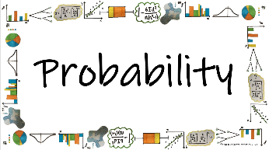
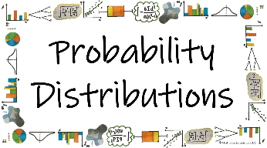
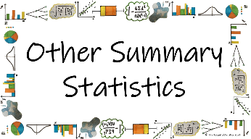


Name: ______________________
Teacher: ______________________
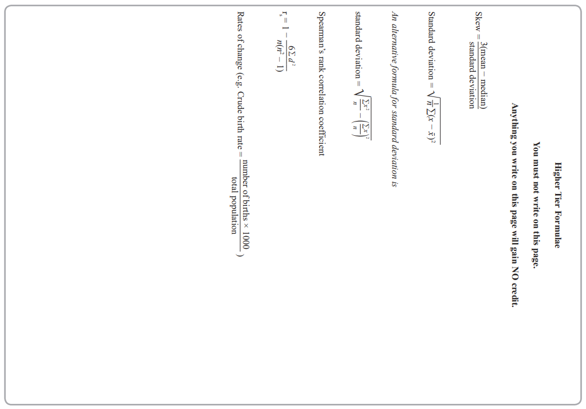
Contents Page
 | What are the different statistical diagrams we can use to represent data and how do we interpret them?
 |  | Page
*How do we present data in a Tally Chart? |  | 6
*How do we read from and present data in a Pictogram? |  | 11
*How do we read from and present data on bar charts for different types of data? |  | 19
*How do we read data from and complete a multiple or dual bar chart? |  | 36
*How do we read data from and complete a composite bar chart? |  | 44
How do we read data from a population pyramid? |  | 54
*How do we read data from and complete a stem and leaf diagram? |  | 59
*How do we read data from and complete a pie chart? |  | 67
How do we use comparative pie charts to represent different size populations? |  | 75
*How do we plot a frequency polygon and use them to compare data sets? |  | 81
*How do we read data from and complete a histogram? |  | 85
*How do we read data from and complete a cumulative frequency polygon? |  | 94
How do we read data from and complete a cumulative frequency step polygon? |  | 103
How do we read data from and complete a choropleth map? |  | 107
*How do we read from and complete Two Way Tables? |  | 114
*How can graphs be presented to mislead us in out interpretations? |  | 118

  Cross-Curricular  Link | All small questions marked with a * are topics that you will be coving in GCSE Maths as well as GCSE Statistics
Vocabulary Pyramid

Key
Dual
Tally
Composite
Discrete Multiple
Continuous Angle
Cumulative Misleading
Two-Way Table Pictogram
Choropleth Proportion Skew
Population Pyramid Stem-and-Leaf
Pie Chart Comparative Polygon
Histogram Frequency Density
Distribution Class Width

Tier 3 Words
Words specific to the subject ‘Statistics’
These may have different meanings in other subjects

Tier 2 Words
Show Data Identify Describe Discuss
Variables Determine Parameter Statistic Construct
Evaluate Respectively Given Explain Conduct Depict
Suggest Assess Validity Research Investigate Decide
Calculate Practical Suitable Collect Complete Frequency

Words that are often seen written in text and exam questions but are not often spoken

Tier 1 Words
Words that are used often in speech and have the same meaning in most contexts
Which Who What Where When Why How
Age Time Weight Mass Length Breadth Width Height
Chart Graph Diagram Advantages Disadvantages



In this Knowledge Book you will see some of the following symbols with interesting facts and information about the words and terminology which will not be assessed but will deepen your understanding of the words.
 | This gives us the origin of a word and the historical development of its meaning.
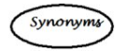 | This gives us a word or phrase that means exactly or nearly the same as another word or phrase in the same language.
  Historical  Origins | Historical Origins. This gives us the historical origin of the word.
  Did you know? | Do you Know? This gives us a fascinating fact about the word or skill,
Cross-Curricular  Link | Cross Curricular Link. This gives us links to where we might use this word or skill in other subjects
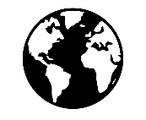  Real World  Application | Real World Application. This gives us an idea of when or how we might use this in the real world.
  Revision Ideas | Revision ideas. This gives us some revision techniques to use for each topic.  Remember to use the revision websites:  - MrsHodgettsStatistics.com  - StatsAcademy.co.uk  - MathsGenie.co.uk  And the Revision techniques websites:  - GetRevising.co.uk
______ / ______ / ______
Tally Charts
 | What are the different statistical diagrams we can use to represent data and how do we interpret them?
 | How do we present data in a Tally Chart?
Key Vocabulary
Vocab | Mathematical Definition
Tally Chart | A statistical diagram which represents frequencies as ‘tallies’ in groups of 5 or less
Frequency | How ‘frequent’ something is. The mathematical word for the total

Tally: comes from the Latin ‘tallia’ meaning stick

Historical  Origins | The oldest tally sticks date to between 35,000 and 25,000 years ago, in the form of notched bones found in the context of the European Aurignacian to Gravettian and in Africa's Late Stone Age.

The Knowledge Phase
A tally chart is a statistical diagram which uses ‘tallies’ in groups of 5 or less
A ‘tally’ is a mark or line (l). when you get to the 5th line you mark it across ( l l l l )

I DO
What is the frequency represented by these tallies?
l l l l l l l l l l l l l l l l l l

WE DO
What is the frequency represented by these tallies?
l l l l l l l l l
YOU DO
What is the frequency represented by these tallies?
l l l l l l l l l l l l l l l
Practice Questions
For each of the tallies below, state the frequency they represent
- l l
- l l l l l l l
- l l l l l l l l l l l l l l l l l l l
- l l l l l l l l l l l l l
- l l l l l l l l
- l l l l l l l l l l
- l l l l l l
- l l l l
- l l l l l l l l l l l l l l l l l
- l l l l l l l l l l l l l l l l
- l l l
- l l l l l l l l l l l
- l l l l l l l l l l l l l l
- l l l l l l l l l l l l
- l l l l l
- l l l l l l l l l l l l l l l l l l l l

The Knowledge Phase
To complete a tally chart we work out way through a data set. For each piece of data we mark a tally, then once all of the data is marked of we complete the frequency
Tally charts can be used for qualitative, discrete and continuous data (where the data can be put in groups)

I DO
Complete the tally chart for the data below  Red Blue Green Red Red Red Blue Red  Blue Green Green Red Red Blue Blue Red | Complete the tally chart for the data below  £2 £3 £1.50 £2 £2.20 £1 £0.75 £3 £1  £2 £2.25 £3.50 £3 £5 £0.59 £1 £4.50
  Colour | Tally | Frequency
  Red
  Blue
  Green
  Price | Tally | Frequency
  £0-£1.99
  £2-£3.99
  £4-£5.99
WE DO
Complete the tally chart for the data below  Cat Dog Cat Dog Dog Dog Rabbit Dog Dog Cat Rabbit Cat Dog Cat Dog Rabbit Dog Dog Dog | Complete the tally chart for the data below  5 4 5 9 6 11 12 7 8 9 5 6 3 0 12 13 5 8 4 9 6 3 10 14 15 11 8 5 2 0 3 6
  Pet | Tally | Frequency
  Cat
  Dog
  Rabbit
  # of trips | Tally | Frequency
  0-5
  6-10
  11-15

YOU DO
Complete the tally chart for the data below  Maths Maths Science Maths Science English Maths Science Maths English Maths Science | Complete the tally chart for the data below  12 20 21 13 8 19 25 17 11 8 4 0 2 23 16 27 14 18 20 25 26 13 10 4 6 15 2 7 11 19 23
  Subject | Tally | Frequency
  Maths
  English
  Science
  # BOOKS | Tally | Frequency
  0-9
  10-19
  20-29

Activity
Watch the video clip on the screen. Watch closely and complete the tally chart below
Colour | Tally from the LEFT | Tally from the RIGHT
Red
Yellow
Blue
Green

Exam Questions
- James asked his friends their favourite colour.

Green Blue Red Green Blue Blue Green Red Blue White Blue Green Red Green Blue Red Blue Green

Complete the frequency table for his results
Colour | Tally | Frequency
Blue
White
Red
Green
(2 marks)
- Sophie asks 20 of her friends to choose their favourite sport. Their replies are
Rugby Football Rugby Hockey Cricket Football Football
Rugby Hockey Football Rugby Cricket Hockey Football
Football Football Rugby Football Football Rugby
Complete the tally and the frequency columns in the table below.
Sport | Tally | Frequency
Ruby
Football
Hockey
Cricket
(2 marks)
- Mollie recorded the number of text messages received on each of 18 days. Here are her results.
7 9 9 8 9 9 10 6 9 9 7 10 9 8
8 6 7 6
Complete the frequency table to show Mollieʼs results
Number of Texts | Tally | Frequency
6
7
8
9
10
(2 marks)

- Cardiff Rovers Football Club played 30 games in a season.
Complete the tally and frequency columns
Result | Tally | Frequency
Win | l l l l l l l l l l
Draw
Loss | l l l l l l
(3 marks)

- A group of students were asked their favourite subject. Here are their replies.
Maths Art Science English Art Maths English
Science Art English Maths Maths Art Maths
Science
Show this information in a tally chart

(2 marks)

- A class of 20 students complete a test. The test is marked out of 50. The scores are recorded below.
34 10 19 41 22 18 28 24 50 48 38 14 23 30 38 27 21 43 25 39
Complete the tally and frequency columns in the chart below.
Score | Tally | Frequency
1-10
11-20
21-30
31-40
41-50
(2 marks)

______ / ______ / ______
Pictograms
What are the different statistical diagrams we can use to represent data and how do we interpret them?
How do we read from and present data in a Pictogram?
Key Vocabulary
Vocab | Mathematical Definition
Pictogram | A statistical diagram which uses pictures to represent frequencies
Key | An indicator of the frequency each picture in the pictogram represents
The Knowledge Phase
A pictogram (also known as a pictograph) is statistical diagram which uses pictures to represent frequencies.
It must have a key which tells us how many each picture is worth. It is rare for a picture to only represent a frequency of one, most often it represents 2 or more. If we need to represent smaller quantities we only use half or a quarter etc of the picture.
Pictograms can be used for qualitative, discrete and continuous data (where the data can be put in groups)

Historical  Origins | Pictographs were used all over the world since 9,000 BC and became popular around 4,000 years later, when they began to develop into logo-graphic writing systems. But the first pictorial signs appeared in 30,000 BC, in the form of cave paintings.

I DO
The pictogram below represents the number of students who choose various dinner options
Option | Key: O = 10 students
Meat | O O O O O O O O O
Vegetarian | O O O
Jacket Potato | O O O O C
Sandwiches | O O O O O O O O C
- How many students choose the meat option?
- How many students did not choose sandwiches?
- How many more students choose Meat than Vegetarian option?

WE DO
The pictograph below represents the number of birds observed at a bird feeder between various hours of the dat.
Time | Key: W = 2 birds
8am – 10am | W W W W
10am = 12pm | W W W W W V
12pm – 2pm | W W W W
2pm – 4pm | V
- How many birds were observed between 10am and 12pm?
- How many birds were observed in total?
- How many more birds were observed in the morning than the afternoon?

YOU DO
The pictogram below represents the number of tshirts sold by a store on different days of the week
Day | Key: 👕 = 4 tshirts
Monday | 👕 👕 👕 👕
Tuesday | 👕 👕 👕
Wednesday | 👕
Friday | 👕 👕 👕 👕 👕 👕
- On which day did they sell the most tshirts?
- How many tshirts were sold on Wednesday?
- How many more tshirts were sold on Monday than Tuesday?
Practice Questions

Eye Colour | Key: 👁️ = 2 people
Blue | 👁️ 👁️ 👁️ 👁️ 👁️
Brown | 👁️ 👁️ 👁️ 👁️
Green | 👁️
Other | 👁️ 👁️ 👁️

- Which colour eyes were most common?
- How many people had blue eyes?
- How many people had either green or brown eyes?
- How many more people had blue eyes than green?

Farmer | Key:🚜= 2 harvests
James | 🚜 🚜 🚜 🚜 🚜
Carole | 🚜
Peter | 🚜 🚜 🚜 🚜 🚜 🚜
Michael | 🚜 🚜 🚜 🚜 🚜

- Who made the most harvests?
- How many harvests did Carole make?
- Which two farmers made the same number of harvests?
- How many more harvests did Michael make than Carole?

No. of detentions | Key: 🙁 = 4 students
0 | 🙁 🙁 🙁 🙁 🙁
1-10 | 🙁 🙁 🙁 🙁
11-20 | 🙁 🙁
21+ | 🙁

- How many students got more than 20 detentions?
- How many students get between 1-10 detentions?
- How many people got less than 11 detentions?
- How many more people got 0 detentions than more than 20?

Day | Key: 🍩 = 10 donuts
Monday | 🍩 🍩 🍩
Wednesday | 🍩
Friday | 🍩
Weekend | 🍩 🍩 🍩 🍩 🍩

- On which day did they sell the most donuts?
- On which day did they sell the least donuts?
- How many donuts were sold on Monday?
- How many more donuts were sold on the Weekend than a Weekday?

Pets Type | Key: 🐱= 6 pets
Cat | 🐱 🐱 🐱 🐱 🐱 🐱
Dog | 🐱 🐱 🐱 🐱
Fish | 🐱
Other | 🐱 🐱 🐱 🐱 🐱 🐱

- How many Cats did people bring to the clinic?
- How many Other pets were brought to the clinic?
- How many pets were brought to the clinic in total?
- How many more Cats were brought in than Dogs?

The Knowledge Phase
When constructing a pictogram, it is important that we:
- Include a key
- Use a symbol in the key to represent more than one
- Ensure that the symbol can be easily manipulated for smaller values

I DO
In a bid to make the school more eco-friendly, students were asked how they travelled to school.

For the data given below, construct a pictogram using the key: 🙂 = 2 people

Car Walk Car Bus Walk Walk Walk Bus
Walk Walk Car Walk Car Walk Bus Car
Walk Car Walk Bus Walk Walk Walk Car

WE DO
Fast n Fun is a fast food store that sells burgers, nuggets and chips

The data below is the first 24 items that have been ordered today. Display this information on a pictogram using a suitable key

Chips Chips Chips Nuggets Chips Nuggets
Burger Chips Chips Nuggets Chips Burger
Burger Burger Chips Burger Nuggets Chips
Chips Burger Nuggets Chips Burger Chips

YOU DO
Boys at the local Scouts group were asked which football team they supported. There responses are shown below.

Show this information in a pictogram using the key ⚽ = 4 Scouts

Wolves WBA Wolves Wolves Villa WBA
Wolves Wolves Wolves Villa Wolves WBA
None Wolves Villa Villa WBA None
Wolves Wolves WBA WBA Wolves Villa
Practice Questions

1. 20 people were asked what colour their eyes are, here are the results:
Blue Brown Green Blue Brown Brown Blue
Other Blue Green Other Brown Green Other
Blue Brown Brown Brown Blue Brown
Now use the key to put the information onto the pictogram
Blue
Brown
Green | 
Other
Key:
=2



2. At a local school staff were asked what their favourite drink at school is, here are the results:
Coffee Tea Milk Water Tea Tea Coffee
Tea Water Coffee Tea Milk Coffee Coffee
Coffee Tea Water Tea Coffee Milk
Decide on a suitable key and fill in the chart

3. A group of students were asked what their favourite film genre is, here are the results:

Horror Comedy Thriller Animated
Comedy Comedy Fantasy Rom-com
Animated Horror Rom-com Thriller
Fantasy Comedy Horror Rom-com
Comedy Thriller Fantasy Animated
Rom-com Horror Comedy Comedy
Using these results construct your own pictogram.

Exam Questions
- Sophie asks 20 of her friends to choose their favourite sport. Their replies are
Rugby Football Rugby Hockey Cricket Football Football
Rugby Hockey Football Rugby Cricket Hockey Football
Football Football Rugby Football Football Rugby
- Complete the tally and the frequency columns in the table below.
Sport | Tally | Frequency
Ruby
Football
Hockey
Cricket
- Draw a pictogram to show these results
KEY: O represents 2 people
Ruby
Football
Hockey
Cricket
(2 marks)

- The table shows information about the number of phone calls received by some students last week.
Student | Frequency
Patrick | 12
Andrew | 20
David | 6
George | 9

Show this information on a pictogram
KEY:
Patrick
Andrew
David
George
(3 marks)

- The pictogram shows the amount of money raised by students in some tutor groups at a school
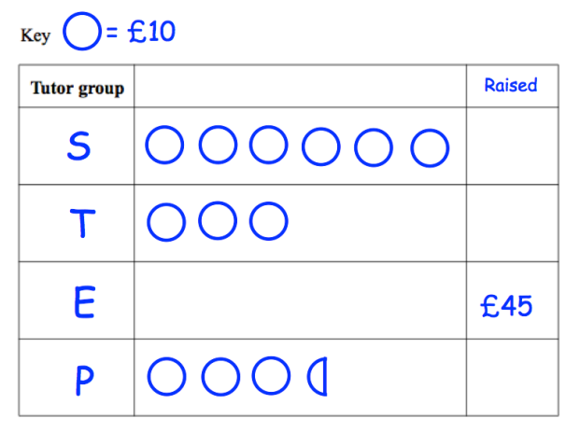
(a) Complete the raised column.
(2 marks)
(b) Complete the pictogram for tutor group E.
(2 marks)
(c) How much money was raised altogether?
(1 mark)
- The pictogram shows the books Claire read last year.
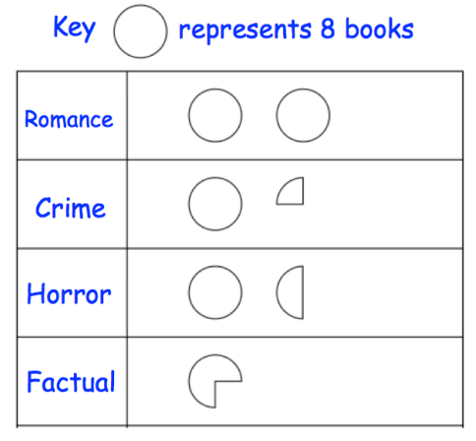
(a) How many romance books did Claire read? ............................. (1)
(1 mark)
(b) How many horror books did Claire read?
(1 mark)
(c) How many books in total did Claire read last year?
(2 marks)
- The number of hours of sunshine on a day, across a number of cities is shown below.
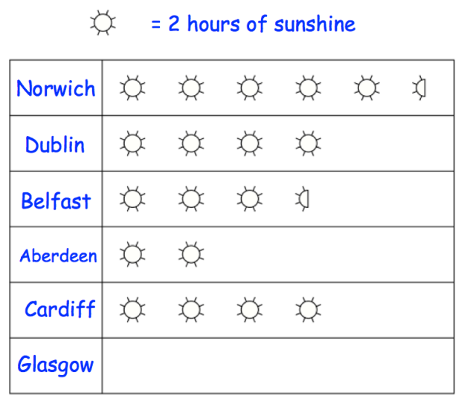
(a) How many more hours of sunshine was there in Norwich than Belfast?
(1 mark)
In Glasgow there was 9 hours of sunshine.
(b) Complete the pictogram.
(2 marks)

______ / ______ / ______
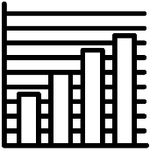
Bar Charts
What are the different statistical diagrams we can use to represent data and how do we interpret them?
How do we read from and present data on bar charts for different types of data?
Key Vocabulary
Vocab | Mathematical Definition
Bar Chart | A bar chart is a diagram in which the numerical values of variables are represented by the height or length of lines or rectangles of equal width
Frequency | Frequency is the mathematical term for ‘how many’ or the ‘total’

The Knowledge Phase

A bar chart or bar graph, is a diagram in which the numerical values of variables are represented by the height or length of lines or rectangles of equal width.
A bar chart must have the variables being counted on the x axis and the frequency on the y axis.
A bar chart must have a title and the axis must be labelled to ensure the reader can understand and interpret the data that is being presented.
A bar chart must have a scale on both the x and y axis that increases in equal gaps (although the two scales do not have to be the same) and they must both start at 0. However, to avoid large area of the graphs looking the same, if a graph’s frequencies are al large we may use a break in the axis.

Bar charts can be used for qualitative, discrete or continuous data:

- For qualitative and discrete data, just as there are gaps in-between each of the variable, there should also be gaps between the bars which represent them

Frequency (y)
Variables (x)

- For continuous data, there are no gaps between the variables and therefore the scale on the x axis representing this data should also be continuous and there should be no gaps between the bars.

Frequency (y)
Variables (x)

Historical  Origins | Many sources consider Nelvin Ks (1759-1824) to have invented the bar chart and the Exports and Imports of Scotland to and from different parts for one day from Christmas 1780 to Christmas 1781 graph from his The Commercial and Political Atlas to be the first bar chart in history.

Interpreting Bar charts
I DO
The bar chart below shows the colour of cars that turned right at the traffic lights recorded by Phoebe | The bar chart below shows the time taken (x seconds) for mice to complete a maze with a treat at the finish
  Frequency
  Frequency | 16
  Frequency | 14
  Frequency | 12
  Frequency | 10
  Frequency | 8
  Frequency | 6
  Frequency | 4
  Frequency | 2
  Frequency | 0
  Frequency | 0 |  | Red |  | Black |  | White |  | Silver |  | Other
  Frequency |  | Colour of Car
  Frequency
  Frequency | 8
  Frequency | 7
  Frequency | 6
  Frequency | 5
  Frequency | 4
  Frequency | 3
  Frequency | 2
  Frequency | 1
  Frequency | 0
  Frequency | 0 | 10 20 30 40 50 60 70 80 90
  Frequency |  | Time (seconds)
- How many Red cars did Phoebe record?  - How many cars did Phoebe record in total?  - What was the most common colour car Phoebe recorded?  - How many more White cars did Phoebe record than Black cars? | - How many mice took between 40 and 50 seconds to complete the maze?  - How many mice took part in the trial?  - How many mice took less than 40 seconds?
WE DO
The bar chart below shows the number of people who recorded various numbers of birds in their garden in the UK Spring Birdwatch challenge in Penn | The bar chart below shows the height of trees found at milking bank park (xcm)
  Frequency
  Frequency | 8
  Frequency | 7
  Frequency | 6
  Frequency | 5
  Frequency | 4
  Frequency | 3
  Frequency | 2
  Frequency | 1
  Frequency | 0
  Frequency | 0 |  | 0 |  | 1 |  | 2 |  | 3 |  | 4
  Frequency |  | Number of birds
  Frequency
  Frequency | 16
  Frequency | 14
  Frequency | 12
  Frequency | 10
  Frequency | 8
  Frequency | 6
  Frequency | 4
  Frequency | 2
  Frequency | 0
  Frequency | 0 | 100 200 300 400
  Frequency |  | Height (xcm)
- How many people recorded no birds in their garden?  - How many people took part in the UK Spring Birdwatch challenge for Penn?  - What was the most number of birds anyone recorded in their garden?  - How many more people recorded 2 birds than 1 in their garden? | - How many trees were recorded as being between 100 and 200 cm tall?  - How many trees were recorded in milking bank park in total?  - How many trees were recorded as being taller than 3 meters?

YOU DO
The bar chart below shows number of students who needed to borrow various equipment in their mock exam | The bar chart below shows the length (x cm) of the shoes on display at a museum
  Frequency
  Frequency | 16
  Frequency | 14
  Frequency | 12
  Frequency | 10
  Frequency | 8
  Frequency | 6
  Frequency | 4
  Frequency | 2
  Frequency | 0
  Frequency | 0 |  | Pen |  | Pencil |  | Rubber |  | Ruler |  | Other
  Frequency |  | Type of equipment borrowed
  Frequency
  Frequency | 8
  Frequency | 7
  Frequency | 6
  Frequency | 5
  Frequency | 4
  Frequency | 3
  Frequency | 2
  Frequency | 1
  Frequency | 0
  Frequency | 0 | 5 10 15 20 25 30 35 40 45
  Frequency |  | Length (xcm)
- How many pens had to be leant out for the exam?  - How many pieces of equipment were leant out altogether?  - What piece of equipment did students need to borrow the most of?  - How many more pens than pencils were leant out? | - How many shoes were measured to be between 20 and 25cm long?  - How many shoes are there on display at the museum?  - How many shoes were measured to be longer then 30cm?

Practice Questions
- The bar chart below shows the number of broken donuts in each box of 4
Frequency
Frequency | 8
Frequency | 7
Frequency | 6
Frequency | 5
Frequency | 4
Frequency | 3
Frequency | 2
Frequency | 1
Frequency | 0
Frequency |  |  | 0 |  | 1 |  | 2 |  | 3 |  | 4
Frequency |  | Number of broken donuts
- How many boxes had 4 broken donuts?
- What was the most common number of broken donuts in a box?
- How many boxes were checked from broken donuts in total?

- The bar chart below shows the distance covered by hamsters in a running wheel
Frequency
Frequency | 8
Frequency | 7
Frequency | 6
Frequency | 5
Frequency | 4
Frequency | 3
Frequency | 2
Frequency | 1
Frequency | 0
Frequency | 0 | 2 4 6 8 10 12 14 16 18
Frequency |  | Distance (xm)
- How many hamsters covered between 0-2 meters in the running wheel?
- What was the furthest distance covered by the hamsters?
- What was the most common distance covered by the hamsters?
- The bar chart below shows the nationality of the British representatives at a horse show
Frequency
Frequency | 16
Frequency | 14
Frequency | 12
Frequency | 10
Frequency | 8
Frequency | 6
Frequency | 4
Frequency | 2
Frequency | 0
Frequency |  |  | English |  | Scottish |  | Welsh |  | Irish |  | Other
Frequency |  | Nationality
- How many representatives were from Wales?
- Which two nationalities were equally represented?
- How many more English representatives were there compared to Scottish?

- The bar chart below shows the length of ad breaks on a new TV channel
Frequency
Frequency | 16
Frequency | 14
Frequency | 12
Frequency | 10
Frequency | 8
Frequency | 6
Frequency | 4
Frequency | 2
Frequency | 0
Frequency | 0 | 1 2 3 4 5 6 7 8 9
Frequency |  | Time (x mins)
- How many ad breaks lasted between 6 and 9 minutes?
- How many ad breaks were measured altogether in this bar chart?
- What is the most common length of ad break?

- The bar chart below shows the number of online purchases made each month by Meg
Frequency
Frequency | 8
Frequency | 7
Frequency | 6
Frequency | 5
Frequency | 4
Frequency | 3
Frequency | 2
Frequency | 1
Frequency | 0
Frequency |  |  | Feb |  | Mar |  | Apr |  | May |  | Jun
Frequency |  | Month
- How many online purchases did Meg make in May?
- In which month did Meg make the fewest online purchases?
- How many online purchases did Meg make from February – June?

- The bar chart below shows the height of the front door step of a sample of houses
Frequency
Frequency | 16
Frequency | 14
Frequency | 12
Frequency | 10
Frequency | 8
Frequency | 6
Frequency | 4
Frequency | 2
Frequency | 0
Frequency | 0 | 50 100 150 200 250 300 350 400 450
Frequency |  | Height (x mm)
- How many houses had a step less than 200mm?
- What is the most common height for a step?
- How many houses were sampled?

- The bar chart below shows the number of goals scored by each team in September
Frequency
Frequency | 16
Frequency | 14
Frequency | 12
Frequency | 10
Frequency | 8
Frequency | 6
Frequency | 4
Frequency | 2
Frequency | 0
Frequency |  |  | Wolves |  | B’ham |  | A.Villa |  | Walsall |  | WBA
Frequency |  | Team
- Which two teams scored the same number of goals in September?
- Which team scored the most goals in September?
- How many more goals did Walsall score than Birmingham?

- The bar chart below shows the circumference of toilet rolls from various brands
Frequency
Frequency | 8
Frequency | 7
Frequency | 6
Frequency | 5
Frequency | 4
Frequency | 3
Frequency | 2
Frequency | 1
Frequency | 0
Frequency | 0 | 10 20 30 40 50 60 70 80 90
Frequency |  | Circumference (x cm)
- How many toilet rolls had a circumference of more than 40cm?
- What is the modal circumference of the toilet rolls sampled?
- What is the difference between the number of toilet rolls with the largest and smallest circumference?
Drawing Bar charts
When drawing a bar chart, we must remember the key points:
- Always label you x and y axis
- Always ensure that your bars are of equal width
- For discrete data, the bars should have gaps between them
- For continuous data, the bars should be touching and the values on the axis should be continuous

I DO
Draw a bar chart for the data given below which shows the nationality of the teachers employed at Boddington Grammar School  English English English Welsh English French English Welsh Scottish English Scottish English English Welsh English French English  Canadian English English Welsh English | The following data shows the circumference of a sample of plastic tubes used by a builder in Farrough. Draw a bar chart to show this data
  Circumference (xmm) | Frequency
  0 < x ≤ 20 | 4
  20 < x ≤ 40 | 12
  40 < x ≤ 60 | 15
  60 < x ≤ 80 | 14
  80 < x ≤ 100 | 7

WE DO
Construct a bar chart to show the number of people who gave 1 – 5 stars rating for the lecture  1 5 3 5 4 2 5 3 5 2 5 3 4 1 4 5 5 5 4 3 3 | Use a bar chart to depict the following data which represents the percentages students got on their end of year exam  73.8 62.5 49.8 52.8 51.7 75.9 76.4 92.4 81.0 82.3 56.1 47.9 41.2 74.3 78.2 93.4 81.3 62.1

YOU DO
The table below shows the pets owned by girls at a rainbows meeting. Draw a bar chart to show this information | The table below shows the time (x mins) taken for trains from New Street Station to reach their first stop on Wednesday
  Pet | Frequency
  Dog | 13
  Cat | 12
  Fish | 10
  Rabbit | 8
  Other | 5
  Circumference (xmm) | Frequency
  0 < x ≤ 5 | 7
  5 < x ≤ 10 | 6
  10 < x ≤ 15 | 2
  15 < x ≤ 20 | 4
  20 < x ≤ 25 | 3

Practice Questions
- The data below shows the type of pet owned by teachers at Greentime Primary Academy
none dog cat none dog fish dog cat fish cat dog none rabbit
none none cat none dog fish cat none fish none cat dog none
Present this data on the bar chart below
Frequency | 9
Frequency | 8
Frequency | 7
Frequency | 6
Frequency | 5
Frequency | 4
Frequency | 3
Frequency | 2
Frequency | 1
Frequency | 0
- The table below shows the amount of rain recorded each day in April
Rainfall (mm) | 0 < x ≤ 5 | 5 < x ≤ 10 | 10 < x ≤ 15 | 15 < x ≤ 20 | 20 < x ≤ 25
Days | 8 | 7 | 6 | 4 | 6
Represent this data on a bar chart
Frequency | 9
Frequency | 8
Frequency | 7
Frequency | 6
Frequency | 5
Frequency | 4
Frequency | 3
Frequency | 2
Frequency | 1
Frequency | 0
- The number of times a newsreader uses the following words is recorded is the following table
Word | Morning | Welcome | Today | Queen | Britain
Frequency | 17 | 16 | 14 | 3 | 11
Produce a bar chart to represent this data
Frequency
Frequency | 16
Frequency | 14
Frequency | 12
Frequency | 10
Frequency | 8
Frequency | 6
Frequency | 4
Frequency | 2
Frequency | 0
- James is the manager at the local bus station. He records the number of minutes each bus is late returning to the station and records the data as shown
Mins late | 0 < x ≤ 2 | 2 < x ≤ 4 | 4 < x ≤ 6 | 6 < x ≤ 8 | 8 < x ≤ 10
Days | 5 | 4 | 3 | 8 | 6
Display this information in a bar chart
Frequency | 9
Frequency | 8
Frequency | 7
Frequency | 6
Frequency | 5
Frequency | 4
Frequency | 3
Frequency | 2
Frequency | 1
Frequency | 0

- The score teams got in the Maths round of a quiz (out of 5) is shown below
Score | 0 | 1 | 2 | 3 | 4 | 5
Frequency | 1 | 3 | 5 | 7 | 8 | 4
Draw a bar chart to display this information
Frequency
Frequency | 8
Frequency | 7
Frequency | 6
Frequency | 5
Frequency | 4
Frequency | 3
Frequency | 2
Frequency | 1
Frequency | 0
- The area of grass in the gardens of Gardener Grahams customers is shown below
Area (m²) | 0 < x ≤ 50 | 50 < x ≤ 100 | 100 < x ≤ 150 | 150 < x ≤ 200 | 200 < x ≤ 250
Customers | 16 | 15 | 14 | 8 | 3
is information in a bar chart
Frequency | 18
Frequency | 16
Frequency | 14
Frequency | 12
Frequency | 10
Frequency | 8
Frequency | 6
Frequency | 4
Frequency | 2
Frequency | 0

Exam Questions
- The weights of four athletes are displayed below.
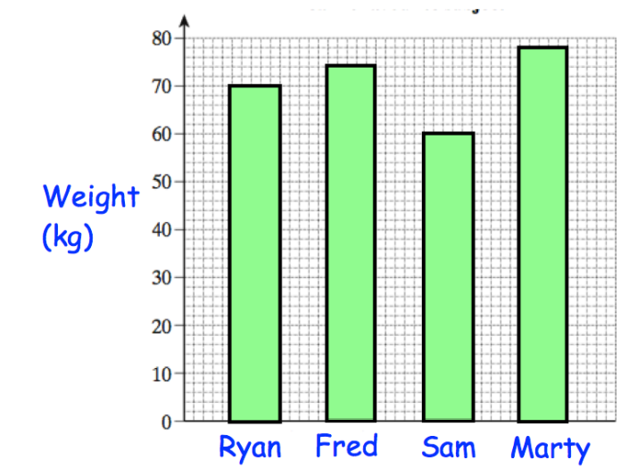

(a) Who is the lightest athlete? (1)
(b) Write down Martyʼs weight. (1)
(c) Work out the range of the weights. (2)

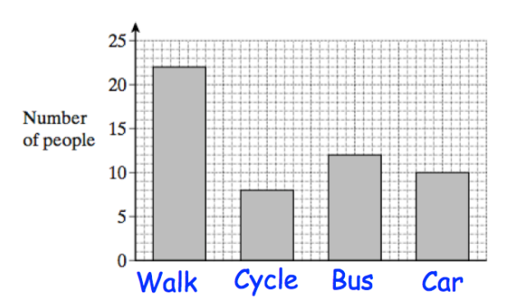
- A manager surveys his employees to find out how they travel to work.

(a) What is the least popular method of transport? (1)
(b) What is the most popular method of transport? (1)
(c) Calculate the total number of employees. (2)
3. James asked his friends their favourite colour.
Green Blue Red Green Blue Blue Green Red Blue
White Blue Green Red Green Blue Red Blue Green
- Complete the frequency table for his results.
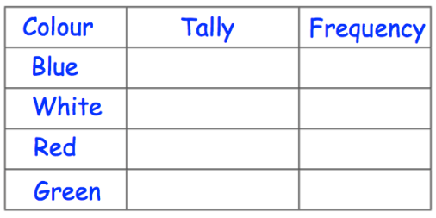 (2)
(b) On the grid, draw a bar chart to show this information.
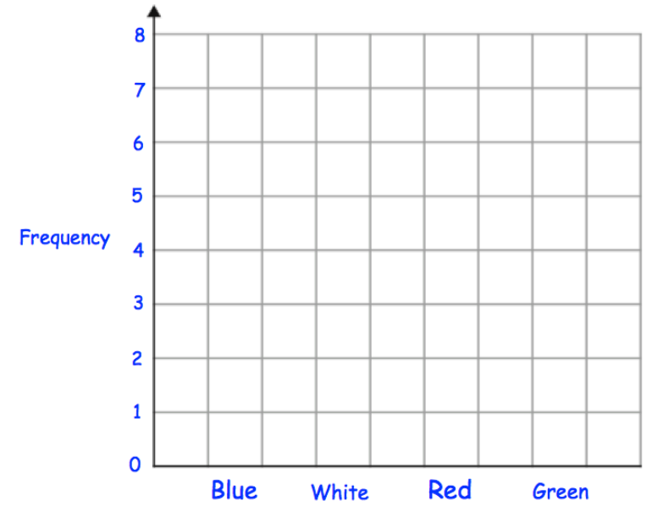 (2)
- Cardiff Rovers Football Club played 30 games in a season.
(a) Complete the tally and frequency columns.
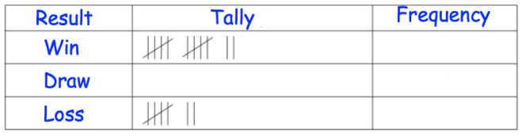 (3)
(b) Draw a bar chart to show this information.
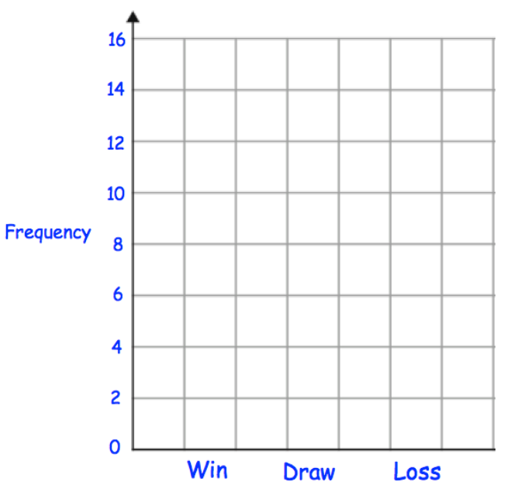 (2)
- Miss Jackson asked the 32 students in her tutor group which language they study.
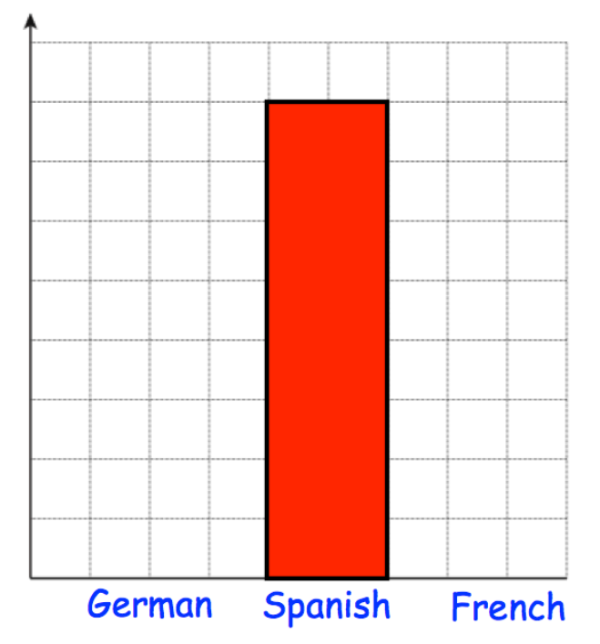
Each student studies one language only. Half of the students in the tutor group study Spanish.
Six more students study German than French. Complete the bar chart. (4)
______ / ______ / ______
Multiple Bar Charts
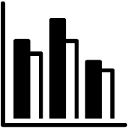 | What are the different statistical diagrams we can use to represent data and how do we interpret them?
 | How do we read data from and complete a multiple or dual bar chart?
Key Vocabulary
Vocab | Mathematical Definition
Multiple | Multiple means more than one
Dual | Dual mean something which has two parts
Bar Chart | A bar chart is a diagram in which the numerical values of variables are represented by the height or length of lines or rectangles of equal width
Frequency | Frequency is the mathematical term for ‘how many’ or the ‘total’

The Knowledge Phase
Multiple bar charts (sometimes known as dual bar charts) are when two or more bars are used to represent each variable. This occurs when data for each variable can be split into categories such as gender.
As with bar charts;
- the height of each bar represents the frequency of each variable
- the bars must be of equal width
- there must be a gap between each variable
HOWEVER, there does not have to be a gap between the bars which correspond to each variable, but there must be a key to distinguish between the different bars.
Multiple bar charts are a good visual way for us to compare data

I DO
The dual bar chart below represents the number of students for each year group who were late or absent to school yesterday.

Frequency |  |  |  |  |  |  |  |  |  |  |  |  |  |  | Late
Frequency | 8
Frequency | 8 |  |  |  |  |  |  |  |  |  |  |  |  |  | Absent
Frequency | 7
Frequency | 6
Frequency | 5
Frequency | 4
Frequency | 3
Frequency | 2
Frequency | 1
Frequency | 0
Frequency | 0 |  | Year 7 |  |  | Year 8 |  |  | Year 9 |  |  | Year 10 |  |  | Year 11

- How many Year 7 students were absent?

- There were 12 year 11 students either late or absent, complete the bar chart to show this information.

- Which year group has more students absent than late?

- How many students were late altogether?

WE DO
The multiple bar chart below shows the hot drink preferences of workers in 4 different offices in town

Frequency |  |  |  |  |  |  |  |  |  |  |  |  |  |  | Coffee
Frequency | 8
Frequency | 8 |  |  |  |  |  |  |  |  |  |  |  |  |  | Tea
Frequency | 7
Frequency | 7 |  |  |  |  |  |  |  |  |  |  |  |  |  | Hot Chocolate
Frequency | 6
Frequency | 5
Frequency | 4
Frequency | 3
Frequency | 2
Frequency | 1
Frequency | 0
Frequency | 0 | Travel Agent |  |  |  | Lawyers |  |  |  | Builders |  |  |  | Tele Sales

- How many Builders preferred Hot Chocolate?

- 15 travel agents gave a hot drinks preference, complete the bar chart to show this information.

- Which office showed no preference to a hot drink?

- How many workers preferred Tea?

YOU DO
The dual bar chart below displays the number of number of customers who arrived at the shopping centre before and after 9am via various modes of transport

Frequency |  |  |  |  |  |  |  |  |  |  |  |  |  |  | Before 9am
Frequency | 8
Frequency | 8 |  |  |  |  |  |  |  |  |  |  |  |  |  | After 9am
Frequency | 7
Frequency | 6
Frequency | 5
Frequency | 4
Frequency | 3
Frequency | 2
Frequency | 1
Frequency | 0
Frequency | 0 |  | Walk |  |  | Car |  |  | Bus |  |  | Tram |  |  | Other

- 5 customers who arrived before 9am did so by car, show this information on the bar chart

- How many customers arrived by Tram?

- How many customers arrived after 9am?

- How many more people arrived after 9am than before 9am?

Practice Questions
- The dual bar chart below represents the number of customers who spent more or less than £20 per transaction in each department of a high street store
Frequency |  |  |  |  |  |  |  |  |  |  |  |  |  |  | Less than £20
Frequency | 8
Frequency | 8 |  |  |  |  |  |  |  |  |  |  |  |  |  | More than £20
Frequency | 7
Frequency | 6
Frequency | 5
Frequency | 4
Frequency | 3
Frequency | 2
Frequency | 1
Frequency | 0
Frequency | 0 |  | Clothing |  |  | Make Up |  |  | Home |  |  | Accessories |  |  | Food
- How many customers made purchases in the Make Up department?
- How many customers spent less than £20?
- How many more customers spent more than £20 in the home department than less than £20?
- 3 customers spent over £20 on clothing show this information on the bar chart

- The multiple bar chart below shows the uniform choice of a sample of students at Hareground High School
Frequency |  |  |  |  |  |  |  |  |  |  |  |  |  |  | Trousers
Frequency | 8
Frequency | 8 |  |  |  |  |  |  |  |  |  |  |  |  |  | Skirt
Frequency | 7
Frequency | 7 |  |  |  |  |  |  |  |  |  |  |  |  |  | Shorts/Culottes
Frequency | 6
Frequency | 5
Frequency | 4
Frequency | 3
Frequency | 2
Frequency | 1
Frequency | 0
Frequency | 0 | KS3 |  |  |  | KS4 |  |  |  | KS5
- How many KS3 students choose to wear Skirts?
- 14 students chose to wear trousers, complete the bar chart to show this information.
- How many students were used for the sample?
- What was the least popular choice of uniform?
- The dual bar chart shows the number of visitors to two different construction sites over the last 3 days
Frequency |  |  |  |  |  |  |  |  |  |  |  |  |  |  | Wednesbury
Frequency | 8
Frequency | 8 |  |  |  |  |  |  |  |  |  |  |  |  |  | Darleston
Frequency | 7
Frequency | 6
Frequency | 5
Frequency | 4
Frequency | 3
Frequency | 2
Frequency | 1
Frequency | 0
Frequency | 0 | Monday |  |  |  | Tuesday |  |  |  | Wednesday
- How many visitors did the two sites have on Monday?
- In total, the Wednesbury site had 10 visitors, use this information to complete the bar chart.
- How many more visitors did Wednesbury have than Darleston?
- On which day did both sites have the same number of visitors?

- The multiple bar chart shows the number of cakes prepared by students for a bake sale on Friday
Frequency |  |  |  |  |  |  |  |  |  |  |  |  |  |  | Chocolate
Frequency | 16
Frequency | 16 |  |  |  |  |  |  |  |  |  |  |  |  |  | Vanilla
Frequency | 14
Frequency | 12
Frequency | 10
Frequency | 8
Frequency | 6
Frequency | 4
Frequency | 2
Frequency | 0
Frequency | 0 | Year 7 |  |  |  | Year 8 |  |  |  | Year 9 |  |  |  | Year 10
- Which year group made the most cakes?
- Of which flavour cake was the most made?
- How many more Chocolate cakes did year 9 make than Vanilla?
- Year 10 made half as many chocolate cakes as year 8 and half as many vanilla cakes as year 9. Show this on the bar chart.
Exam Questions
- The multiple bar chart shows some information about the nutritional content of a standard chicken curry and a light chicken curry.
The information is given as %RDA (percentage of ‘recommended daily allowance’).
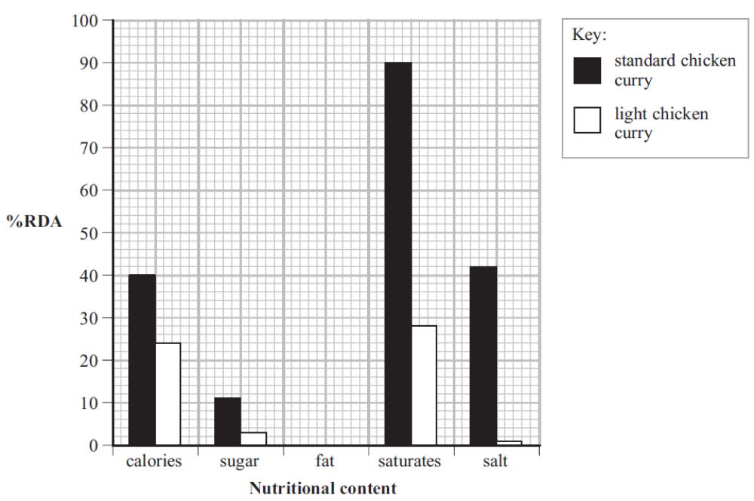
The missing information for fat is
 | %RDA
standard chicken curry | 54
light chicken curry | 12

(a) Complete the multiple bar chart. (2)
(b) Write down the %RDA for the salt in the standard chicken curry. (1)
(c) Write down the nutritional content with the lowest %RDA for a standard chicken curry. (1)
(d) Compare the %RDA for the saturates in the two chicken curries. (2)

- Here is a bar chart showing the number of miles Paula and Rose ran from Monday to Friday in a week.
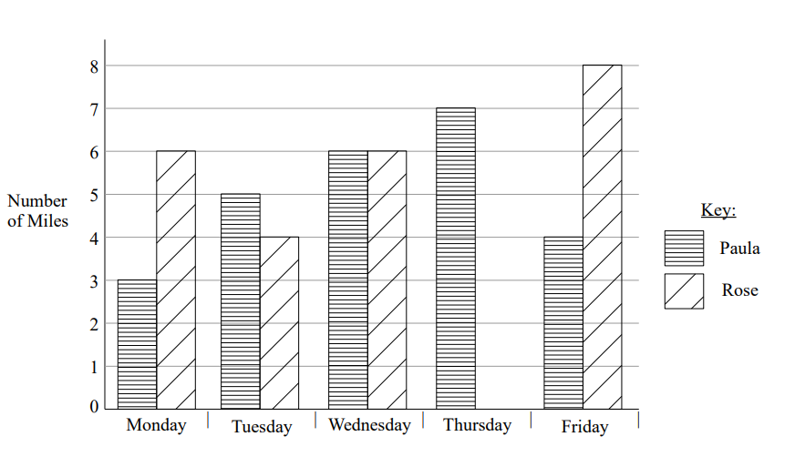

Rose runs further than Paula on Monday
- How much further? (1)
Rose ran 6 miles on Thursday
- Use this information to complete the bar chart. Rose is not going to run on Saturday. (1)
- How many miles would Paula have to run on Saturday so that the number of miles she runs from Monday and Saturday is the same as the number of miles Rose runs from Monday to Saturday? (2)
______ / ______ / ______
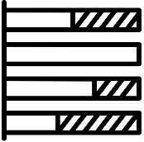
Composite Bar Charts
What are the different statistical diagrams we can use to represent data and how do we interpret them?
How do we read data from and complete a composite bar chart?

Key Vocabulary

Vocab | Mathematical Definition
Composite | Something which is made up of several parts
Bar Chart | A bar chart is a diagram in which the numerical values of variables are represented by the height or length of lines or rectangles of equal width
Frequency | Frequency is the mathematical term for ‘how many’ or the ‘total’

The Knowledge Phase

A composite bar chart is a statistical diagram that uses one vertical bars per variable to represent frequencies which are split into sections and stacked one on top of the other.

THE HEIGHT OF THE BAR IS THE TOTAL FREQUENCY FOR EACH VARIABLE.

EACH SUB CATEGORY MUST BE CALCUATED SEPERATLY FOR EACH VARIABLE

A key is then used to determine which section of each bar represents each category within the variable

We usually label our x axis as our variables and our y axis as our frequencies

- There must be a key
- All bars must be equal in width
- All variables must have equal gaps between them
- The frequencies must start at 0 but may have a scale break

A composite bar chart can be used for:
✓ Qualitative Data
✓ Discrete Data

I DO
The composite bar chart below shows the number of male and female students in each of the 5 houses at a school
Frequency
 |  | 80
 |  | 70
 |  | 60
 |  | 50
 |  | 40
 |  | 30
 |  | 20
 |  | 10
 |  | 0
 |  | 0 |  | A |  |  |  | B |  | C |  |  | D |  | E
 | Boys |  |  |  |  |  | girls

- Which house has the most pupils?

- Which house has the least pupils?

- Which house has the most boys?

- Which house has the most girls?

- Which house has the same number of boys and girls?

WE DO
The composite bar chart shows the proportion of the money earned by 3 teenagers put into savings, donated to charity and spent on treats

 | 100
 | 90
Proportion | 90
Proportion | 80
Proportion | 70
Proportion | 60
Proportion | 50
Proportion | 40
Proportion | 30
Proportion | 20
Proportion | 10
Proportion | 0
Proportion | 0 |  | Olivia |  |  | Jessie |  |  | Haroun

 | Savings |  | Donated |  | Treats

- Who saved the most?

- Jessie donated 30% of her money, complete her bar

- How much of her earnings did Olivia save?

- How much of their earnings did Jessie donate?

- How much of his earnings did Haroun spend on a treat?

YOU DO
The composite bar chart shows the number of points achieved by 4 contestants

Frequency
Frequency | 8
Frequency | 7
Frequency | 6
Frequency | 5
Frequency | 4
Frequency | 3
Frequency | 2
Frequency | 1
Frequency |  |  | Jake |  | Amya |  | HArley |  | Kyra

 | Game 1 |  | Game 2 |  | Game 3

- Jake got the most points overall, show this on the bar chart

- Who got the most points in Game 1?

- Who got the same points in all 3 games?

- How many points did Kyra get overall?

- How many points did Jake get in Game 2?

Practice Questions
- The composite bar chart below shows the number of 6 and 7 years old and which sport they chose for their after-school activity
 | 6-year olds |  | 7-year olds

- 20 7-year olds choose Athletics, show this on the bar chart
- Which sport did most pupils choose?
- Which sport was most popular with 6-year olds?
- How many 7-year olds choose an activity?
- How many more 7-year olds chose Rugby that 6-year olds?

Frequency
Frequency | 40
Frequency | 35
Frequency | 30
Frequency | 25
Frequency | 20
Frequency | 15
Frequency | 10
Frequency | 5
Frequency | 0
Frequency | 0 |  | Football |  | Cricket |  | Rugby |  | Tennis |  | Athletics

- The composite bar chart below shows the number of enquiries and sales made in a shop each day of the week
 | enquiries |  | sales

- On Friday they had 7 customers in store, complete the bar chart
- On which day did they have the most customers?
- On which day did they have the most enquiries?
- On which day did they make the most sales?
- How many sales sis they make over the week?
Frequency
Frequency | 8
Frequency | 7
Frequency | 6
Frequency | 5
Frequency | 4
Frequency | 3
Frequency | 2
Frequency | 1
Frequency | 0
Frequency | 0 |  | Monday |  | Tuesday |  | Wednesday |  | Thursday |  | Friday
- The composite bar chart below shows the number of kits, boots and accessories a football store sold last weekend
 | kits |  | boots |  | accessories

- On Saturday they sold 2 accessories, show this on the bar chart
- On which day did they make the fewest sales?
- On which day did they sell the fewest kits?
- On which day did they sell the fewest boots?
- How many kits did they sell in total?

Frequency
Frequency | 16
Frequency | 14
Frequency | 12
Frequency | 10
Frequency | 8
Frequency | 6
Frequency | 4
Frequency | 2
Frequency | 0
Frequency | 0 |  | Friday |  |  | Saturday |  |  | Sunday

- The composite bar chart below shows the proportion wages 3 parents spend on bills, children and activities
 | bills |  | children |  | activities

- Donna and Markus spend the same proportion of their wages on activities, show this on the bar chart
- Who spend the highest proportion on their bills?
- What proportion of Markus’ wages is spent on their children?
- Why might Siobhan not have any of the dark grey in her bar?
- Why does this bar chart not tell us who spent the most Monday on activities?

 | 100
 | 90
Proportion | 90
Proportion | 80
Proportion | 70
Proportion | 60
Proportion | 50
Proportion | 40
Proportion | 30
Proportion | 20
Proportion | 10
Proportion | 0
Proportion | 0 |  | Donna |  |  | Siobhan |  |  | Markus
Exam Questions
The table shows some information about the number of months of unemployment of males and females aged 16 and over at the end of 2007.
Number of months  of unemployment (x) | Males % | Females %
x < 3 | 33% | 44%
3 ≤ x < 6 | 19% | 20%
6 ≤ x < 12 | 15% | 17%
12 ≤ x < 24 | 14% | 10%
24 ≤ x < 36 | 5% | 4%
x ≥ 36 | 14% | 5%
Total | 100% | 100%
(Data source: Labour force survey, Office for National Statistics)
(b) Use the information in the table to complete the composite bar chart.
Percentages of unemployed males and unemployed females in different age groups
for a given number of months
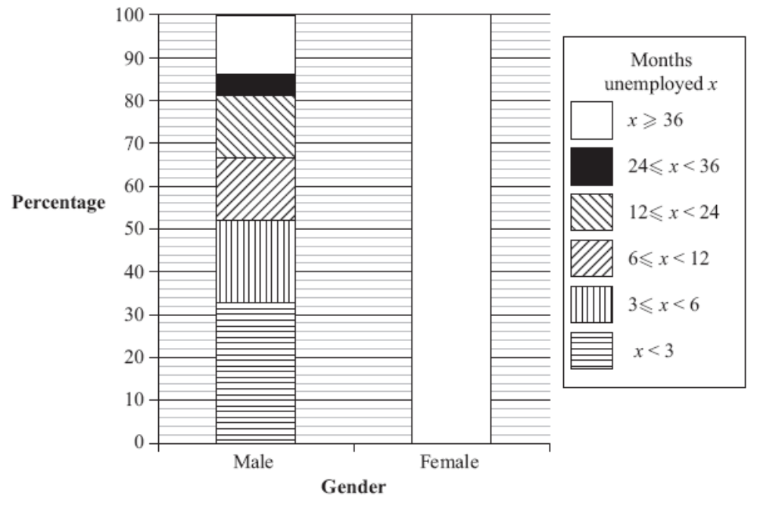(3)

(c) Using information in the composite bar chart, what conclusions can you make about your hypothesis?
Give a reason for your answer. (2)
- Tobi is investigating family spending in the USA and in the UK.
Two of his hypotheses are
Hypothesis 1 The percentage of family spending on housing is greater in the USA
than in the UK.
Hypothesis 2 The percentage of family spending on entertainment is greater in
the USA than in the UK.
Tobi collects data from the internet and draws these composite percentage bar charts.
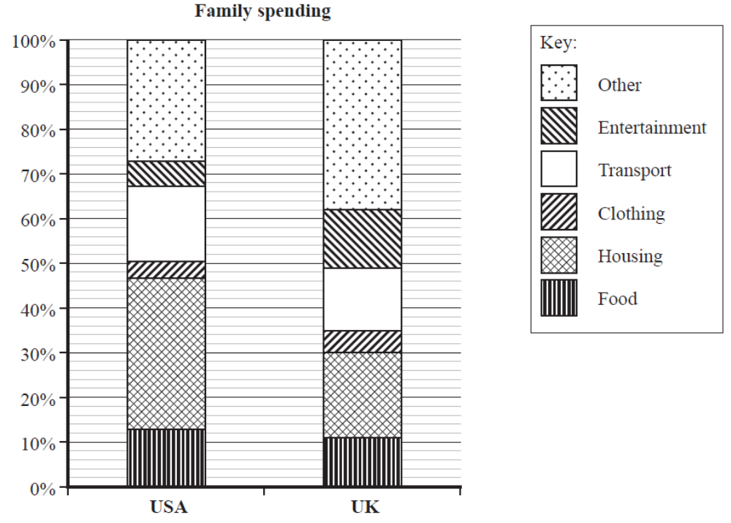
(Data sources: USA – Bureau of Labor Statistics UK – Office for National Statistics)
(a) Find the percentage of family spending on entertainment in the USA. (2)

*(b) Explain, with reasons, whether or not the bar charts support each of Tobi’s hypotheses. (4)

Tobi thinks that the composite bar charts show that family spending on food is more in the USA than in the UK.

(c) Explain why Tobi is not correct. (1)
- The composite bar chart shows information about the area of land with forest and the
area of land with no forest in some countries.

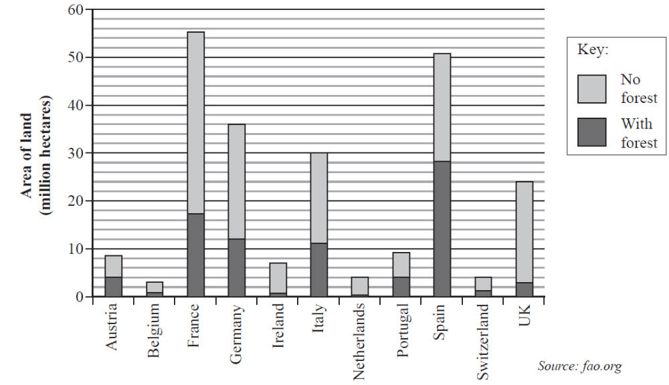
(a) Write down the country
(i) with the largest total area of land,

(ii) with the largest area of forest. (2)

(b) Work out the area of land with no forest in the UK. (2)

(c) Estimate the area of land in Germany with forest as a percentage of the total area of land in Germany.
(2)

- The composite bar chart shows the nutritional content of walnuts.
Nutritional content of Nuts
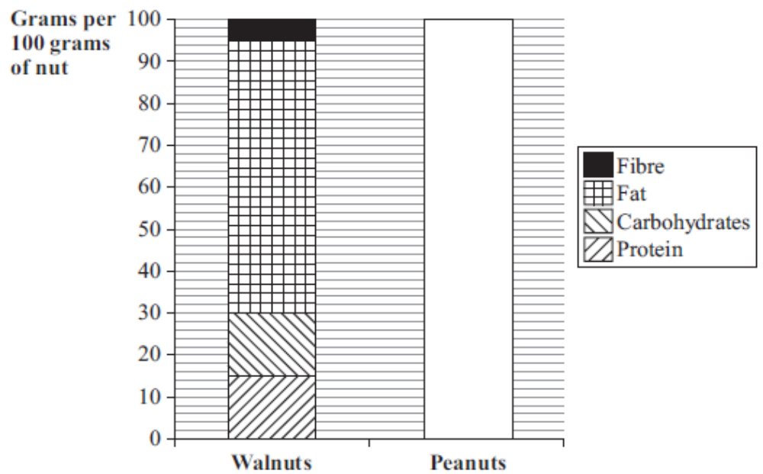
(Source: adapted from Penguin Facts)
The nutritional content of peanuts is shown in the table.
 | Grams per 100 grams of peanut
Protein | 24
Carbohydrates | 20
Fat | 48
Fibre | 8

(a) Complete the composite bar chart for peanuts. (2)

(b) Write down the number of grams of fat in 100g of walnuts. (1)

Michael says that a peanut has more protein than a walnut.

(c) Explain why Michael may not be right. (1)

______ / ______ / ______
Population Pyramids
What are the different statistical diagrams we can use to represent data and how do we interpret them?
How do we read data from a population pyramid?
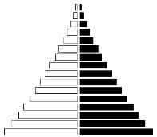
Key Vocabulary
Vocab | Mathematical Definition
Population Pyramid | A population pyramid (age structure diagram) or "age-sex pyramid" is a graphical illustration of the distribution of a population by age groups and sex.
Proportion | being in proportion means that two ratios or fractions are of equal value.

The Knowledge Phase
A popluation pyramid is a back-to-back histograms which allow us to compare two sexes in various age categories.
It is ususal for the age categories to go down the centre of the two histograms and frequency or proportion to be a symmetrical scale both left and right for males and females.
A key is not essential as the two sides are usually labelled.

As most questions for population pyramids will ask you to compare the two data sets it is important to remember:
- Do not just quote values. A comparion should state which is higher/lower and by how much
- It is important when reading from a populaiton pyramid that you identify if the data shown is frequencies or proportions of the population. When commenting on, or comparing the two data sets it is essential that you only comment on the proportion of the population if that is what is shown on the graph.

Cross-Curricular  Link | Population pyramids are often used in Geography to compare differences between male and female populations of an area. They also show the number of dependents (children and, sometimes, elderly people) and general structure of the population at any given moment

Historical  Origins | The first population pyramid was published in 1874 in a statistical atlas of the United States. For a population with high birth and death rates, it is wide at the bottom (young ages) and narrow at the top (old ages), hence the term pyramid. Its shape varies however.
I DO
The population pyramid below shows the proportion of females and males currently in full time education in the UK
Females Males
 |  |  |  |  |  |  |  |  |  |  | 70 ≤ a
 |  |  |  |  |  |  |  |  |  |  | 60 ≤ a < 70
 |  |  |  |  |  |  |  |  |  |  | 50 ≤ a < 60
 |  |  |  |  |  |  |  |  |  |  | 40 ≤ a < 50
 |  |  |  |  |  |  |  |  |  |  | 30 ≤ a < 40
 |  |  |  |  |  |  |  |  |  |  | 20 ≤ a < 30
 |  |  |  |  |  |  |  |  |  |  | 10 ≤ a < 20
 |  |  |  |  |  |  |  |  |  |  | 0 ≤ a < 10
100 |  | 80 |  | 60 |  | 40 |  | 20 |  |  |  |  | 20 |  | 40 |  | 60 |  | 80 |  | 100

- What propotion of males age between 30 ≤ a < 40 are in currently in full time education in the UK?
- Which age catagories have the same proprotion of males and females currently in full time educaiton in the UK?
- Is there a higher proportion of males or females currently in full time educaiton in the UK?

WE DO
The population pyramid below shows the number of male and female employees at a factory
Females Males
 |  |  |  |  |  |  |  |  |  |  | 55 ≤ a
 |  |  |  |  |  |  |  |  |  |  | 50 ≤ a < 55
 |  |  |  |  |  |  |  |  |  |  | 45 ≤ a < 50
 |  |  |  |  |  |  |  |  |  |  | 40 ≤ a < 45
 |  |  |  |  |  |  |  |  |  |  | 35 ≤ a < 40
 |  |  |  |  |  |  |  |  |  |  | 30 ≤ a < 35
 |  |  |  |  |  |  |  |  |  |  | 25 ≤ a < 30
 |  |  |  |  |  |  |  |  |  |  | 18 ≤ a < 25
20 |  | 16 |  | 12 |  | 8 |  | 4 |  |  |  |  | 4 | 8 |  | 12 |  | 16 |  | 20

- How many female employees does the factoy have?
- How many male employees over the age of 40 does the factory have?
- How many more male employees does the factory have compared to female employees?

YOU DO
The population pyramid below shows the number of girls any boys at a dance acadmey in London
Girls Boys
 |  |  |  |  |  |  |  |  |  | 16 ≤ a
 |  |  |  |  |  |  |  |  |  | 14 ≤ a < 16
 |  |  |  |  |  |  |  |  |  | 12 ≤ a < 14
 |  |  |  |  |  |  |  |  |  | 10 ≤ a < 12
 |  |  |  |  |  |  |  |  |  | 8 ≤ a < 10
 |  |  |  |  |  |  |  |  |  | 6 ≤ a < 8
 |  |  |  |  |  |  |  |  |  | 4 ≤ a < 6
 |  |  |  |  |  |  |  |  |  | 2 ≤ a < 4
10 |  | 8 |  | 6 |  | 4 |  | 2 |  |  |  | 2 |  | 4 |  | 6 |  | 8 |  | 10

- How many boys are at the dance academy?
- How mnay girls under the age of 10 are at the dance academy?
- Which age catagories have the fewest number of members at the dance academy?

Practice Questions
- For the following population pyramid, answer the corresponding questions
The percentage of people in full time education
Males Females
 |  |  |  |  |  |  |  |  |  |  | 65 ≤ a
 |  |  |  |  |  |  |  |  |  |  | 60 ≤ a < 65
 |  |  |  |  |  |  |  |  |  |  | 55 ≤ a < 60
 |  |  |  |  |  |  |  |  |  |  | 50 ≤ a < 55
 |  |  |  |  |  |  |  |  |  |  | 45 ≤ a < 50
 |  |  |  |  |  |  |  |  |  |  | 40 ≤ a < 45
 |  |  |  |  |  |  |  |  |  |  | 35 ≤ a < 40
 |  |  |  |  |  |  |  |  |  |  | 30 ≤ a < 35
 |  |  |  |  |  |  |  |  |  |  | 25 ≤ a < 30
 |  |  |  |  |  |  |  |  |  |  | 20 ≤ a < 25
 |  |  |  |  |  |  |  |  |  |  | 15 ≤ a < 20
 |  |  |  |  |  |  |  |  |  |  | 10 ≤ a < 15
 |  |  |  |  |  |  |  |  |  |  | 5 ≤ a < 10
 |  |  |  |  |  |  |  |  |  |  | 0 ≤ a < 5
100 |  | 80 |  | 60 |  | 40 |  | 20 |  |  |  |  | 20 |  | 40 |  | 60 |  | 80 |  | 100

What percentage of females age 0 ≤ a < 5 are in full time education?
________________ %
What percentage of females age 55 ≤ a < 60 are in full time education?
________________ %
What percentage of males age 15 ≤ a < 20 are in full time education?
________________ %
What percentage of males age 40 ≤ a < 45 are in full time education?
________________ %
Who has a higher percentage of 0 ≤ a < 5 year olds in full time education?
□ Males □ Females □ Equal □ Can’t Tell
Who has a more 5 ≤ a < 10 year olds in full time education?
□ Males □ Females □ Equal □ Can’t Tell
Who has a higher percentage of 10 ≤ a < 15 year olds in full time education?
□ Males □ Females □ Equal □ Can’t Tell
Who has a higher percentage of 20 ≤ a < 25 year olds in full time education?
□ Males □ Females □ Equal □ Can’t Tell
Who has a higher percentage of 30 ≤ a < 35 year olds in full time education?
□ Males □ Females □ Equal □ Can’t Tell
Who has a more 35 ≤ a < 40 year olds in full time education?
□ Males □ Females □ Equal □ Can’t Tell
Who has a higher percentage of 40 ≤ a < 45 year olds in full time education?
□ Males □ Females □ Equal □ Can’t Tell
Who has a higher percentage of 50 ≤ a < 55 year olds in full time education?
□ Males □ Females □ Equal □ Can’t Tell
Exam Questions
- The two population pyramids show the percentages of males and females in each age group in China for the years 1977 and 2017
Each percentage is based on the total population of China for that year.
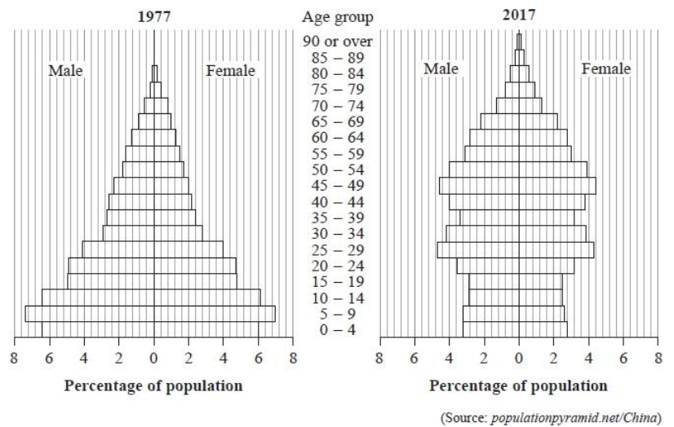
(a) For the year 1977, write down the percentage of the population who are female in the age group 0–4 years.
(1 mark)
(b) For the year 2017, write down the age group that has the greatest percentage of females.
(1 mark)
Eric says that more than 25% of the population of China is aged 9 or under in 1977
(c) Determine whether or not Eric is correct. You must show your working.
(3 marks)
(d) Compare the percentages of people in China in the 60 – 64 age group in 1977 with the percentages of people in China in the 60–64 age group in 2017
(2 marks)

- The population pyramid shows information about the numbers (in thousands) of drivers of each gender who made car insurance claims in the UK in 2015
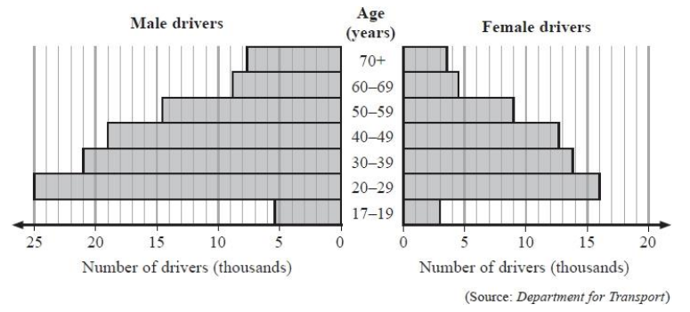
(a) How many female drivers aged 50–59 in the UK in 2015 made car insurance claims?
(1 mark)
The population pyramid shows that the age group which has the fewest number of drivers who made car insurance claims is the 17–19 age group.
(b) Suggest a reason why this should be so.
(1 mark)
In 2014, the number of male drivers aged 20–49 in the UK who made car insurance claims was 66 700
(c) Compare the number of male drivers aged 20–49 in the UK who made car insurance claims in 2014 with the number of male drivers aged 20–49 in the UK who made car insurance claims in 2015 You must show your working.
(3 marks)
The SafeDrive insurance company charges young male drivers more for car insurance than it charges all other drivers.
(d) Explain two features of the population pyramid which SafeDrive might use as its justification for doing this.
(2 marks)
Jeremy says, "The population pyramid shows that the total number of male drivers in the UK in 2015 is greater than the total number of female drivers in the UK in 2015" (e) Explain whether or not Jeremy's conclusion is appropriate.
(1 mark)
Vicki says, "In the UK in 2019, there will be more male drivers who make car insurance claims than female drivers who make car insurance claims"
(f) Explain whether or not the information in the population pyramid can be used to support Vicki's statement.
(1 mark)

______ / ______ / ______
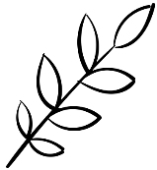
Stem and Leaf Diagram
What are the different statistical diagrams we can use to represent data and how do we interpret them?
How do we read data from and complete a stem and leaf diagram?
Key Vocabulary
Vocab | Mathematical Definition
Stem and Leaf Diagram | a special table where each data value is split into a "stem" (the first digit or digits) and a "leaf" (usually the last digit)
Key | An indicator of the value represented by each ‘leaf’

Historical  Origins | The origin of the stem-and-leaf diagram is often associated with Tukey, J.W. (1977). Its concept is based on the histogram, which dates back to the 18th century.

The Knowledge Phase
We use stem and leaf diagrams to display lots of numerical data

We split each data value into a:
- "leaf" (the last digit) and a
- "stem" (the other digit(s))
The "stem" values are listed down the side, and the "leaf" values go right from the stem values.

A key is used to explain the meaning of the stem and leaf, an example is usually made of the first number represented on the diagram
The "stem" is used to group the scores and each "leaf" indicates the individual scores within each group.

A stem and leaf diagram must:

🗸 Have a key

🗸 Be in numerical order

I DO
Represent these numbers on a stem and leaf diagram

13 13 13 13 15 15 16 19 21 22 26 29 30 31 31 31 31 32 35 38 39 42

WE DO
Represent these numbers on a stem and leaf diagram

1.5 1.9 2.3 2.6 2.6 2.8 2.9 3.0 3.5 3.8 3.8 3.9 4.0 4.2 4.4 4.5

YOU DO
Represent these numbers on a stem and leaf diagram

214 205 211 209 226 217 205 208 216 227 210 219 206 211 225 230 228 203

` Practice Questions
- For each of the following stem and leaf diagrams, state why it is not fully correct:

1 | 3 3 5 6
2 | 2 5 5 6 8 8 9
3 | 4 4 7

6 | 4 5 6 7 7 8
7 | 0 2 2 3 4
8 | 9 9 9 9

2 | 3 6 2 4 5 1 2
3 | 0 0 2 5 8 4 KEY
4 | 4 5 5 6 8 5 2 l 3 = 23

21 | 5 5 2 1
22 | 3 2 1 0 KEY
23 | 8 8 7 6 5 21 l 5 = 21.5

- For each of the following stem and leaf diagrams, state the value of the digit highlighted by a star:

1 | 2 2 6 5
2 | 3 4 5 9
3 | 1
4 | 2 2 8 KEY
5 | 0 1 2 3 3 1 l 2 = 12

1 | 3 3 3 5
2 | 3 4 8 8 9
3 | 7 8
4 | 0 1 KEY
5 | 1 2 3 3 4 1 l 3 = 1.3

14 | 0 0 1 2 3 4
15 | 2 5 5 6
16 | 1 2
17 | 0 4 7 KEY
18 | 6 6 8 9 14 l 0 = 14.0

42 | 5 5 6 9
43 | 0 1 2
44 | 4 4 4 5
45 | 3 6 7 KEY
46 | 4 5 5 6 42 l 5 = 425

- For each of the following stem and leaf diagrams;
i. State the smallest number, ii. State the largest number, iii. State how many numbers are represented
c.
2 | 0 0 1 2 3 4
3 | 2 5 5 6
4 | 0 4 7 KEY
5 | 6 6 8 9 2 l 0 = 2.0
d.
34 | 5 5 6 9
35 | 4 4 4 5
36 | 3 6 7 KEY
37 | 4 5 5 6 34 l 5 = 345

6 | 2 2 6 5
7 | 1
8 | 2 2 8 KEY
9 | 0 1 2 3 3 6 l 2 = 62

11 | 3 4 8 8 9
12 | 7 8
13 | 0 1 KEY
14 | 1 2 3 3 4 11 l 3 = 11.3

- Order the following stem and leaf diagrams

2 | 2 6 5 4 |  | 2
3 | 0 7 4 1 2 |  | 3
4 | 9 9 5 2 3 6 2 KEY |  | 4 | KEY
5 | 4 5 7 4 1 2 l 2 = 22 |  | 5 | 2 l 2 = 22

6 | 2 2 5 4 1 |  | 6
7 | 0 9 5 2 |  | 7
8 | 3 3 5 5 4 2 5 KEY |  | 8 | KEY
9 | 6 6 7 7 5 6 l 2 = 6.2 |  | 9 | 6 l 2 = 6.2

51 | 7 5 8 4 9 6 0 2 |  | 51
52 | 2 5 3 6 |  | 52
53 | 6 5 4 7 5 KEY |  | 53 | KEY
54 | 0 1 4 7 5 6 51 l 7 = 517 |  | 54 | - l 7 = 517

- Draw an ordered stem and leaf diagram for each of the following data sets:

  - 3.5, 3.6, 3.2, 4.5, 4.7, 4.0, 3.1, 5.0, 6.2, 5.8, 6.1, 6.4, 5.2, 3.7, 3.8, 4.0
3
4
5 | KEY
6 | 3 l 2 = 3.2

  - 315, 327, 339, 305, 302, 316, 324, 327, 318, 335, 332, 319, 306, 326, 334, 317
30
31
32 | KEY
33 | 30 l 2 = 302

  - 65, 68, 75, 79, 81, 95, 86, 90, 72, 76, 63, 61, 92, 87, 74, 62

  - 114, 108, 93, 87, 116, 117, 105, 85, 92, 86, 112, 93, 107

The Knowledge Phase
A back -to-back stem and leaf diagram allows us to compare two sets of data which are based around the same values
As with a stem and leaf diagram we split each data value into a:
- "leaf" (the last digit) and a
- "stem" (the other digit(s))

However, the "stem" values are listed down the centre and the "leaf" values go either side starting with the smallest value closest to the stem.

A back-to-back stem and leaf diagram must:

🗸 Have a key

🗸 Be in numerical order

I DO
Represent the following data on a back to back stem and leaf diagram:

Males: 15g 19g 19g 20g 21g 21g 26g 28g 32g

Females: 11g 12g 12g 12g 14g 16g 17g 20g 22g 24g

WE DO
Represent the following data on a back to back stem and leaf diagram:

Before: 42.6 42.9 43.1 43.2 43.7 43.7 43.8 43.9
44.0 44.2 44.3 44.5 44.6 44.7 44.8 44.8 45.1

After: 40.5 40.8 41.2 41.8 41.9 42.5 42.5 42.5 42.6
42.7 42.9 43.0 43.4 43.8 43.8 43.9 44.0 44.0 44.1

YOU DO
Draw a back to back stem and lead diagram to represent the following data:

Class 1W: 18s 19s 20s 25s 18s 20s 22s 30s 32s 25s 24s 20s 18s 19s 20s 26s 30s 21s 31s 17s 19s 22s

Class 1JR: 19s 16s 20s 25s 26s 23s 28s 29s 21s 18s 27s 28s 21s 18s 29s 25s 19s 29s 28s 30s 35s 21s

Practice Questions
- Draw a back-to-back stem and leaf diagram for the following pairs of data

  - Team A: 23, 26, 21, 20, 8, 9, 17, 15, 33, 37, 14, 7, 3, 6, 5, 15, 12, 9, 5, 15, 18, 12

Team B: 13, 35, 34, 26, 29, 24, 25, 9, 10, 17, 14, 15, 8, 16, 23, 24, 21, 35, 30

0
1
2
3

  - Girls: 60, 62, 58, 53, 89, 64, 68, 62, 60, 87, 86, 85, 83, 81, 80, 75, 54, 92, 93, 97, 91, 56, 55, 61

Boys: 58, 60, 61, 64, 72, 73, 99, 85, 64, 48, 59, 53, 60, 62, 81, 94, 84, 72, 70, 73, 71

5
6
7
8
9

  - 9A: 12, 25, 14, 37, 16, 39, 15, 48, 54, 47, 35, 26, 29, 15, 35, 26, 48, 57
9M: 24, 38, 47, 51, 35, 26, 49, 51, 24, 37, 54, 59, 46, 28, 36, 26, 27, 42, 50, 30

2. The stem and leaf diagram below shows the ages of people who use
Learn2drive and DriveXpress
Learn2drive 9 9 9 9 9 8 8 8 7 7 7 | 1 | 7 7 7 7 7 7 7 8 8 8 8 9 DriveXpress
9 8 6 4 3 2 2 2 2 1 1 0 0 0 0 | 2 | 0 5 5 9
8 6 2 1 | 3 | 2 2 2 3 4 7 8
2 | 4 | 3 3 4 7 8 KEY
7 | 5 | 2 2 3 5 1 l 7 = 17
- How many people use Learn2drive?
- How many people use DriveXpress?
- Which company has the oldest learner?
- Which company has more learners over 30?

3. The stem and leaf diagram below shows the weights of bags at two separate check in desks

Desk A 9 9 9 8 8 8 8 7 6 5 5 5 4 | 19 | 2 4 4 7 7 8 9 9 Desk B
9 9 9 9 9 9 9 8 8 7 5 5 3 3 | 20 | 1 2 2 4 4 5 5 5 6 6 7 7 8
9 5 5 4 4 3 3 3 3 3 2 1 1 1 0 0 | 21 | 0 0 0 0 1 2 3 4 4 5 8
8 6 4 4 3 3 3 2 1 1 1 1 0 0 0 0 0 | 22 | 0 0 0 0 0 2 5 5 6 8 KEY
8 6 5 4 2 2 1 0 | 23 | 0 1 1 1 1 2 3 5 7 19 l 1 = 19.2

- Which desk checked in the most bags?
- Which Desk checked in the heaviest bag?
- Which desk checked in the lightest bag?
- Which desk checked in the most bags under 20kg?

Exam Questions
- Here are the ages of 14 adults.
42 35 56 39 40 51 47 38 42 55 42 48 49 41
Draw an ordered stem and leaf diagram for these ages
(3 marks)
- Helen plays darts. Here are her scores.
55 23 48 29 41 47 36 35 40 35 44 34 35
(a) Draw an ordered stem and leaf diagram to show her scores.
(3 marks)
- Here are the lengths in millimetres of 15 earthworms.
43 19 35 28 21 28 28 18
24 33 31 36 12 41 28
(a) Complete an ordered stem and leaf diagram to show this information.
(3 marks)
(b) How many earthworms are over 40 millilmetres?
(1 mark)

- The number of people visiting a cafe each day, for 11 days, is listed below.
104 131 120 115 109 124 128 118 116 120 125
(a) Complete an ordered stem and leaf diagram for this information. A key has been included
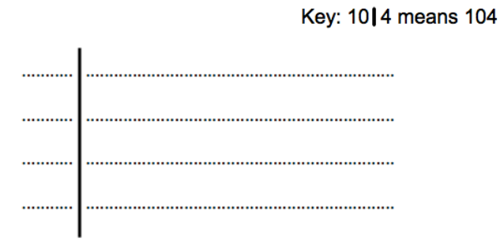
(2 marks)

______ / ______ / ______
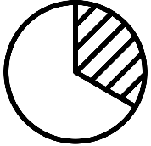
Pie Charts
What are the different statistical diagrams we can use to represent data and how do we interpret them?
How do we read data from and complete a pie chart?
Key Vocabulary
Vocab | Mathematical Definition
Pie Chart | a graph using a divided circle where each section represents a percentage of the total
Frequency | How ‘frequent’ something is. The mathematical word for the total
Angle | the amount of turning between two rays
Proportion | being in proportion means that two ratios or fractions are of equal value.
Population | Everything or everybody that could possibly be involved in an investigation

The Knowledge Phase
Completing Pie Charts
Pie charts are a circle split into different sized sections where each section of the pie chart represents a different category.
They must have a key but do not have to contain any numerical values
Pie charts can be used to:
- represent univariate data
- compare 2 or more sets of unpaired data.

For data sets that are unequal in size we should use proportionate comparative pie charts

IMPORTANT:
They show us the proportion of data within various categories not the total
Without knowing the total population for a pie chart we cannot know the total of each category but we can compare the proportions

To calculate the angle for a given category we use the formula:
$\frac{frequency}{grand total}$ X 360

Historical  Origins | William Playfair — a businessman, engineer and economics writer from Scotland — created the first known pie chart in 1801. Seeking to illustrate the Turkish Empire’s landholdings for his statistical breviary on the European nation-states, Playfair sliced a circle into three wedges whose sizes were determined by land area.
I DO
Complete the pie chart for the following information | 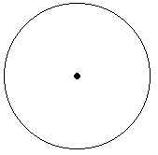
  Colour | Frequency | Angle
  Red | 17
  Blue | 15
  Green | 21
  Yellow | 19

WE DO
Complete the pie chart for the following information
Celebrity | Frequency | Angle
M McIntyre | 23
J Dommett | 34
H Willoughby | 11
L Whitmore | 26

YOU DO
Complete the pie chart for the following information
Flavour | Frequency | Angle
Ready Salted | 8
Salt & Vinegar | 4
Cheese & Onion | 2
Prawn Cocktail | 4

Practice Questions
For each of the following data sets, calculate the angles required and draw the on the pie chart
Car | Frequency | Angle
Ford | 3
Seat | 13
Citroen | 14
VW | 6

b)
Subject | Frequency | Angle
Maths | 3
English | 1
Geography | 2
History | 4

c)
Scent | Frequency | Angle
Floral | 24
Fresh Linen | 18
New Car | 7
Baby Powder | 22

Make | Frequency | Angle
Apple | 61
Samsung | 47
Nokia | 22
Google | 39
The Knowledge Phase
Reading from Pie Charts
Pie charts are a circle split into different sized sections where each section of the pie chart represents a different category. They must have a key but do not have to contain any numerical values
Pie charts can be used to:
- represent univariate data
- compare 2 or more sets of unpaired data.
For data sets that are unequal in size we should use proportionate comparative pie charts
IMPORTANT:
They show us the proportion of data within various categories not the total
Without knowing the total population for a pie chart we cannot know the total of each category but we can compare the proportions
To calculate the number in a given category we use a manipulation of the formula:
proportion X total OR $\frac{angle}{360}$ X total
I DO
The pie chart below represents the 30 students in a class and their choice of drink at break time
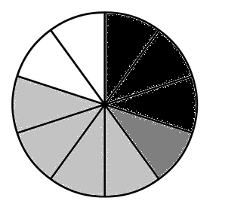
None
Orange
Water
Milk

Calculate the number of pupils who chose milk
WE DO
The pie chart below represents the favourite afternoon TV show of 72 residents in a residential home
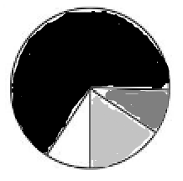
The Chase
Tipping Point
Pointless
Flog it!

240⁰
40⁰
30⁰
50⁰

Calculate the number of pupils who chose each show
YOU DO
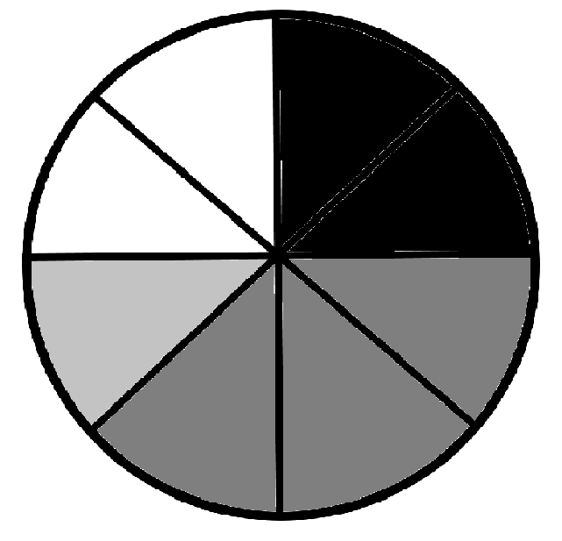The pie chart below represents the number of occupants in each of the 96 cars that passed a certain point between 1-2pm
1 occupant
2 occupants
3 occupants
4+ occupants

How many more cars had one occupants than three?

Practice Questions
- Each of the pie charts below represent 120 people. Calculate the number represented in each section

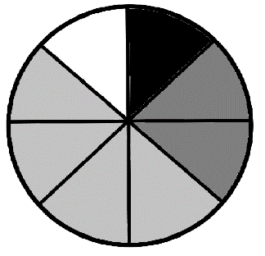

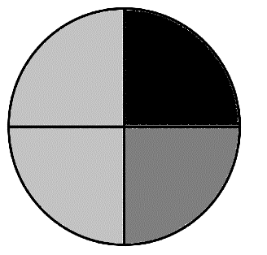

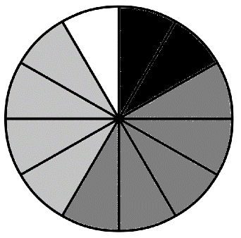

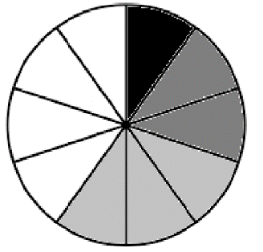

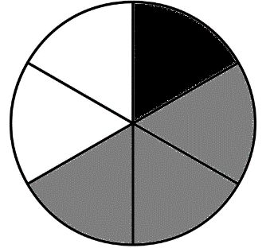

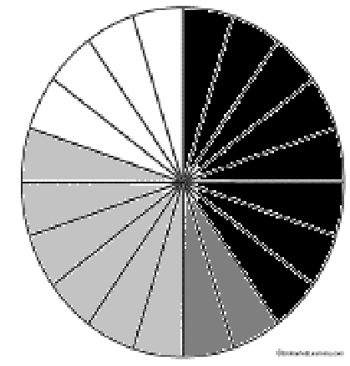

- The pie chart below represents the colour of the 18 socks that are in the bottom of the wash basket
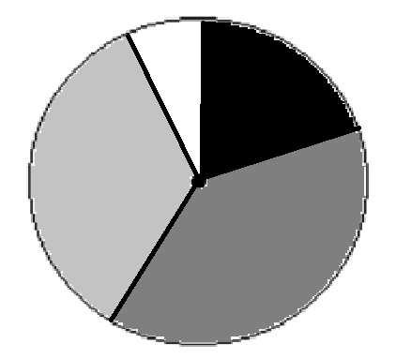
              - How many socks were black?
140⁰
80⁰
20⁰
Black
Blue
Green
White

120⁰

              - How many socks were blue?

              - How many socks were green?

              - How many socks were white?

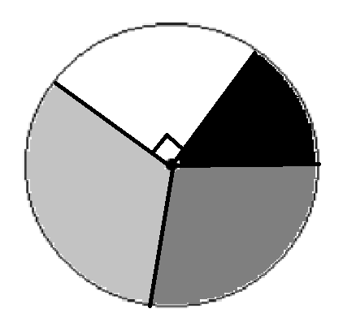
- The pie chart below represents the number of goals scored per match for a season of 108 games
40⁰
110⁰
0 goals
1 goals
2 goals
3+ goals

              - How many matches saw no goals scored?

              - How many matches saw more than 1 goal scored?
120⁰
              - How many more matches saw goals scored than none?

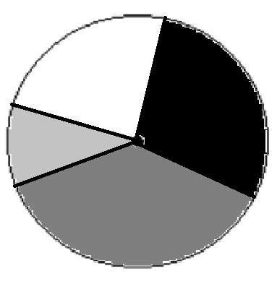
- The pie chart below shows the favourite comedian of 54 employees of the Utilita Arena
160⁰
100⁰
              - Which comedian was most popular with the employees?
M McIntyre
P Kay
R Gilbert
J Carr

80⁰
              - What proportion of employees liked M McIntyre the best?

              - How many employees liked R Gillbert the best?

- The pie chart below shoes the make of car of each of the 180 customers in Tesco at 3pm on Friday
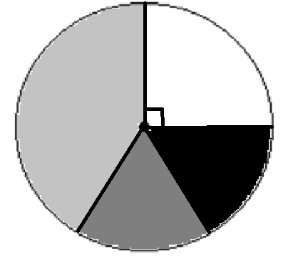
              - What proportion of customers had a Nissan?
Ford
Volkswagen
Range Rover
Nissan

              - How many customers has a Ford?
156⁰
52⁰
              - How many more customers has a Range Rover than a Volkswagen?

The Knowledge Phase
Comparing Pie Charts
Pie charts are a circle split into different sized sections where each section of the pie chart represents a different category.

They must have a key but do not have to contain any numerical values

Pie charts can be used to:
- represent univariate data
- compare 2 or more sets of unpaired data.

For data sets that are unequal in size we should use proportionate comparative pie charts

IMPORTANT:
They show us the proportion of data within various categories not the total
Without knowing the total population for a pie chart we cannot know the total of each category but we can compare the proportions

When comparing two pie charts we must never refer to one being ‘bigger’ or ‘more’ than the other, we must always refer to one having a ‘higher proportion’ than the other

Exam Questions
- The table gives information about the holiday destination of 18 students in a class.
Draw an accurate pie chart to show this information. (4)
Country | Frequency
France | 3
Wales | 4
England | 11

- The table gives information about the dogs in a village
Draw an accurate pie chart to show this information. (4)
Breed | Frequency
Spaniel | 11
Poodle | 7
Greyhound | 4
Jack Russel | 14

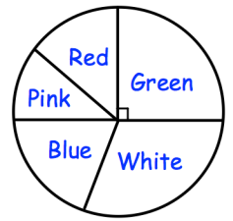
- The pie chart shows the colours of 32 beads.
How many green beads are there? (1)

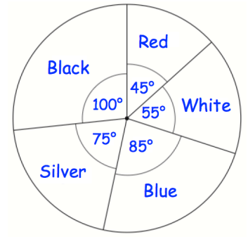
- The pie chart shows the colours of cars in a car park.

(a) What is the most common colour of car in the car park? (1)

(b) What is the least common colour of car park? (1)

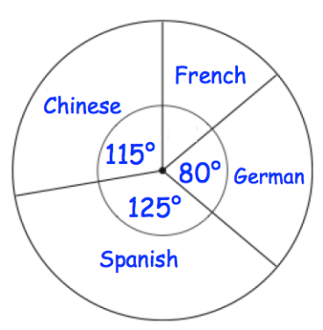
- The pie chart shows information about the languages studied in a school.
There are 648 students in the school.
Each student studies one language.
How many more students study Chinese than French? (4)

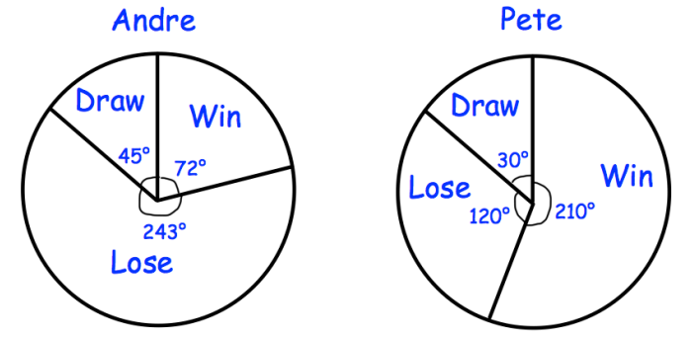
- The pie charts show information about the results of chess matches that two players have played in over the course of a year.

Andre drew 5 matches.
(a) How many matches did Andre win? (2)
Edward says “the pie charts show that Pete won more matches than Andre.”
(b) Is Edward correct? You must explain your answer. (1)
______ / ______ / ______
Comparative Pie Charts
What are the different statistical diagrams we can use to represent data and how do we interpret them?
How do we use comparative pie charts to represent different size populations?
Key Vocabulary
Vocab | Mathematical Definition
Pie Chart | a graph using a divided circle where each section represents a percentage of the total
Frequency | How ‘frequent’ something is. The mathematical word for the total
Angle | the amount of turning between two rays
Proportion | being in proportion means that two ratios or fractions are of equal value.
Population | Everything or everybody that could possibly be involved in an investigation
Comparative | To be able to judge the similarities and differences between two data sets
The Knowledge Phase

Pie charts show the proportion of each category represented on it
When comparing pie charts, without a total, we can only compare the proportion of each category

Comparative pie charts are used to show 2 or more sets of data and allow us to compare totals without values.
To do this accurately you must ensure that the areas of the circles are in the same proportion as the totals displayed on each chart

The larger the area of the pie chart / segment, the large the frequency of the pie chart / segment

Area of a Circle: πr²

Area of comparative pie charts method:
- Calculate the area of pie chart (a)
- Work out the proportion difference between the frequency total of pie chart (a) & (b)
- Multiply the area of pie chart (a) by the proportion difference to give you the area of pie chart (b)
- You may then want to work backwards using the formula for the area of a circle to find the radius of pie chart (b)
I DO
A college has 1000 pupils and another college has 2000 pupils.
A student wants to draw comparative pie charts to represent
the number of students.
He draws a pie chart for the first college with a diameter of
10cm.
Calculate the radius of the pie chart for the second college

WE DO
Information for the number of Freeview devices per household in Bluestone and Peachford are given below
Bluestone |  |  | Peachford
Nº of Devices | Freq |  | Nº of Devices | Freq
0 | 89 |  | 0 | 14
1 | 157 |  | 1 | 90
2 | 848 |  | 2 | 418
3 | 415 |  | 3 | 362
4+ | 91 |  | 4+ | 16
If the radius for the pie chart representing Bluestone is drawn as 2cm, calculate the radius for a comparative pie chart for Peachford.

YOU DO
In 2000, 1000 people chose Fun Package Tours
In 2001, their reputation grew and 20% more people chose
them as their tour operator
Fun Package Tours would like to show this data in their
brochure using pie charts
They chose a radius of 3cm for their 2000 pie chart
What radius should they use for the 2001 pie chart?

Practice Questions
- For each of these pairs of comparative pie charts, choose which has the largest total frequency

- Using the comparative pie charts above, choose all the statements which are definatly true
□ The number of detentions for year 7 in the autumn was more than for year 9 in the autumn
□ There were more females in 2018 than in 2008
□ The number of touchdowns scored by team B was less than team A in the 4th quarter
□ There company had more calls after the 2nd lockdown than before the first lockdown
□ The number of detentions for year 9 in the spring was more than year 7 in the spring
□ There were more males in 2008 than in 2018
□ The number of touchdowns scored by team B was more than team A in the 3rd quarter
□ There were more calls to the company recorded after the 2nd lockdown than after the 1st

- Using the 4 step method, calcuate the radius of the compartive pie chart if:
- There are 211 year 7 students and 252 year 11 students.
The radius for the year 7 pie chart is 3cm
What will the radius of the year 11 pie chart be?
1: _________________________________________________________
2: _________________________________________________________
3: _________________________________________________________
4: _________________________________________________________

- In 2018 the company sold 22514 holidays and in 2019 they sold 1643 holidays
The radius for the pie chart for 2018 was 10cm
What will the radius of the pie chart be for 2019?
1: _________________________________________________________
2: _________________________________________________________
3: _________________________________________________________
4: _________________________________________________________
Exam Questions
- The pie charts show information about the departure country of the overseas visitors to the UK in January 2016 and in July 2016
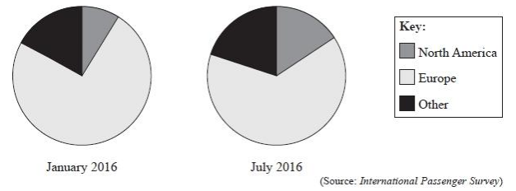
Based on the two pie charts, Raul makes these two conclusions.
1 There are more visitors from Europe than from North America in both months.
2 There are more visitors from Europe in January than in July. (a) Assess the validity of each of Raul's conclusions. (2 marks)
Judith decides to replace the pie charts with comparative pie charts.
(b) Explain how comparative pie charts are more appropriate than pie charts to compare the number of visitors in each month. (1 mark)
The total number of overseas visitors to the UK in January 2016 was 2 599 000 The total number of overseas visitors to the UK in July 2016 was 3 786 000 Judith's comparative pie chart for January 2016 has radius 3 cm.
(c) Calculate the radius of Judith's comparative pie chart for July 2016 Give your answer correct to 1 decimal place. (2 marks)

- Hilary and Mika are investigating the distribution of bees in a nature reserve. Hilary and Mika are producing a report about the nature reserve. They want to include information about the types of small mammals recorded in the nature reserve in one week in 2008 and in one week in 2018 Hilary thinks that they should use pie charts. Mika thinks that they should use comparative pie charts.
(a) What advice would you give to Hilary and to Mika on their choice of diagram? (2 marks)
Mika is drawing his comparative pie charts. He has the following information about the total number of small mammals recorded in one week in 2008 and in one week in 2018 in the nature reserve.
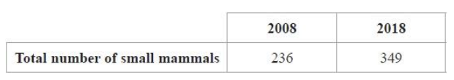
Mika is going to use a circle of radius of 5 cm for his pie chart for 2008
(b) Calculate the radius of the circle that Mika should use for his comparative pie chart for 2018 Give your answer correct to 1 decimal place. (2 marks)

- phones use one of a number of Operating Systems. The table shows information about worldwide sales of mobile phones during Quarter 3 of 2012 and Quarter 3 of 2013
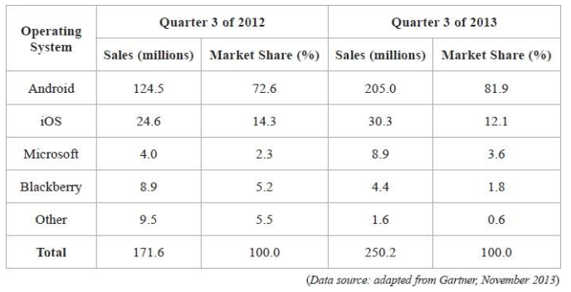
Debra plans to draw comparative pie charts to show the information in the table for each year.
(a) Give a reason why she might do this instead of drawing multiple bar charts. (1 mark)
(b) Find the size of the angle she should use for iOS in the 2012 pie chart. (2 marks)
Debra uses a radius of 5 cm for the 2012 pie chart.
(c) Work out the radius she should use for the 2013 pie chart. (2 marks)

- The pie charts show information about the numbers of visitors to the UK for the given reasons in January 2017 and in July 2017
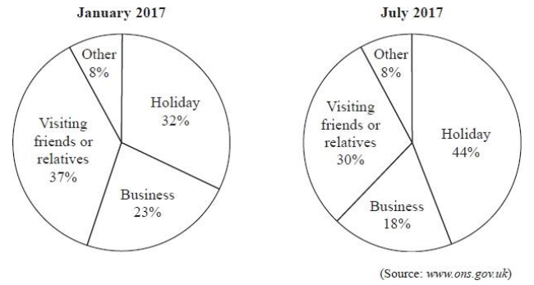
(a) The pie charts do not show that there were more visitors to the UK on business in January 2017 than in July 2017 Explain why. (1 mark)
The number of visitors to the UK in January 2017 in order to visit friends or relatives is 1 080 733
(b) Work out the number of visitors to the UK in January 2017 to have a holiday. (2 marks)
The table gives information about the total number of visitors to the UK in January 2017 and in July 2017
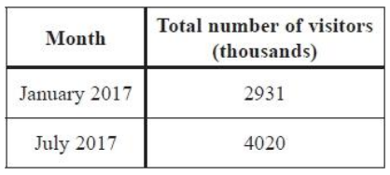
Ruth thinks there is a more appropriate way to draw pie charts now that she knows the information in the table.
(c) Explain, giving reasons, how she should do this. You must refer to the information in the table in your explanation.
(5 marks)
- The comparative pie charts give information about the number of women who got married in 1991 and in 2005 and the age at which they married.
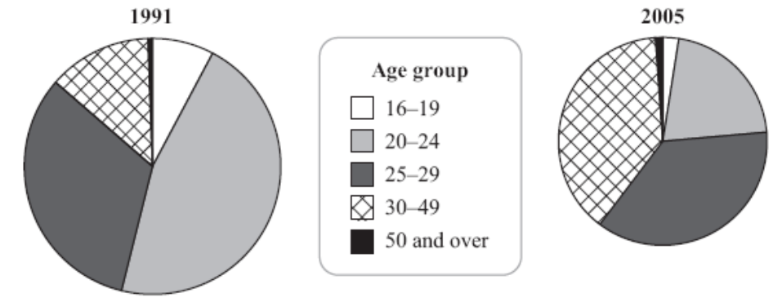
(Source: adapted from www.statistics.gov.uk)
(a) What has happened to the total number of women who married in 2005 compared to the total number in 1991?
Comment on how the pie charts show this.
(2 marks)
(b) Write down the age group with the greatest decrease from 1991 to 2005.
(1 mark)
(c) For the 30–49 age group, describe how the number of women who married changed in 2005 compared to 1991.
Give a reason for your answer.
______ / ______ / ______
Frequency Polygons
What are the different statistical diagrams we can use to represent data and how do we interpret them?
How do we plot a frequency polygon and use them to compare data sets?
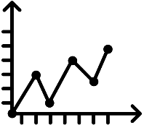
Key Vocabulary
Vocab | Mathematical Definition
Frequency | How ‘frequent’ something is. The mathematical word for the total
Polygon | a plane figure with at least three straight sides and angles, and typically five or more
Skew | when data has a long tail on one side or the other, so it is not symmetrical

The Knowledge Phase
A frequency polygon is a statistical diagram for continuous data.
The x axis represents the continuous variable and the y axis represents the frequency.

To plot a frequency ploygon you should:
- Find the midpoint of each class
- Plot the midpoint again the frequency
- Join up the points with straight lines

It is sometimes introduced as drawing a histogram with equal class widths, then marking the midpoint of the top of each bar and joing them with a straight line but you must remember to rub out the histogram afterwards

2 or more frequency polygons can be plotted on one graph with a key to distinguish between them. This allows for eacy compasrions between sets of continuous data

When comparing data from two or more frequency polygons we should always try to comment on:
Spread: Identify which polygon has the largest range of data
- To caluclate the range you work out the difference between where the graph starts and ends
Average: Identify which polygon has the largest median
- The mode on a frequency polygon is the peak of the graph
Skew: Identify whether each polygon has a positive or negative skew

Positive skew is where the peak
is closer to the start of the graph
Negative skew is where the peak
is closer to the end of the graph

I DO
Plot the data shown in the table below as a frequency polygon on the graph to the right  What do you notice about the skew of the data?
  Age | Freq. | MP
  11 ≤ a < 12 | 12
  12 ≤ a < 13 | 14
  13 ≤ a < 14 | 28
  14 ≤ a < 15 | 20
   | 32
   | 28
   | 24
   | 20
   | 16
   | 12
   | 8
   | 4
   | 0
   | 0 |  | 11 |  |  |  | 12 |  |  |  | 13 |  |  |  | 14 |  |  |  | 15
  Age
WE DO
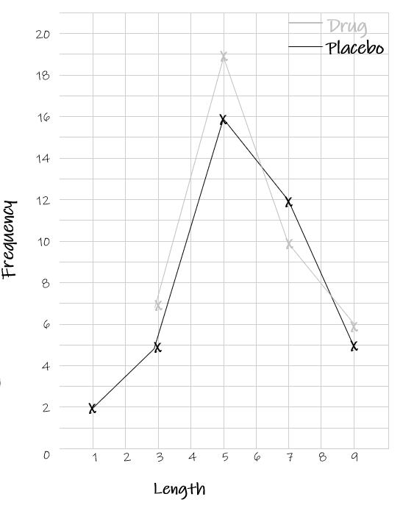 | a) Which group had the largest range of growth?  □ Drug □ Placebo  b) Which group had the longest growth, on average (the mode)?  □ Drug □ Placebo  c) What is the skew for the data for the ‘drug’ group?  □ Positive □ Negative □ Symmetrical  d) What is the skew for the data for the ‘placebo’ group?  □ Positive □ Negative □ Symmetrical
YOU DO
Plot the data shown in the table below as a frequency polygon on the graph to the right  What do you notice about the skew of the data?
  Width | Freq. | MP
  0 ≤ w < 10 | 2
  10 ≤ w < 20 | 7
  20 ≤ w < 30 | 5
  30 ≤ w < 40 | 3
   | 8
   | 7
   | 6
   | 5
   | 4
   | 3
   | 2
   | 1
   | 0
   | 0 |  | 10 |  |  |  | 20 |  |  |  | 30 |  |  |  | 40 |  |  |  | 50
  Width
Practice Questions
Complete frequency polygons for each of the following data sets and detect the skew that can be seen
- Plot the data shown in the table below as a frequency polygon on the graph to the right  □ Positive □ Negative □ Symmetrical
  x | Freq. | MP
  0 ≤ a < 5 | 8
  5 ≤ a < 10 | 9
  10 ≤ a < 15 | 15
  15 ≤ a < 20 | 12
   | 16
   | 14
   | 12
   | 10
   | 8
   | 6
   | 4
   | 2
   | 0
   | 0 |  |  |  | 5 |  |  |  | 10 |  |  |  | 15 |  |  |  | 20
  x
- Plot the data shown in the table below as a frequency polygon on the graph to the right  □ Positive □ Negative □ Symmetrical
  x | Freq. | MP
  0 ≤ a < 100 | 3
  100 ≤ a < 200 | 7
  200 ≤ a < 300 | 7
  300 ≤ a < 400 | 4
   | 8
   | 7
   | 6
   | 5
   | 4
   | 3
   | 2
   | 1
   | 0
   | 0 |  |  |  | 100 |  |  |  | 200 |  |  |  | 300 |  |  |  | 400
  x
- Plot the data shown in the table below as a frequency polygon on the graph to the right  □ Positive □ Negative □ Symmetrical
  x | Freq. | MP
  10 ≤ a < 30 | 25
  30 ≤ a < 50 | 30
  50 ≤ a < 70 | 15
  70 ≤ a < 90 | 5
   | 40
   | 35
   | 30
   | 25
   | 20
   | 15
   | 10
   | 5
   | 0
   | 0 |  | 10 |  |  |  | 30 |  |  |  | 50 |  |  |  | 70 |  |  |  | 90
  x
Exam Questions
- The table shows information about the weights (w grams) of 80 peaches.

Weight (w grams) | Frequency
120 < w ≤ 130 | 7
130 < w ≤ 140 | 13
140 < w ≤ 150 | 18
150 < w ≤ 160 | 28
160 < w ≤ 170 | 14

(a) Draw a frequency polygon for this information.

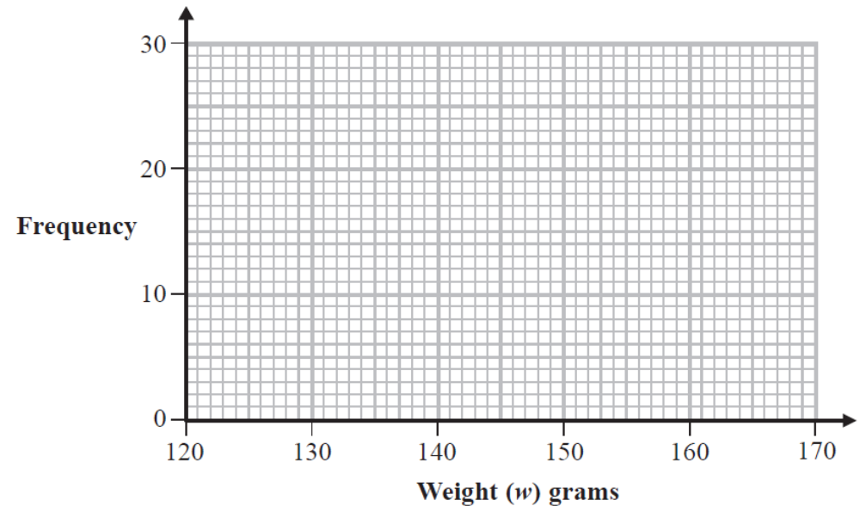
(2)
Marc says that the median weight of these peaches is in the modal class interval.

(b) (i) Write down the modal class interval.
(ii) Does the information support what Marc says?
You must explain your answer. (2)

______ / ______ / ______
Histograms
What are the different statistical diagrams we can use to represent data and how do we interpret them?
How do we read data from and complete a histogram?
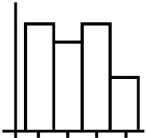
Key Vocabulary
Vocab | Mathematical Definition
Frequency | How ‘frequent’ something is. The mathematical word for the total
Frequency Density | Frequency density is the frequency per unit for the data in each class
Class Width | the difference between the upper-class limit and the lower-class limit of a class interval
Histogram | - a diagram consisting of rectangles whose area is proportional to the frequency of a variable and whose width is equal to the class interval.
Distribution | The way in which data is shared out between the variables
Skew | when data has a long tail on one side or the other, so it is not symmetrical
The Knowledge Phase
Frequency Density
A histogram is an example of a continuous bar chart which is best used for data with unequal class intervals.

Unlike a bar chart, the area of the bar is what represents the frequency rather than the height.

F

FD
CW

Using the formula triangle:
Frequency Density = Frequency Frequency = Frequency Density X Class Width
Class Width
*Where the class width is the difference between the lower and upper bound of the class

A histogram can be used for:
✓ Continuous Data

I DO
Fill in the missing class widths and calculate the necessary frequency densities for the table below
x | Frequency | Class Width | Frequency Density
0 ≤ x < 10 | 8 | 10
10 ≤ x < 20 | 10
20 ≤ x < 40 | 7 | 20
40 ≤ x < 60 | 8
60 ≤ x < 100 | 4 | 40

WE DO
Calculate the missing frequencies and frequency densities for the table below
x | Frequency | Class Width | Frequency Density
0 ≤ x < 5 | 8
5 ≤ x < 10 | 12
10 ≤ x < 20 |  |  | 2.5
20 ≤ x < 50 |  |  | 1.0
50 ≤ x < 100 | 9

YOU DO
Fill in the missing class widths and calculate the necessary frequency densities for the table below
x | Frequency | Class Width | Frequency Density
0 ≤ x < 0.5 |  |  | 12.0
0.5 ≤ x < 1.0 | 17
1.0 ≤ x < 5.0 | 15
5.0 ≤ x < 7.5 |  |  | 4.4
7.5 ≤ x < 10.0 |  |  | 3.2

Practice Questions
- For each of the following frequency tables, calculate the (Class Widths and) Frequency Density required for a histogram

Time, t (secs) | Frequency | Class Width | Frequency Density
0 ≤ t < 5 | 30 | 5 – 0 = 5
5 ≤ t < 10 | 20 | 10 – 5 = 5
10 ≤ t <12 | 26 | 12 – 10 = 2
12 ≤ t < 15 | 27 | 15 – 12 = 3
15 ≤ x < 25 | 50 | 25 – 15 = 10

Length, l (cm) | Frequency | Class Width | Frequency Density
0 ≤ l < 10 | 8 | 10
10 ≤ l < 15 | 8 | 5
15 ≤ l < 20 | 6 | 5
20 ≤ l < 30 | 12 | 10
30 ≤ l < 50 | 16 | 20

Width, w (mm) | Frequency | Class Width | Frequency Density
0 ≤ w < 4 | 12
4 ≤ w < 8 | 8
8 ≤ w < 10 | 10
10 ≤ w < 12 | 9
12 ≤ w < 15 | 15

Time, t (mins) | Frequency | Class Width | Frequency Density
0 ≤ t < 1 | 7
1 ≤ t < 2 | 6
2 ≤ t < 3 | 8
3 ≤ t < 5 | 8
5 ≤ t < 10 | 10

- For each of the following frequency tables, calculate the (Class Widths and) Frequency represented by each frequency density

Depth, d (m) | Frequency | Class Width | Frequency Density
0 ≤ d < 10 |  |  | 2.7
10 ≤ d < 20 |  |  | 3.1
20 ≤ d < 40 |  |  | 1.8
40 ≤ d < 60 |  |  | 1.5
60 ≤ d < 80 |  |  | 0.6

Time, t (hrs) | Frequency | Class Width | Frequency Density
0 ≤ t < 1 |  |  | 5.0
1 ≤ t < 2 |  |  | 6.0
2 ≤ t < 5 |  |  | 3.5
5 ≤ t < 10 |  |  | 2.8
10 ≤ t < 20 |  |  | 0.8

Breadth, b (ft) | Frequency | Class Width | Frequency Density
0 ≤ b < 8 |  |  | 2.5
8 ≤ b < 10 |  |  | 3.5
10 ≤ b < 12 |  |  | 4.0
12 ≤ b < 14 |  |  | 2.5
14 ≤ b < 20 |  |  | 2.0

The Knowledge Phase
Drawing Histograms (unequal class widths)
A histogram is an example of a continuous bar chart which is best used for data with unequal class intervals.

Unlike a bar chart, the area of the bar is what represents the frequency rather than the height.

The height of each bar is therefore the FREQUENCY DENSITY

A histogram can be used for:
✓ Continuous Data

I DO
Complete the histogram for the data shown below
  x | Freq | Class Width | Frequency Density
  0 ≤ x < 4 | 6 | 4 | 1.5
  4 ≤ x < 8 | 8 | 4 | 2.0
  8 ≤ x < 10 | 6 | 2 | 3.0
  10 ≤ x < 12 | 5 | 2 | 2.5
  12 ≤ x < 20 | 8 | 8 | 1.0
   | f.density
   | 0
   | 0 |  | 2 |  | 4 |  | 6 |  | 8 |  | 10 |  | 12 |  | 14 |  | 16 |  | 18
  x

WE DO
Complete the histogram for the data shown below
  x | Freq | Class Width | Frequency Density
  0 ≤ x < 10 | 15 | 10
  10 ≤ x < 20 | 12 | 10
  20 ≤ x < 25 | 10 | 5
  25 ≤ x < 30 | 8 | 5
  30 ≤ x < 40 | 9 | 10
   | f.density
   | 0
   | 0 |  | 4 |  | 8 |  | 12 |  | 16 |  | 20 |  | 24 |  | 28 |  | 32 |  | 36
  x

YOU DO
Complete the histogram for the data shown below
  x | Freq | Class Width | Frequency Density
  0 ≤ x < 1 | 2
  1 ≤ x < 2 | 3
  2 ≤ x < 3 | 2
  3 ≤ x < 5 | 5
  5 ≤ x < 10 | 16
   | f.density
   | 0
   | 0 |  | 1 |  | 2 |  | 3 |  | 4 |  | 5 |  | 6 |  | 7 |  | 8 |  | 9
  x
Practice Questions
- Complete the histogram for the data shown below
  x | Freq | Class Width | Frequency Density
  0 ≤ x < 6 | 12
  6 ≤ x < 12 | 18
  12 ≤ x < 15 | 9
  15 ≤ x < 18 | 6
  18 ≤ x < 24 | 12
   | f.density
   | 0
   | 0 |  | 3 |  | 6 |  | 9 |  | 12 |  | 15 |  | 18 |  | 21 |  | 24
  x
- Complete the histogram for the data shown below
  x | Freq | Class Width | Frequency Density
  0 ≤ x < 4 | 2
  4 ≤ x < 8 | 4
  8 ≤ x < 10 | 3
  10 ≤ x < 12 | 1
  12 ≤ x < 16 | 2
   | f.density
   | 0
   | 0 |  | 2 |  | 4 |  | 6 |  | 8 |  | 10 |  | 12 |  | 14 |  | 16 |  | 18
  x
The Knowledge Phase
Interpreting Histograms (unequal class widths)
A histogram is an example of a continuous bar chart which is best used for
data with unequal class intervals.
CW
F
FD
Unlike a bar chart, the area of the bar is what represents the frequency
rather than the height.

Using the formula triangle:
Frequency = Frequency Density X Class Width
*Where the class width is the difference between the lower and upper bound of the class

This formula can be used for any class width, so if you are asked for a total between two value you may have to work out separate class widths and add them together

When commenting on data from a histogram we should always try to comment on:
Spread: calculate the range of the data
- To caluclate the range you work out the difference between where the graph starts and ends
Average: calculate an estimate for the mean or median
- You will need to calculate the frequency for each class first
Skew: Identify whether each polygon has a positive or negative skew

Positive skew is where the peak
is closer to the start of the graph
Negative skew is where the peak
is closer to the end of the graph

A histogram can be used for:
✓ Continuous Data
I DO
From the histogram shown below, calculate the range, estimate the mean and comment on the skew of the data
f.density | 16
f.density | 14
f.density | 12
f.density | 10
f.density | 8
f.density | 6
f.density | 4
f.density | 2
f.density | 0
 | 0 |  | 2 |  | 4 |  | 6 |  | 8 |  | 10 |  | 12 |  | 14 |  | 16 |  | 18
x

WE DO
From the histogram shown below, calculate the range, state the median class and comment on the skew of the data
f.density | 4.0
f.density | 3.5
f.density | 3.0
f.density | 2.5
f.density | 2.0
f.density | 1.5
f.density | 1.0
f.density | 0.5
f.density | 0
 | 0 |  | 4 |  | 8 |  | 12 |  | 16 |  | 20 |  | 24 |  | 28 |  | 32 |  | 36
x

YOU DO
From the histogram shown below, calculate the range, estimate the mean and comment on the skew of the data
f.density | 16
f.density | 14
f.density | 12
f.density | 10
f.density | 8
f.density | 6
f.density | 4
f.density | 2
f.density | 0
 | 0 |  | 1 |  | 2 |  | 3 |  | 4 |  | 5 |  | 6 |  | 7 |  | 8 |  | 9
x

Practice Questions
From the histogram shown below, calculate the range, state the median class and comment on the skew of the data | Range: ______ - ______ = ______  Data:  Median Class: __________________  Skew: □positive □negative  □symmetrical
  f.density | 1.4
  f.density | 1.2
  f.density | 1.0
  f.density | 0.8
  f.density | 0.6
  f.density | 0.4
  f.density | 0.2
  f.density | 0
   | 0 |  | 5 |  | 10 |  | 15 |  | 20 |  | 25 |  | 30 |  | 35 |  | 40 |  | 45
  X
From the histogram shown below, calculate the range, state the median class and comment on the skew of the data | Range: ______ - ______ = ______  Data:  Median Class: __________________  Skew: □positive □negative  □symmetrical
  f.density | 3.8
  f.density | 2.4
  f.density | 2.0
  f.density | 1.6
  f.density | 1.2
  f.density | 0.8
  f.density | 0.4
  f.density | 0
   | 0 |  | 2 |  | 4 |  | 6 |  | 8 |  | 10 |  | 12 |  | 14 |  | 16 |  | 18
  x
From the histogram shown below, calculate the range, estimate the mean and comment on the skew of the data | Range: ______ - ______ = ______  Data:  Mean Estimate: ________________  Skew: □positive □negative  □symmetrical
  f.density | 2.4
  f.density | 2.1
  f.density | 1.8
  f.density | 1.5
  f.density | 1.2
  f.density | 0.9
  f.density | 0.6
  f.density | 0.3
  f.density | 0
   | 0 |  | 10 |  | 20 |  | 30 |  | 40 |  | 50 |  | 60 |  | 70 |  | 80 |  | 90
  x
Exam Questions
- The table gives information about the lengths of the reigns, in years, of the English Kings and Queens since the year 1014.

Length l (in years) | 0 < l ≤ 5 | 5 < l ≤ 15 | 15 < l ≤ 25 | 25 < l ≤ 45 | 45 < l ≤ 65
Frequency | 12 | 11 | 12 | 8 | 4

The incomplete histogram shows some of these data.

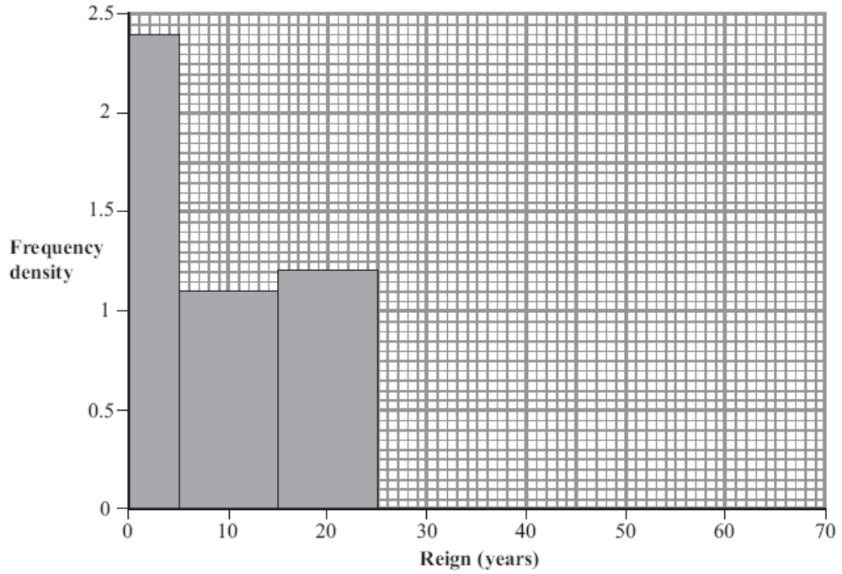

(a) Complete the histogram.
(3)

(b) Estimate how many English Kings and Queens reigned for between 20 and 50 years.

______ / ______ / ______
Cumulative Frequency Polygon
What are the different statistical diagrams we can use to represent data and how do we interpret them?
How do we read data from and complete a cumulative frequency polygon?
Key Vocabulary
Vocab | Mathematical Definition
Continuous | numerical data which is measurable
Frequency | How ‘frequent’ something is. The mathematical word for the total
Cumulative Frequency | A running total calculated by adding each frequency in turn
Polygon | a plane figure with at least three straight sides and angles, and typically five or more
The Knowledge Phase
You use these for a set of continuous data to show how the data grows

You must know the CUMULATIVE FREQUENCY before you can draw one

Cumulative frequency is the total frequency up to and including a particular data point
I DO
Complete the cumulative frequency for the table below
x | 0 | 1 | 2 | 3 | 4 | 5
Frequency | 12 | 15 | 19 | 20 | 8 | 11
C.F

WE DO
Complete the cumulative frequency for the table below
age | 0 - 5 | 6 - 10 | 11 - 15 | 16 - 20 | 21 - 25 | 26 – 30
Frequency | 204 | 115 | 127 | 106 | 94 | 52
C.F

YOU DO
Complete the cumulative frequency for the table below
weight | 12 ≤ w < 14 | 14 ≤ w < 16 | 16 ≤ w < 18 | 18 ≤ w < 20 | 20 ≤ w < 22 | 22 ≤ w < 24
Frequency | 8 | 23 | 37 | 34 | 28 | 17
C.F

Practice Questions
Complete the cumulative frequencies for each of the following tables

x | 5 | 10 | 15 | 20 | 25 | 30
Frequency | 6 | 7 | 8 | 4 | 5 | 6
C.F

X | 0-1 | 1-2 | 2-3 | 3-4 | 4-5 | 5-6 | 6-7 | 7-8
Frequency | 15 | 14 | 17 | 18 | 15 | 12 | 16 | 15
C.F

X | 0 ≤ x < 2 | 2 ≤ x < 4 | 4 ≤ x < 6 | 6 ≤ x < 8 | 8 ≤ x < 10 | 10 ≤ x < 12 | 12 ≤ x < 14
Frequency | 15 | 29 | 34 | 24 | 25 | 16 | 25
C.F

X | 1-10 | 11-20 | 21-30 | 31-40 | 41-50 | 51-60 | 61-70 | 71-80 | 81-90
Frequency | 54 | 51 | 26 | 35 | 68 | 48 | 59 | 64 | 24
C.F

x | 10 ≤ x < 10.5 | 10.5 ≤ x < 11 | 11 ≤ x < 11.5 | 11.5 ≤ x < 12 | 12 ≤ x < 12.5 | 12.5 ≤ x < 13
Frequency | 48 | 41 | 32 | 30 | 26 | 21
C.F

X | 1-100 | 101-200 | 201-300 | 301-400 | 401-500 | 501-600 | 601-700
Frequency | 5 | 7 | 9 | 6 | 5 | 8 | 5
C.F

x | 1 ≤ x < 4.5 | 4.5 ≤ x < 9 | 9 ≤ x < 13.5 | 13.5 ≤ x < 18 | 18 ≤ x < 22.5 | 22.5 ≤ x < 27
Frequency | 84 | 90 | 83 | 79 | 92 | 71
C.F
Cumulative Frequency Polygon
You plot the upper bound of the data (x axis) against the cumulative frequency (y axis) then join the plotted points together with a smooth curve, Once plotted, statistics can then be estimated for the quartiles
A Cumulative Frequency Polygon can be used for Continuous Data ONLY
I DO
Plot the following data on a cumulative frequency curve  Calculate and estimate for the range
  weight | frequency
  90 ≤ w < 100 | 8
  100 ≤ w < 110 | 12
  110 ≤ w < 120 | 6
  120 ≤ w < 130 | 3
  c.frequency
  c.frequency | 0
  weight
WE DO
Plot the following data on a cumulative frequency curve  Calculate and estimate for the median
  height | frequency
  20 ≤ h < 40 | 17
  40 ≤ h < 60 | 6
  60 ≤ h < 80 | 2
  80 ≤ h < 100 | 11
  c.frequency
  c.frequency | 0
  height
YOU DO
Plot the following data on a cumulative frequency curve  Calculate and estimate for the inter-quartile range
  time | frequency
  0 ≤ t < 60 | 9
  60 ≤ t < 120 | 13
  120 ≤ t < 180 | 18
  180 ≤ t < 240 | 1
  c.frequency
  c.frequency | 0
  time
Practice Questions
- Plot the following data on a cumulative frequency curve  Calculate and estimate for the range
  width | frequency
  5 ≤ w < 10 | 19
  10 ≤ w < 15 | 12
  15 ≤ w < 20 | 5
  20 ≤ w < 25 | 0
  25 ≤ w < 30 | 17
  c.frequency
  c.frequency | 0
  width
- Plot the following data on a cumulative frequency curve  Calculate and estimate for the median
  mass | frequency
  0 ≤ m < 1 | 5
  1 ≤ m < 2 | 10
  2 ≤ m < 3 | 11
  3 ≤ m < 4 | 4
  c.frequency
  c.frequency | 0
  mass
- Plot the following data on a cumulative frequency curve  Calculate and estimate for the 20th – 80th inter-percentile range
  speed | frequency
  0 ≤ s < 2 | 19
  2 ≤ s < 4 | 20
  4 ≤ s < 6 | 6
  6 ≤ s < 8 | 3
  8 ≤ s < 10 | 8
  c.frequency
  c.frequency | 0
  speed
Exam Questions
- The table shows information about the number of car journeys per person in a year that are a distance of between 0 and 50 miles. The information is based on a sample of 382 people from the 2016 National Travel Survey.
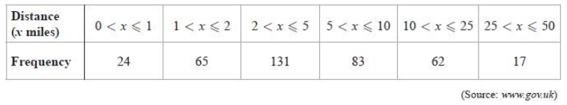
(a) Complete the cumulative frequency table for the information above. (1 mark)
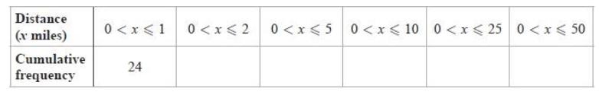
(b) Draw a cumulative frequency diagram for this information (3 marks)
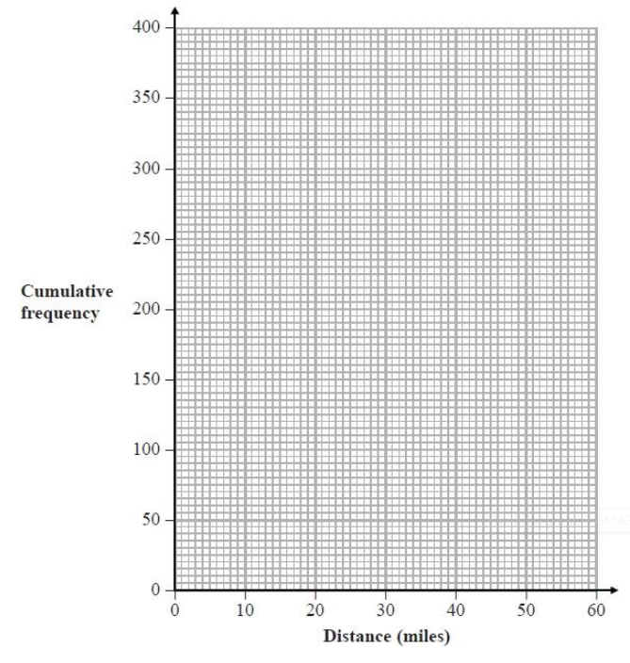
In the same survey, the median distance travelled by train for a sample of people was 11.3 miles. Hamish says, "The information collected in the survey shows that people in these samples travel on average further by train than by car."
c) Assess whether or not Hamish's conclusion is appropriate. (2 marks)
Hamish recorded the number of passengers travelling on 250 buses.
Information about his results is shown in the cumulative frequency table below.
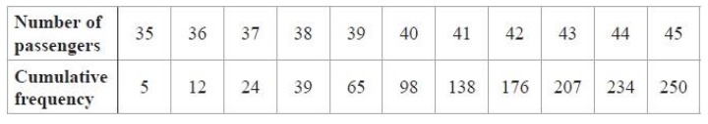
Hamish plans to draw a cumulative frequency step polygon for his results rather than the type of cumulative frequency diagram drawn in part (b).
(d) Explain why Hamish's plan is appropriate. (1 mark)

- The cumulative frequency diagram shows some information about the heights, in metres, of a random sample of 50 of the tallest roller coasters in the world.
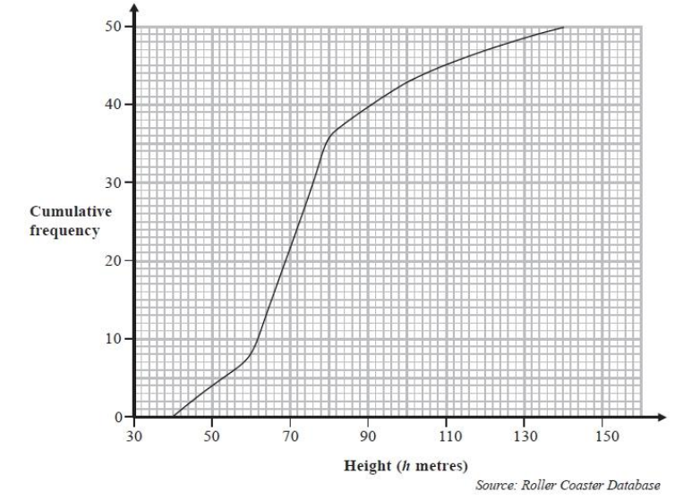
(a) Write down the number of roller coasters with a height of 80 metres or less. (1 mark)
(b) Work out an estimate of the number of these roller coasters with a height between 60 metres and 110 metres.
(2 marks)
A safety company is going to inspect roller coasters with a height greater than 86 metres.
(c) Calculate an estimate of the percentage of the 50 roller coasters that the safety company is going to inspect.
(3 marks)
- The cumulative frequency diagram gives information about the heights, in metres, of a sample of 100 oak trees in Camden, London.
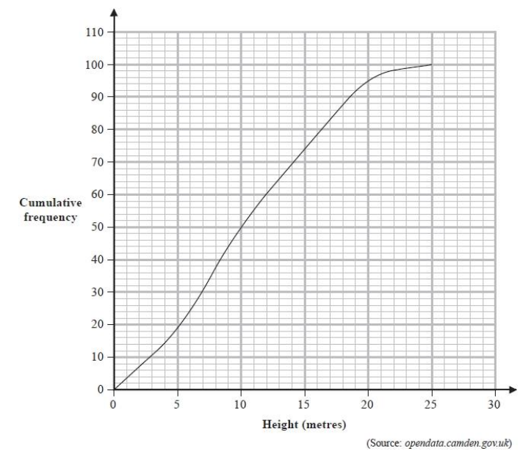
Using the cumulative frequency diagram, complete the table below for the heights of these 100 trees.
  - marks)
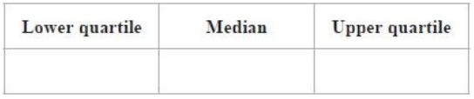

- Kunal was investigating the ages of owners of electronic tablets. He used information from a survey carried out in the USA in 2012 to find the age distribution for a representative 100 people. Kunal then drew this cumulative frequency graph for his information.
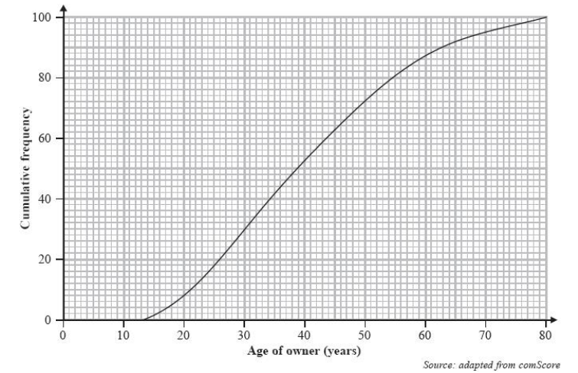
(a) Find the number of these electronic tablet owners that are
(i) under 30 years old,
(ii) between 60 and 70 years old.
(3 marks)
Kunal wants to use this survey to predict the percentage of electronic tablet owners in the United Kingdom that are under 30 years old. (b) Explain whether or not it is sensible to use the results of this survey for his prediction.
(2 marks)
This table gives information, from the same 2012 USA survey, about the ages of owners of smartphones.
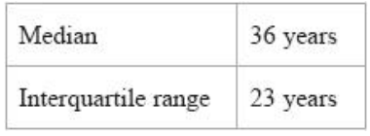
(c) Use the information from the table and from the graph to compare the ages of owners of electronic tablets with the ages of owners of smartphones in the USA.
(4 marks)

- The cumulative frequency diagram shows the distribution of ages of a sample of 100 teachers in the UK.
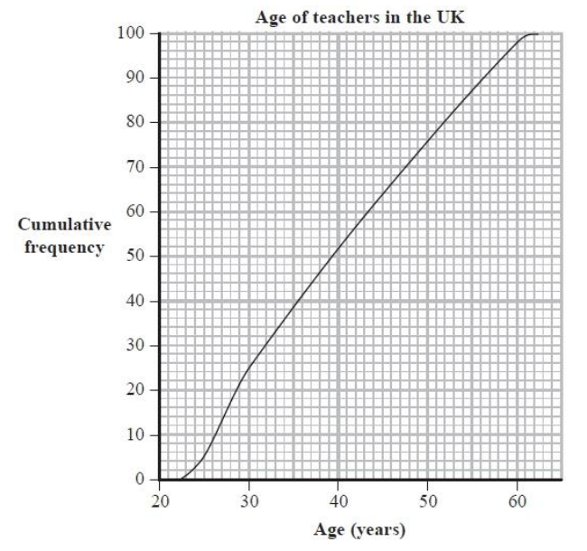
Complete this table for the ages of these 100 teachers.
(2 marks)
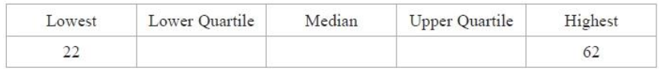
______ / ______ / ______
Cumulative Frequency Step Polygon
What are the different statistical diagrams we can use to represent data and how do we interpret them?
How do we read data from and complete a cumulative frequency step polygon?
Key Vocabulary
Vocab | Mathematical Definition
Discrete | numerical data which is countable
Frequency | How ‘frequent’ something is. The mathematical word for the total
Cumulative Frequency | A running total calculated by adding each frequency in turn
Polygon | a plane figure with at least three straight sides and angles, and typically five or more
The Knowledge Phase
You use these for a set of discrete data to show how the data grows

You must know the CUMULATIVE FREQUENCY before you can draw one

Cumulative frequency is the total frequency up to and including a particular data point

You plot the data (x axis) against the cumulative frequency (y axis) then join the plotted points together in steps
YOU MUST DRAW THE STEPS ACROSS and the UP

As with a cumulative frequency polygon once plotted, statistics can then be estimated for the quartiles

A Cumulative Frequency Step Polygon can be used for:
✓ Discrete Data

I DO
Plot the following data on a cumulative frequency step polygon  Calculate and estimate for the range
  Siblings | frequency
  0 | 2
  1 | 5
  2 | 9
  3 | 12
  c.frequency
  c.frequency | 0
  siblings
WE DO
Plot the following data on a cumulative frequency step polygon  Calculate and estimate for the median
  Eggs | frequency
  1 | 8
  2 | 9
  3 | 4
  4 | 7
  c.frequency
  c.frequency | 0
  eggs

YOU DO
Plot the following data on a cumulative frequency step polygon  Calculate and estimate for the 30th – 70th inter-percentile range
  Pens | frequency
  5 | 5
  10 | 0
  15 | 2
  20 | 9
  c.frequency
  c.frequency | 0
  pens
Practice Questions
- Plot the following data on a cumulative frequency step polygon  Calculate and estimate for the range
  nails | frequency
  10 | 8
  11 | 10
  12 | 11
  13 | 16
  c.frequency
  c.frequency | 0
  width

- Plot the following data on a cumulative frequency step polygon  Calculate and estimate for the inter-quartile range
  bags | frequency
  1 | 2
  2 | 8
  3 | 4
  4 | 7
  5 | 9
  c.frequency
  c.frequency | 0
  mass

- Plot the following data on a cumulative frequency step polygon  Calculate and estimate for the median
  score | frequency
  11 | 1
  12 | 5
  13 | 7
  14 | 0
  15 | 4
  c.frequency
  c.frequency | 0
  speed
Exam Questions
The cumulative frequency step polygon shows information about the numbers of students in the 48 teaching sets in Year 12 at Pearson Academy.
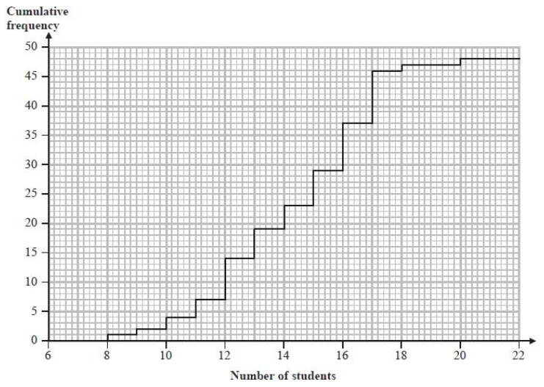
(a) For the numbers of students in the teaching sets, find
(i) the median,
(ii) the interquartile range,
(iii) the mode.
(4 marks)
(b) Write down the number of students in the largest teaching set.
(1 mark)
(c) Find the number of teaching sets which have more than 16 students.
(2 marks)

______ / ______ / ______
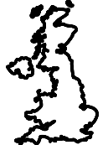
Choropleth Maps
What are the different statistical diagrams we can use to represent data and how do we interpret them?
How do we read data from and complete a choropleth map?
Key Vocabulary
Vocab | Mathematical Definition
Choropleth Map | a statistical diagram used to show the density of populations in different areas

The Knowledge Phase
Choropleth maps are a statistical diagram used to show the density of populations in different areas.
They are presented on maps, sometimes of an area, a county or even the world.
There must be a key to show the density each colour represents.
We usually see that the higher the density, the darker the shading.

Cross-Curricular  Link | A choropleth map is appropriate when presenting data for geographical areas and regions. Common uses of choropleth maps include presenting population density (e.g. the number of people per km2), weather and climate data and development indicators such as GDP and life expectancy.

I DO
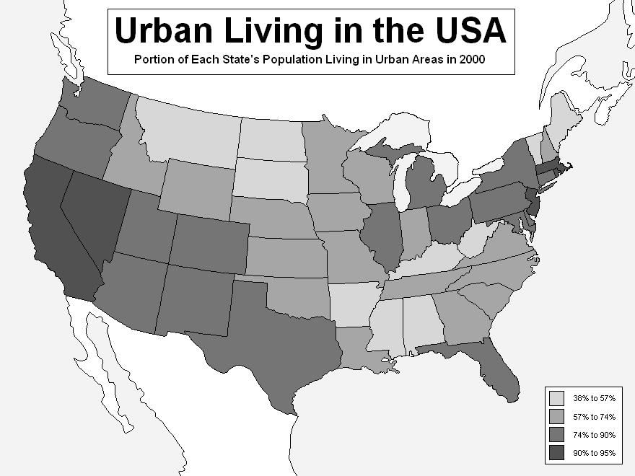
The choropleth map represents the proportion of each states population living in urban areas in 2000.
How many states has a proportion of over 90% of its population living in urban areas in 2000?
WE DO
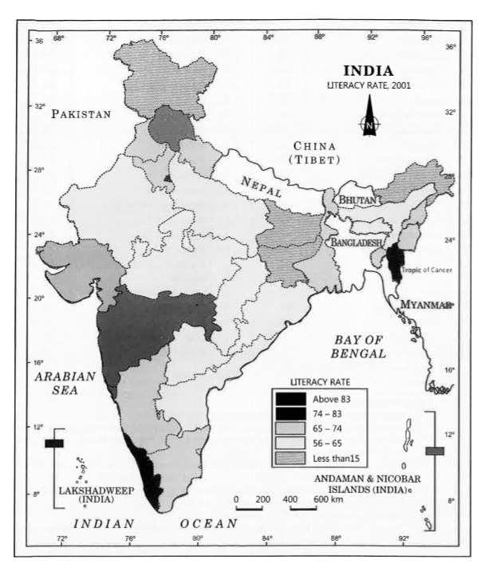
The choropleth map shows the literacy rate of the different regions on India from 2001
What is the modal literacy rate across the country?

YOU DO
STAGE

0 seats | 1-5 seats | 6-10 seats | 11-20 seats | 21-50 seats
The choropleth map shows the number of seats occupied in the 12 different areas of a theatre.
Where have the majority of the audience decided to sit?
Why do you think this is?
Practice Questions

- This diagram shows the percentage change in life satisfaction in the UK.
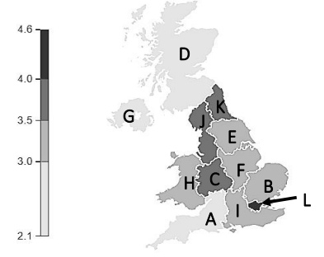
(a) Which region has the biggest increase in life satisfaction occurred?
(b) Which regions had between 2.1% and 3% increase in life satisfaction?

- The diagram shows the amount of litter in a small town.
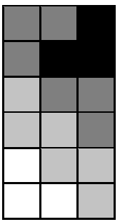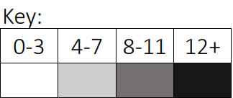
There is a fast food restaurant in town. Where would you expect this to be situated?

- The diagrams show sea temperatures in Peru. Compare the sea temperatures in Peru in 1981 and 1983.
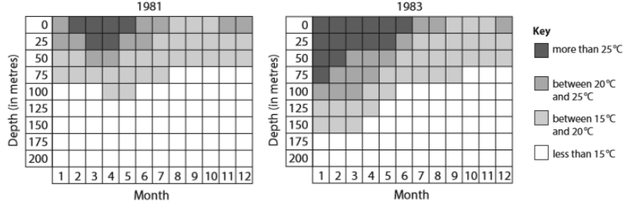
The Knowledge Phase
How to Make a Choropleth Map
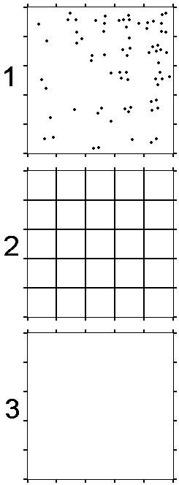
1) Look at picture number 1 on the right. Each dot in the square represents a child standing in the school playground.
2) Using a ruler and a pencil, join up the markers on opposite sides of the square. You will need to draw 8 straight lines. When you have done this, you will have made a grid (with 25 squares in total).

3) Count the number of children in each square in picture 1, and write down that number in the correct square on picture 2.

4) On picture 3, join up the markers on opposite sides of the square. Now, colour in the squares on this picture using the correct shading from the key below:
Number of children  in each square | Density | Shading
0 - 2 | Low | Light
3 - 5 | Medium | Medium
6 - 8 | High | Dark

5) Now look at your results. Why do you think children are not spread evenly across the playground? Suggest some possible reasons in the space below.

Practice Questions

- The map below shows the distribution of students on a school playground.
  - Use the key to complete the choropleth map on the right

 | A | B | C | D |  | KEY |  |  | A | B | C | D
E | 2 | 1 | 3 | 0 |  |  | 0 - 3 | E
F | 1 | 2 | 3 | 2 |  |  | 4 – 7 | F
G | 5 | 8 | 6 | 9 |  |  | 8 – 11 | G
H | 7 | 14 | 11 | 12 |  |  | 12 + | H

  - Which area of the map is the darkest? _______________________
  - Give a reason for this
______________________________________________________________________________________________________________________________________________________________________________________________

- The map below shows the distribution of sharks spotted in a section of the ocean.
  - Use the key to complete the choropleth map on the right

 | A | B | C | D |  | KEY |  |  | A | B | C | D
E | 12 | 13 | 16 | 21 |  |  | 0 – 9 | E
F | 15 | 24 | 26 | 28 |  |  | 10 – 19 | F
G | 34 | 31 | 28 | 26 |  |  | 20 -29 | G
H | 15 | 7 | 4 | 9 |  |  | 30 + | H

  - Which area of the map is the lightest? _______________________
  - Give a reason for this
______________________________________________________________________________________________________________________________________________________________________________________________

- The map below shows the % of positive cases in various areas of a work building.
  - Use the key to complete the choropleth map on the right.

 | A | B | C | D |  | KEY |  |  | A | B | C | D
E | 12 | 8 | 2 | 1 |  |  | 0 – 4 | E
F | 6 | 3 | 1 | 0 |  |  | 5 – 9 | F
G | 5 | 2 | 0 | 1 |  |  | 10 – 14 | G
H | 0 | 1 | 0 | 0 |  |  | 15 + | H

  - Which area of the map is the darkest? _______________________
  - Give a reason for this
______________________________________________________________________________________________________________________________________________________________________________________________

Exam Questions
1. The diagram represents a children's playground that has been divided into 20 squares of equal area.
In the playground there are some children and some play equipment only.
The number of children in each square at 11 am one Saturday is shown below.
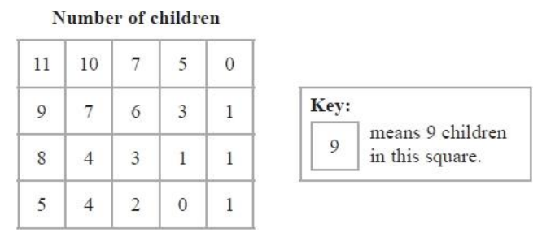

(a) Use the information above to complete this choropleth map.
(2 marks)
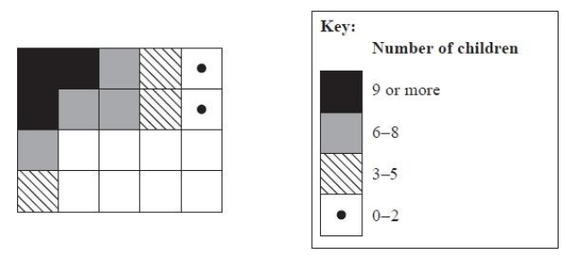

Grace concludes that there is likely to be more play equipment in that part of the playground represented by the squares in the top left hand corner of the choropleth map than elsewhere in the playground.
(b) Assess the validity of Grace's conclusion with reference to the choropleth map.
- mark)

2. Hilary and Mika are investigating the distribution of bees in a nature reserve.
They have divided the nature reserve into 36 squares of equal size.
The number of bees observed in each square in a fixed time period was recorded.
The number of wildflowers observed in each square was also recorded.
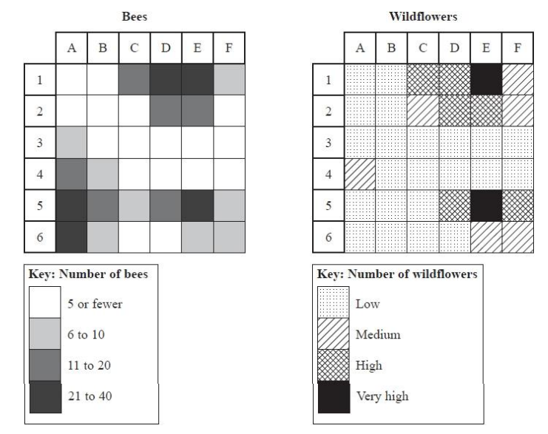
The choropleth maps below are drawn using this information.

Hilary says that there are more bees in those regions of the nature reserve with greater numbers of wildflowers.
Does the information in the choropleth maps support her conclusion? Give reasons for your answer.
(2 marks)

 | Historical  Origins |  | The earliest known choropleth map was created in 1826 by Baron Pierre Charles Dupin, depicting the availability of basic education in France by department. ... The term "choropleth map" was introduced in 1938 by the geographer John Kirtland Wright, and was in common usage among cartographers by the 1940s.
______ / ______ / ______
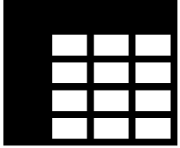
Two Way Tables
 |  | What are the different statistical diagrams we can use to represent data and how do we interpret them?
 |  | How do we read from and complete Two Way Tables?
Key Vocabulary
Vocab | Mathematical Definition
Two-Way Table | a statistical diagram that is used to present two sets of data simultaneously

The Knowledge Phase
A two-way table is a statistical diagram that is used to present two sets of data simultaneously.

We need to be able to interpret data from a two-way table and complete missing data from a two-way table.

When interpreting data, we must look at the column and row title for each value.

When completing missing data from a two-way table we must complete each row or column which has only one piece of data missing. If there is more than one piece of data missing, we cannot work it out straight away and must do a different missing value first.

A two-way table can be used for:
✓ Qualitative Data
✓ Discrete Data
✓ Continuous Data (if presented in groups)

I DO
   | Right | Left
   | Handed | Handed | Total
  Men | 15 | 15 | 30
  Women | 9 | 16 | 25
  Total | 24 | 31 | =
  Fill in any missing values form the table and state:
  (a) | The total number of right-handed men surveyed
  (b) | The total number of females surveyed
  (c) | The total number of left-handed people surveyed
  (d) | The total number of people surveyed

WE DO
   | French | German | Spanish | Total
  Male | 13 | 25 | 13 | 51
  Female | 14 | 20 | 13 | 47
  Total | 27 | 45 | 26 | 98
  Fill in any missing values form the table and state:
  (a) | The total number of Males French students surveyed
  (b) | The total number of German Female students surveyed
  (c) | The total number of Spanish students surveyed
  (d) | The total number of students surveyed

YOU DO
   | Maths | English | Total
  Females | 20 | 3 | 23
  Males | 22 | 27 | 49
  Total | 42 | 30 | 72
  Fill in any missing values form the table and state:
  (a) | The number of females taking maths
  (b) | The number of males taking English
  (c) | The total number of females questioned
  (d) | The total number of people questioned

Practice Questions

 | Cats | Dogs | Other | Total
Boys | 21 | 12 | 14 | 47
Girls | 10 | 25 | 7 | 42
Total | 31 | 37 | 21 | 89

Fill in any missing values form the table and state:
- The total number of Boys who prefer dogs
- The total number of Girls who prefer other pets
- The total number of boys surveyed
- The total number of people who preferred cats

 | Blue | Eye Colour | Other | Total
  Brown
 | 7 | 11 | 8 | 26
  Black
Brown | 5 | 4 | 6 | 15
Blonde | 4 | 4 | 10 | 18
Red  Hair Colour | 12 | 6 | 10 | 28
Other | 8 | 12 | 5 | 25
Total | 36 | 37 | 39 | 112
- The total number of students with black hair
- The total number of students with red hair
- The total number of students with blue eyes
- The total number of students with the same coloured eyes as hair

- Look at the following two-way table. Fill in the missing numerical values and then fill in the blanks of information below

Birth Month |  | Year 7 | Year 8 | Year 9 | Total
Birth Month | Jan – June | 118 |  | 127
Birth Month | July - Dec | 145 | 161 |  | 482
Birth Month | Total |  | 304

- There are ______ year 7 students whose birthday is in Jan-June
- There are ______ year 8 students whose birthday is in Jan-June
- There are ______ year 9 students whose birthday is in Jan-June
- There are ______ year 7 students whose birthday is in July-Dec
- There are ______ year 8 students whose birthday is in July-Dec
- There are ______ year 9 students whose birthday is in July-Dec
- There are ______ students in year 7
- There are ______ students in year 8
- There are ______ students in year 9
- There are ______ students whose birthday is in Jan-June
- There are ______ students whose birthday is in July-Dec
- There are ______ students altogether in Key Stage 3
- The year group with the most students is ______
- The year group with the least students is ______
- In year 7 more people have their birthday in _____________________
- In year 8 more people have their birthday in _____________________
- In year 9 more people have their birthday in _____________________
Exam Questions
- A holiday in which people can visit two cities is called a two-centre holiday.
A travel company offers four two-centre holidays.
The two-way table shows the numbers of these holidays booked in 2010.
 | Venice | Rome | Total
Geneva | 24 | 26
Paris | 32 | 12
Total

(a) Complete the two-way table. (2)
(b) Which of the two-centre holidays did most people choose?
Give a reason for your answer. (2)
- The table shows information about the membership of a tennis club.
Type of member | male | female | Total
Adult | 43 | 31
Teenage | 12 | 10 | 22
Junior | 10 |  | 24
Total |  | 55 | 120

Complete the table. (1)
- A researcher caught moths in two different traps.
The two traps were put in the same part of a wood.
Two different types of moths were caught in the traps.
The two-way table shows information about the numbers of moths caught.
 | Trap 1 | Trap 2 | Total
Moth Type A | 8 | 16
Moth Type B | 32 | 12
Total |  |  | 68

Complete the table. (2)
______ / ______ / ______

Misleading Diagrams
What are the different statistical diagrams we can use to represent data and how do we interpret them?
How can graphs be presented to mislead us in out interpretations?
Key Vocabulary
Vocab | Mathematical Definition
Misleading | Manipulating the truth to give the wrong idea or impression

The Knowledge Phase
Statistics is the practice of collecting, organizing, and representing large amounts of numerical data.
These are used to present summarised information to large volumes of people, often people who would not understand the raw data itself.
Misleading Statistics can come in the form of numerical values or statistical diagrams.
- Misleading statistics are never false
- They are usually vague statements that use basic statistics
- They are true statistics that have been manipulated to show only certain information and hide other parts.
- They are used to make things appear better or more popular than they really are (or vice versa)

Misleading diagrams
What to look for (these are all negative points)

- Missing labels on axis
- Scales not starting at zero
- Unequal gaps between equal numbers
- 3D graphs
- Incorrectly calculated angles
- Percentages that don't add up to 100%
- Different scales used for comparing graphs
- No key where necessary

Real World  Application | Misleading diagrams are seen in the media constantly on the TV, on social media and on advertisments.
I DO
□ Missing labels on axis
□ Scales not starting at zero
□ Unequal gaps between equal numbers
□ 3D graphs
□ Incorrectly calculated angles
□ Percentages that don't add up to 100%
□ Different scales used for comparing graphs
□ No key (where necessary)

WE DO
□ Missing labels on axis
□ Scales not starting at zero
□ Unequal gaps between equal numbers
□ 3D graphs
□ Incorrectly calculated angles
□ Percentages that don't add up to 100%
□ Different scales used for comparing graphs
□ No key (where necessary)

YOU DO
 | □ Missing labels on axis  □ Scales not starting at zero  □ Unequal gaps between equal numbers  □ 3D graphs  □ Incorrectly calculated angles  □ Percentages that don't add up to 100%  □ Different scales used for comparing graphs  □ No key (where necessary)
  1 | 2 3 3 5
  2 | 2 5 8
  3 | 1 1 1 2
  4 | 2 4 7 8 9
  5 | 0 2
  6 | 1 5 6 9
  7 | 0

Exam Questions
- A national newspaper printed this bar chart.
Re-offending for serious offences in England and Wales 2006–2007
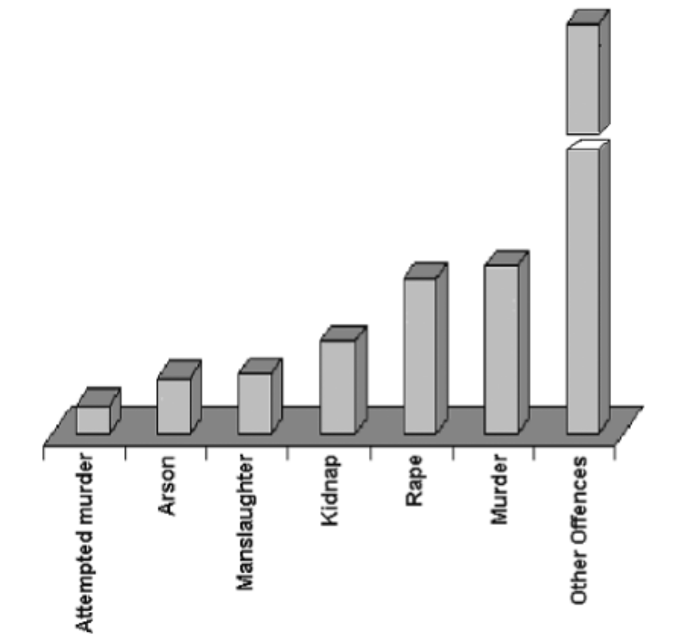
(Source: adapted from Ministry of Justice Information)
Write down three ways in which this bar chart is misleading. (3)

2. The graph shows the number of secondary schools in the UK that became Academies
between April 2011 and April 2012.
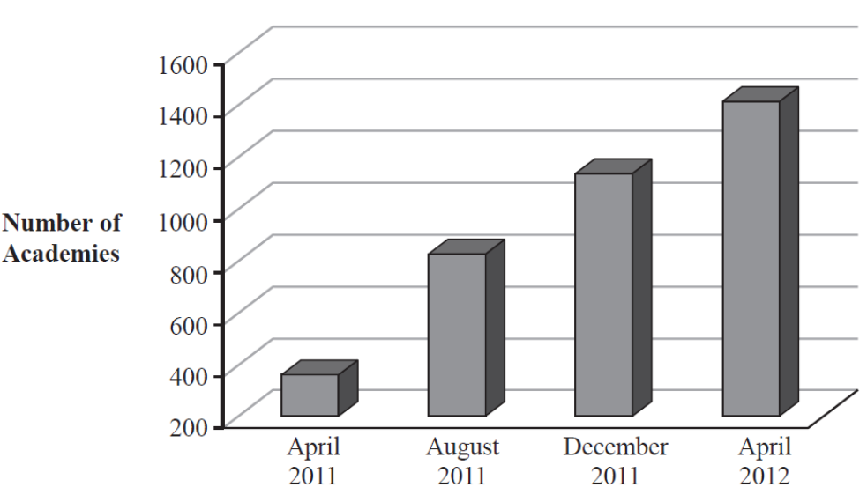
(Data source: Department for Education)
Give two reasons why this graph may be seen as misleading. (2)
3. The graph gives information about regular household waste and recycling in England.
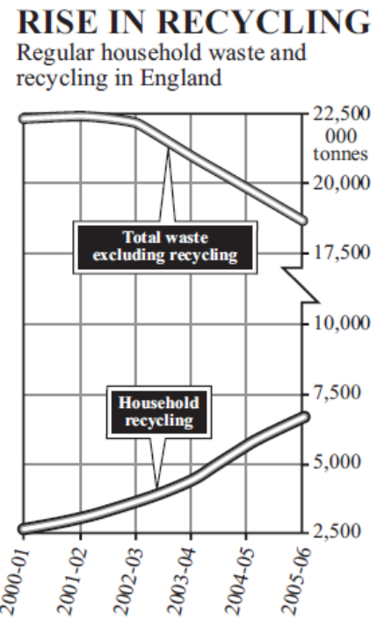Household
(Source: Dept. for Environment, Food and Rural Affairs 2008)

Describe three features of the graph that are misleading. (3)

4. The pie chart shows information about the numbers of officers in the Royal Navy, Army and Air Force.
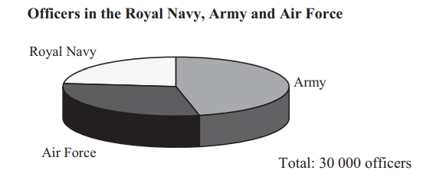
The pie chart is misleading.
(a) Write down one reason why. (1)

A new pie chart is to be drawn which is not misleading. The number of officers in the Royal Navy is 7000
(b) Calculate the angle needed for the Royal Navy. (2)
5. The pie chart gives information about land use in the U.K.
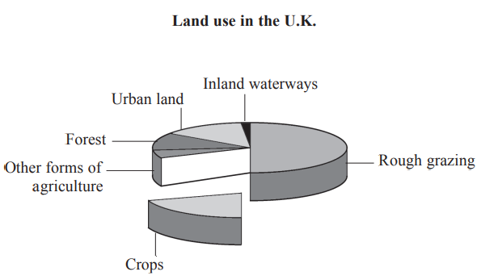
(Source: www.sustainable-development.gov.uk) Describe two features of the diagram that can be misleading. 1
(2)
Key words to learn

Formulas to learn
Copyright List
https://corbettmaths.com/wp-content/uploads/2013/02/bar-charts-tally-charts-and-pictograms-pdf.pdf
https://d7dae41c-6434-48e6-a64a-691272fdccba.usrfiles.com/ugd/d7dae4_460bc12e7c7b48d0b832b17840875e0d.pdf
https://d7dae41c-6434-48e6-a64a-691272fdccba.usrfiles.com/ugd/d7dae4_02839111b01e4408a01888ea730b3c62.pdf
https://d7dae41c-6434-48e6-a64a-691272fdccba.usrfiles.com/ugd/d7dae4_923fb210a8db4f6399ffb5e838181fbd.pdf
https://corbettmaths.com/wp-content/uploads/2013/02/stem-and-leaf-pdf.pdf
https://d7dae41c-6434-48e6-a64a-691272fdccba.usrfiles.com/ugd/d7dae4_3cd56ae5df4b491ab8e0b243a9ebe940.pdf
h ttps://www.mathsgenie.co.uk/resources/2-bar-charts.pdf
https://corbettmaths.com/wp-content/uploads/2013/02/drawing-pie-charts-pdf.pdf
https://corbettmaths.com/wp-content/uploads/2013/02/reading-pie-charts-pdf.pdf
https://www.tes.com/resources/search/?q=choropleth%20map&sortBy=lowestPrice&page=2
chadrobin.blogspot.com/2011/04/choropleth-map-urban-percentage.html
https://www.learncbse.in/practical-work-in-geography-class-12-solutions-chapter-3/
https://www.teachingideas.co.uk/maps-and-atlases/how-to-make-a-choropleth-map

