
Mathematics and Statistics Department

Knowledge Book
GCSE Statistics
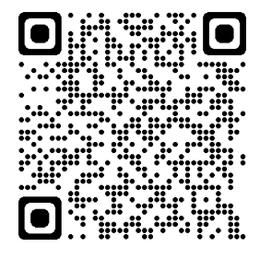
Term 10.3
Statistical Representation and Interpretation
Scan here for revision materials
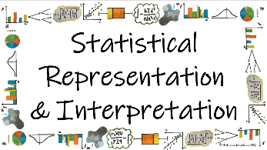
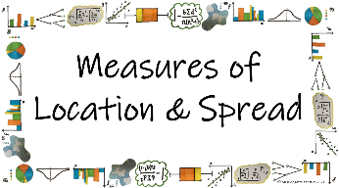
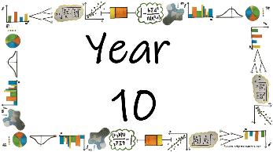
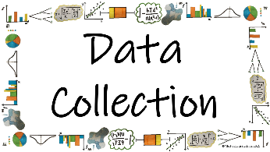

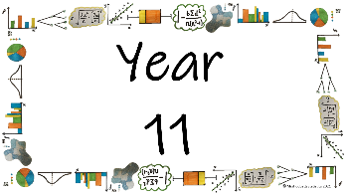
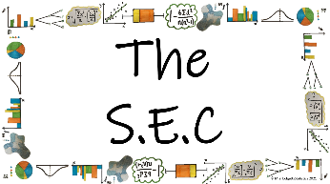
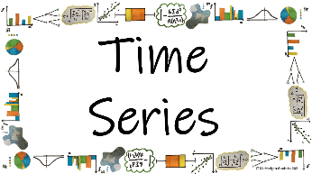
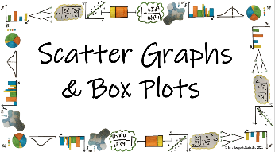

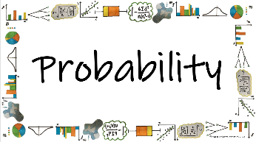
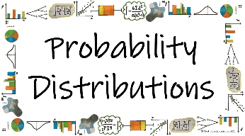
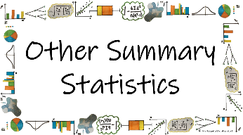


Name: ______________________
Teacher: ______________________
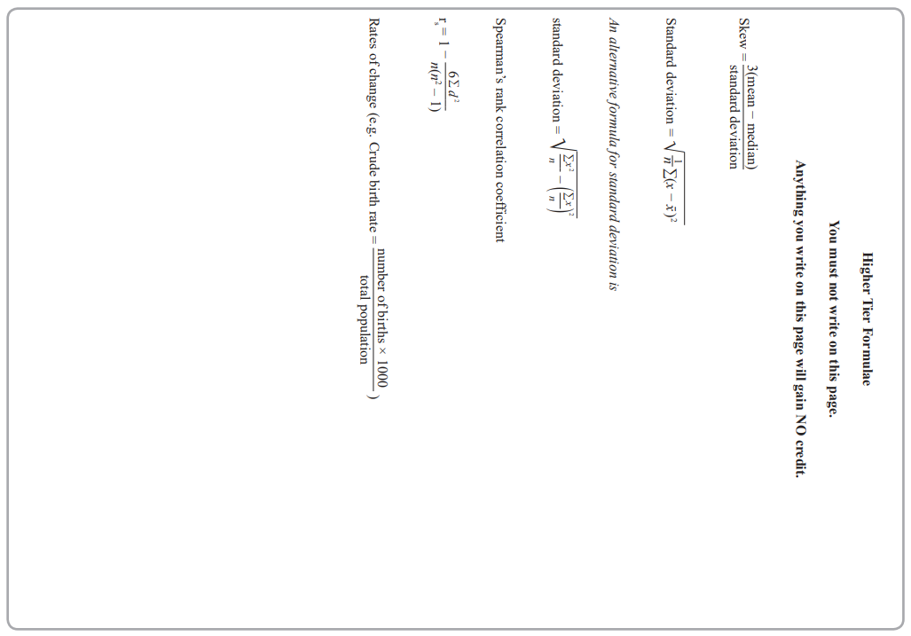
Contents Page
 | What are the different statistical diagrams we can use to represent data and how do we interpret them?
 |  | Page
*How do we present data in a Tally Chart?
*How do we read from and present data in a Pictogram?
*How do we read from and present data on bar charts for different types of data?
*How do we read data from and complete a multiple or dual bar chart?
*How do we read data from and complete a composite bar chart?
How do we read data from a population pyramid?
*How do we read data from and complete a stem and leaf diagram?
*How do we read data from and complete a pie chart?
How do we use comparative pie charts to represent different size populations?
*How do we plot a frequency polygon and use them to compare data sets?
*How do we read data from and complete a histogram?
*How do we read data from and complete a cumulative frequency polygon?
How do we read data from and complete a cumulative frequency step polygon?
How do we read data from and complete a choropleth map?
*How do we read from and complete Two Way Tables?
*How can graphs be presented to mislead us in out interpretations?

  Cross-Curricular  Link | All small questions marked with a * are topics that you will be coving in GCSE Maths as well as GCSE Statistics
Vocabulary Pyramid

Key
Dual
Tally
Composite
Discrete Multiple
Continuous Angle
Cumulative Misleading
Two-Way Table Pictogram
Choropleth Proportion Skew
Population Pyramid Stem-and-Leaf
Pie Chart Comparative Polygon
Histogram Frequency Density
Distribution Class Width

Tier 3 Words
Words specific to the subject ‘Statistics’
These may have different meanings in other subjects

Tier 2 Words
Show Data Identify Describe Discuss
Variables Determine Parameter Statistic Construct
Evaluate Respectively Given Explain Conduct Depict
Suggest Assess Validity Research Investigate Decide
Calculate Practical Suitable Collect Complete Frequency

Words that are often seen written in text and exam questions but are not often spoken

Tier 1 Words
Words that are used often in speech and have the same meaning in most contexts
Which Who What Where When Why How
Age Time Weight Mass Length Breadth Width Height
Chart Graph Diagram Advantages Disadvantages

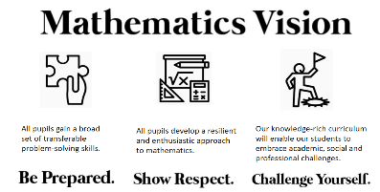

In this Knowledge Book you will see some of the following symbols with interesting facts and information about the words and terminology which will not be assessed but will deepen your understanding of the words.
 | This gives us the origin of a word and the historical development of its meaning.
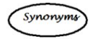 | This gives us a word or phrase that means exactly or nearly the same as another word or phrase in the same language.
  Historical  Origins | Historical Origins. This gives us the historical origin of the word.
  Did you know? | Do you Know? This gives us a fascinating fact about the word or skill,
Cross-Curricular  Link | Cross Curricular Link. This gives us links to where we might use this word or skill in other subjects
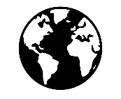  Real World  Application | Real World Application. This gives us an idea of when or how we might use this in the real world.
  Revision Ideas | Revision ideas. This gives us some revision techniques to use for each topic.  Remember to use the revision websites:  - MrsHodgettsStatistics.com  - StatsAcademy.co.uk  - MathsGenie.co.uk  And the Revision techniques websites:  - GetRevising.co.uk
______ / ______ / ______
Tally Charts
 | What are the different statistical diagrams we can use to represent data and how do we interpret them?
 | How do we present data in a Tally Chart?
Key Vocabulary
Vocab | Mathematical Definition
Tally Chart | A statistical diagram which represents frequencies as ‘tallies’ in groups of 5 or less
Frequency | How ‘frequent’ something is. The mathematical word for the total

Tally: comes from the Latin ‘tallia’ meaning stick

Historical  Origins | The oldest tally sticks date to between 35,000 and 25,000 years ago, in the form of notched bones found in the context of the European Aurignacian to Gravettian and in Africa's Late Stone Age.

The Knowledge Phase
A tally chart is a statistical diagram which uses ‘tallies’ in groups of 5 or less
A ‘tally’ is a mark or line (l). when you get to the 5th line you mark it across ( l l l l )

The Knowledge Phase
To complete a tally chart we work out way through a data set. For each piece of data we mark a tally, then once all of the data is marked of we complete the frequency
Tally charts can be used for qualitative, discrete and continuous data (where the data can be put in groups)

______ / ______ / ______
Pictograms
What are the different statistical diagrams we can use to represent data and how do we interpret them?
How do we read from and present data in a Pictogram?
Key Vocabulary
Vocab | Mathematical Definition
Pictogram | A statistical diagram which uses pictures to represent frequencies
Key | An indicator of the frequency each picture in the pictogram represents
The Knowledge Phase
A pictogram (also known as a pictograph) is statistical diagram which uses pictures to represent frequencies.
It must have a key which tells us how many each picture is worth. It is rare for a picture to only represent a frequency of one, most often it represents 2 or more. If we need to represent smaller quantities we only use half or a quarter etc of the picture.
Pictograms can be used for qualitative, discrete and continuous data (where the data can be put in groups)

Historical  Origins | Pictographs were used all over the world since 9,000 BC and became popular around 4,000 years later, when they began to develop into logo-graphic writing systems. But the first pictorial signs appeared in 30,000 BC, in the form of cave paintings.

The Knowledge Phase
When constructing a pictogram, it is important that we:
- Include a key
- Use a symbol in the key to represent more than one
- Ensure that the symbol can be easily manipulated for smaller values

______ / ______ / ______
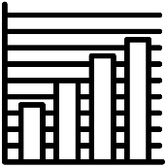
Bar Charts
What are the different statistical diagrams we can use to represent data and how do we interpret them?
How do we read from and present data on bar charts for different types of data?
Key Vocabulary
Vocab | Mathematical Definition
Bar Chart | A bar chart is a diagram in which the numerical values of variables are represented by the height or length of lines or rectangles of equal width
Frequency | Frequency is the mathematical term for ‘how many’ or the ‘total’

The Knowledge Phase

A bar chart or bar graph, is a diagram in which the numerical values of variables are represented by the height or length of lines or rectangles of equal width.
A bar chart must have the variables being counted on the x axis and the frequency on the y axis.
A bar chart must have a title and the axis must be labelled to ensure the reader can understand and interpret the data that is being presented.
A bar chart must have a scale on both the x and y axis that increases in equal gaps (although the two scales do not have to be the same) and they must both start at 0. However, to avoid large area of the graphs looking the same, if a graph’s frequencies are al large we may use a break in the axis.

Bar charts can be used for qualitative, discrete or continuous data:

- For qualitative and discrete data, just as there are gaps in-between each of the variable, there should also be gaps between the bars which represent them

Frequency (y)
Variables (x)

- For continuous data, there are no gaps between the variables and therefore the scale on the x axis representing this data should also be continuous and there should be no gaps between the bars.

Frequency (y)
Variables (x)

Historical  Origins | Many sources consider Nelvin Ks (1759-1824) to have invented the bar chart and the Exports and Imports of Scotland to and from different parts for one day from Christmas 1780 to Christmas 1781 graph from his The Commercial and Political Atlas to be the first bar chart in history.

Drawing Bar charts
When drawing a bar chart, we must remember the key points:
- Always label you x and y axis
- Always ensure that your bars are of equal width
- For discrete data, the bars should have gaps between them
- For continuous data, the bars should be touching and the values on the axis should be continuous

______ / ______ / ______
Multiple Bar Charts
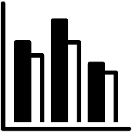 | What are the different statistical diagrams we can use to represent data and how do we interpret them?
 | How do we read data from and complete a multiple or dual bar chart?
Key Vocabulary
Vocab | Mathematical Definition
Multiple | Multiple means more than one
Dual | Dual mean something which has two parts
Bar Chart | A bar chart is a diagram in which the numerical values of variables are represented by the height or length of lines or rectangles of equal width
Frequency | Frequency is the mathematical term for ‘how many’ or the ‘total’

The Knowledge Phase
Multiple bar charts (sometimes known as dual bar charts) are when two or more bars are used to represent each variable. This occurs when data for each variable can be split into categories such as gender.
As with bar charts;
- the height of each bar represents the frequency of each variable
- the bars must be of equal width
- there must be a gap between each variable
HOWEVER, there does not have to be a gap between the bars which correspond to each variable, but there must be a key to distinguish between the different bars.
Multiple bar charts are a good visual way for us to compare data

______ / ______ / ______
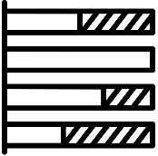
Composite Bar Charts
What are the different statistical diagrams we can use to represent data and how do we interpret them?
How do we read data from and complete a composite bar chart?

Key Vocabulary

Vocab | Mathematical Definition
Composite | Something which is made up of several parts
Bar Chart | A bar chart is a diagram in which the numerical values of variables are represented by the height or length of lines or rectangles of equal width
Frequency | Frequency is the mathematical term for ‘how many’ or the ‘total’

The Knowledge Phase

A composite bar chart is a statistical diagram that uses one vertical bars per variable to represent frequencies which are split into sections and stacked one on top of the other.

THE HEIGHT OF THE BAR IS THE TOTAL FREQUENCY FOR EACH VARIABLE.

EACH SUB CATEGORY MUST BE CALCUATED SEPERATLY FOR EACH VARIABLE

A key is then used to determine which section of each bar represents each category within the variable

We usually label our x axis as our variables and our y axis as our frequencies

- There must be a key
- All bars must be equal in width
- All variables must have equal gaps between them
- The frequencies must start at 0 but may have a scale break

A composite bar chart can be used for:
✓ Qualitative Data
✓ Discrete Data

______ / ______ / ______
Population Pyramids
What are the different statistical diagrams we can use to represent data and how do we interpret them?
How do we read data from a population pyramid?
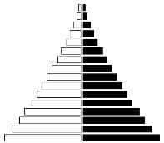
Key Vocabulary
Vocab | Mathematical Definition
Population Pyramid | A population pyramid (age structure diagram) or "age-sex pyramid" is a graphical illustration of the distribution of a population by age groups and sex.
Proportion | being in proportion means that two ratios or fractions are of equal value.

The Knowledge Phase
A popluation pyramid is a back-to-back histograms which allow us to compare two sexes in various age categories.
It is ususal for the age categories to go down the centre of the two histograms and frequency or proportion to be a symmetrical scale both left and right for males and females.
A key is not essential as the two sides are usually labelled.

As most questions for population pyramids will ask you to compare the two data sets it is important to remember:
- Do not just quote values. A comparion should state which is higher/lower and by how much
- It is important when reading from a populaiton pyramid that you identify if the data shown is frequencies or proportions of the population. When commenting on, or comparing the two data sets it is essential that you only comment on the proportion of the population if that is what is shown on the graph.

Cross-Curricular  Link | Population pyramids are often used in Geography to compare differences between male and female populations of an area. They also show the number of dependents (children and, sometimes, elderly people) and general structure of the population at any given moment

 | Historical  Origins |  | The first population pyramid was published in 1874 in a statistical atlas of the United States. For a population with high birth and death rates, it is wide at the bottom (young ages) and narrow at the top (old ages), hence the term pyramid. Its shape varies however.
______ / ______ / ______

Stem and Leaf Diagram
 |  | What are the different statistical diagrams we can use to represent data and how do we interpret them?
 |  | How do we read data from and complete a stem and leaf diagram?
Key Vocabulary
Vocab | Mathematical Definition
Stem and Leaf Diagram | a special table where each data value is split into a "stem" (the first digit or digits) and a "leaf" (usually the last digit)
Key | An indicator of the value represented by each ‘leaf’

Historical  Origins | The origin of the stem-and-leaf diagram is often associated with Tukey, J.W. (1977). Its concept is based on the histogram, which dates back to the 18th century.

The Knowledge Phase
We use stem and leaf diagrams to display lots of numerical data

We split each data value into a:
- "leaf" (the last digit) and a
- "stem" (the other digit(s))
The "stem" values are listed down the side, and the "leaf" values go right from the stem values.

A key is used to explain the meaning of the stem and leaf, an example is usually made of the first number represented on the diagram
The "stem" is used to group the scores and each "leaf" indicates the individual scores within each group.

A stem and leaf diagram must:

🗸 Have a key

🗸 Be in numerical order

______ / ______ / ______
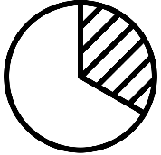
Pie Charts
What are the different statistical diagrams we can use to represent data and how do we interpret them?
How do we read data from and complete a pie chart?
Key Vocabulary
Vocab | Mathematical Definition
Pie Chart | a graph using a divided circle where each section represents a percentage of the total
Frequency | How ‘frequent’ something is. The mathematical word for the total
Angle | the amount of turning between two rays
Proportion | being in proportion means that two ratios or fractions are of equal value.
Population | Everything or everybody that could possibly be involved in an investigation

The Knowledge Phase
Completing Pie Charts
Pie charts are a circle split into different sized sections where each section of the pie chart represents a different category.
They must have a key but do not have to contain any numerical values
Pie charts can be used to:
- represent univariate data
- compare 2 or more sets of unpaired data.

For data sets that are unequal in size we should use proportionate comparative pie charts

IMPORTANT:
They show us the proportion of data within various categories not the total
Without knowing the total population for a pie chart we cannot know the total of each category but we can compare the proportions

To calculate the angle for a given category we use the formula:
$\frac{frequency}{grand total}$ X 360

Historical  Origins | William Playfair — a businessman, engineer and economics writer from Scotland — created the first known pie chart in 1801. Seeking to illustrate the Turkish Empire’s landholdings for his statistical breviary on the European nation-states, Playfair sliced a circle into three wedges whose sizes were determined by land area.
The Knowledge Phase
Reading from Pie Charts
Pie charts are a circle split into different sized sections where each section of the pie chart represents a different category. They must have a key but do not have to contain any numerical values
Pie charts can be used to:
- represent univariate data
- compare 2 or more sets of unpaired data.
For data sets that are unequal in size we should use proportionate comparative pie charts
IMPORTANT:
They show us the proportion of data within various categories not the total
Without knowing the total population for a pie chart we cannot know the total of each category but we can compare the proportions
To calculate the number in a given category we use a manipulation of the formula:
proportion X total OR $\frac{angle}{360}$ X total

______ / ______ / ______
Comparative Pie Charts
What are the different statistical diagrams we can use to represent data and how do we interpret them?
How do we use comparative pie charts to represent different size populations?
Key Vocabulary
Vocab | Mathematical Definition
Pie Chart | a graph using a divided circle where each section represents a percentage of the total
Frequency | How ‘frequent’ something is. The mathematical word for the total
Angle | the amount of turning between two rays
Proportion | being in proportion means that two ratios or fractions are of equal value.
Population | Everything or everybody that could possibly be involved in an investigation
Comparative | To be able to judge the similarities and differences between two data sets
The Knowledge Phase

Pie charts show the proportion of each category represented on it
When comparing pie charts, without a total, we can only compare the proportion of each category

Comparative pie charts are used to show 2 or more sets of data and allow us to compare totals without values.
To do this accurately you must ensure that the areas of the circles are in the same proportion as the totals displayed on each chart

The larger the area of the pie chart / segment, the large the frequency of the pie chart / segment

Area of a Circle: πr²

Area of comparative pie charts method:
- Calculate the area of pie chart (a)
- Work out the proportion difference between the frequency total of pie chart (a) & (b)
- Multiply the area of pie chart (a) by the proportion difference to give you the area of pie chart (b)
- You may then want to work backwards using the formula for the area of a circle to find the radius of pie chart (b)
______ / ______ / ______
Frequency Polygons
What are the different statistical diagrams we can use to represent data and how do we interpret them?
How do we plot a frequency polygon and use them to compare data sets?
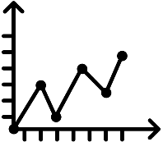
Key Vocabulary
Vocab | Mathematical Definition
Frequency | How ‘frequent’ something is. The mathematical word for the total
Polygon | a plane figure with at least three straight sides and angles, and typically five or more
Skew | when data has a long tail on one side or the other, so it is not symmetrical

The Knowledge Phase
A frequency polygon is a statistical diagram for continuous data.
The x axis represents the continuous variable and the y axis represents the frequency.

To plot a frequency ploygon you should:
- Find the midpoint of each class
- Plot the midpoint again the frequency
- Join up the points with straight lines

It is sometimes introduced as drawing a histogram with equal class widths, then marking the midpoint of the top of each bar and joing them with a straight line but you must remember to rub out the histogram afterwards

2 or more frequency polygons can be plotted on one graph with a key to distinguish between them. This allows for eacy compasrions between sets of continuous data

When comparing data from two or more frequency polygons we should always try to comment on:
Spread: Identify which polygon has the largest range of data
- To caluclate the range you work out the difference between where the graph starts and ends
Average: Identify which polygon has the largest median
- The mode on a frequency polygon is the peak of the graph
Skew: Identify whether each polygon has a positive or negative skew

Positive skew is where the peak
is closer to the start of the graph
Negative skew is where the peak
is closer to the end of the graph

______ / ______ / ______
Histograms
What are the different statistical diagrams we can use to represent data and how do we interpret them?
How do we read data from and complete a histogram?
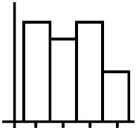
Key Vocabulary
Vocab | Mathematical Definition
Frequency | How ‘frequent’ something is. The mathematical word for the total
Frequency Density | Frequency density is the frequency per unit for the data in each class
Class Width | the difference between the upper-class limit and the lower-class limit of a class interval
Histogram | - a diagram consisting of rectangles whose area is proportional to the frequency of a variable and whose width is equal to the class interval.
Distribution | The way in which data is shared out between the variables
Skew | when data has a long tail on one side or the other, so it is not symmetrical
The Knowledge Phase
Frequency Density
A histogram is an example of a continuous bar chart which is best used for data with unequal class intervals.

Unlike a bar chart, the area of the bar is what represents the frequency rather than the height.

F

FD
CW

Using the formula triangle:
Frequency Density = Frequency Frequency = Frequency Density X Class Width
Class Width
*Where the class width is the difference between the lower and upper bound of the class

A histogram can be used for:
✓ Continuous Data

The Knowledge Phase
Drawing Histograms (unequal class widths)
A histogram is an example of a continuous bar chart which is best used for data with unequal class intervals.

Unlike a bar chart, the area of the bar is what represents the frequency rather than the height.

The height of each bar is therefore the FREQUENCY DENSITY

A histogram can be used for:
✓ Continuous Data

The Knowledge Phase
Interpreting Histograms (unequal class widths)
A histogram is an example of a continuous bar chart which is best used for
data with unequal class intervals.
CW
F
FD
Unlike a bar chart, the area of the bar is what represents the frequency
rather than the height.

Using the formula triangle:
Frequency = Frequency Density X Class Width
*Where the class width is the difference between the lower and upper bound of the class

This formula can be used for any class width, so if you are asked for a total between two value you may have to work out separate class widths and add them together

When commenting on data from a histogram we should always try to comment on:
Spread: calculate the range of the data
- To caluclate the range you work out the difference between where the graph starts and ends
Average: calculate an estimate for the mean or median
- You will need to calculate the frequency for each class first
Skew: Identify whether each polygon has a positive or negative skew

Positive skew is where the peak
is closer to the start of the graph
Negative skew is where the peak
is closer to the end of the graph

A histogram can be used for:
✓ Continuous Data

______ / ______ / ______
Cumulative Frequency Polygon
What are the different statistical diagrams we can use to represent data and how do we interpret them?
How do we read data from and complete a cumulative frequency polygon?
Key Vocabulary
Vocab | Mathematical Definition
Continuous | numerical data which is measurable
Frequency | How ‘frequent’ something is. The mathematical word for the total
Cumulative Frequency | A running total calculated by adding each frequency in turn
Polygon | a plane figure with at least three straight sides and angles, and typically five or more
The Knowledge Phase
You use these for a set of continuous data to show how the data grows

You must know the CUMULATIVE FREQUENCY before you can draw one

Cumulative frequency is the total frequency up to and including a particular data point

Cumulative Frequency Polygon
You plot the upper bound of the data (x axis) against the cumulative frequency (y axis) then join the plotted points together with a smooth curve, Once plotted, statistics can then be estimated for the quartiles
A Cumulative Frequency Polygon can be used for Continuous Data ONLY

______ / ______ / ______
Cumulative Frequency Step Polygon
What are the different statistical diagrams we can use to represent data and how do we interpret them?
How do we read data from and complete a cumulative frequency step polygon?
Key Vocabulary
Vocab | Mathematical Definition
Discrete | numerical data which is countable
Frequency | How ‘frequent’ something is. The mathematical word for the total
Cumulative Frequency | A running total calculated by adding each frequency in turn
Polygon | a plane figure with at least three straight sides and angles, and typically five or more
The Knowledge Phase
You use these for a set of discrete data to show how the data grows

You must know the CUMULATIVE FREQUENCY before you can draw one

Cumulative frequency is the total frequency up to and including a particular data point

You plot the data (x axis) against the cumulative frequency (y axis) then join the plotted points together in steps
YOU MUST DRAW THE STEPS ACROSS and the UP

As with a cumulative frequency polygon once plotted, statistics can then be estimated for the quartiles

A Cumulative Frequency Step Polygon can be used for:
✓ Discrete Data

______ / ______ / ______
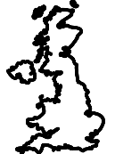
Choropleth Maps
What are the different statistical diagrams we can use to represent data and how do we interpret them?
How do we read data from and complete a choropleth map?
Key Vocabulary
Vocab | Mathematical Definition
Choropleth Map | a statistical diagram used to show the density of populations in different areas

The Knowledge Phase
Choropleth maps are a statistical diagram used to show the density of populations in different areas.
They are presented on maps, sometimes of an area, a county or even the world.
There must be a key to show the density each colour represents.
We usually see that the higher the density, the darker the shading.

Cross-Curricular  Link | A choropleth map is appropriate when presenting data for geographical areas and regions. Common uses of choropleth maps include presenting population density (e.g. the number of people per km2), weather and climate data and development indicators such as GDP and life expectancy.

The Knowledge Phase
How to Make a Choropleth Map
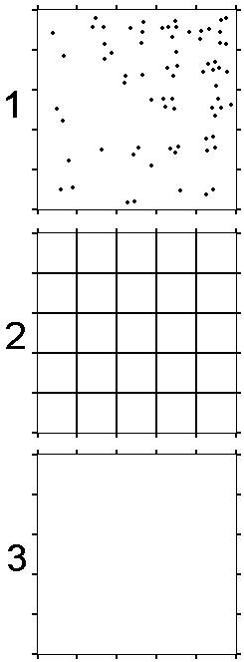
1) Look at picture number 1 on the right. Each dot in the square represents a child standing in the school playground.
2) Using a ruler and a pencil, join up the markers on opposite sides of the square. You will need to draw 8 straight lines. When you have done this, you will have made a grid (with 25 squares in total).

3) Count the number of children in each square in picture 1, and write down that number in the correct square on picture 2.

4) On picture 3, join up the markers on opposite sides of the square. Now, colour in the squares on this picture using the correct shading from the key below:
Number of children  in each square | Density | Shading
0 - 2 | Low | Light
3 - 5 | Medium | Medium
6 - 8 | High | Dark

5) Now look at your results. Why do you think children are not spread evenly across the playground? Suggest some possible reasons in the space below.

______ / ______ / ______
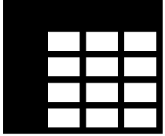
Two Way Tables
What are the different statistical diagrams we can use to represent data and how do we interpret them?
How do we read from and complete Two Way Tables?
Key Vocabulary
Vocab | Mathematical Definition
Two-Way Table | a statistical diagram that is used to present two sets of data simultaneously

The Knowledge Phase
A two-way table is a statistical diagram that is used to present two sets of data simultaneously.

We need to be able to interpret data from a two-way table and complete missing data from a two-way table.

When interpreting data, we must look at the column and row title for each value.

When completing missing data from a two-way table we must complete each row or column which has only one piece of data missing. If there is more than one piece of data missing, we cannot work it out straight away and must do a different missing value first.

A two-way table can be used for:
✓ Qualitative Data
✓ Discrete Data
✓ Continuous Data (if presented in groups)

______ / ______ / ______

Misleading Diagrams
What are the different statistical diagrams we can use to represent data and how do we interpret them?
How can graphs be presented to mislead us in out interpretations?
Key Vocabulary
Vocab | Mathematical Definition
Misleading | Manipulating the truth to give the wrong idea or impression

The Knowledge Phase
Statistics is the practice of collecting, organizing, and representing large amounts of numerical data.
These are used to present summarised information to large volumes of people, often people who would not understand the raw data itself.
Misleading Statistics can come in the form of numerical values or statistical diagrams.
- Misleading statistics are never false
- They are usually vague statements that use basic statistics
- They are true statistics that have been manipulated to show only certain information and hide other parts.
- They are used to make things appear better or more popular than they really are (or vice versa)

Misleading diagrams
What to look for (these are all negative points)

- Missing labels on axis
- Scales not starting at zero
- Unequal gaps between equal numbers
- 3D graphs
- Incorrectly calculated angles
- Percentages that don't add up to 100%
- Different scales used for comparing graphs
- No key where necessary

Real World  Application | Misleading diagrams are seen in the media constantly on the TV, on social media and on advertisments.
Copyright List
https://corbettmaths.com/wp-content/uploads/2013/02/bar-charts-tally-charts-and-pictograms-pdf.pdf
https://d7dae41c-6434-48e6-a64a-691272fdccba.usrfiles.com/ugd/d7dae4_460bc12e7c7b48d0b832b17840875e0d.pdf
https://d7dae41c-6434-48e6-a64a-691272fdccba.usrfiles.com/ugd/d7dae4_02839111b01e4408a01888ea730b3c62.pdf
https://d7dae41c-6434-48e6-a64a-691272fdccba.usrfiles.com/ugd/d7dae4_923fb210a8db4f6399ffb5e838181fbd.pdf
https://corbettmaths.com/wp-content/uploads/2013/02/stem-and-leaf-pdf.pdf
https://d7dae41c-6434-48e6-a64a-691272fdccba.usrfiles.com/ugd/d7dae4_3cd56ae5df4b491ab8e0b243a9ebe940.pdf
h ttps://www.mathsgenie.co.uk/resources/2-bar-charts.pdf
https://corbettmaths.com/wp-content/uploads/2013/02/drawing-pie-charts-pdf.pdf
https://corbettmaths.com/wp-content/uploads/2013/02/reading-pie-charts-pdf.pdf
https://www.tes.com/resources/search/?q=choropleth%20map&sortBy=lowestPrice&page=2
chadrobin.blogspot.com/2011/04/choropleth-map-urban-percentage.html
https://www.learncbse.in/practical-work-in-geography-class-12-solutions-chapter-3/
https://www.teachingideas.co.uk/maps-and-atlases/how-to-make-a-choropleth-map

Key words to learn

Formulas to learn

