
Mathematics and Statistics Department

Knowledge Book

GCSE Statistics
Term 10.4
Scatter Graphs and
Scan here for revision materials
Box Plots
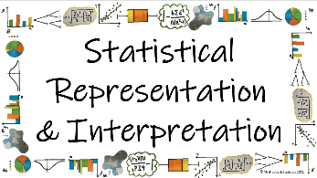
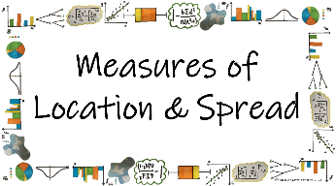
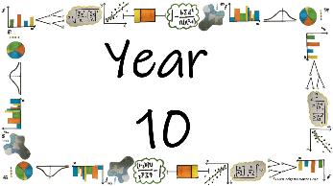
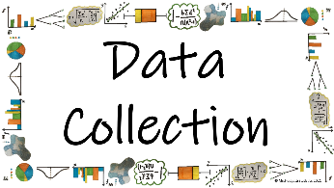

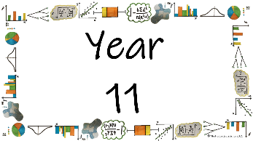
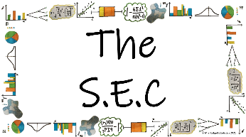
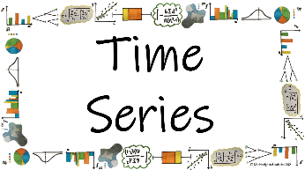
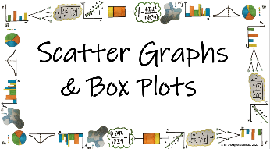

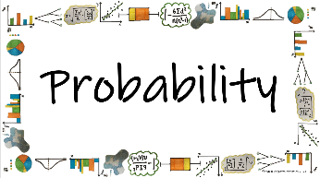
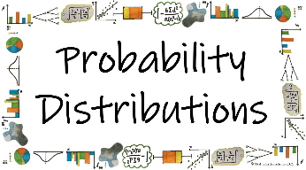
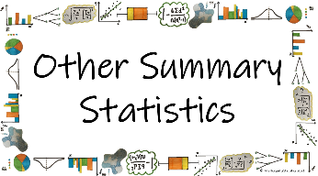


Name: ______________________
Teacher: ______________________
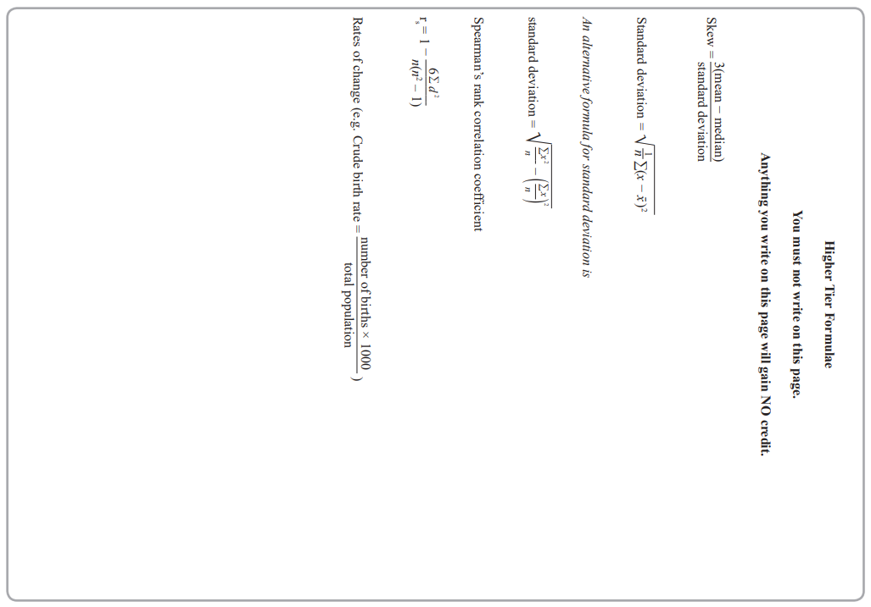
Contents Page
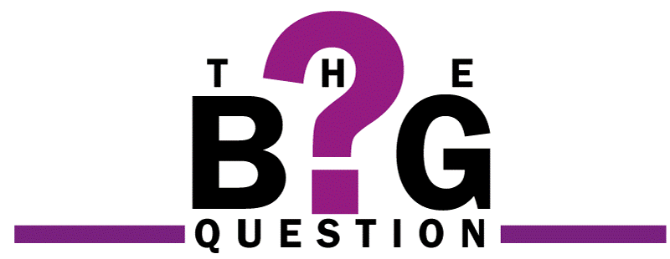 | How do we use box plots and scatter graphs to represent and compare large data sets?
 |  | Page
*How do I identify the 5 quartiles and measures of spread from a box plot?
*How do I present a set of data on a box plot?
In what way are outliers presented on a box plot?
How do I calculate outliers statistically?
How is skew described and calculated?
*How do I compare two sets of data presented on box plots?

*How do I plot a scatter graph?
*What is correlation and how is it used to describe data on a scatter graph?
What is the difference between interpolation and extrapolation?
What does PMCC stand for and what does the value of the PMCC imply about the data?
How do I calculate and interpret the value of the SRCC?
How do I decide whether PMCC or SRCC is the most appropriate measure of correlation?

  Cross-Curricular  Link | All small questions marked with a * are topics that you will be coving in GCSE Maths as well as GCSE Statistics
Vocabulary Pyramid

SRCC
PMCC
Mean
Range
Median Quartiles
Box and Whisker Plot
Inter Quartile Range
Skew Bivariate Correlation
Outliers Causality
Line of Best Fit Estimate
Anomalies Gradient y-Intercept
Interpolation Extrapolation
Measure of Location Measures of Spread

Tier 3 Words
Words specific to the subject ‘Statistics’
These may have different meanings in other subjects

Tier 2 Words
Show Data Identify Describe Discuss
Variables Determine Parameter Statistic Construct
Evaluate Respectively Given Explain Conduct Depict
Suggest Assess Validity Research Investigate Decide
Calculate Practical Suitable Collect Complete Frequency

Words that are often seen written in text and exam questions but are not often spoken

Tier 1 Words
Words that are used often in speech and have the same meaning in most contexts
Which Who What Where When Why How
Age Time Weight Mass Length Breadth Width Height
Chart Graph Diagram Advantages Disadvantages

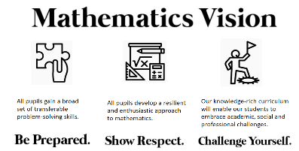

In this Knowledge Book you will see some of the following symbols with interesting facts and information about the words and terminology which will not be assessed but will deepen your understanding of the words.
 | This gives us the origin of a word and the historical development of its meaning.
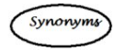 | This gives us a word or phrase that means exactly or nearly the same as another word or phrase in the same language.
  Historical  Origins | Historical Origins. This gives us the historical origin of the word.
  Did you know? | Do you Know? This gives us a fascinating fact about the word or skill,
Cross-Curricular  Link | Cross Curricular Link. This gives us links to where we might use this word or skill in other subjects
  Real World  Application | Real World Application. This gives us an idea of when or how we might use this in the real world.
  Revision Ideas | Revision ideas. This gives us some revision techniques to use for each topic.  Remember to use the revision websites:  - MrsHodgettsStatistics.com  - StatsAcademy.co.uk  - MathsGenie.co.uk  And the Revision techniques websites:  - GetRevising.co.uk
______ / ______ / ______
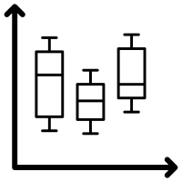
Reading from Box Plots
 | How do we use box plots and scatter graphs to represent and compare large data sets?
 | How do I identify the 5 quartiles and measures of spread from a box plot?
Key Vocabulary
Vocab | Mathematical Definition
Box and Whisker Plot | A statistical diagram used to represent the distribution of the data using quartiles
Quartiles | A term used to split an ordered set of data into four equal groups
Median | A measure of location (average) which identifies the middle data value
Range | The difference between the largest and smallest number in a data set
Inter Quartile Range | The difference between the lower and upper quartile
The Knowledge Phase
A Box and Whisker plot is names because of how it looks (a box with whiskers either side)
It is a statistical diagram used to display and compare discrete and continuous data.
The statistics presented on a Box and Whisker plot are:
- Minimum Value Q₀
- Lower Quartile Q₁
- Median Q₂
- Upper Quartile Q₃
- Maximum Value Q₄

Once these values have been obtained, we are then also able to calculate some measures of spread:
- The range (Q₄ – Q₀)
- The Inter Quartile Range (Q₃ – Q₁)

Historical  Origins | The range-bar method was first introduced by Mary Eleanor Spear in her book "Charting Statistics" in 1952 and again in her book "Practical Charting Techniques" in 1969. The box-and-whisker plot was first introduced in 1970 by John Tukey, who later published on the subject in his book "Exploratory Data Analysis" in 1977.
A Box and Whisker plot will look something like this:

Q₀ |  | Q₂ |  | Q₄

 | Q₁ |  | Q₃

The Knowledge Phase
As well as being able to identify the 5 quartiles from a box plot we can use the information can be used to talk about the distribution of the data
- We know that the lower quartile (Q₁) is positioned a quarter of the way through the data
- We know that the median (Q₂) is positioned half way through the data
- We know that the upper quartile (Q₃) is positioned three quarters of the way through the data
25% of the data is here
25% of the data is here
25% of the data is here
25% of the data is here

50% of the data is here
50% of the data is here

______ / ______ / ______
Drawing Box Plots
How do we use box plots and scatter graphs to represent and compare large data sets?
How do I present a set of data on a box plot?
Key Vocabulary
Vocab | Mathematical Definition
Box and Whisker Plot | A statistical diagram used to represent the distribution of the data using quartiles
Quartiles | A term used to split an ordered set of data into four equal groups
Median | A measure of location (average) which identifies the middle data value
Range | The difference between the largest and smallest number in a data set
Inter Quartile Range | The difference between the lower and upper quartile

The Knowledge Phase
When plotting a box and whisker plot we need to make sure that we have all 5 quartiles before we can start.
We must then choose out scale for the x axis which must be a minimum width of the range of data (preferable slightly larger)
Similarly, to a bar chart it is important that the values on the x axis are equally spaced
We can plot a box plot if we have been given the quartiles or we may be asked to calculate the quartiles first from raw data or a cumulative frequency graph

______ / ______ / ______
Outliers on a box plot
How do we use box plots and scatter graphs to represent and compare large data sets?
In what way are outliers presented on a box plot?
Key Vocabulary
Vocab | Mathematical Definition
Box and Whisker Plot | A statistical diagram used to represent the distribution of the data using quartiles
Quartiles | A term used to split an ordered set of data into four equal groups
Median | A measure of location (average) which identifies the middle data value
Range | The difference between the largest and smallest number in a data set
Inter Quartile Range | The difference between the lower and upper quartile
Outliers | Values which are unusual in comparison with the rest of data
The Knowledge Phase
Outliers are values that are unusual in comparison with the rest of the data.
They can skew statistical calculations and give false impressions about a data set
An outlier is either:
- a value that has been mis-recorded or
- a value that has been measured and recorded correctly but does not fall in line with the rest of the data

An outlier on a box and whisker plot is identified as an ‘x’ either side of the whiskers

Lower Outlier
 | X |  |  |  |  |  |  |  |  |  |  |  |  |  |  |  |  | X

Upper Outlier

Transferred meaning "outsider" (in reference to persons) is recorded from 1680s, especially "one who does not reside in the place of his office or duties;" the sense of "anything detached from its main body" is from 1849; the geological sense is from 1833.

______ / ______ / ______
Calculating Outliers
How do we use box plots and scatter graphs to represent and compare large data sets?
How do I calculate outliers statistically?
Key Vocabulary
Vocab | Mathematical Definition
Box and Whisker Plot | A statistical diagram used to represent the distribution of the data using quartiles
Quartiles | A term used to split an ordered set of data into four equal groups
Median | A measure of location (average) which identifies the middle data value
Range | The difference between the largest and smallest number in a data set
Inter Quartile Range | The difference between the lower and upper quartile
Outliers | Values which are unusual in comparison with the rest of data
The Knowledge Phase
We can NEVER disregard a data value but, if we can statistically PROVE that it is an outlier, we can remove it from the data
Outliers are defined as:
- Anything above UQ + (1.5 x IQR)
- Anything below LQ - (1.5 x IQR)
*these formulas are not given on the formula page or in the exam paper so must be learnt
If identified, an outlier is represented on the box plot as an ‘x’ and the next value above or below the identified outlier is used as the new maximum or minimum value

______ / ______ / ______
Skew
How do we use box plots and scatter graphs to represent and compare large data sets?
How is skew described and calculated?
Key Vocabulary
Vocab | Mathematical Definition
Box and Whisker Plot | A statistical diagram used to represent the distribution of the data using quartiles
Quartiles | A term used to split an ordered set of data into four equal groups
Median | A measure of location (average) which identifies the middle data value
Range | The difference between the largest and smallest number in a data set
Inter Quartile Range | The difference between the lower and upper quartile
Skew | A measurement of the distortion of symmetrical distribution or asymmetry in a data set.
The Knowledge Phase
Negative Skew
The median is closer to the upper quartile than the lower quartile
This means that although the range of the data is wide, the average
of the data is towards the lower end of the scale

Positive Skew
The median is closer to the lower quartile than the upper quartile
This means that although the range of the data is wide, the average
of the data is towards the upper end of the scale

Neither of these distributions are better than the other, it just helps us describe the distribution of the data and compare them

Symmetrical Skew
Should the median be equidistant from both the lower and upper
quartiles, then the skew is said to be ‘symmetrical’

The Knowledge Phase
Skew can be identified from a statistical diagram such as a box plot but it can also be calculated with a numerical value
N.B we will know if the skew is positive or negative just from the mean and median values
The formula for calculating skew is given as:
$$\frac{3(mean-median)}{standard deviaiton}$$
*This formula is given on the formula page in the front of your exam paper

skew (v.) c. 1400, "turn aside, take an oblique course, run obliquely or at an angle," also "escape," intransitive senses now archaic or obsolete, from Old North French eskiuer "shy away from, avoid," Old French eschiver (see eschew; also compare shy (adj.)).

______ / ______ / ______
Comparing Box Plots
How do we use box plots and scatter graphs to represent and compare large data sets?
How do I compare two sets of data presented on box plots?
Key Vocabulary
Vocab | Mathematical Definition
Measure of Spread | The statistical term used to describe statistics which gives information about how spread out the data is
Measure of Location | The statistical term used to describe statistics which gives information about the position of the data on a number line
Skew | A measurement of the distortion of symmetrical distribution or asymmetry in a data set.
Anomalies | Another term for an outlier: Values which are unusual in comparison with the rest of data

The Knowledge Phase
When comparing box plots it is important to look for how many comparisons they want.
The number of marks on offer tells you how many comparisons they want. i.e. 3 marks means 3 comparisons
You need to do your best to comment on different aspects of the box plots rather than all on the same thing.
You must also make sure that you use the correct statistical language
The four main comparison areas are 'SASkIa’:

- Spread - this refers to the ranges or interquartile ranges calculated from the box plots.

- Averages - this refers to the medians seen on the box plots

- Skew - this refers to the skews seen on each box plots

- Interpretation - this refers to an explanation of the spread or average IN CONTEXT

- anomalies - this refers to an outliers

Spread
1. Use the scale to work out the values for the range and IQR in each box plot.
2. State which box plot has the largest spread
3. Decide which is the most significant (usually you will see a more significant difference between the box plots in one than the other)
Averages
1. Use the scale to work out the value for the median in each box plot
2. State which box plot has the highest median
Skew
1. By looking at each box plot state the skew that is seen
Interpretation
1. Comment on how much more 'spread out' the data is for one set or how the data is spread similarly for both sets
2. Comment on which set of data is higher/lower/faster/slower etc 'on average'
anomalies
1. You may also wish to mention any outliers that can be seen with an ‘x’ on the box plots

______ / ______ / ______
Bivariate Data - Scatter Graphs
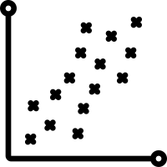 | How do we use box plots and scatter graphs to represent and compare large data sets?
 | How do I plot a scatter graph?
Key Vocabulary
Vocab | Mathematical Definition
Bivariate | Data which has two variables
Mean | A measure of location (average) which uses the formula $\frac{\sum{x}}{n}$
Line of Best Fit | A straight line that passes through the centre of the plotted coordinates
Gradient | The steepness of the line
y-intercept | The point at which the line passes through the y axis

The Knowledge Phase
A scatter graph is a statistical diagram used to display Bivariate Data
They allow you to plot two pieces of data simultaneously using a small cross and when lots of data is presented together on a scatter graph we can look for a relationship (Called a correlations) between the two variables
When plotting a scatter graph you need to use a table of values. Whichever variable is on the top row/the left row should be put on the x axis and plot the data as pairs of coordinates.

Historical  Origins | Michael Friendly and Daniel Denis suggested that the first scatter plot was created by John F. W. Herschel in 1833. He used a scatter plot in a scientific article to show the relationship between the positional angle of double stars and the year of measurement.

The Knowledge Phase
The equation of the line of best fit
y = m x + c

Where the value of ‘m’ represents the value of the gradient : the coefficient of x
Where the value of ‘c’ represents the value of the y-intercept : the constant

The Knowledge Phase

The Gradient
To find the gradient you need to:
- pick 2 points on your line of best fit
- join them with a triangle
- divide the number down by the number across

The y-intercept
The y - intercept is the point at which
the line passes the y axis

The Knowledge Phase
Gradient in context
- The gradient tells us the 'steepness' of the line
- It is calculated: for every one we count across, how many to we count up?
- It tells us the increase (or decrease) in y for each change by one in x
y-intercept in context
- The y-intercept tells us the point at which the line crosses the y axis
- It tells us the value of y when x = 0

______ / ______ / ______
Correlation
How do we use box plots and scatter graphs to represent and compare large data sets?
What is correlation and how is it used to describe data on a scatter graph?
Key Vocabulary
Vocab | Mathematical Definition
Bivariate | Data which has two variables
Line of Best Fit | A straight line that passes through the centre of the plotted coordinates
Correlation | The way in which the data is related on a scatter graph
Causality | The relationship between a cause and effect
The Knowledge Phase
Correlation is the way in which the data is related on a scatter graph
We need to know about three types of correlation

Positive Correlation
As one variable increases so does the other
E.G. The hotter the weather the higher the ice cream sales

Negative Correlation
As one variable increases the other decreases
E.G. The hotter the weather the fewer jumpers are sold

No Correlation
There is no visible relationship between the two variables
E.G. There is no link between the number of GCSEs and a person’s shoe size

The strength of the correlation is dependant on how close the points are to a straight line. i.e. if the points make a perfect straight line it is strong correlation but if we can only just see a line with is called weak correlation
Historical  Origins | Correlation derives from the Latin cor- 'together' and -relatio 'relation'––the word is all about things that go together. But beware: just because a study shows a correlation between two variables, it doesn't mean one necessarily causes the other.

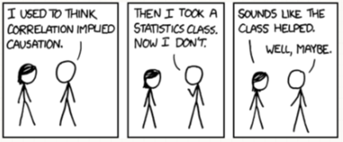
Causality
Correlation implies a connection between 2 variables
Causality implies a direct link between 2 variables. i.e. 1 variable causes the other


Take a look at how correlation and causality were used by Sesame Street producers to increase the popularity of the show with parents

Historical  Origins | Historical causation involves the ability to identify, analyze, and evaluate the relationship among multiple historical causes and effects, distinguishing between those that are long-term and proximate, and among coincident, causation, and correlation.

______ / ______ / ______
Interpolation and Extrapolation
How do we use box plots and scatter graphs to represent and compare large data sets?
What is the difference between interpolation and extrapolation?
Key Vocabulary
Vocab | Mathematical Definition
Bivariate | Data which has two variables
Line of Best Fit | A straight line that passes through the centre of the plotted coordinates
Estimate | An approximate calculation based on data that has already been collected
Interpolation | An estimate that is found from within a set of data
Extrapolation | An estimate that is found from outside of a set of data
The Knowledge Phase
Interpolation and extrapolation are the names given to a way of estimating or predicting using pre-existing data values.
This can be done from:
- Within a data set
- A scatter graph
- A time Series graph
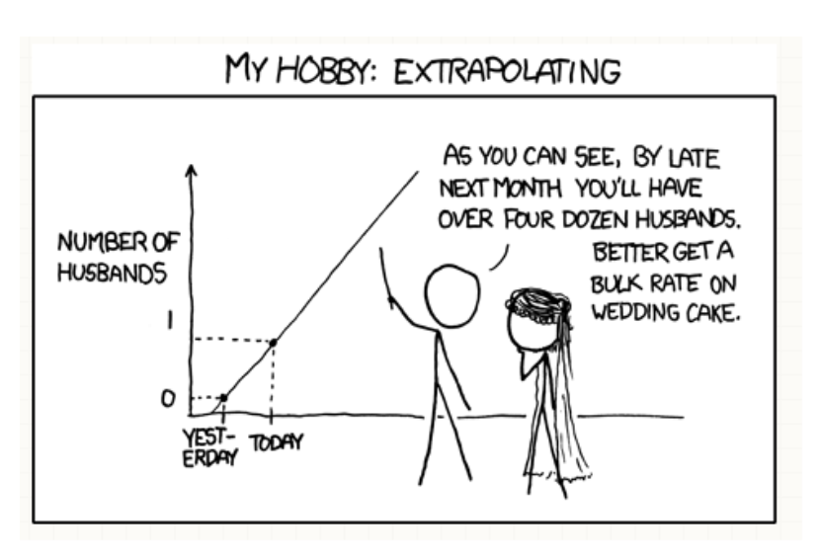
Interpolation is when an estimate is found from within the data you already have. i.e. there will be explanatory variables either side of the value you are using to create the estimate Interpolation can be estimated from a data set(see separate notes on interpolation)
Extrapolation is when the estimate (or prediction) is found from outside of the data set i.e. the will be explanatory variables either above or below the value you are using to create the estimate but not both.

Which one should I use?
Interpolation is the most accurate of the two estimates as it has variables either side to assist with the prediction.
Extrapolation can be unreliable as we have no data to base what may happen at the lower or upper end.
Particularly with time series graphs, we can follow the trend and variation of the data to make a prediction but you never know what may happen in the future which may change the outcome.
From Latin interpolare, Latin interpolatum, from inter (“between”) and polire (“to polish”).
Extrapolation comes from the word extra, meaning “outside,” and a shortened form of the word interpolation

______ / ______ / ______
PMCC
How do we use box plots and scatter graphs to represent and compare large data sets?
What does PMCC stand for and what does the value of the PMCC imply about the data?
Key Vocabulary
Vocab | Mathematical Definition
Bivariate | Data which has two variables
Line of Best Fit | A straight line that passes through the centre of the plotted coordinates
Correlation | The way in which the data is related on a scatter graph
PMCC | Product Moment Correlation Coefficient
The Knowledge Phase
Product Moment Correlation Coefficient or PMCC is a value given to a correlation between two variables.
The PMCC is a measure of the strength of a linear association between two variables and is denoted by r.
Basically, if you were to draw a line of best fit through the data of two variables, the PMCC, r, indicates how far away all these data points are to this line of best fit
Product Moment Correlation should be used if:
- the variables are either interval or ratio measurements (i.e. numerical values which are not already ranked),
- each variable is approximately normally distributed
- there is a linear relationship between the two variables.

The PMCC is a value between – 1 and + 1 (where 0 indicates no correlation)
- A negative value implies a negative correlation
- A positive value implies a positive correlation
- The closer the value is to zero, the weaker the correlation is

-1.0 |  | -0.9 |  | -0.8 |  | -0.7 |  | -0.6 |  | -0.5 |  | -0.4 |  | -0.3 |  | -0.2 |  | -0.1 |  | 0 |  | 0.1 |  | 0.2 |  | 0.3 |  | 0.4 |  | 0.5 |  | 0.6 |  | 0.7 |  | 0.8 |  | 0.9 |  | 1.0
 | Very Strong Negative Correlation |  | Strong  Negative Correlation |  |  |  | Moderate Negative Correlation |  |  |  |  |  |  |  |  |  | Weak  Negative Correlation |  |  |  | Weak  Positive Correlation |  |  |  | Moderate Positive Correlation |  |  |  |  |  |  |  |  |  | Strong  Positive Correlation |  |  |  | Very Strong Positive Correlation

______ / ______ / ______
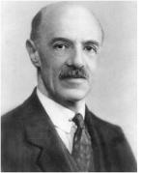
SRCC
How do we use box plots and scatter graphs to represent and compare large data sets?
How do I calculate and interpret the value of the SRCC?
Key Vocabulary
Vocab | Mathematical Definition
Bivariate | Data which has two variables
Line of Best Fit | A straight line that passes through the centre of the plotted coordinates
Correlation | The way in which the data is related on a scatter graph
SRCC | Spearman’s Rank Correlation Coefficient
The Knowledge Phase
Spearman’s Rank Correlation Coefficient or SRCC is a special case of the PMCC which is a value given to the correlation between the ranks of two variables.
It can be used when the data is qualitative (as when we rank the data, we make it quantitative) It can be used for non-linear data (the pairs of data are on different scales and therefore unfair to compare)
- SPEARMAN’S – it is named after Charles Spearman
- RANK – it required you to rank the data
- CORRELATION – it is a measure of the relationship between two variables
- COEFFICIENT – it is a numerical value It is calculated using a statistical formula given on the formula page of the exam paper
$$1- \frac{6\sum{d^{2}}}{n(n^{2}-1)}$$
- Where d is the differences between the ranks
- Where n is the total number of pairs of data
Just like the PMCC, the SRCC is a value between – 1 and + 1 (where 0 indicates no correlation)
- A negative value implies a negative correlation
- A positive value implies a positive correlation
- The closer the value is to zero, the weaker the correlation is

-1.0 |  | -0.9 |  | -0.8 |  | -0.7 |  | -0.6 |  | -0.5 |  | -0.4 |  | -0.3 |  | -0.2 |  | -0.1 |  | 0 |  | 0.1 |  | 0.2 |  | 0.3 |  | 0.4 |  | 0.5 |  | 0.6 |  | 0.7 |  | 0.8 |  | 0.9 |  | 1.0
 | Very Strong Negative Correlation |  | Strong  Negative Correlation |  |  |  | Moderate Negative Correlation |  |  |  |  |  |  |  |  |  | Weak  Negative Correlation |  |  |  | Weak  Positive Correlation |  |  |  | Moderate Positive Correlation |  |  |  |  |  |  |  |  |  | Strong  Positive Correlation |  |  |  | Very Strong Positive Correlation
The main difference between the calculation on the SRCC compared to the PMCC is that the data must first be RANKED
Ranking
- Always rank from smallest to largest (unless otherwise stated)
- If two or more values are equal they MUST share the median rank
- The final rank should be equal to n

The Knowledge Phase
1. Rank both sets of data separately
2. Work out the difference between each pair of ranks [d]
3. Square each of these differences [d²]
4. Add all of these d² values together [Σd²]
5. Multiply this answer by 6 [6Σd²]
6. Count the number of pairs of data [n]
7. Multiply this by the number of pairs of data ^{squared} - 1 [n(n² - 1)]
8. Substitute point 5 and point 7 into the formula and subtract from 1

I

______ / ______ / ______
Which Coefficient to use
How do we use box plots and scatter graphs to represent and compare large data sets?
How do I decide whether PMCC or SRCC is the most appropriate measure of correlation?
Key Vocabulary
Vocab | Mathematical Definition
Bivariate | Data which has two variables
Correlation | The way in which the data is related on a scatter graph
PMCC | Product Moment Correlation Coefficient
SRCC | Spearman’s Rank Correlation Coefficient
The Knowledge Phase

Product Moment Correlation Coefficient
Spearman’s Rank Correlation Coefficient

Both measure the strength of the correlation of 2 variables
Both calculate a value from - 1 to + 1

PMCC calculates the relationship between the 2 sets of data values
PMCC can only be calculated for numerical data
You will not be expected to calculate PMCC, only interprets its value

SRCC calculates the relationship between the rankings of 2 sets of data
SRCC can be calculated for both numerical and non-numerical data
You MUST rank the data before you calculate the SRCC
You need to be able to calculate the SRCC using the formula given in the front of the exam book

It is common for SRCC to be stronger than PMCC as it is more likely for ranks to be equal than actual values
Use PMCC
YES

NO
YES
YES
Is the data linear? (on the same scale from start to finish)

Is the data Bivariate?
Rank the data and use SRCC
NO
Is the data numerical?
(ranked data is NOT numerical)
NO
A Correlation Coefficient cannot be calculated

Key words to learn

Formulas to learn

Copyright List

https://www.statsacademy.co.uk/_files/ugd/d7dae4_49e1dc934fba4515ae29f1d0495c85ba.pdf
https://www.mrbartonmaths.com/resources/GCSE%20Revision/GCSE%20Maths%20Takeaway/4.%20Grades%20B%20to%20A-star/91_cumulative-frequency-and-box-plots.pdf
https://corbettmaths.com/wp-content/uploads/2013/02/cumulative-frequency-pdf1.pdf
https://d7dae41c-6434-48e6-a64a-691272fdccba.usrfiles.com/ugd/d7dae4_e41df9df3042428f88d6e5439a7e1a07.pdf
h ttps://d7dae41c-6434-48e6-a64a-691272fdccba.usrfiles.com/ugd/d7dae4_20341da04da34ac584113232fbed9b28.pdf

