
Mathematics and Statistics Department

Knowledge Book

GCSE Statistics
Term 11.2
Probability Distributions
Scan here for revision materials
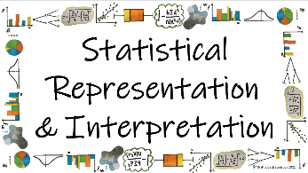
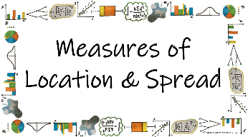
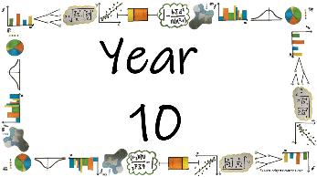
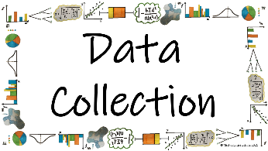

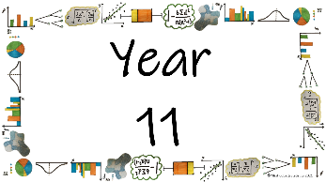
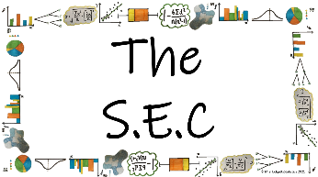
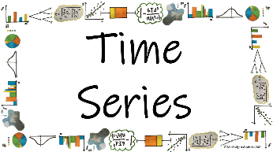
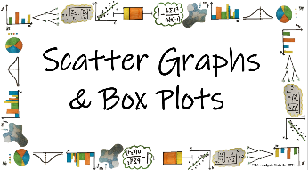

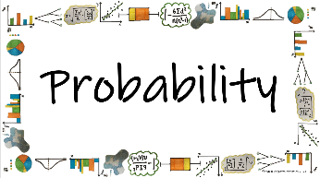
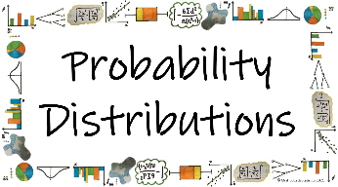
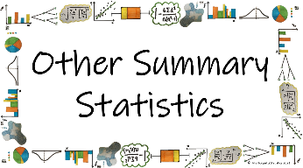


Name: ______________________
Teacher: ______________________
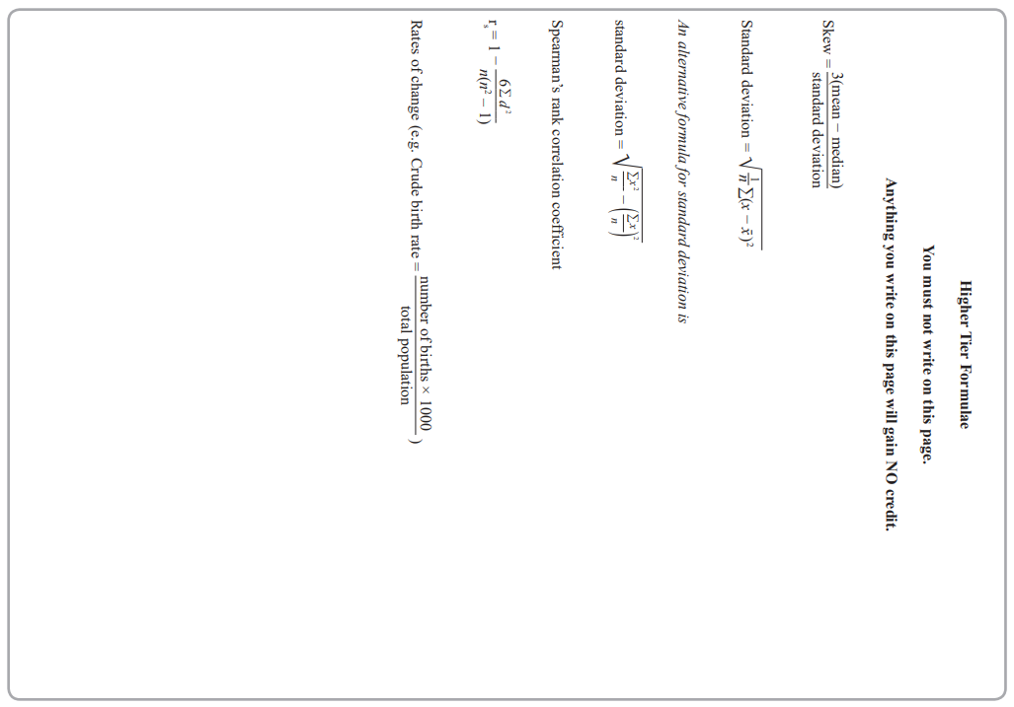
Contents Page
 | How can the different probability distributions be used to calculate probabilities is specific circumstances?

 | Page

What does the Uniform Distribution look like and how can we use it to predict values? | 6

What are the conditions for the Binomial Distribution? | 12
What are combinations and how do we calculate them using a calculator? | 14
What is the notation for the Binomial Distribution? | 17
What is the formula for the Binomial Distribution and how do we use it to calculate Binomial probabilities? | 19

What are the properties of a normal distribution? | 27

  Cross-Curricular  Link | All small questions marked with a * are topics that you will be coving in GCSE Maths as well as GCSE Statistics
Vocabulary Pyramid

Skew
Uniform
Distribution
Probability
Predict
Conditions Binomial
Notation Formula
Histogram Compare
Positive Negative Symmetrical
Standard Deviation Mean

Tier 3 Words
Words specific to the subject ‘Statistics’
These may have different meanings in other subjects

Tier 2 Words
Show Data Identify Describe Discuss
Variables Determine Parameter Statistic Construct
Evaluate Respectively Given Explain Conduct Depict
Suggest Assess Validity Research Investigate Decide
Calculate Practical Suitable Collect Complete Frequency

Words that are often seen written in text and exam questions but are not often spoken

Tier 1 Words
Words that are used often in speech and have the same meaning in most contexts
Which Who What Where When Why How
Age Time Weight Mass Length Breadth Width Height
Chart Graph Diagram Advantages Disadvantages

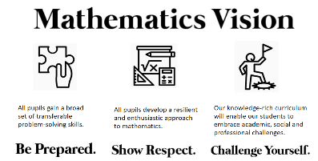

In this Knowledge Book you will see some of the following symbols with interesting facts and information about the words and terminology which will not be assessed but will deepen your understanding of the words.
 | This gives us the origin of a word and the historical development of its meaning.
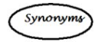 | This gives us a word or phrase that means exactly or nearly the same as another word or phrase in the same language.
  Historical  Origins | Historical Origins. This gives us the historical origin of the word.
  Did you know? | Do you Know? This gives us a fascinating fact about the word or skill,
Cross-Curricular  Link | Cross Curricular Link. This gives us links to where we might use this word or skill in other subjects
  Real World  Application | Real World Application. This gives us an idea of when or how we might use this in the real world.
  Revision Ideas | Revision ideas. This gives us some revision techniques to use for each topic.  Remember to use the revision websites:  - MrsHodgettsStatistics.com  - StatsAcademy.co.uk  - MathsGenie.co.uk  And the Revision techniques websites:  - GetRevising.co.uk
______ / ______ / ______
 | How can the different probability distributions be used to calculate probabilities is specific circumstances?
 | What does the Uniform Distribution look like and how can we use it to predict values?
Key Vocabulary
Vocab | Mathematical Definition
Uniform | variables or result which are identical
Distribution | the way in which something is shared out among a group or spread over an area
The Knowledge Phase
The Discrete Uniform Distribution occurs when the probability of each outcome is equally likely
Uniform
mid 16th century (as an adjective): from French uniforme or Latin uniformis (see uni-, form). Sense 1 of the noun dates from the mid 18th century.

Examples of this include:

- Rolling a fair dice

- Flipping a fair coin
- Choosing a card from a fair deck

If the distribution has outcomes of 1, 2, 3, ..., n then the probability of each value occurring is 1/n
N.B if the distribution has outcomes which does not start at 1 we must take this into consideration when calculation the probability.
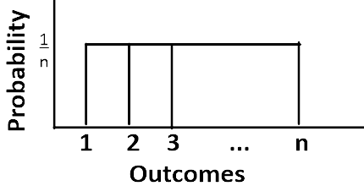
The Discrete Uniform Distribution is also
known as the RECTANGULAR distribution
as it looks like a rectangle
when drawn

Historical  Origins | According to James Landau's entry to Jeff Miller's Earliest Known Uses of Some of the Words of Mathematics: "Uniform distribution appears in 1937 in Introduction to Mathematical Probability by J. V. Uspensky.

Skills Check
From the diagrams shown below, circle any which represent a Uniform Distribution
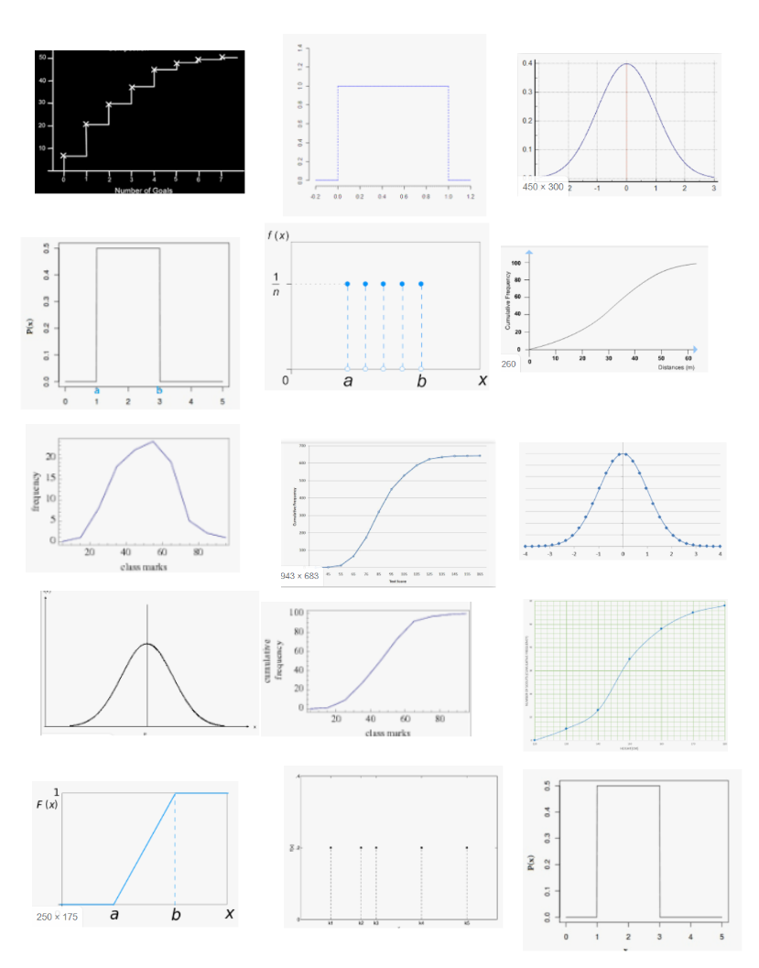*EXT Can you name any of the other diagrams?
The Knowledge Phase
We can calculate averages from a Uniform distribution. We know that to calculate the mean of any set of data we add all of the values together and divide by the total number of values.
When calculating the weighted mean we use a similar process but must take into consideration the weight of each piece of data.
For a discrete uniform distribution, when the data is evenly spaced and of equal weight we know that the mean and median will be the same value.
With the uniform distribution, because the probability (weight) of each value is the same we can calculate these values using a shortcut:
- adding the first and last values
- dividing by 2

I DO
When you roll a fair dice, each of the six faces
is equally likely to occur.

Draw a probability diagram to show this

WE DO
When you roll a fair dice, each of the six faces is equally likely to occur.

Calculate the mean and median score from the dice

YOU DO
Random numbers from 0 to 9 are created using a calculator.
Draw a diagram to illustrate the probability distribution
(a) what is the probability of each value?
(b) what is the expected mean value?

Practice Questions
- Which of the following distributions of X are likely to be modelled by a discrete uniform distribution?
For those which are likely to be modelled by a discrete uniform distribution state the parameter 1/n
For those which are not are likely to be modelled by a discrete uniform distribution explain why
- X = the height of a students selected at random from a class of 7-year olds
- X = the day of the week on which an adult is selected at random was born
- X = the last digit of a telephone number selected at random from a telephone directory
- X = the number showing when a fair dice is rolled
- X = the number drawn in a lottery where all numbers between 1 and 50 are equally likely
- X = the colour of a sweet chosen at random from a box which contains 3 red, 2 pink and 4 green sweets
- X = the number of a raffle ticket when 200 people have bought 1 ticket each
- X = the score achieved by a professional darts played when throwing 1 dart at a board

- Draw a probability distribution for a regular octahedron with the numbers 1,2,3,4,5,6,7 and 8 on its faces. Write down the mean value

- Mr Jones uses an online spinner to randomly choose students to answer questions in his class. The programme allocates pupils an equal proportion of a circular spinner and spins for 12 seconds. The random variable X represents the name that is at the top of the spinner when it stops.
- State the name of the distribution of X
Mr Jones has 23 pupils in his year 8 class.
- Calculate the probability that Ben is chosen to answer a question.

- A fair six-sided die is rolled. The random variable Y represents the score on the uppermost, face.
a) Write down the probability function of Y.
b) State the name of the distribution of Y.

- A dart board has 20 equal sized sectors number 1 to 20. A dart is thrown to land in the number 20 sector. If the dart misses it is thrown again
A discrete uniform distribution is suggested as a model to describe the sector in which the dart lands. Comment on this suggestion.

- Draw a probability distribution for a regular octahedron with the numbers 1,2,3,4,5,6,7 and 8 on its faces.

- Taxi numbers run consecutively from 1 to n.
Jodie collects the taxi numbers from vehicles she has hired.
The numbers are 27, 35, 64, 62 and 48.
  - Use the mean to estimate the number of taxis
  - Use the median to estimate the number of taxis

- Ahmed also records the numbers of vehicles that he has hired.
His data is 23, 42, 10, 6, 89.
  - Use the mean to estimate the number of taxis
  - Use the median to estimate the number of taxis
  - Which of these estimates is impossible? Explain your answer

- Random numbers from 0 to n are created using a calculator.
The first 5 numbers to be drawn out are 45, 21, 3, 17 and 29
  - Calculate the mean of these numbers and use it to estimate the number of values available
  - Calculate the median of these numbers and use it to estimate the number of values available

Exam Questions
- Sketch A shows the distribution of colours of sweets in a box
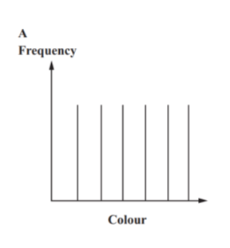
Write down the name of the distribution that will model the data

............................................................................................................ [1 mark]

______ / ______ / ______
How can the different probability distributions be used to calculate probabilities is specific circumstances?
What are the conditions for the Binomial Distribution?
Key Vocabulary
Vocab | Mathematical Definition
Binomial | where two terms are used as part of the calculation
Distribution | the way in which something is shared out among a group or spread over an area
The Knowledge Phase
The Binomial Distribution
Binomial
mid 16th century: from French binôme or modern Latin binomium (from bi- ‘having two’ + Greek nomos ‘part, portion’) + -al

If a variable is binomially distributed it must satisfy the following conditions:

- Each trial can only have two outcomes (success(p) or failure(q))
- There must be a fixed number of trials (n)
- The probability of success (p) must be the same for each trial

I DO WE DO
The number of heads obtained when a fair coin is flipped 3 times  Calculate p, q and n |  | The number of odd numbers scored when rolling a fair dice 100 times  Calculate p, q and n

YOU DO
The number of hearts obtained when drawing a card from a regular pack 10 times
Calculate p, q and n

Historical  Origins | Swiss mathematician Jakob Bernoulli, in a proof published posthumously in 1713, determined that the probability of k such outcomes in n repetitions is equal to the kth term (where k starts with 0) in the expansion of the binomial expression (p + q)^{n}, where q = 1 − p. (Hence the name binomial distribution.)

Skills Check
- The number of multiples of 3 obtained on a fair dice when rolled 50 times
Success (p) =
Failure (q) =
Trials (n) =

- The number of face cards obtained when drawing a card from a regular pack 3 times
Success (p) =
Failure (q) =
Trials (n) =

- The number of square numbers obtained on a fair dice when rolled 20 times
Success (p) =
Failure (q) =
Trials (n) =

- The number of vowels drawn from the letters of the alphabet in a bag 5 times
(Assume the letters are replaced after each pick)
Success (p) =
Failure (q) =
Trials (n) =

- The number of consonants drawn from the letters of the alphabet in a bag 30 times
(Assume the letters are replaced after each pick)
Success (p) =
Failure (q) =
Trials (n) =
______ / ______ / ______
How can the different probability distributions be used to calculate probabilities is specific circumstances?
What are combinations and how do we calculate them using a calculator?
Key Vocabulary
Vocab | Mathematical Definition
Combinations | the different ways in which a sequence of numbers or letters can be formed

Combination
late Middle English: from late Latin combinatio(n- ), from the verb combinare ‘join two by two’ (see combine¹).

Let’s Think …
I flip a coin 3 times
How many different ways can I get exactly 3 heads?

I flip a coin 3 times
How many different ways can I get exactly 2 heads?

I flip a coin 3 times
How many different ways can I get exactly 1 head?

I flip a coin 100 times
How many different ways can I get exactly 1 head?

I flip a coin 100 times
How many different ways can I get exactly 3 heads?

The Knowledge Phase
The combination button on the Calculator
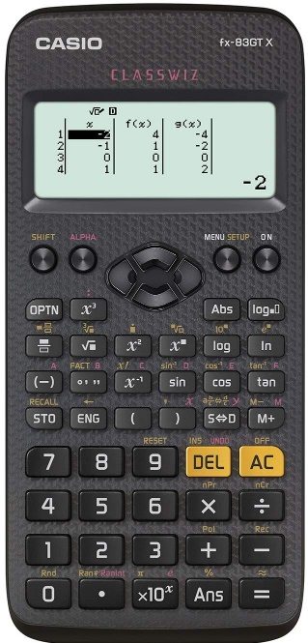

_{n}C_{r}

Skills Check - Together
I flip a coin 3 times
How many different ways can I get exactly 3 heads?

I flip a coin 3 times
How many different ways can I get exactly 2 heads?

I flip a coin 3 times
How many different ways can I get exactly 1 head?

I flip a coin 100 times
How many different ways can I get exactly 1 head?

I flip a coin 100 times
How many different ways can I get exactly 3 heads?

Practice Questions

1. I flip a coin 10 times. How many different ways can I get:
a) 3 heads?
b) 5 tails?
c) 8 heads?
d) 4 tails?
e) 2 heads?
f) 6 tails?

2. I flip a coin 25 times. How many different ways can I get:
a) 5 heads?
b) 6 tails?
c) 12 heads?
d) 20 tails?
e) at most 2 tails?
f) at most 3 heads?

3. I flip a coin 15 times. How many different ways can I get:
a) 3 heads?
b) 2 tails?
c) at most 4 heads?
d) at most 10 tails?
e) at least 12 heads?
f) at least 4 tails?
______ / ______ / ______
How can the different probability distributions be used to calculate probabilities is specific circumstances?
What is the notation for the Binomial Distribution?
Key Vocabulary
Vocab | Mathematical Definition
Notation | a series or system of written symbols used to represent numbers, amounts, or elements in something such as music or mathematics
The Knowledge Phase
We cannot use the binomial formula without n and p
If a random variable X is binomially distributed we use the notation

X~B(n,p)

where n = __________________ p = ____________________ q =____________________

I DO
For the distribution X~B(12,0.3)
State n, p and q

WE DO
For the distribution X~B(17,0.05)
State n, p and q

YOU DO
For the distribution X~B(62,0.428)
State n, p and q

Skills Check

For each of the following distributions state n, p and q

1. X~B(30,0.7) n = _____ p = _____ q = _____
2. X~B(15,0.4) n = _____ p = _____ q = _____
3. X~B(90,0.1) n = _____ p = _____ q = _____
4. X~B(22,0.35) n = _____ p = _____ q = _____
5. X~B(14,0.09) n = _____ p = _____ q = _____
6. X~B(45,0.325) n = _____ p = _____ q = _____
7. X~B(38,0.65) n = _____ p = _____ q = _____
8. X~B(10,0.3) n = _____ p = _____ q = _____

Practice Questions
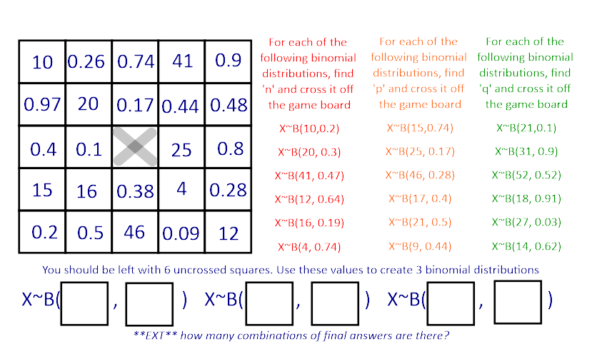

______ / ______ / ______
How can the different probability distributions be used to calculate probabilities is specific circumstances?
What is the formula for the Binomial Distribution and how do we use it to calculate Binomial probabilities?
Key Vocabulary
Vocab | Mathematical Definition
The Knowledge Phase
The Binomial Formula is used as a shortcut for repeated probabilities which follow a Binomial Distribution and a tree diagram is simply too complicated to use

Formula
early 17th century (in the sense ‘fixed form of words’): from Latin, diminutive of forma ‘shape, mould’.

EXAMPLE - together
Rob has a faulty alarm clock and is late for school 20% of the time
In one school week, what is the probability he is late on 3 days?
Use a tree diagram to show your probabilities

The Binomial Formula
P(X = r) = _{n}C_{r} X p^{r} X q^{n – r}
where :
n =
r =
p =
q =

2 Player Game

- You must take it in turn to roll the dice

- Every time you land on a 6 you can put your hand in the formula box and select a card

- You can then place the card on your playboard

- If you already have that card you must put it back in the box

- The aim of the game is to be the first person to draw out all 11 cards and correctly complete the playboard

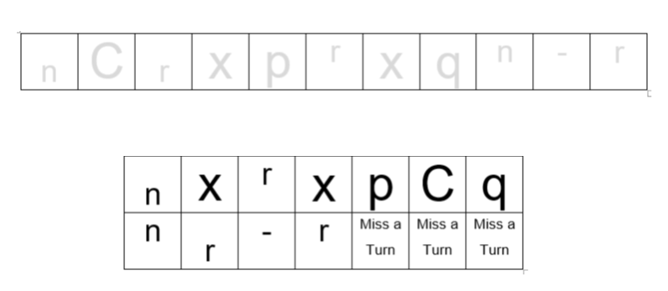
I DO
Gordon is going to throw five stones in turn at the target  Gordon can hit the target with a probability of 0.8 with any one of these five stones  Work out the probability that he will hit the target with only one of the five stones | Step 1: State the Binomial Formula  Step 2: Identify the:  n = number of trials =  r = number of successes =  p = probability of success =  q = probability of failure =  Step 3: Substitute the values into the formula and calculate

WE DO
Abena ad Kofi want to have 4 children together  Work out the probability that at most one of their 4 children will have sickle cell disease | Step 1: State the Binomial Formula  Step 2: Identify the:  n = number of trials =  r = number of successes =  p = probability of success =  q = probability of failure =  Step 3: Substitute the values into the formula and calculate
YOU DO
Carlos has to go to school every day this week  The probability that he is late to school on any one day is 0.46  Work out the probability the most likely number of times he will be late to school this week | Step 1: State the Binomial Formula  Step 2: Identify the:  n = number of trials =  r = number of successes =  p = probability of success =  q = probability of failure =  Step 3: Substitute the values into the formula and calculate

Practice Questions

1. Helen and Tom want to buy their four children each a new calculator.
The probability that one of the calculators is faulty is 0.1
Work out the probability that one of the calculators is faulty

Step 1: State the Binomial Formula P(X = r) = nCr x p^{r} x q^{n - r}

Step 2: Identify the:
n = number of trials =
r = number of successes =
p = probability of success =
q = probability of failure =

Step 3: Substitute the values into the formula and calculate
P(X = r) = nCr x p^{r} x q^{n - r} = P(X = ) = C x x =
2. The probability that a clock is faulty is 0.05
There are four clocks in a sample.
Calculate the probability that exactly three of the clocks are not faulty.
Step 1: State the Binomial Formula P(X = r) = nCr x p^{r} x q^{n - r}
Step 2: Identify the:
n = r = p = q =
Step 3: Substitute the values into the formula and calculate
P(X = r) = nCr x p^{r} x q^{n - r} = P(X = ) = C x x =

3.a) Jamie is going to throw five rubbers at Phil
Jamie can hit Phil with a probability of 0.1 with any one of these five rubbers
Work out the probability that he will hit Phil with only one of the five rubbers.
Step 1: State the Binomial Formula P(X = r) = nCr x p^{r} x q^{n - r}
Step 2: Identify the:
n = r = p = q =
Step 3: Substitute the values into the formula and calculate
P(X = r) = nCr x p^{r} x q^{n - r} = P(X = ) = C x x =

3.b) Work out the probability that he will hit Phil with at least one of the five rubbers.

4 John has 10 shots on goal
The poprbability that John scores a goal on each attempt is 0.6
Fond the probability that John scores exactly 5 goals

5 The probability of a baby being a boy is 0.53
In a maternity unit on one day 6 babies were born
Find the porbaiblity that exactly 4 of them were boys

6 Farmer Giles has 10 seeds
The probability of one of them germinating is 0.15
Find the probability that:
    - None of them germinates
    - Exactly 2 of them germinates
Exam Questions
1 A biased coin is twice as likely to land Heads as Tails.
An experiment involves flipping 9 identical biased coins
X represents the number of Heads obtained in the experiment.
Michael says that the values of X can be modelled by the distribution B(9, $\frac{2}{3}$)
(a) Write down the name of this distribution model.
........................................................... (1)
(b) Using Michael's model, show why the mean of X is 6
........................................................... (1)

The experiment is carried out 15 times and the number of Heads obtained in each experiment is recorded.
Michael uses his model to find an estimate for the number of experiments in which the number of Heads recorded is exactly 6
(c) Find Michael's estimate.
........................................................... (4)
(d) Write down two assumptions which Michael needs to make about the experiment so that the distribution is an appropriate model to use.
...........................................................................................................................................................................................
...........................................................................................................................................................................................
.......................................................................................................................................................................................(2)

2 The table gives information about blood donations in the UK.
It shows the blood groups O, A, B and AB and the number of donations for each blood group expressed as a percentage of the total number of all donations.
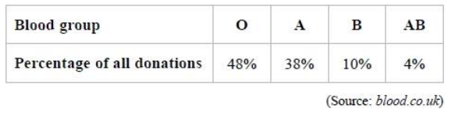
6 people attend a clinic on Monday to donate blood.
(a) (i) Name the probability distribution that can be used to model the number of people from these 6 people who will have blood group AB.
...........................................................
(ii) Write down one condition needed so that this distribution is a suitable model.
............................................................................................................................................. (2)
(b) Work out the probability that exactly one of these 6 people will have blood group AB. Give your answer correct to 3 decimal places.
........................................................... (3)
On Tuesday n people attend the clinic to donate blood. The probability that at least one of these n people will have blood group AB is greater than 0.5
(c) What can you conclude, if anything, about the value of n? You must show your working. ...........................................................................................................................................................................................
...........................................................................................................................................................................................
.......................................................................................................................................................................................(3)

3 Jasper has 3 coins.
In an experiment, Jasper flips each of the 3 coins and records the total number of heads that he gets.
Jasper believes that each coin is biased so that the number of heads he gets can be modelled by the binomial distribution, B(3, 0.4).
(a) Show that P(0 heads) = 0.216

(1)
(b) Work out the probability that the outcome of the experiment is exactly 1 head.
........................................................... (2)
Jasper carries out the experiment 100 times.
The table shows information about the number of heads he gets for each experiment.
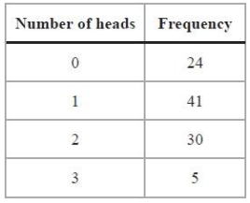
(c) Determine whether or not the model B(3, 0.4) is suitable for Jasper's experiment.

(5)
4 Fruitees sweets come in different flavours.
There are 8 sweets in a pack of mixed flavours and the flavours for each pack are chosen at random.
The mean number of strawberry flavour Fruitees in a pack of 8 sweets is 2
Ed suggests that the number of strawberry flavour Fruitees in a pack of 8 sweets can be modelled by a binomial distribution.
(a) By considering the conditions that make a binomial distribution a suitable model, explain why Ed's suggestion is appropriate.
...........................................................................................................................................................................................
.......................................................................................................................................................................................(2)
One sweet is selected at random from a pack of Fruitees.
(b) Find the probability that the flavour of this sweet is strawberry.
........................................................... (1)
Ed buys a pack of Fruitees.
(c) Find the probability that there will be exactly 3 strawberry flavour Fruitees in the pack.
........................................................... (2)
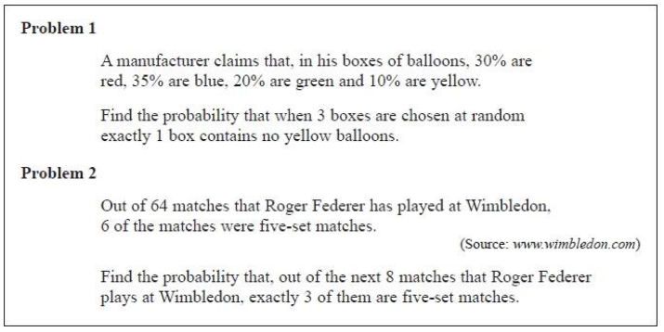
5 Nina suggests that each of the following problems can be answered by using a binomial distribution B(n, p).
(a) Assess the suitability of using a binomial distribution model to answer each of the problems.
If a binomial model is suitable, you should consider any assumptions that must be made and give possible values of n and p for the model.
If a binomial model is not suitable, you should explain why.

Problem 1 ...........................................................................................................................................................................
...........................................................................................................................................................................................
...........................................................................................................................................................................................
Problem 2 ...........................................................................................................................................................................
...........................................................................................................................................................................................
.......................................................................................................................................................................................(6)
The probability that a particular machine has a fault is 7%. A random sample of 6 of these machines are taken and each machine is checked.
(b) Work out the probability that at least 2 of these machines have the fault. Give your answer correct to 3 decimal places.
........................................................... (3)
______ / ______ / ______
How can the different probability distributions be used to calculate probabilities is specific circumstances?
What are the properties of a normal distribution?
Key Vocabulary
Vocab | Mathematical Definition
Histogram | a diagram consisting of rectangles whose area is proportional to the frequency of a variable and whose width is equal to the class interval.
Skew | when data has a long tail on one side or the other, so it is not symmetrical
The Knowledge Phase
Last year we looked at histograms. A histogram is a bar chart for continuous data where the frequency is represented by the area of the bar rather than its height.
When a histogram is drawn we can see how the data is distributed across the scale and get a feel for what the data shows.
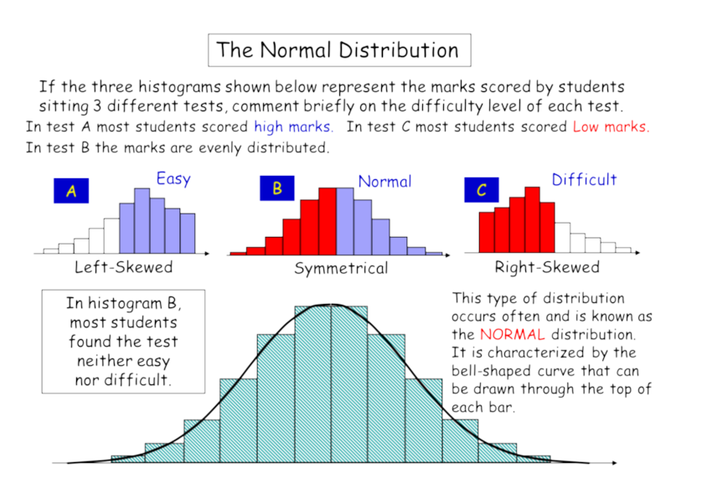
If the histogram peaks towards the end of the graph we would say that this is has a negative skew. This suggests that the majority of the data is found to the right of the graph

If the histogram peaks towards the beginning of the graph we would say that this is has a positive skew. This suggests that the majority of the data is found to the left of the graph

If the histogram peaks in the centre of the graph we would say that this is has a symmetrical skew. This suggests that the data is quite evenly shared out between the lower and upper end of the graph

This type of distribution is common and is called the normal distribution

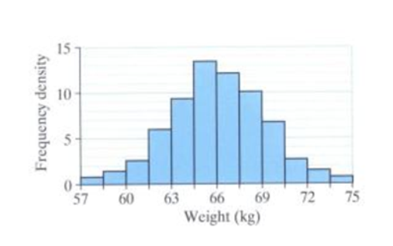
A histogram for the weights of 100 boys might
look like this

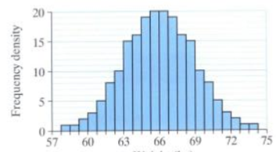
If the number of boys doubles and the class
intervals halved it would look like this

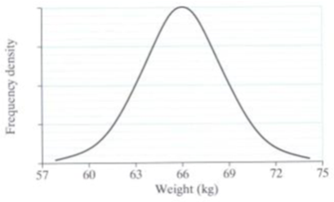
If we kept repeating this process the bars would
become more and more smoothed out and we
would eventually get a bell shaped curve.

Variables which have these qualities are said to be normally distributed

Skills Check
For each of the histograms drawn below, circle those which are normally distributed
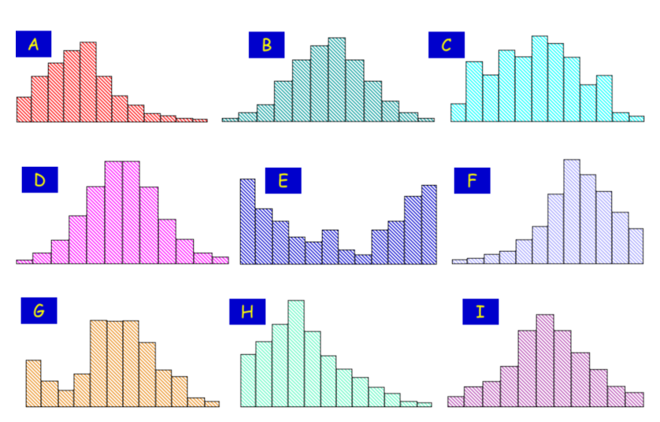
EXT can you state the skew of the other histograms?

Normal
mid 17th century (in the sense ‘right-angled’): from Latin normalis, from norma ‘carpenter's square’ (see norm). Current senses date from the early 19th century.

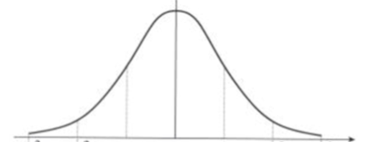
The Knowledge Phase
- the distribution is
symmetrical about the mean
- the mean, median and mode are all equal
- 68% of observations lie within one standard deviation of the mean
- 95% of observations lie within two standard deviations of the mean
- 99.8% of observations lie
within three standard deviations of the mean
NB The wider the curve the shorter it will be as they should both have the same area underneath them

I DO
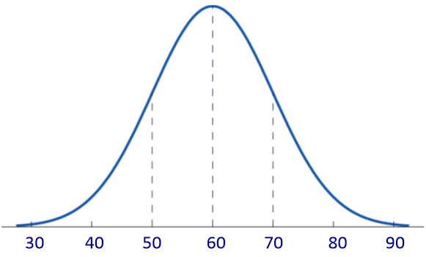
Estimate the mean and standard deviation of this distribution

WE DO
Data sets A and B are normally distributed with the following parameter.  Sketch these on the axes shown  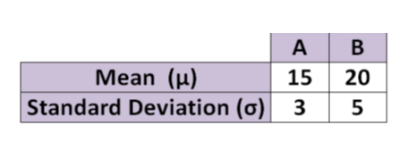 | 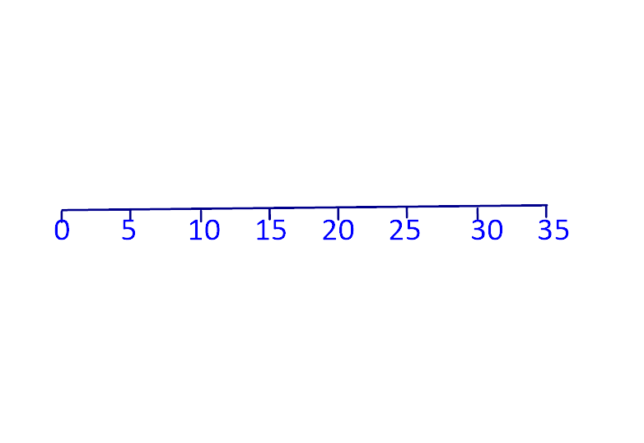
Practice Questions

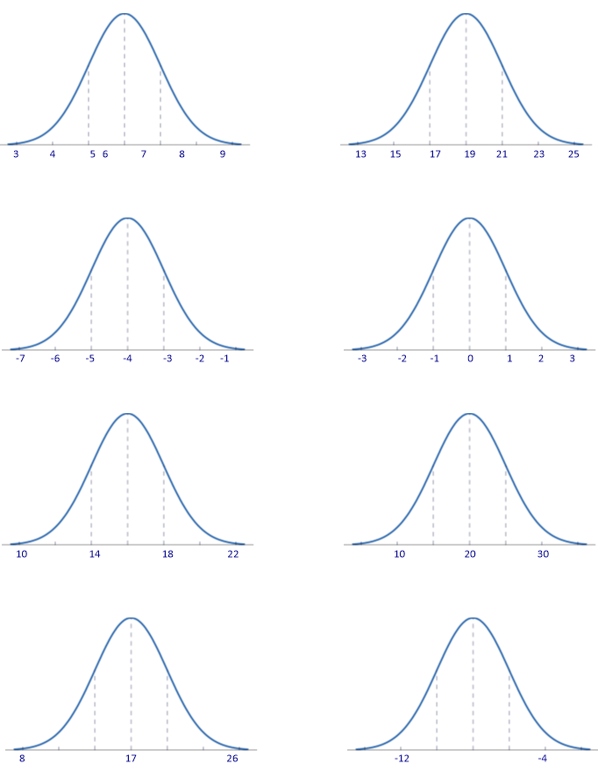
- For each of the distributions below estimate the mean and standard deviation

- Below is the mean and standard deviation for pairs of data
Sketch each pair on a normal distribution graph

- boys mean = 35
boys s.d. = 3
girls mean = 39
girls s.d. = 5

- red mean = 142
red s.d. = 7
green mean = 78
green s.d. = 12

- yr 7 mean = 5
yr 7 s.d. = 9
yr 11 mean = 12
yr 11 s.d. = 9

- <30 mean = 24
<30 s.d. = 5.5
≥30 mean = 26
≥30 s.d. = 6

- WWFC mean = 2.3
WWFC s.d. = 1.4
WBA mean = 2.1
WBA s.d. = 2.6

- WHS mean = 28
WHS s.d. = 0.4
KFORD mean = 24
KFORD s.d. = 0.7

*REACHING FOR 7+* Using your knowledge from last year of mean and standard deviation, write a sentence next to each sketch explaining what is shown by each pair of data

Historical  Origins | in Feller (1971). de Moivre developed the normal distribution as an approximation to the binomial distribution, and it was subsequently used by Laplace in 1783 to study measurement errors and by Gauss in 1809 in the analysis of astronomical data (Havil 2003, p. 157).

The Knowledge Phase
I DO
A Normal Distribution is used to represent the results of a test out of 30 for students in 11B
The mean score is known to be 20 with a standard deviation of 3
a) Between which two scores are 68% of the marks between?
b) Between which two scores are 95% of the marks between?
c) Between which two scores are 99.8% of the marks between?

WE DO
A Normal Distribution is used to represent the weights of 3000 chocolate bars with a standard deviation of 3g and a mean of 120g.
a) How many bars would you expect to weigh between 117g and 123g?
b) How many bars would you expect to weigh between 114g and 126g?
c) How many bars would you expect to weigh less than 114g?

Practice Questions

- The results of a test are normally distributed with a mean score of 56 and a standard deviation of 4
- What percentage of students should score between 52 and 60 marks?

- What percentage of students should score between 48 and 64 marks?

- What percentage of students should score over 64 marks?

- In a sample of 2000 adult males, the mean height was found to be 175cm and the sd was 5cm. Assuming a normal distribution:
- How many adults would you expect to be between 170cm and 180cm?

- Find the heights between which the central 95% of the distribution should lie

- How many adults would you expect to be taller than 185cm?

- The time taken for Jenny to walk to school is normally distributed with a mean time of 18mins and a standard deviation of 4mins. Calculate:
- The number of days last academic year (192 days) on which you would expect Jenny to take between 10 and 26 minutes to arrive to school

- The number of days on which you would expect her to take less than 14minutes

- The mean lifetime of a particular types of battery is 8.5 hours with a standard deviation of 30 minutes. In a batch of 5000 batteries and assuming the lifetimes are normally distributed:
- How many of the batteries would you expect to last for between 8 and 9 hours?

- How many of the batteries would you expect to last for between 7.5 and 9.5 hours?

Exam Questions
1 A company makes bars of chocolate on a production line in a factory.
If a chocolate bar is found to weigh less than 60 g, the company will not be allowed to sell it.
The company uses quality assurance control charts to monitor the weight of the chocolate bars.
Samples of chocolate bars are taken at regular intervals. The mean weights of the samples are normally distributed.
(a) Explain why it would not be appropriate for the production line to be set so that 60 g is the target weight.
...........................................................................................................................................................................................
.......................................................................................................................................................................................(1)
In fact the production line is set so that the sample means should be normally distributed with a mean of 62 g and a standard deviation of 0.4 g.
(b) What can be deduced from this information about the mean and standard deviation of all of the chocolate bars made on the production line?
...........................................................................................................................................................................................
.......................................................................................................................................................................................(2)

2 Some students at a school walk home and some students go home by bus.
The times taken by the students at the school to walk home have a mean of 25 minutes and a standard deviation of 6 minutes.
The times taken to walk home can be modelled by a normal distribution.
(a) Shanaya says, "More than 80% of the students who walk home take between 19 and 37 minutes" Use statistical calculations to assess Shanaya's conclusion.
(5)
The diagram below shows a sketch of the distribution of the times taken by students to go home by bus.
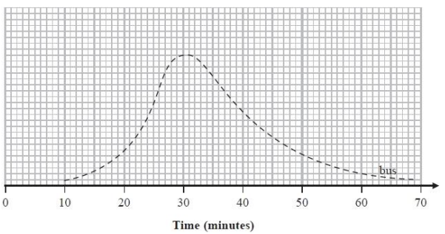
(b) Explain why it is not appropriate to use a normal distribution to model the times taken by students to go home by bus.
...........................................................................................................................................................................................
.......................................................................................................................................................................................(1)
(c) On the same grid, sketch a diagram showing the distribution of the times taken by students to walk home. (2)
3 The table gives the time that Lena took to complete successfully each of two skills tests, test A and test B.
The mean and the standard deviation for each of these tests for all the students who completed the tests are also given.
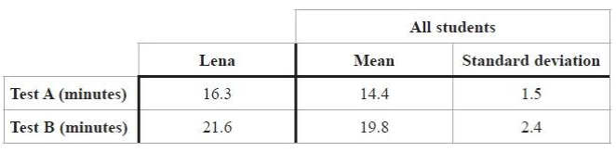
(a) Using standardised scores, compare Lena's performance in Test A relative to the other students with her performance in Test B relative to the other students.
Explain how you reach your conclusion.
...........................................................................................................................................................................................
...........................................................................................................................................................................................
...........................................................................................................................................................................................
...........................................................................................................................................................................................
.......................................................................................................................................................................................(5)
The times taken to complete successfully each test are normally distributed.
(b) Work out an estimate for the percentage of the times taken by the students to complete test B which are between 19.8 minutes and 22.2 minutes.
...........................................................................................................................................................................................
.......................................................................................................................................................................................(2)
4 The table gives information about the scores achieved by students in a French test and in a German test. The scores in each test are modelled by a normal distribution.
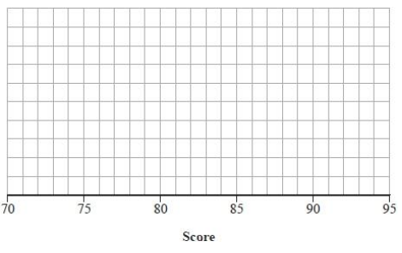
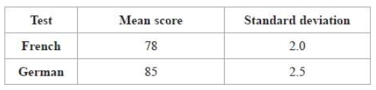
(a) On the grid, sketch a diagram of each distribution of scores. Label each diagram.

(4)

(b) Use the information in the table to make two comparisons between the scores in the French test and the scores in the German test. Interpret your comparisons in context. ...........................................................................................................................................................................................
.......................................................................................................................................................................................(3)
Key words to learn
Formulas to learn

Copyright List
https://www.statsacademy.co.uk/_files/ugd/d7dae4_420973afb80442f18e64023e051cd95a.pdf
https://slideplayer.com/slide/736361/
https://www.britannica.com/science/binomial-distribution
https://mathworld.wolfram.com/NormalDistribution.html#:~:text=in%20Feller%20(1971).,157).
https://hsm.stackexchange.com/questions/7371/who-coined-the-term-uniform-as-in-uniform-distribution#:~:text=According%20to%20James%20Landau's%20entry,Mathematical%20Probability%20by%20J.%20V.%20Uspensky.

