Mathematics and Statistics Department


Knowledge Book
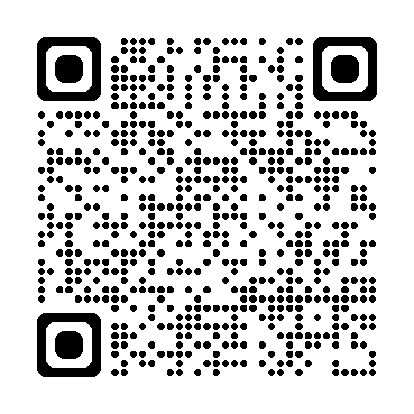
GCSE Statistics
Term 10.1
Data Collection
Scan here for revision materials
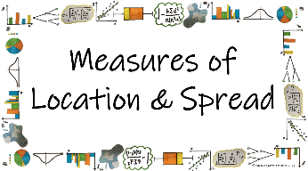
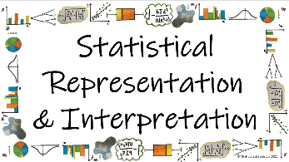
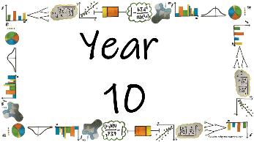
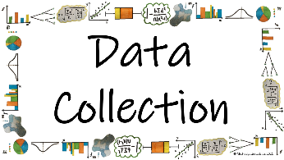

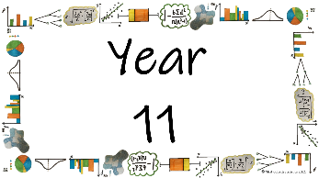
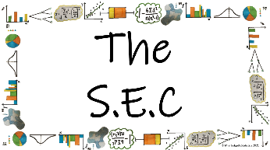
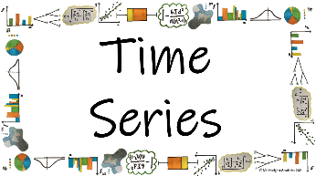
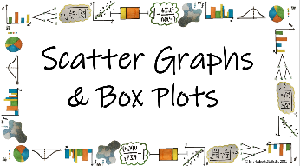

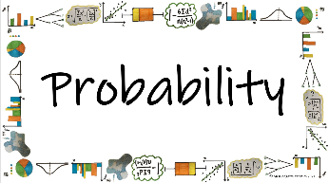
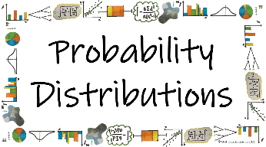
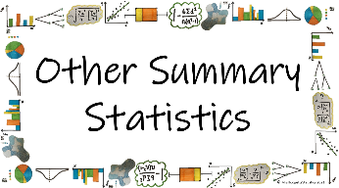


Name: ______________________
Teacher: ______________________
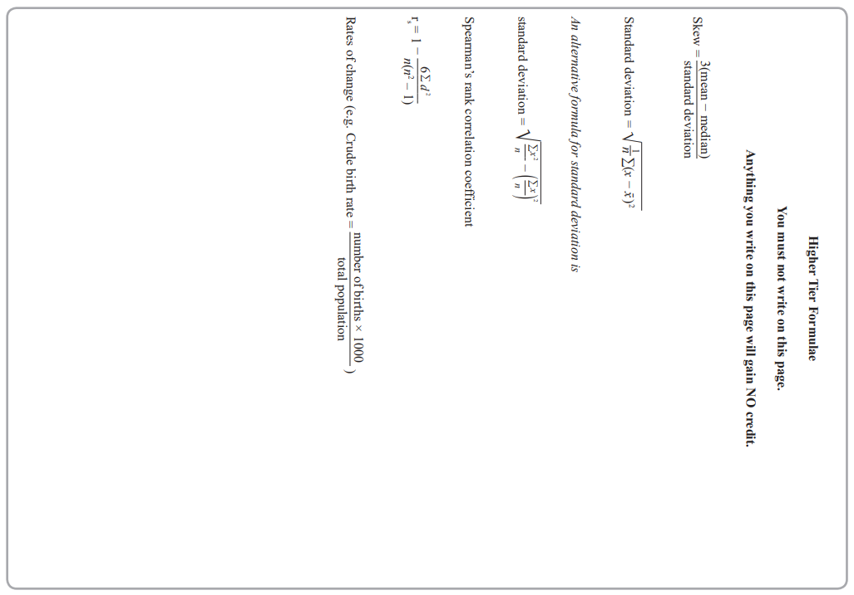
Contents Page
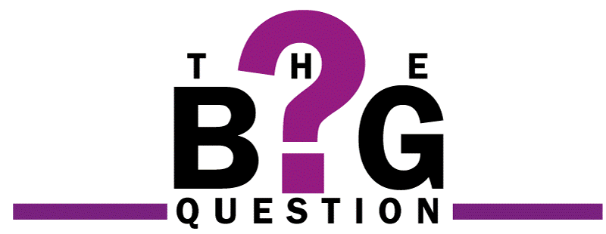 | What is ‘data’ and how can we collect it?
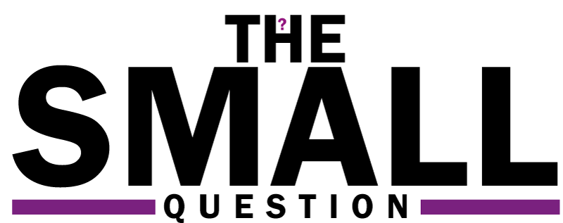 |  | Page
*How can we identify if data is Primary or Secondary?
*How can we identify if data is Qualitative or Quantitative?
How can we identify if data is Categorical, Ranked or Bivariate?
How can we write an appropriate hypothesis for an investigation?
How do we identify the population needed for an investigation?
*What are the pros and cons to taking a census?
How do we identify a sample, sample units and sample frame?
How do we determine whether data given to us is a parameter or a statistic?
*How can we explain how to take a random sample?
*How do we calculate and explain how to take a stratified sample?
How do we calculate and explain how to take a systematic sample?
How can we identify the sampling method from a written scenario?
What are the advantages and disadvantages of the various sampling methods?
*How can we use the capture/recapture method for estimating population sizes?
*How do we ensure that a questionnaire is useful, practical and suitable for an investigation?
How and why do we ‘clean’ data?

  Cross-Curricular  Link | All small questions marked with a * are topics that you will be coving in GCSE Maths as well as GCSE Statistics
Vocabulary Pyramid

Sample
Census
Sample_Units
Sample_Frame
Discrete Continuous
Primary Secondary
Qualitative Quantitative
Categorical Ranked Bivariate
Population Random Strata Stratified
Systematic Cluster Quota Convenience
Capture/Recapture Questionnaire Open
Closed Pilot_Survey Cleaning_Data

Tier 3 Words
Words specific to the subject ‘Statistics’
These may have different meanings in other subjects

Tier 2 Words
Data Identify Describe Discuss
Variables Determine Parameter Statistic
Evaluate Respectively Given Explain Conduct
Suggest Assess Validity Research Investigate
Calculate Practical Suitable Collect
Words that are often seen written in text and exam questions but are not often spoken

Tier 1 Words
Words that are used often in speech and have the same meaning in most contexts
Who What Where When Why How
Age Time Weight Mass Length Breadth Width Height
Cheap Expensive Quick Time_Consuming
Advantages Disadvantages

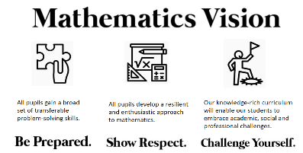

In this Knowledge Book you will see some of the following symbols with interesting facts and information about the words and terminology which will not be assessed but will deepen your understanding of the words.

 | This gives us the origin of a word and the historical development of its meaning.
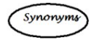 | This gives us a word or phrase that means exactly or nearly the same as another word or phrase in the same language.
  Historical  Origins | Historical Origins. This gives us the historical origin of the word.
  Did you know? | Do you Know? This gives us a fascinating fact about the word or skill,
Cross-Curricular  Link | Cross Curricular Link. This gives us links to where we might use this word or skill in other subjects
  Real World  Application | Real World Application. This gives us an idea of when or how we might use this in the real world.
  Revision Ideas | Revision ideas. This gives us some revision techniques to use for each topic.  Remember to use the revision websites:  - MrsHodgettsStatistics.com  - StatsAcademy.co.uk  - MathsGenie.co.uk  And the Revision techniques websites:  - GetRevising.co.uk
______ / ______ / ______
Primary and Secondary Data
 | What is ‘data’ and how can we collect it?
 | *How can we identify if data is Primary or Secondary?
Key Vocabulary
Vocab | Mathematical Definition
Primary Data | data which you collect yourself or is collected by your team specifically for the investigation in hand
Secondary Data | data which has already been collected or already exists but can be used for the investigation in hand
The Knowledge Phase
Primary Data – data which you collect yourself or is collected by your team specifically for the investigation in hand
Examples:
- _____________________________________________________________
- _____________________________________________________________
- _____________________________________________________________

Advantages
✓ The collection method is known
✓ The accuracy is known
✓ The questions can be tailored to the investigation
Disadvantages
x Time consuming
x Expensive

Secondary Data – data which has already been collected or already exists but can be used for the investigation in hand
Examples:
- _____________________________________________________________
- _____________________________________________________________
- _____________________________________________________________

Advantages
✓ Cheap
✓ Quicker than Primary
✓ Can be more accurate if from a reliable source
Disadvantages
x May be out of date
x May have mistakes
x May not answer the investigation properly

______ / ______ / ______
Qualitative and Quantitative Data
What is ‘data’ and how can we collect it?
*How can we identify if data is Qualitative or Quantitative?
Key Vocabulary
Vocab | Mathematical Definition
Qualitative Data | data which is non-numerical
Quantitative Data | data which is numerical. This can be split into two sub-categories
Discrete Data | numerical data which is countable
Continuous Data | numerical data which is measurable

Qualitative: Latin ‘qualitas’ and the English ‘quality’
Quantitative: Latin ‘quantitas’ and the English ‘quality’
Discrete: Latin ‘discretus’ meaning to separate
Continuous: Latin ‘continuus’ meaning uninterrupted

The Knowledge Phase
Qualitative Data – data which is non-numerical
Examples:
- _____________________________________________________________
- _____________________________________________________________
- _____________________________________________________________

Quantitative Data - data which is numerical. This can be split into two sub-categories
Discrete Data – numerical data which is countable
Examples:
- _________________________________
- _________________________________
- _________________________________

Continuous Data – numerical data which is measurable
Examples:
- _________________________________
- _________________________________
- _________________________________

______ / ______ / ______
Categorical, Ranked and Bivariate Data
What is ‘data’ and how can we collect it?
How can we identify if data is Categorical, Ranked or Bivariate?
Key Vocabulary
Vocab | Mathematical Definition
Categorical Data | A set of data is categorical if values or observations belonging to it can be sorted into different categories
Ranked Data | Values that can be ranked or have a rating  scale attached. It can be counted and ordered but NOT measured
Bivariate Data | Pairs of related variables

The Knowledge Phase
Categorical Data – A set of data is categorical if values or observations belonging to it can be sorted into different categories
*Categorical Data can be both Qualitative or Quantitative*
Examples:
- _____________________________________________________________
- _____________________________________________________________
- _____________________________________________________________

Ranked Data – Values that can be ranked or have a rating
scale attached. It can be counted and ordered but NOT measured
*Ranked Data can be both Qualitative or Quantitative*
Examples:
- _____________________________________________________________
- _____________________________________________________________
- _____________________________________________________________

Bivariate Data – Pairs of related variables
*Bivariate Data can only be Quantitative*
Examples:
- _____________________________________________________________
- _____________________________________________________________
- _____________________________________________________________

______ / ______ / ______
Hypotheses
What is ‘data’ and how can we collect it?
How can we write an appropriate hypothesis for an investigation?
Key Vocabulary
Vocab | Mathematical Definition
Hypothesis | a sensible assumption written as a statement that can be tested to see if it is correct or not

Hypotheses: Greek ‘hupo’ and ‘thesis’ meaning under placing
The Knowledge Phase
A hypothesis is a sensible assumption made as a starting point for an investigation. This can then be tested using a variety of statistical techniques to see if it is correct or not. Hence, it may or may not be true.

Some things we need to remember when writing a hypothesis …
- A hypothesis is not a question
- A hypothesis should be a statement
- A hypothesis should suggest a testable answer to the question
- A hypothesis should relate to as many aspects of the scenario as possible

How to start a hypothesis …
- The most popular / most common / most frequent … is …
- The average … is …
- There is a
a. weak / moderate / strong / very strong
b. positive / negative relationship between … and …
- … do better on average than …

And remember …
- If you are writing a hypothesis about averages include a time frame. E.G. The average cost PER HOUR / PER DAY / PER WEEK / PER MONTH / PER YEAR
- Your hypothesis must be testable. i.e. do not write a hypothesis about something you cannot measure or get the information for – be specific NOT vague

______ / ______ / ______
Population
What is ‘data’ and how can we collect it?
How do we identify the population needed for an investigation?
Key Vocabulary
Vocab | Mathematical Definition
Population | Everything or everybody that could possibly be involved in an investigation
Census | Data collected from the whole population

Population: Latin ‘populus’ meaning people
Census: Latin ‘censere’ meaning to assess

The Knowledge Phase
Population - everything or everybody that could possibly be involved in an investigation.
- This does not have to be the 'population' of Britain or the world
- The definition of ‘population’ can vary — for example it could be a class group or the cars in a car park.

**REMEMBER** to use the phrase ‘all of the’ when describing the population

Sometimes, the population is small and easy to collect data from.
Other times the population is too large to handle or impossible to list and therefore a sample (see page 15+) is used to collect the data

______ / ______ / ______
Census
What is ‘data’ and how can we collect it?
What are the pros and cons to taking a census?
Key Vocabulary
Vocab | Mathematical Definition
Population | Everything or everybody that could possibly be involved in an investigation
Census | Data collected from the whole population

Population: Latin ‘populus’ meaning people
Census: Latin ‘censere’ meaning to assess

The Knowledge Phase
A census is data collected from the whole population.
A census is:

✓ Unbiased
✓ Accurate
✓ Takes every member of the population into account

x Time consuming
x Expensive
x Can be a lot of data to handle
x Can be difficult to ensure every member of the population takes part

Did you know? | The most well know example of a census is the UK National census which is carried out every 10 years since 1801 by the ONS.

Historical  Origins | The UK census was first recorded in 1801

______ / ______ / ______
Sampling
What is ‘data’ and how can we collect it?
How do we identify a sample, sample units and sample frame?
Key Vocabulary
Vocab | Mathematical Definition
Sample | A small proportion of the population
Sample Units | The people or things being sampled
Sample Frame | A list of the population from which the sample can be obtained

The Knowledge Phase
A Sample is a small proportion of the population
Samples can be collected in a variety of way (we will look into this further later in the unit)
A sample contains information about part of the population as opposed to a census which contains information about all of the population
The purpose of a sample is to provide information which can be used to infer information about the population in a more convenient way
A sample:

✓ is quick
✓ is cheap
✓ is more convenient

x can be biased
x can be influenced by outliers
x does not take every member of the population into account

The Sample Units are the people or things being samples
The Sample Frame is a list of the population from which a sample can be obtained.
- An employee or student register
- An electoral roll
- An inventory list

**AMAZING FACT YOU SHOULD KNOW**
A statistically large sample is any sample that is ≥30
______ / ______ / ______
Parameters and Statistics
What is ‘data’ and how can we collect it?
How do we determine whether data given to us is a parameter or a statistic?
Key Vocabulary
Vocab | Mathematical Definition
Parameter | Any numerical value which is calculated or known about the population
Statistic | Any numerical value which is calculated or known about the sample

The Knowledge Phase
A Parameter is defined as any numerical value which is calculated or known about the population
A Statistic is defined as any numerical value which is calculated or known about the sample

______ / ______ / ______
Random Sampling
What is ‘data’ and how can we collect it?
How can we explain how to take a random sample?
Key Vocabulary
Vocab | Mathematical Definition
Population | Everything or everybody that could possibly be involved in an investigation
Sampling | A small proportion of the population
Random | Something that happens without method or conscious decision.
Random Sampling | A sampling method in which everyone or everything has an equal chance of being chosen

The Knowledge Phase
A random Sample is one where everyone and everything from the population has an equal chance of being chosen.
A random sample is chosen without a conscious decision about what or who is selected from the population
Random Numbers can be found in a variety of ways:
- Names in a hat
- Internet generators
- Computer programmes such as Excel
- Random Number Tables
- Ran# on the calculator
Ran# on the calculator
The Ran# button gives you a number between 0 and 0.99 to 3 decimal places
The RanInt# button given you an integer between two identified values (which can b e manipulated as required)
The Knowledge Phase
In the exam, your instructions for how to take a random sample must be clear
1) Number the units from 1-n in the sampling frame
2) Choose a random number from a random number generator
3) Ignore any repeats and numbers > n
4) Continue until x numbers obtained and choose the corresponding units from the population

______ / ______ / ______
Stratified Sampling
What is ‘data’ and how can we collect it?
How do we calculate and explain how to take a stratified sample?
Key Vocabulary
Vocab | Mathematical Definition
Population | Everything or everybody that could possibly be involved in an investigation
Sampling | A small proportion of the population
Strata | A group or category which the population has be split into
Stratified Sampling | A sampling method which ensure the sample taken is proportionate to the strata which makes up the population

The Knowledge Phase
Strata is the statistical name for the groups/categories a population is split into.
These could be, qualitative discrete or continuous groups such as, colour, nationality, shoe size, total, height, length etc. Each group or category is known as a ‘strata’
When populations are split into strata it is common for them to be uneven in size and by taking a random sample it could be that different strata are under or over represented or not represented at all.
Stratified Sampling allows us to take a random sample that represents the population accurately
It considered the proportion of the population which resides in each strata and ensures that the same proportion is represented in the sample.
i.e. if, in a population of 400 laptops, 25% of them are blue and the rest are black; in a sample of 40 laptops a stratified sample would ensure that 10 of them were blue and the rest black

To calculate the number needed for each strata sample:
$\frac{Strata Total}{Population Total}$ X Sample Size

The Knowledge Phase
In the exam, your instructions for how to take a stratified sample must be clear
A) Calculate the number to be sampled for each strata
1) Number the units from 1-n in the first strata
2) Choose random numbers from a random number generator
3) Ignore any repeats and numbers > n
4) Continue until x numbers obtained and choose the corresponding units from the strata
B) Repeat this for each strata

Make sure you have copied the strata formula onto your formula page at the back on the KB
Create a flip book with the four steps for stratified sampling to test yourself.

______ / ______ / ______
Systematic Sampling
What is ‘data’ and how can we collect it?
How do we calculate and explain how to take a systematic sample?
Key Vocabulary
Vocab | Mathematical Definition
Population | Everything or everybody that could possibly be involved in an investigation
Sampling | A small proportion of the population
Systematic Sampling | A sampling method which uses a system of a regular interval to find the sample.
Regular Interval | A calculated value which determines how often a sample unit should be selected from the sample

The Knowledge Phase
A Systematic Sample is a sampling method which uses a system of a regular interval to find the sample.
After selecting a random starting point, we then calculate what is known as the ‘regular interval’ which determines how often we select a sample unit form the population.
This ‘regular interval’ is not random and must be calculated using the population size (or an estimate of it) and the sample size you are intending to create
When Taking a Systematic sample we must first be able to calculate the interval:
Population
Sample
The Knowledge Phase
In the exam, your instructions for how to take a random sample must be clear
A) Calculate the 'regular interval'
1) Number the subjects from 1 to n
2) Choose a random number using a random number generator
3) Choose the corresponding subject from the population as a starting point
B) Using the 'regular interval' calculate the subjects needed for your sample

Create a flip book with the four steps for systematic sampling to test yourself.

______ / ______ / ______
Other Sampling Methods
What is ‘data’ and how can we collect it?
How can we identify the sampling method from a written scenario?
Key Vocabulary
Vocab | Mathematical Definition
Population | Everything or everybody that could possibly be involved in an investigation
Sampling | A small proportion of the population
Cluster Sampling | A sampling method which groups data into categories and with either takes a sample of one cluster or a sample from a small group of clusters
Quota Sampling | A sampling method which includes categories of data to fit a given quota
Convenience Sampling | A sampling method which collects data in the most convenient way to the investigator

The Knowledge Phase
As well as being able to write instructions for how to take a random, stratified and systematic sample, you should be able to identify each of these from a written scenario along with cluster sampling, convenience sampling and quota sampling,

Cluster Sampling
- we group people into 'clusters'
- we randomly select a small sample of clusters
- we then either sample everyone from each of the chosen clusters
OR take a further random sample from each of the chosen clusters
* BE CAREFUL* this reads very similarly to stratified sampling.

WTLF: whether they sample a proportionate amount from each group (Stratified Sampling) or just a random sample from some of the groups (Cluster Sampling)

Convenience Sampling
- we sample the people that are most convenient for us to find

WTLF: the phrase ‘asked the first __ people’ or ‘sampled the first ___ items’

Quota Sampling
- we are told the criteria of the type of people to be samples (our 'quota')
- we take a convenience sample of these types of people
- this method is most often used by market researchers

WTLF: a set number from different groups that haven’t been calculated.

Create flash cards with lots of different examples of various sampling methods to test yourself with. Try using GetRevising.co.uk

______ / ______ / ______
Advantages and Disadvantages of Sampling Methods
What is ‘data’ and how can we collect it?
What are the advantages and disadvantages of the various sampling methods?
Key Vocabulary
Vocab | Mathematical Definition
Sampling | A small proportion of the population
Random Sampling | A sampling method in which everyone or everything has an equal chance of being chosen
Stratified Sampling | A sampling method which ensure the sample taken is proportionate to the strata which makes up the population
Systematic Sampling | A sampling method which uses a system of a regular interval to find the sample.
Cluster Sampling | A sampling method which groups data into categories and with either takes a sample of one cluster or a sample from a small group of clusters
Quota Sampling | A sampling method which includes categories of data to fit a given quota
Convenience Sampling | A sampling method which collects data in the most convenient way to the investigator

The Knowledge Phase
As well as being able to write instructions for how to take a variety of samples and identifying which sample is being taken from a set of instructions, we must also know the advantages and disadvantages of each sampling method to help us to decide which one to use if different situations.

Sampling Method | Advantage | Disadvantages
Random | - Everyone or everything has an equal chance of being chosen  - Minimal bias | - May not be representative of the whole population  - May not be possible to number the whole population
Stratified | - Is representative of the whole population  - Minimal bias | - Time Consuming / Expensive  - May not be possible to number the whole population
Systematic | - Quick / Cheap  - Easy / Convenient  - Suitable for populations which are a constant flow such as a production line | - Can be biased as the regular interval could be stopping certain members of the population from being chosen  - Not random once the first number has been chosen
Cluster | - Quick / Cheap  - Easy / Convenient | - Can be biased as it may not represent the whole population  - Not Random
Quota | - Quick / Cheap  - Easy / Convenient  - Ensures you have the type of sample you need | - Prone to bias  - Not Random
Convenience | - Quick / Cheap  - Easy / Convenient | - Can be biased  - Not Random

Create a mind map of the different sampling methods, their process and their advantages & disadvantages. Try using GetRevising.co.uk

______ / ______ / ______
Capture/Recapture
What is ‘data’ and how can we collect it?
How can we use the capture/recapture method for estimating population sizes?
Key Vocabulary
Vocab | Mathematical Definition
Population | Everything or everybody that could possibly be involved in an investigation
Sample | A small proportion of the population
Capture/Recapture | A way of estimating the size of a population that cannot be counted easily

Historical  Origins | Capture-recapture methods have a long history, and they were first applied in the study of fish and wildlife populations before being adapted for other purposes. The application of these methods to the study of epidemiologic problems came relatively late in this history and thus has been able to draw on advances in the other areas as well as in statistical methods more broadly.

The Knowledge Phase

Some population are easy to count such as the number of students in a school, the number of products produced at a factory on a particular day, the members at a tennis club etc.
However, other population can be trickier such as the number of squirrels on the Isle of Wight, the number of deer at a national park etc.

The capture/recapture method is a way of estimating the size of a population that cannot be counted easily.

To use the capture/recapture method we need to follow these steps:
1. Assume a population has a total of N
2. Catch M members of the population, tag or mark them
3. Put these members back and allow a little time for the to mix with the population
4. Catch a sample of n members
5. Count how many of this sample are tagged or marked (m)
6. Formulate and solve the equivalent fraction for N $\frac{m}{n}$ = $\frac{M}{N}$

What must we always assume for this method to be an accurate estimate?
- The initial sample must have enough time to mix with the rest of the population
- The initial sample must not have too much time so that the population will have changed drastically
- The markings placed on the initial sample must have not come off the sample or transferred onto the rest of the population
______ / ______ / ______
Questionnaires, Interviews and Pilot Surveys
What is ‘data’ and how can we collect it?
How do we ensure that a questionnaire is useful, practical and suitable for an investigation?
Key Vocabulary
Vocab | Mathematical Definition
Interview | A way for one person to ask questions and another to answer them.
Questionnaire | A set of questions that have been written and used to obtain data
Open Questions | Questions which have no suggested answers
Closed Questions | Questions which have suggested answers
Pilot Surveys | A trial run of some questions for a questionnaire

Questionnaire: French ‘questionner’ meaning to question
Interview: French ‘s’entrevoir’ meaning to see each other

The Knowledge Phase
Interviews
An interview is a way for one person to ask questions and another to answer them.
This is most often thought of as a face-to-face meeting but it DOES NOT have to be a face to face conversation. It can also be:
- a phone call
- post or e-mail (similar to a questionnaire)

When choosing the best method for interview techniques there are 5 things we need to consider:

UNDERSTANDING: think about how we can explain the questions if needs be

CANDOUR: think about what will make the interviewee be more honest

RESOURCES: think about time/costs

INCLUSIVITY: think about how we can ensure everyone responds

INTERVIEWER BIAS: think about the influence of the interviewer

Considering these 5 points, choose the type of interview that is best for each aspect:
 | Face-to-Face | Phone Call | Email/Letter
Understanding
Candour
Resources
Inclusivity
Interviewer Bias

*NOTE* there is no one method if interview that is better than the rest, they all have their advantages and disadvantages. When choosing the best method the context is important.

Questionnaires
A questionnaire is a set of questions that have been written and used to obtain data
Questions on a questionnaire come under two categories

Open Questions
These are questions which have no suggested answers and gives the responder free reign on how to answer
✓ this can give you ideas of responses that you wouldn’t have thought of

x this can give you too many varied responses and make the data too hard to analyse

Closed Questions
These are questions which have suggested answer and the responder must choose their answer
✓ this gives you data which is easy to analyse

x the suggested answers may not exhaust all possibilities or may overlap and confuse responders

Pilot Survey
To overcome the problem of open questions we can use a pilot survey
A pilot survey is a trial run of some of the possible questions you may want to ask
You ask a smaller sample than you intend to give the questionnaire to
We use them to:
- ask open questions and use responses to create closed question options
- check that the questions make sense to participants
- help to see if the questions are necessary and the responses are helpful
We then use the responses to help tweak the questionnaire to be used
Criticising Questionnaires – C.O.L.E
C: Choice of Answers
Make sure the question covers all possible options of answers and that they are clear for all responders
(look at where the options start and finish, are there other possibilities?)

O: Overlapping Boxes
Make sure that the options given to people do not overlap
This is often corrected with the use of inequalities rather than ‘-‘

L: Leading Questions
Make sure that the questions is not sharing the writers opinion and/or asking responders to
agree/disagree

E: Embarrassing Questions
Questions which are personal may be considered embarrassing to responders and this can lead to non-
responses or false information
Whilst some questions need to be asked only include persona questions if they are necessary to the
investigation

(

______ / ______ / ______
Cleaning Data
What is ‘data’ and how can we collect it?
How and why do we ‘clean’ data?
Key Vocabulary
Vocab | Mathematical Definition
Data | Facts and information which is collect and presented so it can be analysed
Cleaning Data | A method of sorting through data to make it more easily analysable

The Knowledge Phase
When you have some data the first thing you need to do is to check it out and get rid of any obviously wrong or false data
This is called “Cleaning the Data”

WTLF:

Pointy Pete
Pete has a problem with the decimal point.
He puts decimals where there shouldn't be one
He moves the point around
Sometimes he does this on purpose but most of the time this is an accident

Obvious Olive
Olive is a little clumsy
She makes lots of obvious errors
Sometimes she does this on purpose but most of the time its just an accident
Silly Samantha
Samantha thinks she's funny
She like to write 'funny' answers to questions
She usually does this on purpose to try and make everyone's life more awkward

Devious Dave
Dave is a bit of a trickster
He messes with the data ON PURPOSE
He does it in ways that are not clear to see straight away

Key words to learn

Formulas to learn

